Tools used for testing – SonarQube

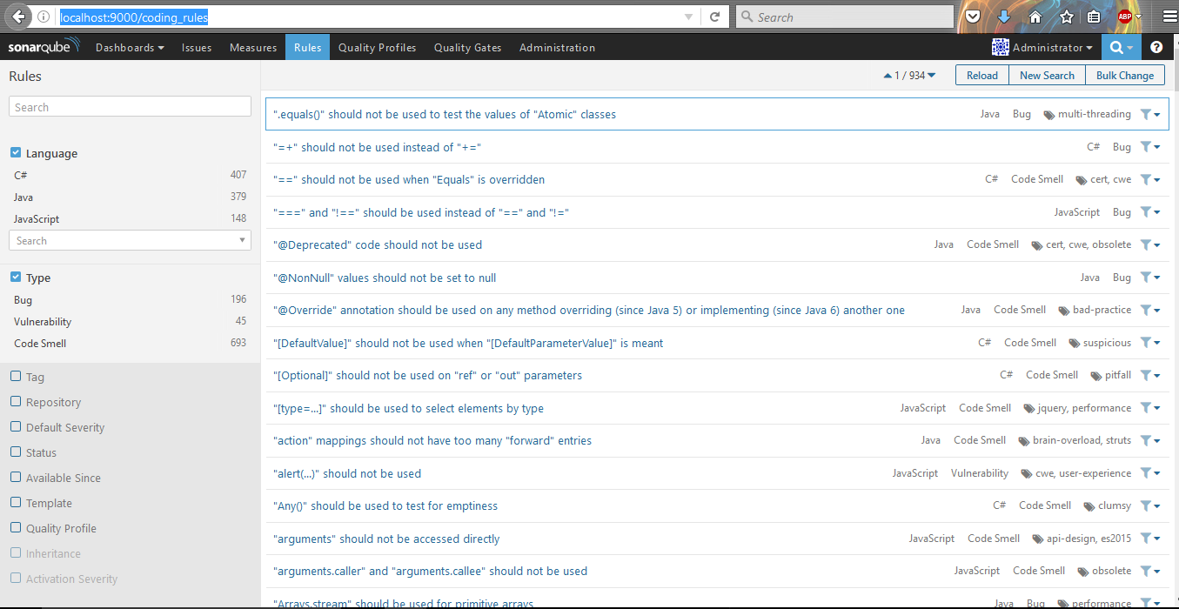

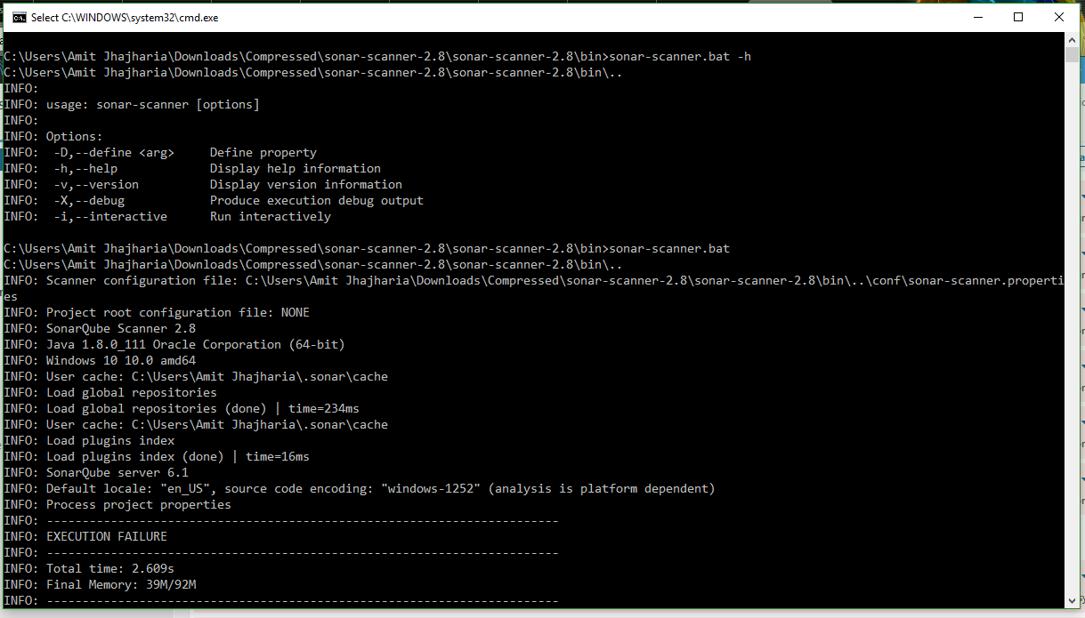

Initial Test Results :

80 Vulnerabilities and bugs were found in the initial Run.

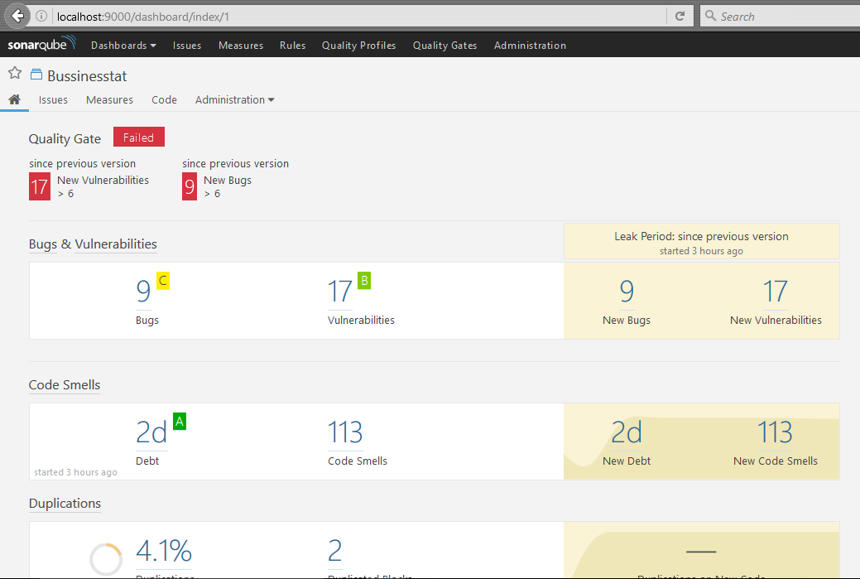

Ratings achieved were as follows:

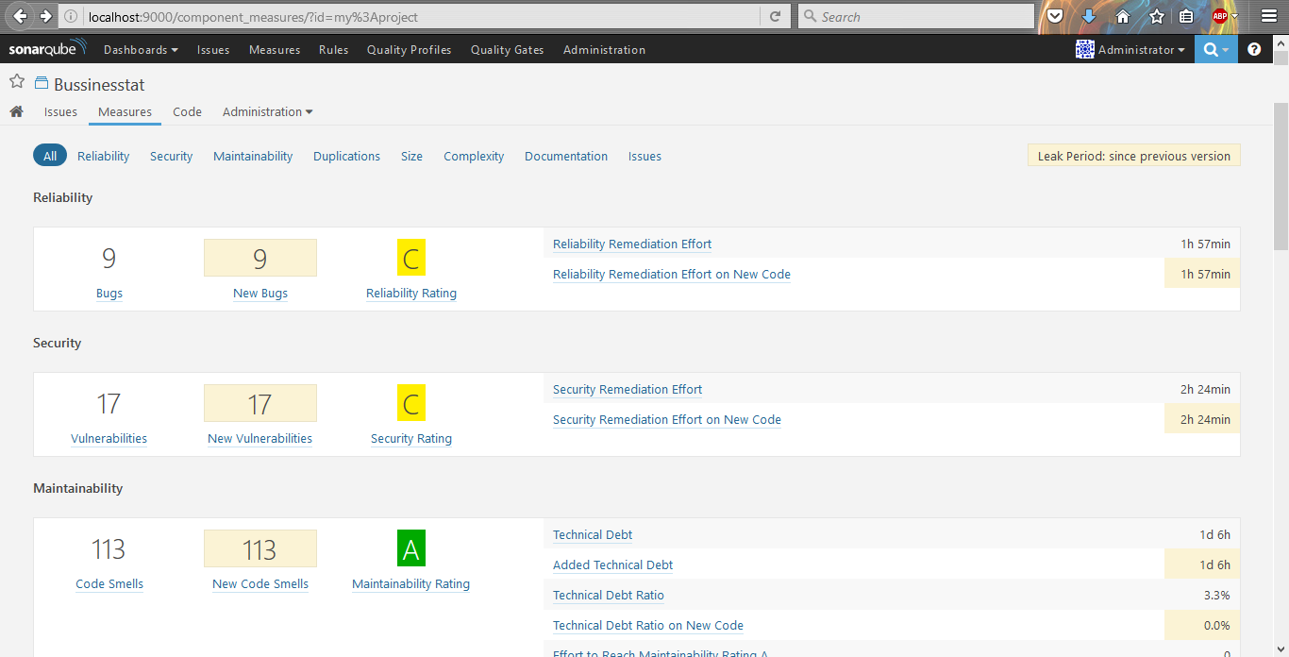

Some Error were as follows:

These are categorized as : Critical ,Major,Minor

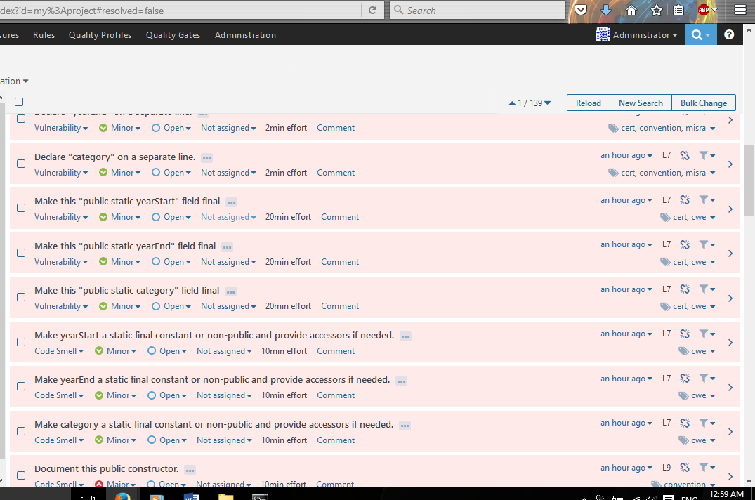

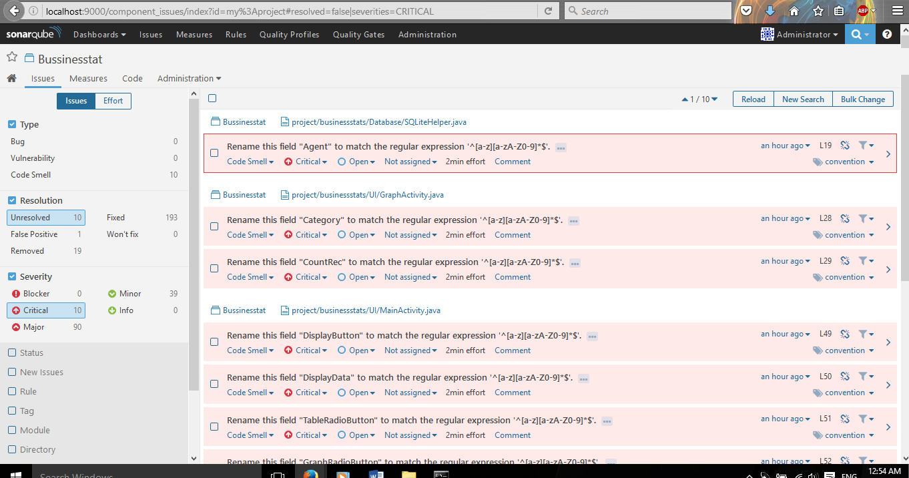

Second Phase of Testing :

30 New vulnerabilities along with some minor and major bugs were found.

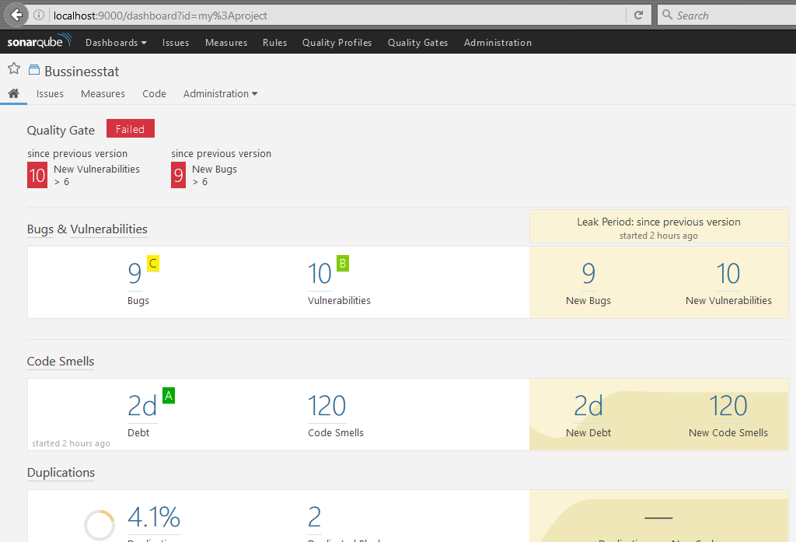

Ratings after second Phase were as follows:

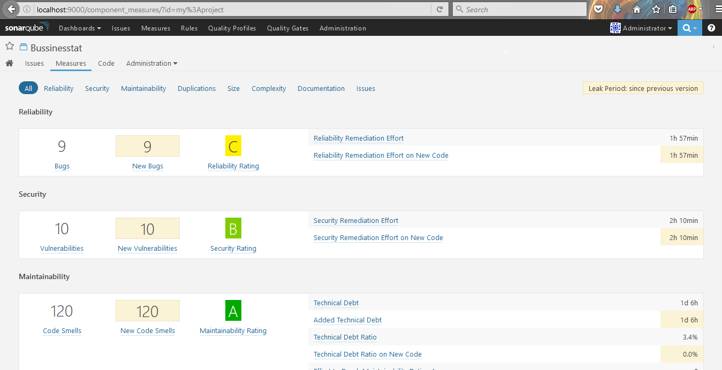

Some Major errors were fixed and categorized as minor bugs.



Results after third phase of testing:

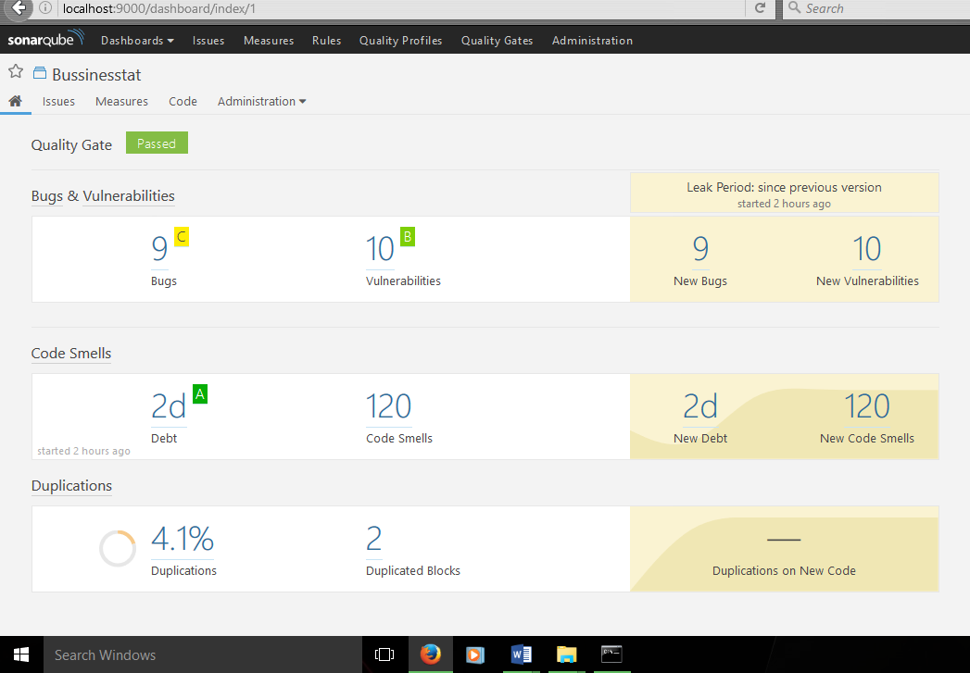

Ratings after third phase of testing:

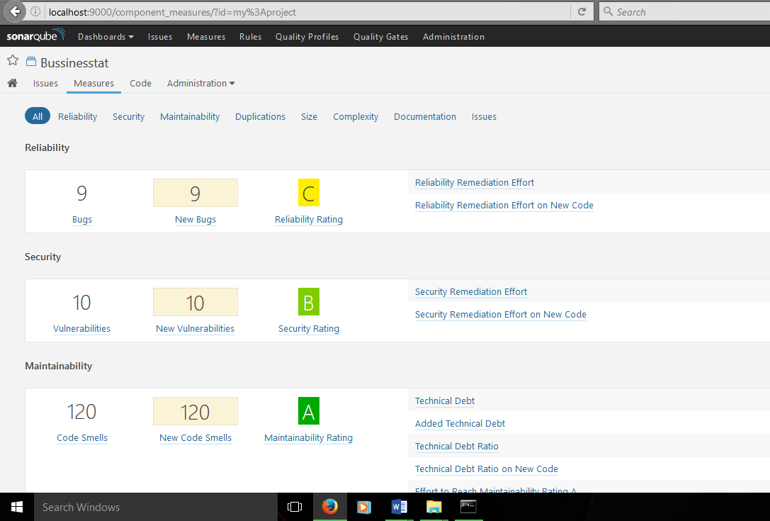

Many errors were fixed after the third phase: ☺

