Software Design Specification

- Introduction

  - Purpose of this document

The purpose of this document is to describe the implementation of BusinessStats, whose requirements have been described in the SRS.

This software is an app designed to run on Android OS that allows the user to manage his business.
This document provides guidelines related to the structure and design of the project and contains the following components-

Component Diagram: Information about the external and internal components of the system.

Class Diagram: is a type of static structure diagram that describes the structure of a system by showing the system's classes, their attributes, operations (or methods), and the relationships among objects.

Sequence Diagram: is an interaction diagram that shows how objects operate with one another and in what order. It is a construct of a message sequence chart. A sequence diagram shows object interactions arranged in time sequence.

1.2 Scope of the development project

- The name of the project is “BusinessStats” and it runs on Android OS.

- It is being tailor made according to the specifications given by the owner of a Tours and Travels business for his own personal use to manage his business.

- It has various features which are listed in detail in the SRS and in other sections of this document.

Advantages

- It allows the user to manage his business on-the-go right from his smartphone/tablet.

- It can be easily modified to work with some other business as well

- Though it is platform specific to Android OS, it runs on all versions above 5.0 Lollipop which covers more than 75% of the total Android user base.

- This app is Open Source which means that anyone has the right to contribute to it and/or modify it to add more features according to their needs. (This does not mean that the private data of our client will be shared publicly with the rest of the source code).

1.3 Definitions, acronyms, and abbreviations

- TBD: To be decided.

- Android SDK: It is a set of development tools used to develop applications for android platform.

- API: (Application Programming Interface) is a set of functions and procedures which allow the creation of applications which access the features or data of an operating system, application, or other service.

- Apache POI: It provides pure Java libraries for reading and writing files in Microsoft Office formats, such as Word, PowerPoint and Excel.

- JSON: JSON (JavaScript Object Notation) is a lightweight data-interchange format. It is easy for humans to read and write. It is easy for machines to parse and generate.

- Client/Server system: It is a distributed system in which some sites are client sites and other are server sites, all data resides at the server sites and all applications execute at the client sites.

- Distributed System: It is a model in which components located on networked computers communicate and coordinate their actions by passing messages.

- Statistics: The practice or science of collecting and analyzing numerical data in large quantities

1.4 References

- IEEE. IEEE Standard 1016 IEEE Recommend Practice for Software Design Specifications. IEEE Computer Society, 1998.
- www.stackoverflow.com
- developer.android.com
- www.wikipedia.org

1.5 Overview of document

- Following Section 1, this document is divided into Sections 2, 3, 4, 5, 6 and 7.

This document also includes the following-
- System Architecture description
- Description of components of the app
- Reuse of other open source code/libraries
- Design decisions

To provide a better understanding of the working of this app, a class diagram and a sequence diagram has been added into this document.

2. System architecture description
This project makes use of modules. We have tried to achieve as much functional cohesion and data coupling as possible.

2.1 Overview of modules / components

Remote Tour Database : The main company tour database hosted on the cloud.

JSONParser : The remote database is queried and all records are stored on the device locally, in the form of an SQLite Database.

QueryBuilder : Based on the search inputs given by the user, QueryBuilder will generate and return an expression to query the remote tour database.

Local SQLite Database : The records obtained when the remote database is queried will be stored locally in a SQLite Database and read from when required.

Search : Makes the required function calls to all the other components to begin the searching process. It acts like the main() function in a C program.

DisplayData : Reads the records present in the local SQLite Database and presents the data to the user in a tabular or graphical format for easy visual representation.

Multiple File Picker : Allows the user to pick multiple excel files containing flight schedules.

ExcelParser : Allows reading/writing to and from excel files.

Schedule Standardizer : Makes the required function calls to invoke the custom FilePicker Activity, returns the selected files to the ExcelParser, standardizes them into a single schedule file and saves it onto the user’s device.

2.2 Structure and relationships

Class Diagram
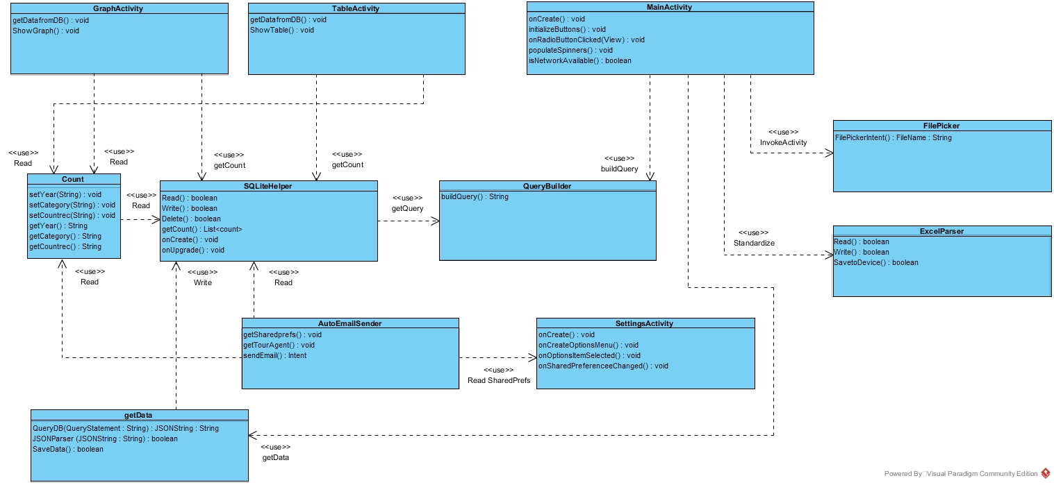
Component Diagram

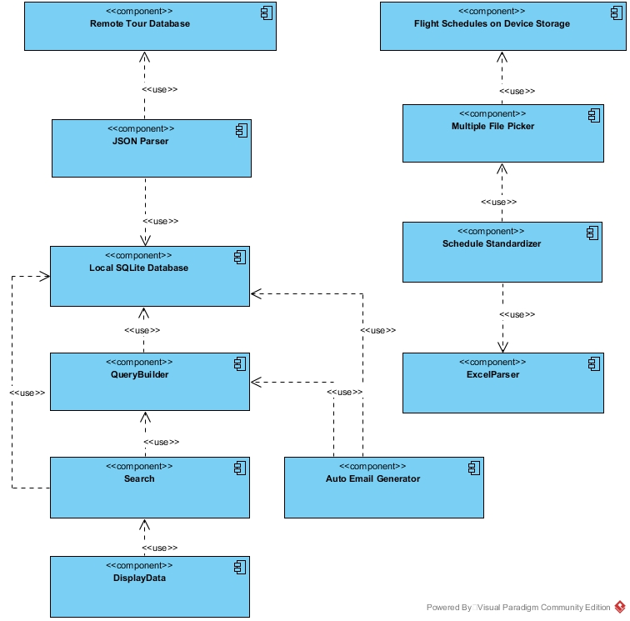

Sequence Diagram
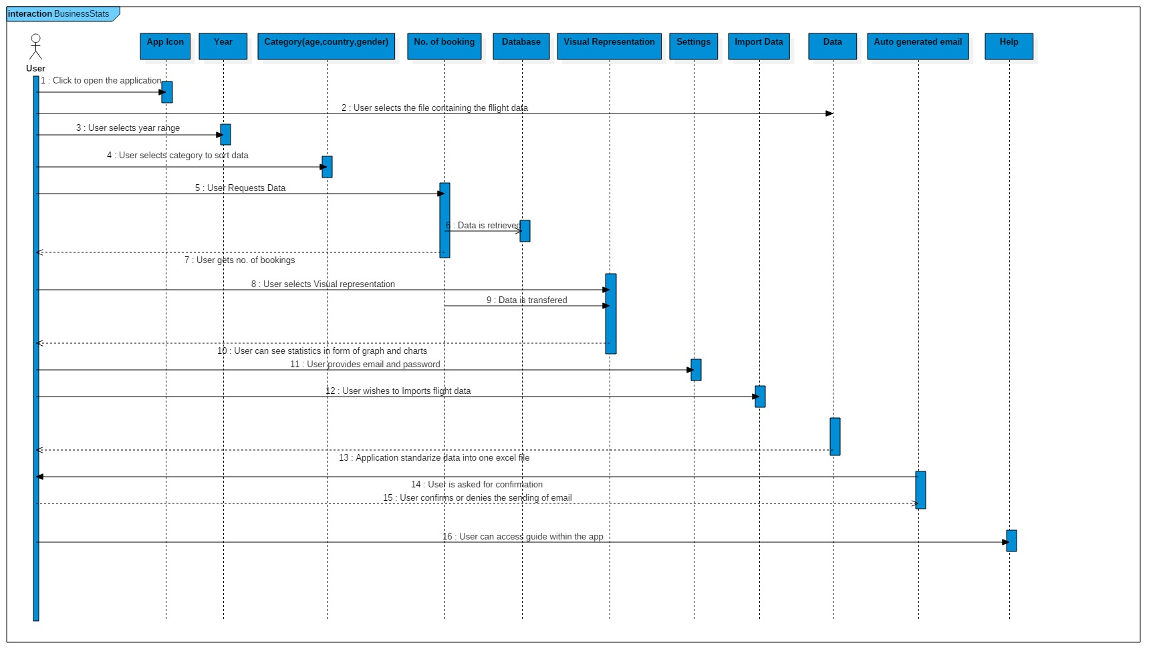

2.3 User interface issues

The user interface of this app follows Material Design principles.

Starting Screen: User is presented with various options
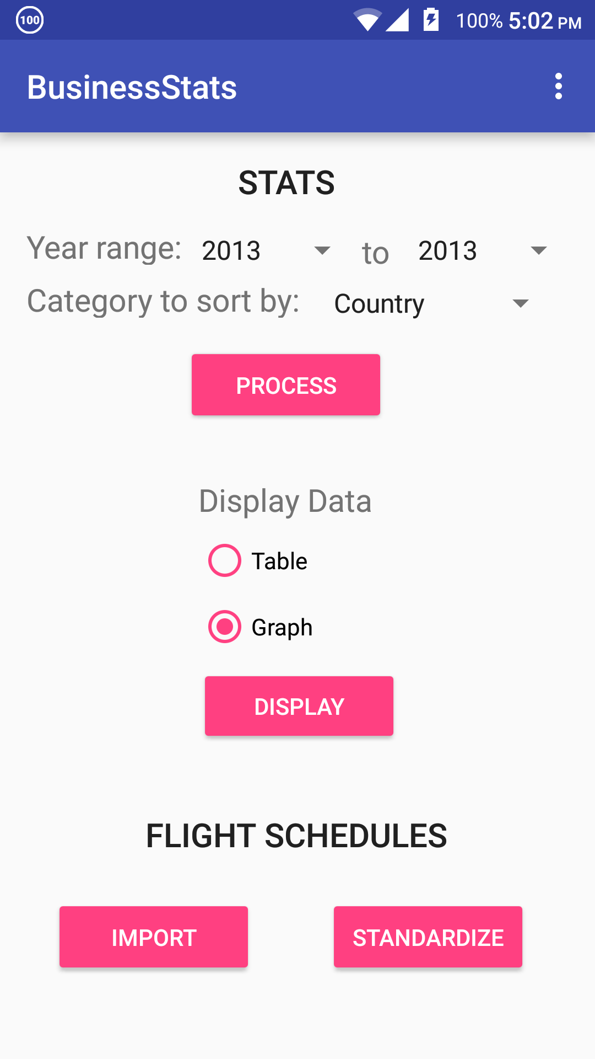

Graph Screen: On selecting “Graph” and pressing on the “Display” Button, the graph screen will show
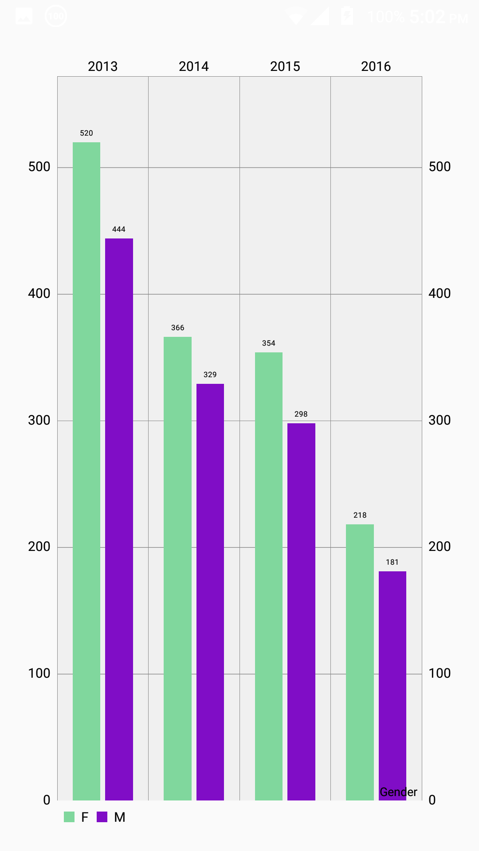

Settings Screen: On pressing the 3 dots show in the upper right corner of the main screen, the user will be presented with an options menu (called overflow menu). From there, pressing “Settings” will show the settings screen.
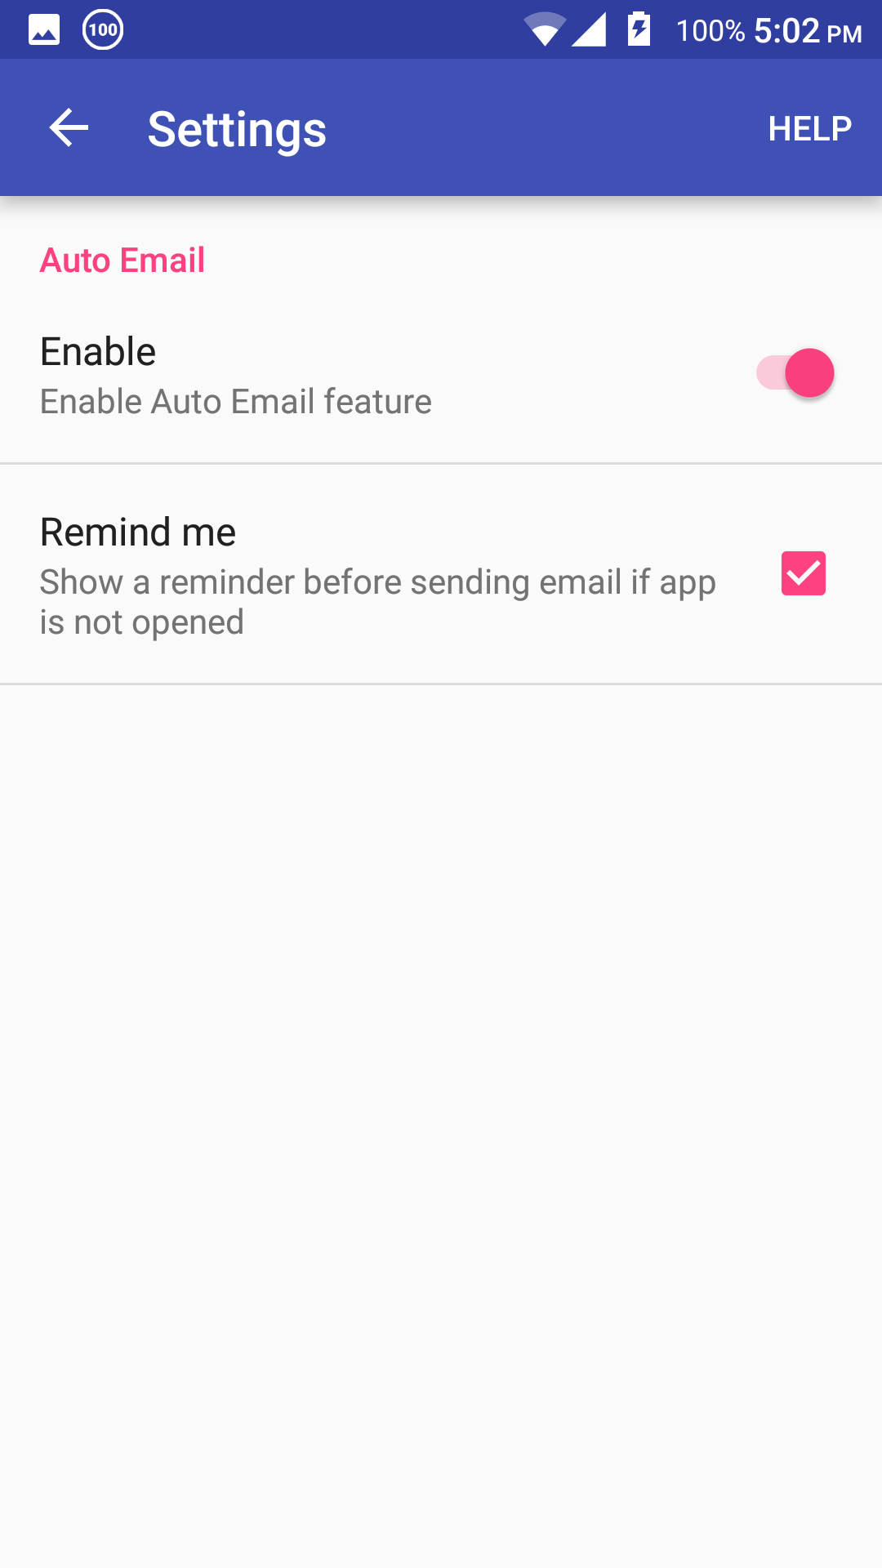

3. Detailed description of components

3.1 Main Activity

Class: MainActivity.java
Description: This class represents the Starter Activity of the app and handles all UI related tasks. It initiates all the functionalities of the app by calling the required methods from other modules/classes and initiating the process.

3.2 Fetch Data from Remote database

Class: getData.java
Description: This class queries the remote database, parses the returned JSON data and saves it into the local SQLite Database.

3.3 SQLite Helper

Class: SQLiteHelper.java
Description: This class contains all the methods required to maintain the local SQLite Database. It allows other classes to read, write and delete entries from the database.

Class: Count.java
Description: This class is a contract class that makes it easier to read/write to/from databases from other classes rather than getting the data directly from SQLiteHelper.

3.4 Query Builder

Class: QueryBuilder.java
Description: This class reads the inputs given by the user and accordingly, builds a query to read the items from the local SQLite database.

3.4 Display Data

Class: TableActivity.java
Description: This class reads the items from the SQLite database according to the query returned by the QueryBuilder class and shows the data in the form of a table.

Class: GraphActivity.java
Description: This class reads the items from the SQLite database according to the query returned by the QueryBuilder class and shows the data in the form of a graph.

3.5 Excel File parser

Class: ExcelFileParser.java
Description: The flight schedules (in excel format) are used as inputs to the methods of this class. This class can extract data from the xls files, modify it, and create new excel files.

3.6 FilePicker

Class: FilePicker.java
Description: This class contains methods that invoke a new Activity when called that displays the contents of the device’s Internal Storage/SD Card and allows him to select multiple files.

Class: FilteredFilePickerFragment.java
Description: This is a fragment of the Activity of FilePicker.java class. It filters the files on the device’s storage and displays only files in xls or xlsx format to the user.

3.7 Settings

Class: SettingsActivity.java
Description: This class deals with the UI elements present in the settings screen. It reads the state of all the UI elements present on that screen and returns the state to the calling method.

3.7 Auto Email Sender

Class: AutoEmailSender.java
Description: This class deals with automatically sending an email on 1st January to the Travel Agent having the most number of bookings for the previous year. A broadcastIntentReceiver and a service is implemented so that a reminder notification can be shown if the user doesn’t open the app on 1st Jaunary.

4.0 Reuse and relationships to other products
This project is new. No enhancement work is being done on a previously designed system.
There are various Java open source libraries being used in this project in order to implement certain features that cannot be implemented using the native Android API.
There is no code being reused from elsewhere. All code is being written from scratch as there is no suitable prewritten code that will be useful in this project.

5.0 Design decisions and tradeoffs

Design Decisions
This app is written in Java using the Android API (SDK 23).

Libraries Used

- Apache POI – This is a Java library that allows reading/writing from/to Microsoft Office file formats like xls, docx, pptx, etc.

- NoNonsenseApps FilePicker – This is a custom implementation of a file picker that lets you select multiple files from the device’s Internal Storage/SD Card. The one in the Android API only allows you to select one file at a time.

- MPAndroidChart - This is an open source library designed for Android to represent statistical data in a visual format in the forms of bar graphs, pie charts, tables, etc.

- SortableTableView – This is an open source library designed for Android to represent statistical data in a tabular form.

We have made the above mentioned design decisions and implemented the system on the Android OS because our client wanted a business management system that is fast, easy to use and portable.

Tradeoffs
The only tradeoff is that implementing such a system on a mobile platform like Android makes it difficult to add more complex functionality to the app due to the limited hardware capabilities of mobile devices and the lack of more advanced libraries.

6.0 Pseudo code for components

1. Search Feature
MainActivity
- User selects year range and category to sort booking records.
- Inflate all UI elements
- Inflate overflow menu
- Check for network connection
- Generate Query Statement
- call getDatafromDB() in getData class
- once all processing is complete, call methods of DisplayData

getData
- getDatafromDB() queries remote database and returns items in JSON
- JSONParser() interprets the JSON String and calls write() in SQLiteHelper

SQLiteHelper
- Write() saves the queried records to the local SQLite Database
- Read() gets the required records from the local SQLite Database
- Delete() deletes an entry from the local SQLite Database

- DisplayData
- ShowGraph() in GraphActivity class calls read() from SQLiteHelper and shows data in the form of a graph
- ShowTable() in TableActivity calls read() from SQLiteHelper and shows data in a the form of a table

2. Schedule Standardization Feature
- MainActivity
- User presses “Import file” button and FileSelector() from FilePicker is called
- Selected files are passed onto read() in ExcelParser
- Processing is done to read each cell and accordingly standardize the file
- SavetoDevice() is called and the standardized file is saved to user’s device

3. Auto Email Generation Feature
- A service and a BroadcastIntentReceiver is implemented to enable this feature to be active in the background.
- On 1st January of every year, an email gets generated automatically
- User presented with a dialogue box to confirm sending the email (can be postponed).
- If app is not opened on that day, a notification is shown to remind the user.

