Software Requirements Specification

For

Organic Dairy Farming- ERP System

Version 1.0 approved

Prepared by Ashwin Jayadev

NIIT University

Date : 12/09/2016

Revision History

|  |  |  |  |
| --- | --- | --- | --- |
| **Name** | **Date** | **Reason For Changes** | **Version** |
|  |  |  |  |
|  |  |  |  |

# Introduction

## Purpose

The main purpose of this document is to explain the various functionalities of the ERP website, the various conditions in which the system can operate. It explains about both the functional and non-functional requirements This document is intended for both the stakeholders and the developers of the system.

## Document Conventions

This document is written in Arial Font, and used font-size: 18 for main Headings, font-size: 14 for sub-headings and font-size: 12 for all the paragraphs. Every requirement statement is to have its own priority.

## Intended Audience and Reading Suggestions

This document is intended mainly for the farm owner which in our case is also the Admin. Further the document is intended for the developers, marketing staff and users. This SRS explains the designing and functionality of the software. Follow the document sequentially as numbered, the requirements of the software are well mentioned in section 4.

## Product Scope

Our Product is an ERP system which facilitates various functionalities that will make the Product owner free of managing all his day to day data on paper. All he needs to do is fill the data on the respective fields provided in the product. Using this ERP system he could easily update the data and also by making the data uploaded to the Cloud, he could access the data anywhere from the world.

# Overall Description

## Product Perspective

The ERP system database is a new self-contained product, to ease the tasks of the Product Owner, to manage and organize his tasks with minimum effort.

## Product Functions

Database entry

* Cattle
* Fodder
* User Data (Know Your Customer)

View the current status of the cattle

Sale of dairy products

Alert system for emergency

## User Classes and Characteristics

I anticipate the product will be used by mainly by the Product Owner (Admin), Employees to update the day to day report. Customers of the Dairy Products who will be purchasing the products.

## Operating Environment

HTTP supporting browsers (Google Chrome, Safari, Mozilla Firefox, IE, Netscape, etc)

It is compatible with PC and Tablets.

Work with Win 98 and above, IOS, linux etc

## Design and Implementation Constraints

We are using Django Framework to develop the ERP.

Language: HTML, CSS, Bootstrap for Frontend while Python and Django for Backend.

Database: Mysql

## User Documentation

We will be providing a user manual that will be delivered along with the software, which help the first time users of the Product.

## Assumptions and Dependencies

One of the assumed factors is that the users of this software have internet access. It has been assumed that the users will access the portal using a PC or tablet with HTTP supporting browsers.

# External Interface Requirements

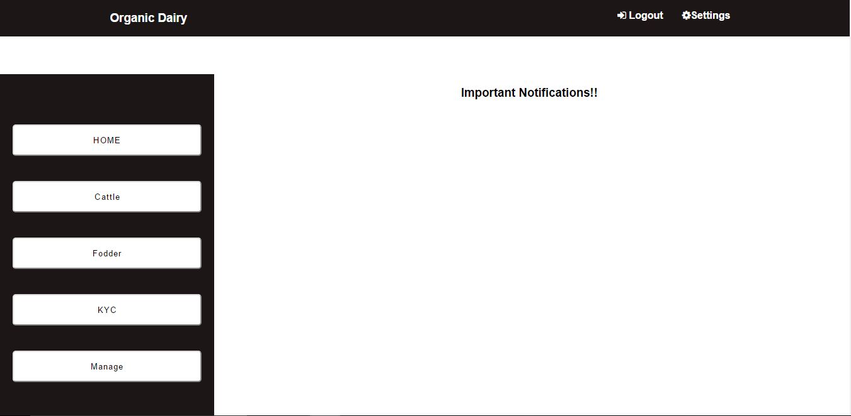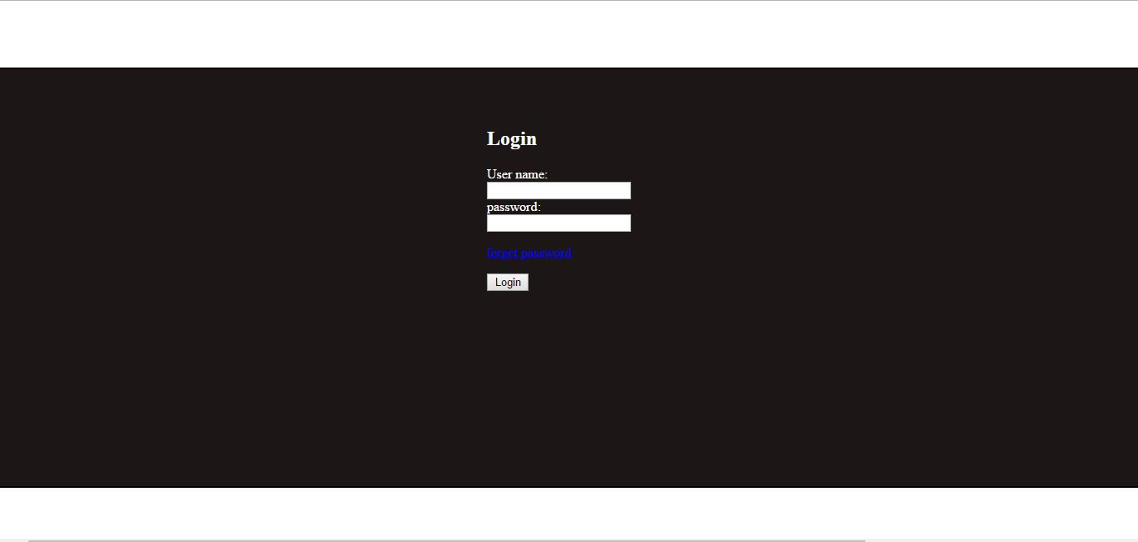

## User Interfaces

* The first page of the ERP portal will be of LOGIN page, the user can access the Main Page only after login in with proper credentials.
* In the Main Page, there is a navigation bar at the top with logout option.
* Then there is a vertical navigation bar with following options which are
  + Home Page for posting important notifications
  + Cattle which deals with cattle database
  + Fodder which deals with fodder database
  + Customer which deals with customer database
  + Manage accounts, where the accessibility rights will be given to the employees.
* The various database pages will include:-
  + Cattle database – It will have set of information such as cattle id, name, breed, age, sex, etc.
  + Fodder database – The various fields here will be type of seed, fertilizers used, irrigation, harvest, etc.
  + Customer database – Here, the data on each and every customer will be stored. The data will include customer id, name, address, contact info, purchase info, etc.
* The database can be updated by Admin and authorized employees.
* The product store is having a navigation bar at the top which will have search, signup and login.
* The page will have a list of all the available products along with add to cart option.
* The payment receipts will be sent to the customers via email.

## Hardware Interfaces

The software Product will work on PCs, laptops and tablets, with HTTP supported browsers.

## Software Interfaces

Our Product requires a Database for storing the Cattle, Fodder and Customer information. So, we have used MySql for that. And, have used Django web framework for developing the ERP website. The data is updated by the Employees at the Farm, which in turn can be viewed by the owner or admin for rectification and other purposes.

## Communications Interfaces

The communication standards used by us is HTTP.

# System Features

|  |  |  |
| --- | --- | --- |
| **REQUIREMENT IDENTIFIER** | **REQUIREMENT NAME** | **DESCRIPTION** |
| REQ 1 | Login | Each user has to login with proper credentials to go to the Main Page |
| REQ 2 | Change password/Forgot Password | The user can change the current password by clicking on the option and verifying it via registered E-mail |
| REQ 3 | Add data to cattle database | Only Admin and authorized employees can add cattle info to the cattle database |
| REQ 4 | Add data to fodder database | Only Admin and authorized employees can add fodder info to the fodder database |
| REQ 5 | Add data to customer database | Allows Admin and authorized employees to add a customer's feedback |
| REQ 6 | View cattle data | Allows logged in users to view cattle info through the portal |
| REQ 7 | View fodder data | Allows logged in users to view fodder info through the portal |
| REQ 8 | View customer data | Allows logged in users to view customer info through the portal |
| REQ 9 | Add users | Gives admin the choice of adding new users and modifying the accessibility rights |
| REQ 10 | Alert System | Important Notifications will Be posted on the Main page like for Heat notification, Pregnancy due dates, Updates on sick Cattle |
| REQ 11 | Update cattle data | Allows Admin and authorized employees to update the existing cattle data |
| REQ 12 | Update fodder data | Allows Admin and authorized employees to update the existing fodder data |
| REQ 13 | Event Notification through calendars | Implement a color based notification through calendars, by marking important dates |
| REQ 14 | Update product store | Admin and authorized employees can update production info or add new products |
| REQ 15 | View products | Customers can view the products on the store page without sign in |
| REQ 16 | Add to cart | Customers can add products from the main page to cart |
| REQ 17 | Delete from Cart | Customer can delete the products form the cart if they don’t wish to purchase that product |
| REQ 18 | Sign up | Customers can sign up to the website which will help them to view their History of ordered products. |
| REQ 19 | Sign in | Customers can sign in to the website with proper credentials |
| REQ 20 | Update customer profile | Customer can update their profile by signing in to the account |
| REQ 21 | Checkout cart | Here, the customer can make their purchases after being signed in |
| REQ 22 | Payment Of the Product | The payment Will be done through the payment portal, after which a Receipt will be sent via E-mail. |
| REQ 23 | View Purchase history | Customer can view their purchase history after signing in to the website |

USE CASE DIAGRAM

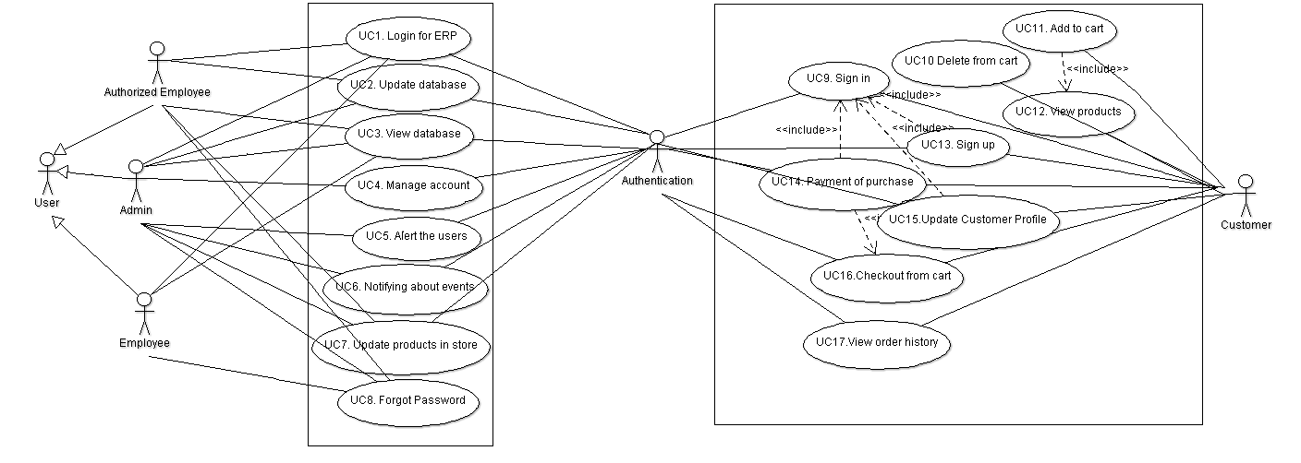

# Other Nonfunctional Requirements

|  |  |  |
| --- | --- | --- |
| **Requirement Id** | **Name** | **Description** |
| N_REQ 5.1 | Performance requirement | Product should work in all conditions that to with minimal configuration, like slow internet etc |
| N_REQ 5.2 | Safety Requirements | Primary safety is to avoid unwanted uploads in to the database. |
| N_REQ 5.3 | Security Requirements | User cannot access the database without proper credentials and before the upload of data, it should be ensured it is free from any kind of malware |
| N_REQ 5.4 | Quality attributes- Adaptable | Our software adapts itself very efficiently, according to the circumstances |
| N_REQ 5.5 | Quality attributes- Correctness | Software always generates correct result |
| N_REQ 5.6 | Quality attributes- Availability | The product is easily available to the user via internet |
| N_REQ 5.7 | Quality attributes- Flexibility | It can be easily be modified with respect to future changes |
| N_REQ 5.8 | Quality attributes- Maintainability | With any future changes that has to be made, it won’t affect the architecture of the product |
| N_REQ 5.9 | Quality attributes- Testability | Developers can easily test the software |
| N_REQ 5.10 | Quality attributes- Usability | Users can be able to use the product very easily, with help of the user manual which will be provided along with the software |