Software Requirements Specification
for
Dairy Farming ERP System
Version 1.0 approved
Prepared by Deep Parikh
NIIT University
17th September, 2016
Table of Contents
Table of Contents ii
Revision History ii
1. Introduction 1
1.1 Purpose 1
1.2 Document Conventions 1
1.3 Intended Audience and Reading Suggestions 1
1.4 Product Scope 1
1.5 References 1
2. Overall Description 2
2.1 Product Perspective 2
2.2 Product Functions 2
2.3 User Classes and Characteristics 2
2.4 Operating Environment 2
2.5 Design and Implementation Constraints 2
2.6 User Documentation 2
2.7 Assumptions and Dependencies 2
3. External Interface Requirements 3
3.1 User Interfaces 3
3.2 Hardware Interfaces 3
3.3 Software Interfaces 3
3.4 Communications Interfaces 3
4. System Features 4
4.1 System Feature 1 4
4.2 System Feature 2 (and so on) 4
5. Other Nonfunctional Requirements 4
5.1 Performance Requirements 4
5.2 Safety Requirements 5
5.3 Security Requirements 5
5.4 Software Quality Attributes 5
5.5 Business Rules 5
6. Other Requirements 5
Appendix A: Glossary 5
Appendix B: Analysis Models 5
Appendix C: To Be Determined List 6

Revision History
Name | Date | Reason For Changes | Version

Introduction

Purpose
This SRS is about an ERP System for Dairy Farming. The document will explain the purpose and features of the system, the interfaces, and what the system will do. This document is about the first version of the system.

Document Conventions
For the primary headings (1. Aa), ¶ Heading 1 has been used. For the secondary headings, ¶ Heading 2 has been used. For the general text, Arial font style has been used, with font size 11.
Every requirement statement has its own priority.

Intended Audience and Reading Suggestions
This SRS is intended for the company owner, marketing staff, users, testers, documentation writers, and the future developers who will work on this software. The rest of this document contains the requirement details, the interfaces, the limitations and the features of the system, organized according to Karl E. Wiegers’ 1999 template of SRS. The readers are recommended to read the document chronologically.

Product Scope
The primary goal of the ERP System is to simplify the task of managing the farm. It helps keep and manage records of all the different functions that occur on a dairy farm. Additionally, the system provides an online product store.

References
<List any other documents or Web addresses to which this SRS refers. These may include user interface style guides, contracts, standards, system requirements specifications, use case documents, or a vision and scope document. Provide enough information so that the reader could access a copy of each reference, including title, author, version number, date, and source or location.>

Overall Description

Product Perspective
This product is a new, self-contained product designed according to the specific requirements mentioned by the farm owner.

Product Functions
The main function of this product is to help in managing the various databases used which are
- Cattle
- Fodder
- Customers

User Classes and Characteristics
Following is a list of user classes according to their importance
- Admin:
  - Can add or delete users.
  - Can modify user accessibility.
  - Can view and modify any of the databases.
- Employee:
  - Can view and modify any of the databases.
- Customers:
  - Can make and view their own purchases.

Operating Environment
This software will be made into a website. It can, hence, be accessed from any system with a HTTP supporting web browser.

Design and Implementation Constraints
We are handling the databases and doing all of the back end implementation using the Django framework of python. The databases have been implemented using MySQL. The front end job has been done using HTML and CSS.

User Documentation
A user manual will be provided along with the product, so as to guide the users through it. A quick first time user video will also be provided so as to help the first time users get acquainted to the software components and interface.

Assumptions and Dependencies
It is assumed the users have access to the Internet, and are accessing the website from a PC or Tablet using a HTTP supporting web browser.

External Interface Requirements

User Interfaces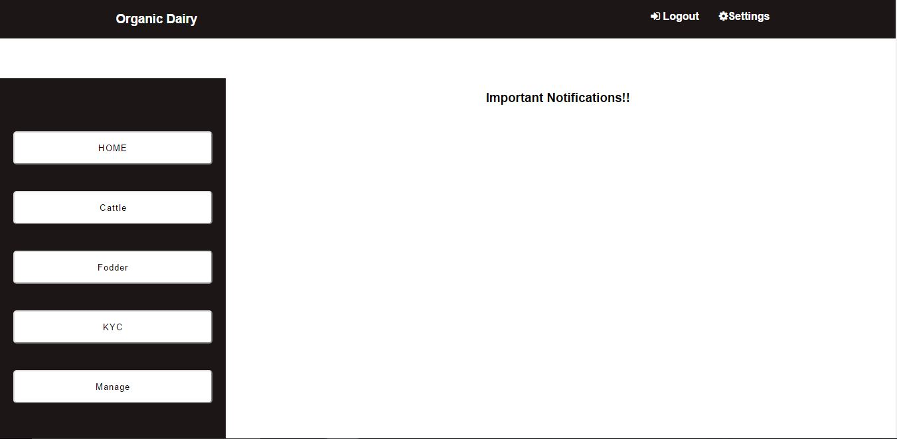
- On starting the system, the first page the user sees, the index page, is the login system. Only the Admin and the users created by the Admin can access this Admin have the authorization for login here.
- The home page for the users is the has two navigation bar. The horizontal navigation bar has the search bar and the logout button.
- There will also be a vertical navigation bar with certain options which are
  - Database, which when chosen, will direct to another page.
  - Create more users, where the accessibility rights will be given to the employees.
- On the right side of the page, there will be a section for daily updates and emergency alerts, along with an option to add or edit them. There will also be a reminder system that will automatically add certain required updates here.
- In the database page, the navigation bar on the left side of the page will contain the list of various databases which are
  - Cattle database – It will have set of information such as cattle id, name, breed, age, sex, etc.
  - Fodder database – The various fields here will be type of seed, fertilizers used, irrigation, harvest, etc.
  - Customer database – Here, the data on each and every customer will be stored. The data will include customer id, name, address, contact info, purchase info, etc.
- Each and every field can be updated by the admin. The options available to the other users will be decided by the admin.
- The product store will have a navigation bar at the top which will have search, signup and login.
- The page will have a list of all the available products along with add to cart option.
- In the view cart section, there will be a checkout option, which can only be accessed after login, and will direct the customer to the payment portal.
- The payment receipts will be sent to the customers via email.

Hardware Interfaces
The software Product works well with any PC or Tablets having an HTTP supported web browsers.

Software Interfaces
Our Product requires a Database for storing the Cattle, Fodder and Customer information. MySQL has been used for that. And, Django web framework has been used for developing the ERP website. The data is updated by the Employees at the Farm, which in turn can be viewed by the owner or admin for rectification and other purposes.

Communications Interfaces
The communication standards used for this product is HTTP.

System Features
Req. ID | Req. Name | Description
REQ 1 | User Login | Allows the Admin and employees to access the system
REQ 2 | Navigation System | Gives a pathway to access the other sections of ERP
REQ 3 | Database Management | Needed for managing the cattle, fodder and customer data
REQ 4 | Adding the data | Helps Admin and authorized users create new entries in the database
REQ 5 | Removing the data | Allows Admin and authorized users remove unnecessary entries from the database
REQ 6 | Modifying the data | Let’s Admin and authorized users change the entries of the database
REQ 7 | Creating new users | Allows Admin to create new users and give/modify accessibility rights
REQ 8 | Alert System | To intimate users of the daily updates and emergencies
REQ 9 | Add Daily Updates | Allows Admin and authorized users to add daily update
REQ 10 | Add Emergency Updates | Allows users to add emergency notifications
REQ 11 | Store section | Allows Admin and authorized users to modify and view the product store
REQ 12 | Add products to store | Let’s the Amin and authorized users add products to store
REQ 13 | Remove products from store | Let’s the Amin and authorized users remove products from store
REQ 14 | Modify products in store | Allows Admin and authorized users update current products' info
REQ 15 | Product Store | A place for buyers to view the available products
REQ 16 | Signup | Allows new buyers to sign up for the store
REQ 17 | Sign in | Let’s existing customers sign in to their accounts
REQ 18 | Add to cart | Let’s buyers add products to their e-shopping cart
REQ 19 | Remove from cart | Allows buyers to remove products from their cart
REQ 20 | Checkout cart | Allows customers to complete the purchase
REQ 21 | Payment portal | Helps users make payment for their purchases

Other Nonfunctional Requirements
Requirement Id | Name | Description
N_REQ 5.1 | Performance requirement | Product should work in all conditions that to with minimal configuration, like slow internet etc
N_REQ 5.2 | Safety Requirements | Primary safety is to avoid unwanted uploads in to the database.
N_REQ 5.3 | Security Requirements | User cannot access the database without proper credentials and before the upload of data, it should be ensured it is free from any kind of malware
N_REQ 5.4 | Quality attributes- Adaptable | Our software adapts itself very efficiently, according to the circumstances
N_REQ 5.5 | Quality attributes- Correctness | Software always generates correct result
N_REQ 5.6 | Quality attributes- Availability | The product is easily available to the user via internet
N_REQ 5.7 | Quality attributes- Flexibility | It can be easily be modified with respect to future changes
N_REQ 5.8 | Quality attributes- Maintainability | With any future changes that has to be made, it won’t affect the architecture of the product
N_REQ 5.9 | Quality attributes- Testability | Developers can easily test the software
N_REQ 5.10 | Quality attributes- Usability | Users can be able to use the product very easily, with help of the user manual which will be provided along with the software

