Software Design Specification

For
Organic Dairy Farming-
ERP System
Version 1.0 approved
Group: Aakriti Arya
Aman Jain
Ashwin Jayadev
Hrithik Puri
Deep Parikh

NIIT University
Date : 28/10/2016
1. DOCUMENT DETAILS
1.1 PURPOSE OF THIS DOCUMENT
The purpose of this document is to present a detailed description of the Organic DairyFarming ERP system. It will explain the purpose and features of the system, the interfaces of the system, what the system will do, the constraints under which it must operate and how the system will react to external stimuli. This document is intended for both the stakeholders and the developers of the system. Topics covered include the following:
- Class hierarchies and interactions
- Data flow and design
- Processing narratives
- Design constraints and restrictions
- User interface design
- Test cases and expected results

In other words this document is written in order to give a in depth understanding to its user as for how the ERP system actually works.
1.2 SCOPE OF THE DEVELOPMENT PROJECT
In todays world organic dairy farming is an upcoming sector as more and more of the people are getting health conscious and switching to organic products. Now imagine with such a fast growing business how difficult it is for the owner of the firm to manage everything write from cattle heat cycles to the amount of organic milk sold that day. Earlier our client was using multiple applications to solve this one problem. Our ERP based System is an all in one solution which would enable the owner to keep a tab of everything right from his employee to his cattle to his customers.
1.3 CORE FEATURES OF THE ERP BASED SYSTEM
- It is a time saver for the owner as one database would be storing all the information.
- It has proper authentication system wherein without permission no one can mess with the database.
- It has many other features like alert and notify which are used in case of emergency by authorized employee or the admin.
1.4 DEFINITIONS,ACRONYMS AND ABBREVIATIONS
ABBREVIATION | DESCRIPTION
admin | Admin is basically the head administrator which is none othe rthan the owner of the firm.
Authorized Employee | Authorized Employee is the employee who has been given some specific rights by the admin. These rights are not given to every other employee.
Employee | Employee is a person who has not been given any special rights by the admin but are employee of the company.
user | By user we refer to one of these three Admin, authorized employee or the employee.
Customer | By customer we mean the person who will be buying the products from our website.
item | Here item refers to the product that we will be selling on the website for example buffalo's milk or cow's milk
ERP | It is a basic web interface for managing the organic dairy farming database and making it convenient for the admin to manage the database.
Database | Collection of data related to organic dairy farming enterprise.

1.5 REFERENCES: none
1.6 OVERVIEW OF DOCUMENT
The earlier SRS document is written for the general audience but this SDS is written for those people who have actually been associated with the project such as software developers, team managers etc.
This overview of the document will help you to jump to any part in which you are specifically interested. This jest of each and every part is described here in this table.
PART 1 | INTRODUCTION: This part of the document explain the reason for making this product, what are our basic goals and objectives and what purpose would it solve.  It also consists of all the details regarding the abbreviation and acronyms used while writing the document which would definitely make your reading convenient.
PART 2 | SYSTEM ARCHITECTURE DESCRIPTION: This section will a detailed account of all the modules that have been used in developing this software. Various components and subsystems are explained in this section along with interdependencies and dependencies that they have among each other. And in the end this part would deal with user interface and explain the main principle of our products user interface. In the end the user would get an idea of how would actually our software look like and how would it function.
PART 3 | DETAILED DESCRIPTION OF COMPONENTS: In this part of the SDS a detailed description of all the classes, their attributes and the functions related to them have been described. What is the function of each and every function has been described in detail.
PART 4 | REUSE AND RELATIONSHIP TO OTHER PRODUCTS
PART 5 | DESIGN DECISIONS AND TRADEOFFS of the design and language specification in for the project
PART 6 | PSEUDOCODE: the pseudocode would give a rough idea about the how the flow will be and how the functions would be called one after another.In the pseudocod e we basically use mroe of english rather than the proper syntax.
PART 7 | APPENDICE: This contains any other additional information that would be required by the user to understand the software.

2. SYSTEM ARCHITECTURE DESCRIPTION

2.1 OVERVIEW OF COMPONENTS
The various components included in this document are:-
1) Class diagram
2) Sequence diagram
3) State chart diagram

Sequence diagram includes View Database, Update Database, Manage Accounts, Forgot Password, Alerts & Notifications, and Customers.

State diagram includes Admin, Users and Customers.

2.2 STRUCTURE AND RELATIONSHIPS
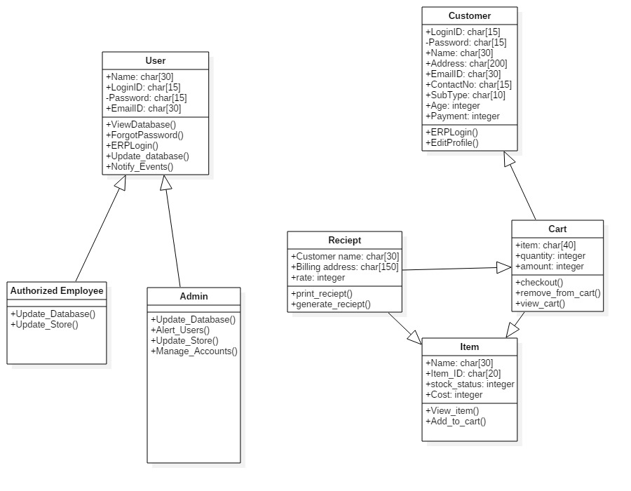

CLASS DIAGRAM

SEQUENCE DIAGRAM FOR VIEW DATABASE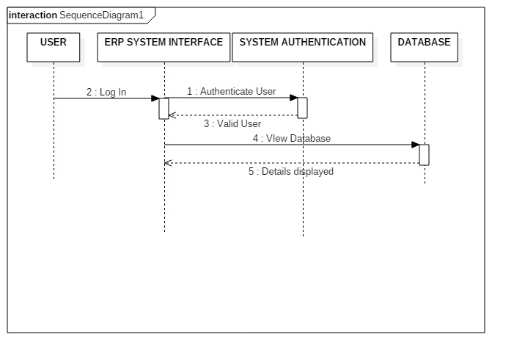
SEQUENCE DIAGRAM FOR UPDATE DATABASE

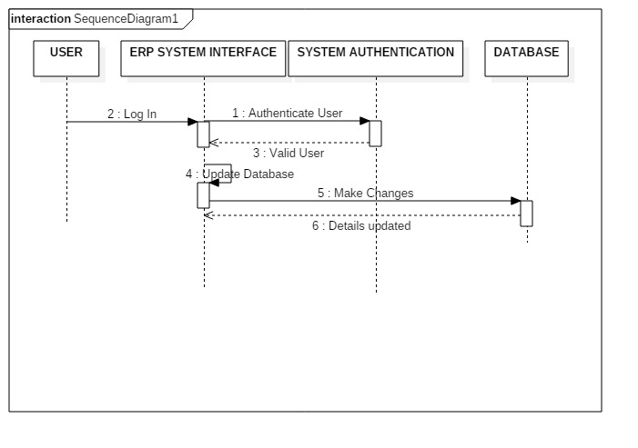

SEQUENCE DIAGRAM FOR MANAGE ACCOUNTS

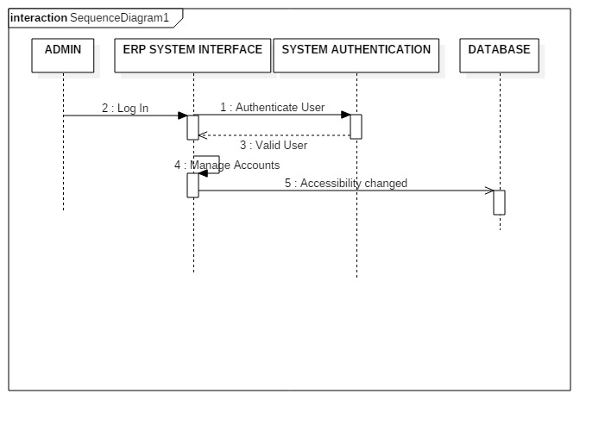
SEQUENCE DIAGRAM FOR ALERTS AND NOTIFICATIONS

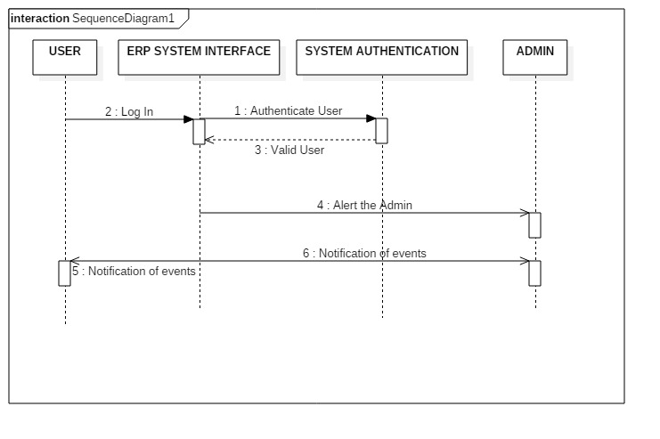

SEQUENCE DIAGRAM FOR FORGOT PASSWORD

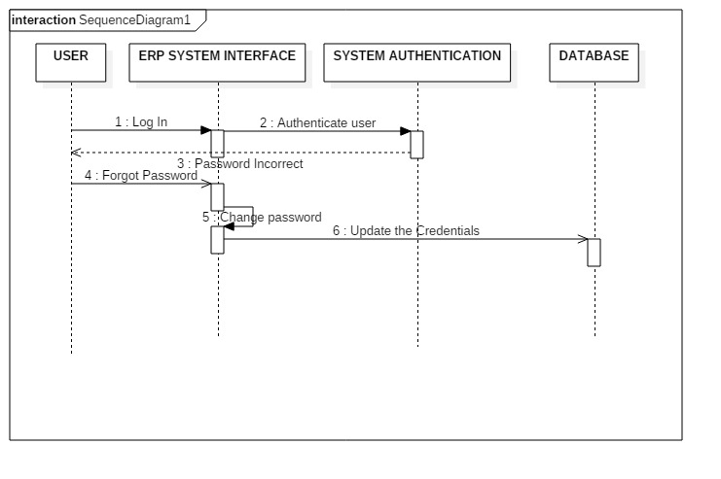

SEQUENCE DIAGRAM FOR CUSTOMER

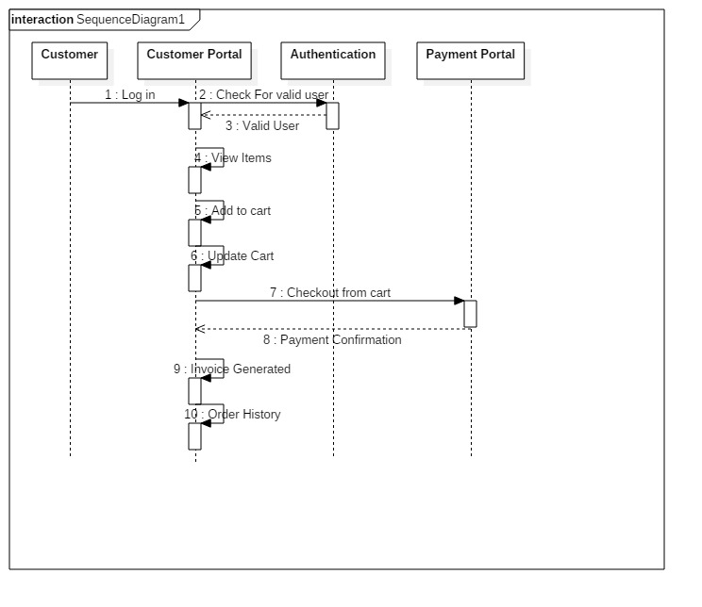

STATE DIAGRAM FOR USER(EMPLOYEE, AUTHORIZED EMPLOYEE)

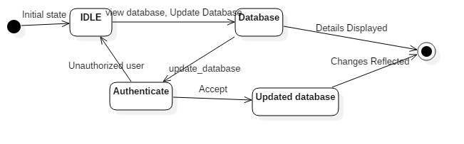

STATE DIAGRAM FOR ADMIN

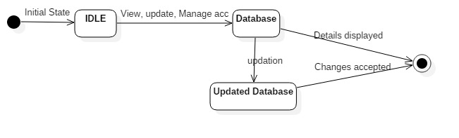

STATE DIAGRAM FOR CUSTOMER

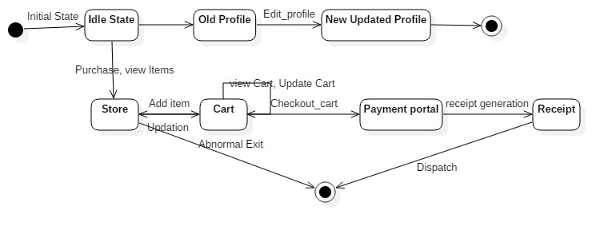

2.3 User Interface Issues
    - The index page of the ERP portal is a login page that directs the user to the main system page. An error will be displayed if the login is unauthorized.Thus just in case if the login ID is not matched with password then the user will have a problem.
    - Each and every field can be updated by the admin. The options available to the other users will be decided by the admin.Thus if a user wants to post or access anything he needs prior permision from the admin.

3. Detailed description of components

Our project basically consists of 7 classes in all:
  - User class
  - Authorized Employee class
  - Admin class
  - Customer class
  - Cart class
  - Receipt class
  - Item class
Each of these classes have some specific attributes and functions related to them.

3.1 USER CLASS

Name | User
Type | Super Class
Attributes | Name: char[30]  LoginId: char[15]  Password:char[15]  EmailID:char[30]
Functions | ErpLogin()  ForgotPassword( )  ViewDatabase( )  Notify_events( )
Description | 1 Name: char[30]  This attribute basically is a string which will store the name of employee whether Admin or Authorized Employee.  2 LoginId: char[15]  This attribute is a string which will store the Login ID of the Employee which he or she would be using to Login into the ERP system and accessing it in terms of viewing, updating and deleting entries. This login ID along with the password also serves the purpose of authentication as certain employees are permitted to do certain limited actions only depending on their designation and thus this Login Id would also take care accessibility. In other words the loginID is EmployeeID.  3 Password:char[15]  This attribute is string which will store the password for the various login ID’s. For each login ID there would be a unique password and thus it would serve for authentication purposes also.This attribute is private data type and should have one special character and would be case sensitive.  4 EmailID:char[30]  This attribute is again a string which would store the Email ID’s of the various employees.
Functional description | 1 ErpLogin()  This function basically enables a person to Login into the ERP by filling the Login ID and respective correct password. After filling in the correct details this function enables the Employee to login into the system.  2 ForgotPassword( )  This function is used when an Employee basically fills in the wrong password for a particular Login ID. In such a case the old password is sent to the email ID provided by the Employee in the database. Thus a genuine Employee who actually forgot his password can use his registered Email ID to reclaim his password.  3 ViewDatabase( )  After successfully login the Employee can actually see the entire ERP system and the various fields in it such as fodder, cattle, vaccination provided etc.  4 Notify_events( )  This function is used to notify minor events such as lack of fodder or maybe when a cattle falls sick the authorized employee and the admin anyone can post a notification on the ERP System
  - Admin class

Name | Admin
Type | Inherited class from User
Attributes | The attributes of this class are the same as the user class as this class is inherited from the user class.
Functions | Alert_users( )  Update_database()  Update_Store( )  Manage_accounts()
Functional Description | 3.2.2.1 Alert_users( )  This function is accessed by the admin in order to report a major event which requires immediate attention. For example if there is a flood in the area where the cattle is kept or any of the cow hits their heat cycles and needs immediate medical attention then in that case the function used etc.  3.2.2.2 Update_database( )  This function is specifically used by the Admin which allows the Admin to update and delete all the fields whether they are related to customers or the cattle.  3.2.2.3 Update_ Store( )  This function enables the admin to update , edit, delete any field of the store which basically contains information about how much fodder is left or how much milk is there. This field deals with the quantity and the availability of the products.  3.2.2.4 Manage_accounts()  Manage accounts is one function which is available only to the Admin and it enables the Admin to all the User accounts and has a tab of all the sensitive information of all the users. He can view and manage all the employee accounts.

3.3 Authorized Employee Class

Name | Authorized Employee
Type | Inherited class from super class user
Attributes | The authorized employee class consists of all the employees. This class is inherited from the user class thus all the attributes and functions of the user class are also present in this class.
Function | Update_database()  Update_store()
Functional Description | 1 Update_database():  This function is available to the authorized employees. These employees are authorized by the admin himself and the level of authority is also decided by the admin. the employees who can access this function have liberty to update and edit the fields in database. Only those fields can be updated for which these authorized employees have been given the permission by the admin.  2 Update_store():  This function is available to the authorized employees. These employees are authorized by the admin himself and the level of authority is also decided by the admin. The employees who can access this function have liberty to update and edit the store which means they can change the quantity and availability of the products. Only those fields can be updated for which these authorized employees have been given the permission by the admin.

3.4 Customer Class

Name | Customer
Type | Class
Attributes | Name:char[30]  LoginId:char[15]  password:char[15]  EmailID:char[30]  Address :char[30]  ContactNo : int[10]  SubType:char[10]  age:integer  payment:integer
Functions | ERPLogin( )  EditProfile( )
Description | 1 Name:char[30]  This attribute is a character string an basically store the name of the customer who is going to buy our products.  2 LoginId:char[15]  This is a character string which is a unique login ID for each customer. In order to facilitate a purchase our customer has to make an account and have a unique login Id.  3 password:char[15]  This attribute is string which will store the password for the various login ID’s. For each login ID there would be a unique password and thus it would serve for authentication purposes also.This attribute is private data type and should have one special character and would be case sensitive.  4 EmailID:char[30]  This attribute is again a string which would store the Email ID’s of the various customers.  5 Address :char[30]  This attribute is a string which basically stores the house address of the customer.  6 ContactNo : int[10]  This attribute is an integer array which will store the current contact number of the customer.  7 SubType:char[10]  This attribute basically stores the information about the subscription type, whether our customer want daily basis organic milk or weekly or monthly.  8 age:integer  This attribute stores the age of the consumer of our organic product. The purpose behind storing the age is to provide recommendation of products according to the age and needs.  9 payment:integer  This attribute stores the outstanding payment value of the customer.
Functional Description | 1 ERPLogin( )  This function enables the customer to log in to the ERP by using his unique login id and password.  2 EditProfile( )  While creating an account a customer enters few details such as his name , contact number, address etc. This function enables the user to edit his or her information in the ERP.

3.5 Item Class

Name | Item
Type | Class
Attributes | 1 Name:char[30]  Item_ID:char[20]  Stock_status:char[10]  Cost:integer
Functions | view_item()  Add_to_cart()
Description | 1 Name:char[30]  This is a character string which contains the name of the product.  2 Item_ID:char[20]  Every product in the stock has a item_id which is unique to every product. This item ID would help us in keeping a tab of availability of the stock.  3 Stock_status:char[10]  The stock status is a character string which tells us about the availibilty of the product which is desired by the customer.  4 Cost:integer  This attribute stores the cost of the product.
Functional Description | 1 view_item()  Once the user has successfully logged in this function enables the user to view all the products .  2 Add_to_cart()  After viewing the products if a customer wishes to buy a product this function enables the user to add the product in the cart.

3.6 Cart Class

Name | Cart
Type | Class
Attributes | item:char[40]  quantity:integer  amount:integer
Functions | view_cart()  update_cart()  checkout()
Description | 1 item:char[40]  This attribute will basically display the item selected by the customer for purchase.  2 quantity:integer  This attribute will display the quantity of the selected product. One can also change the quantity.  3 amount:integer  This is the total amount that the customer is liable to pay.
Functional Description | 1 view_cart()  This function enables the customer to view the cart which basically shows the item selected by the customer to buy, their quantity and amount.  2 update_cart()  Using this function one can make the desirable changes in the cart such as changing the quantity of thr product, adding more products or removing previously selected products.  3 checkout()  This function enables the customer to checkout from the cart when he has finally decided about what to buy and how much to buy and guides the customer to the payment portal.

3.7 Receipt Class

Name | Receipt
Type | Class
Attributes | Customer name:char[30]  Billing address:char[150]  rate:integer
Functions | Generate_receipt()  Print_receipt()
Descriptions | 1Customer name:char[30]  This is a character string and will basically contain the name of the customer who has bought the product.  2 Billing address:char[150]  This contains the address of the place to where the bill will be sent and the payment would be taken from.  3 rate:integer  This is final amount that the customer is liable to pay.
Functional Description | 1 Generate_receipt()  This function takes the attributes of an instance and generates a receipt.  2 Print_receipt()  If the generated receipt needs to be printed out, then this function is called to print the receipt.

4.0 REUSE AND RELATIONSHIP TO OTHER PRODUCTS

NOT APPLICABLE

5.0 Design decisions and tradeoffs

The User class in the project had a single Employee, but different employee had different accessibility with respect to the Updation of the database. For this we had two approaches either split the employee into two categories normal employee and authorized employee with different access rights. Or we could change the interface in such a way that only certain people can change the values but that would have made the interface more complex. Thus the trade-off was to separate the user into different categories.
Tradeoff between the user acceptance and technical complexity- there needs to be a balance in both user acceptance and technical complexity, with single ERP system we are usually giving up some one of the best functionality like Heat date information of the cattle in the same table (ie. Table within the table) or different table for the heat and cattle information differently which can be easier and that would take much more cost to manage. If we go by the best breed route, we are giving up this tight integration for much depth and capabilities within the specific functions.
Table within a table was complex to implement and manage in the user interface. But separating them and operating them is much easier.
Hence we decided to make the heat tables different from the cattle information and combine them both with a foreign key.

Initially we decided to use the .NET framework but we dropped the idea despite it was easy to implement and switched to DJANGO framework which basically works on Python language as it was much more faster and reliable that C#.

6.0 Pseudocode for components

View Database
- Switch case for choosing database
  - Cattle – Display Cattle Table
  - Fodder – Display Fodder Table
  - Customer – Display Customer Table

Update Database
- Input whether to add or edit
- If add
  - Switch case for choosing database
    - Cattle – Input cattle tuple details
    - Fodder – Input fodder tuple details
    - Customer – Input customer tuple details
Else
- Switch case for choosing database
- Select tuple of database
- Remove tuple or edit attributes
Add to Cart
- Enter the item to purchase
- Add_to_cart()
- Enter the quantity of milk
- Quantity = input()
Update Cart
- If Increase the quantity of the milk
- Quantity++
- Else Decrease the quantity of the milk
- Quantity—
- Else Delete item
- Remove_item();

