Testimonials Report

FOR

Share Karo App

Version 1.0 approved

Prepared by Share Karo App members:

***Akshay Gupta: U101114FCS039***

***Anshul Sharma: U101114FCS046 (S2)***

***Ayushi Jain: U101114FCS055***

***Ishitaa Sayal: U101114FCS070 (S3)***

***Jatin Kakkar: U101114FCS072 (S3)***

***Jharana Shrivastava: U101114FCS073 (S3)***

<NIIT UNIVERSITY>

Testimonials

*Testimonials are an integral part of any project’s final development. Unless the customers are satisfied with the delivered product, the app isn’t of any subtle use. Feedbacks prove to be the decision makers that define the success of any particular product.*

*Our team tried collecting testimonials from friends, peers and families who can be the potential customers of this app and have been an integral part in the designing of it.*

*Herewith are presented several survey and testimonial results from our valued customers who generously reviewed the app and provided us with genuine feedbacks.*

1. **Initial responses for the inception idea of the app**

Link to the form: <https://docs.google.com/a/st.niituniversity.in/forms/d/e/1FAIpQLSdQRok8juXlh7KKhXiNcEUZWWn9YxTKTtLWmKertD9MFtg0fA/viewform>

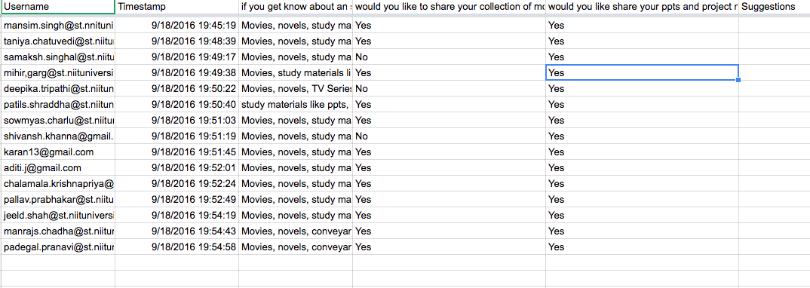

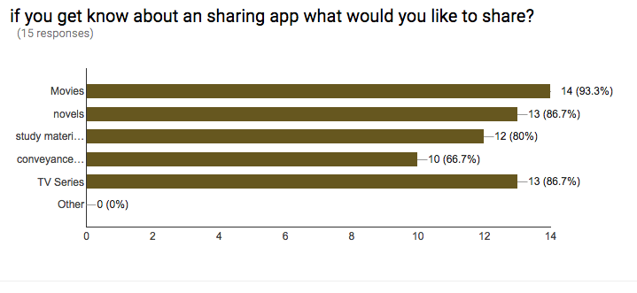

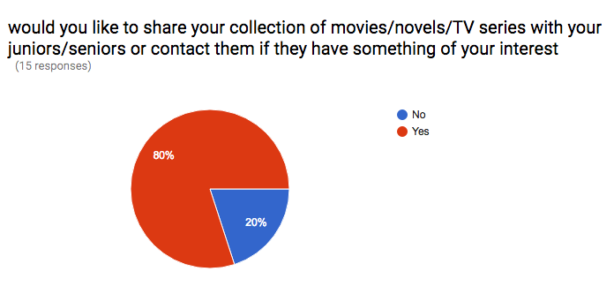

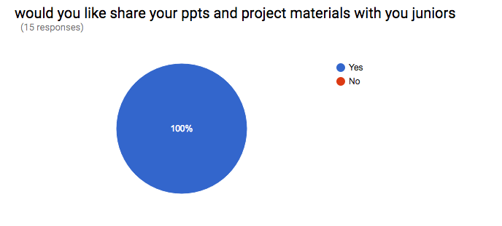

1. **Form Testimonials**

Link for the first set of testimonials: <https://docs.google.com/forms/d/e/1FAIpQLSfPbmTNcCu8Let0fz_cwyKC1sYLuURvTh7DYpvWtiliGMivFg/viewform>

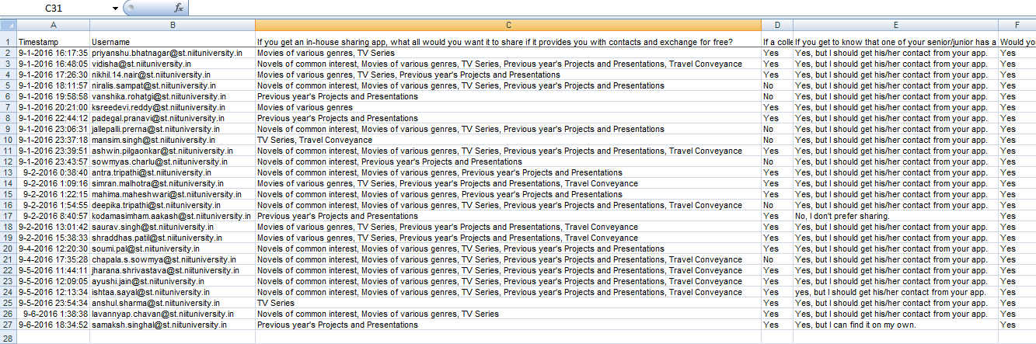

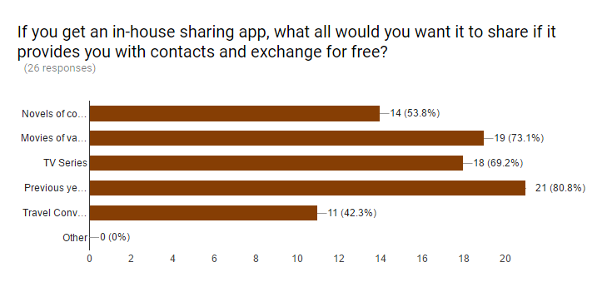

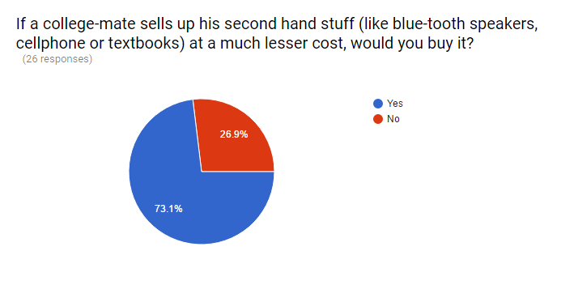

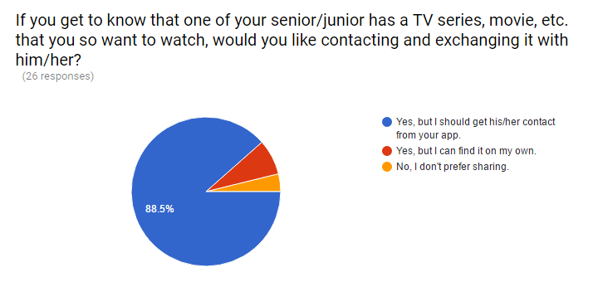

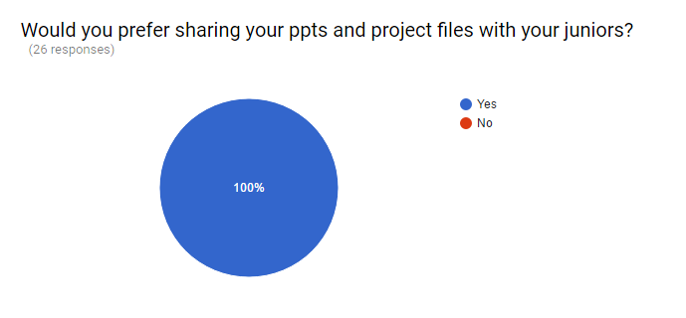

Link for final testimonials: <https://docs.google.com/forms/d/e/1FAIpQLSebqwh9pq7CYkbcUzg88SQlm6ie9C5-cOnnXGS97LzCWlX9AQ/viewform>

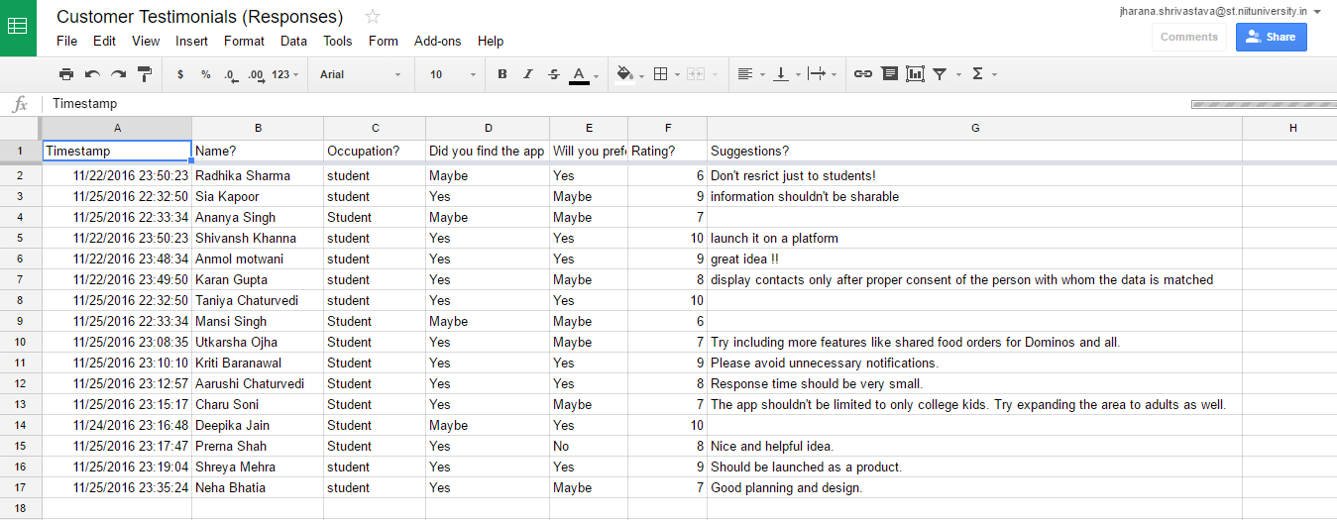

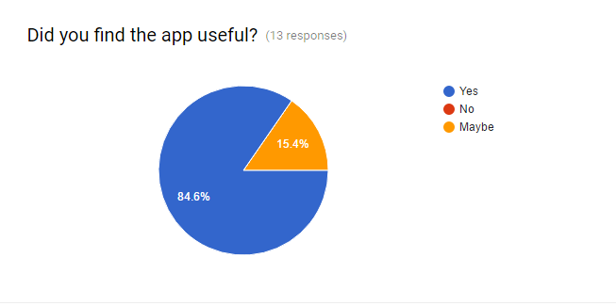

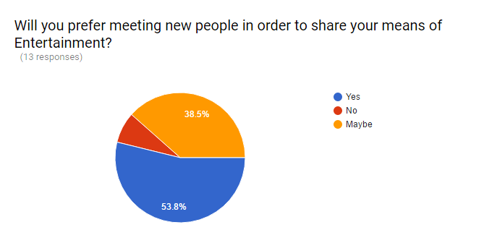

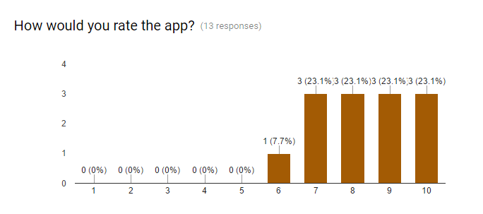

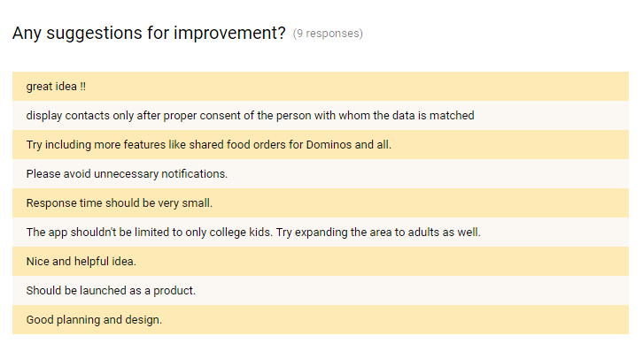

1. **Customer Feedback Form**

Link for the Feedback form: <https://docs.google.com/forms/d/e/1FAIpQLSfPbmTNcCu8Let0fz_cwyKC1sYLuURvTh7DYpvWtiliGMivFg/viewform>

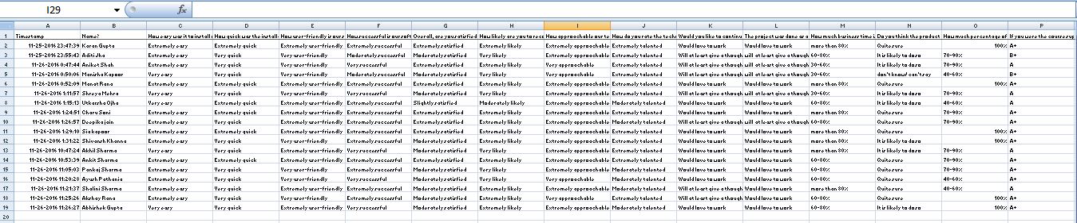

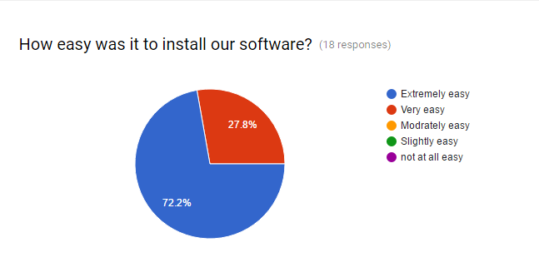

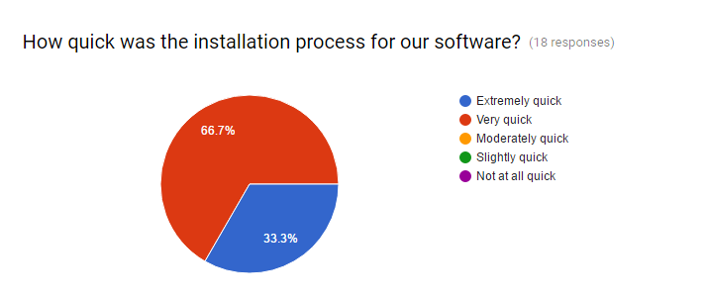

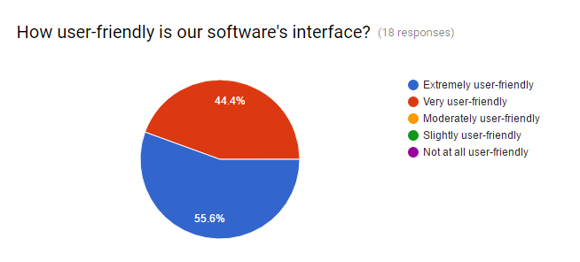

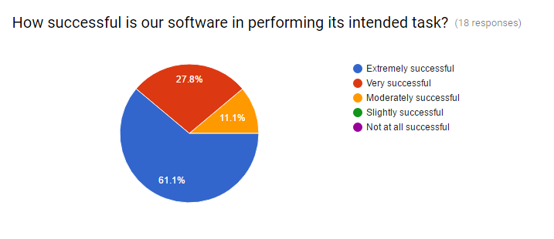

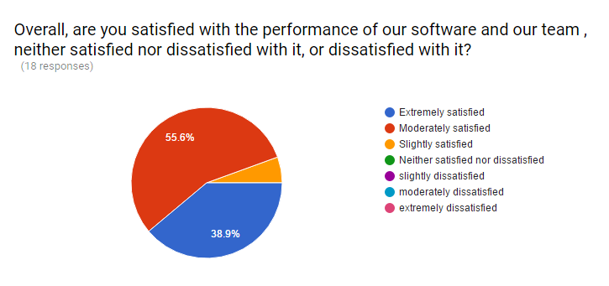

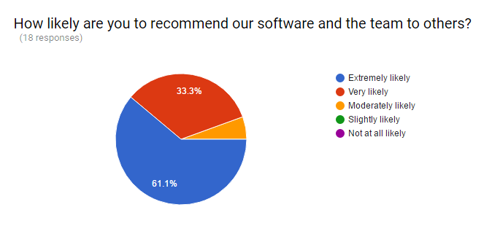

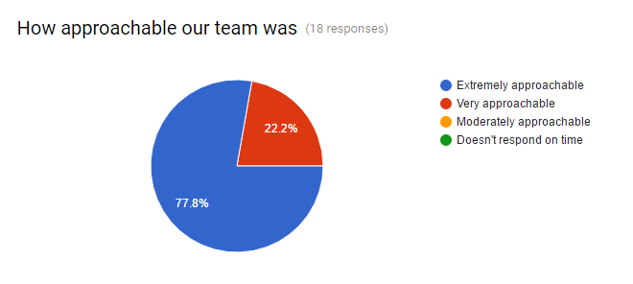

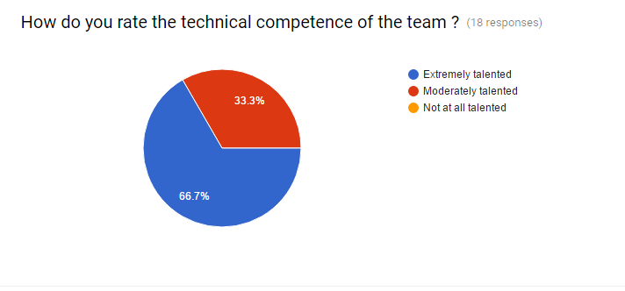

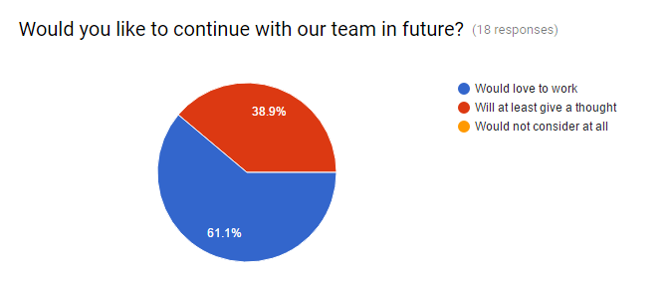

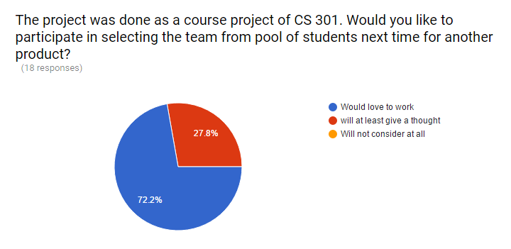

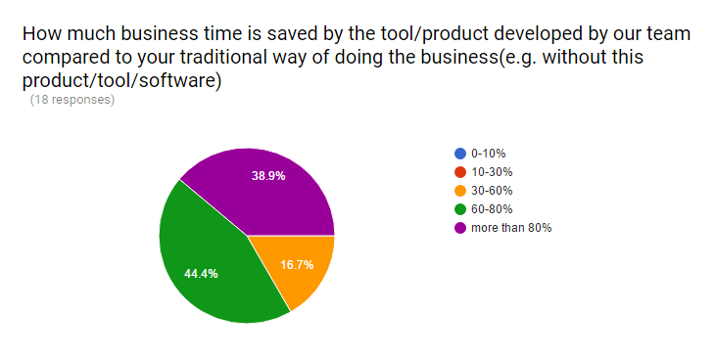

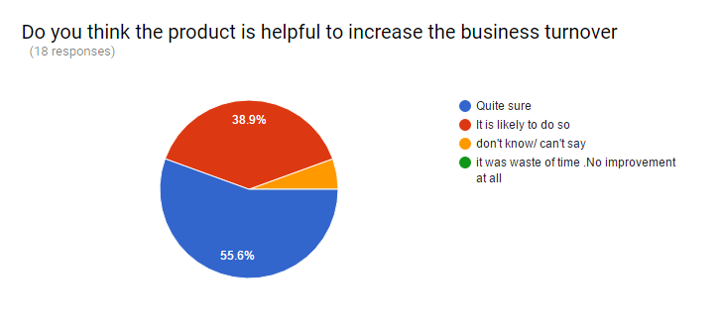

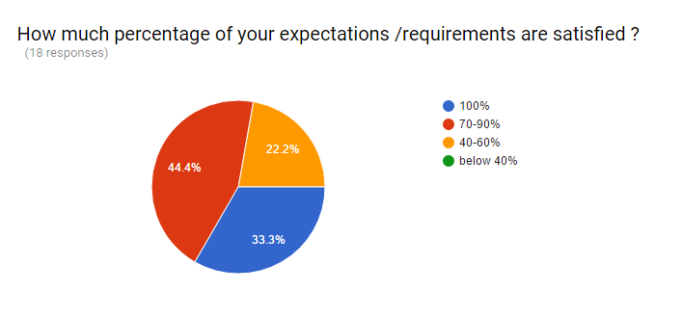

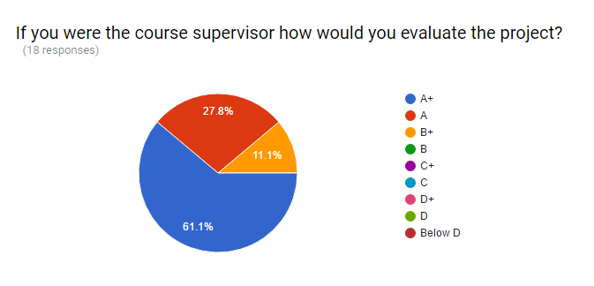

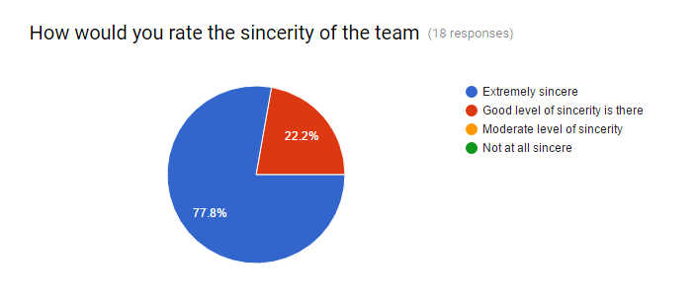

1. **Text Testimonials**

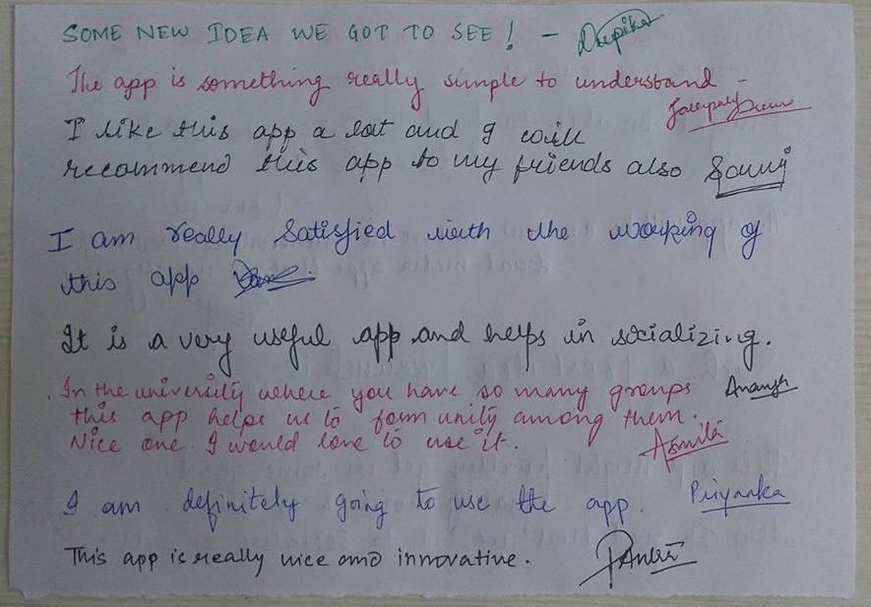

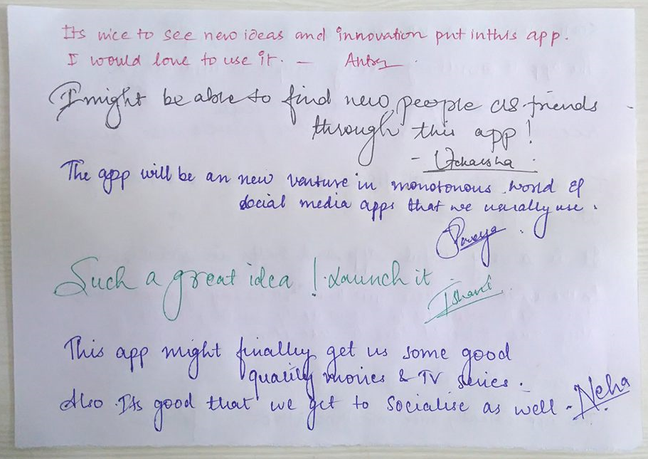

1. **Mailed Testimonials**

