**Development Traceability Matrix**

In **College Mart**(An Online Free Advertisement web Application), there are several Functional Requirement specified in SRS in section 4.And the Id’s of those functional requirement are as follows:

* FR01: The students shall be able to view the source code for the entire application.
* FR02: The students shall be able to, individually, view and understand the code for all pieces on the UI.
* FR03: The students shall be able to debug the application’s source code using Firebug, which is an online tool to inspect, edit, and monitor HTML, CSS, and JavaScript requests directly on the web.
* FR04: The users shall be able to view the categories on the application’s home page.
* FR05: The users shall be able to view items in different categories.
* FR06: The users shall be able add items for ADD.
* FR07: The users shall be able to view more information about an item.
* FR08: The users shall be able to browse through the available items.
* FR09: The users shall be able to view the items added to the saved items list.
* FR010: The users shall be able to continue viewing items.
* FR011: The users shall be able to delete items from the saved items list.
* FR014: The users shall place an ADD by completing the information in the advertisement form.
* FR015: The users shall not be able to place an advertisement if the information in the advertisement form is invalid or incomplete.
* FR016: The administrator shall be able to view all the users’ information that place the advertisement form.
* FR017: The administrator shall be able to delete items from the main page of the OLA application.

**Use Case:** For all these above functional requirement I design the whole use case diagram of the system as follows:

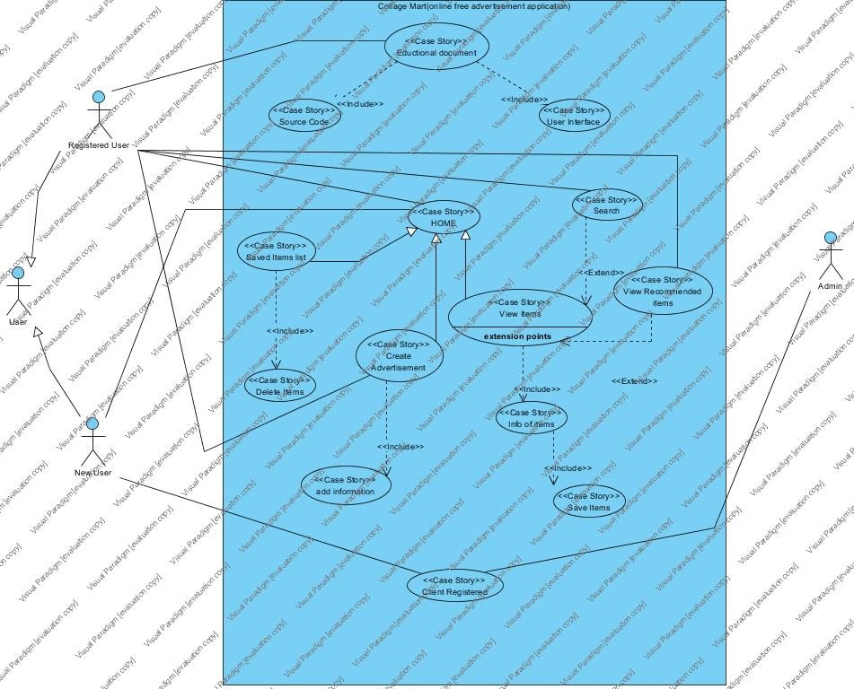

Use Case Diagram

User actor use our web app to make an advertisement online for free of cost. And he/she can also see the advertisement posted by some other users.

Top level use cases are View Items, Saved items, Create new advertisement and Client Register.

View Items use case can be used by the user as top level use case if user only wants to find out and see some advertisement of any product.

Saved Items use case can be used by the user if he/she are our older users who wants to see their saved item’s advertisement for future contact to the owner of the product. It can also be used as a part of View items use case.

Create new advertisement use case can be used by the users both who are new or older ones, they can create an advertisement by filling an advertisement form and uploading the photo of that product.

Client Register use case allows customers to register on the web app

Expect for the user actor there are one more actor Admin.

View items use case is extended by several optional use case – user may search for items, view items recommended for him/her, save items in the saved list. All these use case are extended use case.

Customer Authentication use case included in View Recommended Items and Add to save list because both require the users to be authenticated.

|  |  |  |
| --- | --- | --- |
| Use Case | Use case ID | Description |
| Educational Document | UC01 | The User of College Mart can read out the process of building of this software |
| Source Code | UC02 | The user can see the source code without log in |
| User Interface | UC03 | The user can see the coding of the UI of the system. |
| Home | UC04 | The user is present at home after log in successfully. |
| Saved List Items | UC05 | If the user is not log in first time he/she can see his/her saved items list. |
| Create Advertisement | UC06 | The user can post his/her new advertisement. |
| Add information | UC07 | User should fill the information regarding his/her items. |
| View Items | UC08 | The user can view the items |
| Search Items | UC09 | The users can search an item by some keywords. |
| View Recommended Items | UC10 | The older users must be suggested some items. |
| Information of item | UC11 | The user can see the information regarding the items which he/she wants to buy. |
| Save items | UC12 | The user can save any items for further enquiry. |
| Client Registered | UC13 | New users must be registered first . |
| Delete Items | UC14 | The user is able to delete an item form the saved items list. |

|  |  |  |  |  |
| --- | --- | --- | --- | --- |
| Requirements | Use case addressing the requirement | Classes addressing the Requirements | Methods addressing the Requirement | Unit Test cases addressing the requirement |
| FR01 | UC01,UC02,UC03 |  |  |  |
| FR02 | UC01,UC02,UC03 |  |  |  |
| FR03 | UC01,UC02,UC03 |  |  |  |
| FR04 | UC08,UC09,UC10 |  |  |  |
| FR05 | UC08,UC09,UC10 |  |  |  |
| FR06 | UC06 |  |  |  |
| FR07 | UC11 |  |  |  |
| FR08 | UC08,UC09,UC10 |  |  |  |
| FR09 | UC05 |  |  |  |
| FR10 | UC08,UC09,UC10 |  |  |  |
| FR11 | UC14 |  |  |  |
| FR12 | UC13 |  |  |  |
| FR13 | UC13 |  |  |  |
| FR14 | UC06,UC07 |  |  |  |
| FR15 | UC06,UC07 |  |  |  |
| FR16 | UC08,UC09,UC10 |  |  |  |
| FR17 | UC08,UC09,UC10 |  |  |  |