## Feasibility analysis study for the software engineering project

## Collegemart

We carried out a survey in our university and collected responses from college students regarding the viability of our software engineering project and it turned out that this project does cater to the need of the people providing them a platform to earn some quick money, getting rid of their old ,unused utilities and books , A platform wherein the users will establish an identity of their own as well as the identity of the product that they want to sell , on the other side a buyer can buy a particular product say a bucket or a book or even a drafter at a second hand or lesser price to be particular thereby relieving him from the burden of spending more cash on buying new or unused products ,which he could utilize on more effective things perhaps save or invest.

The important aspect of such an analysis is that it allows us to think whether what we are doing is worthwhile or not and it would not be an overestimation to say that by the responses we received ,it overwhelmed us with the feeling of new energy and excitement to pursue the project with all dedication and sincerity.

So the details of the survey that was done has been shared for further analysis:

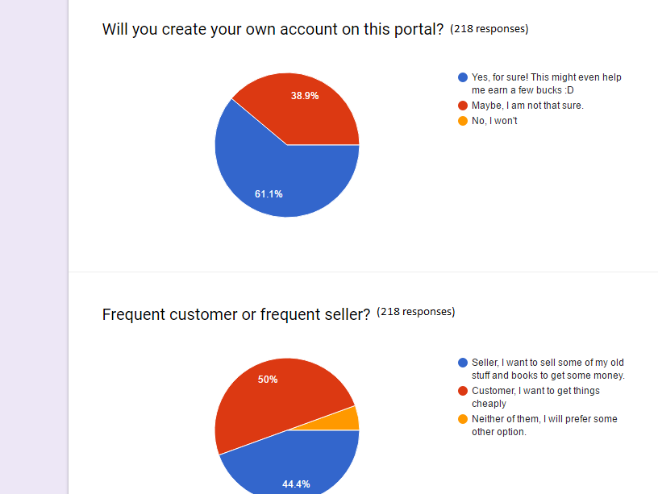

Asking if the survey responder would create an account on our web app or not

Asking if he would be a frequent seller or buyer

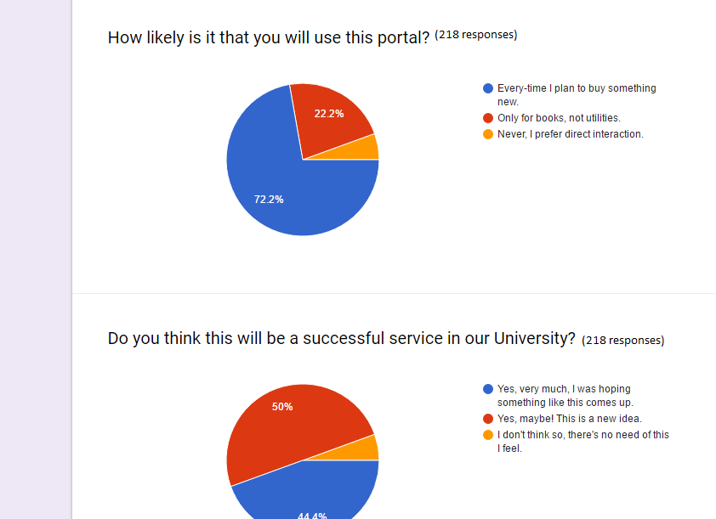

Asking questions on the frequency of use of the web application

Asking if it will be a fruitful service to the university or not

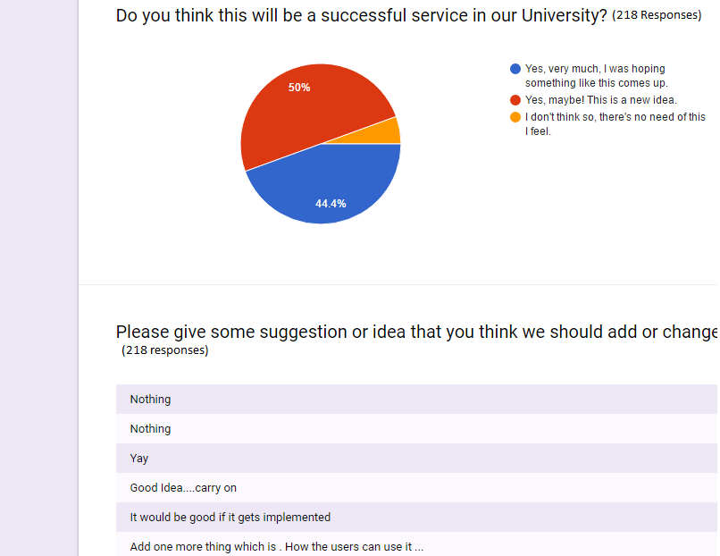

Asking if this service would be worth the hardwork put up to make it

Lastly asking for suggestions and recommendations in order to augment or enhance the idea and foundations behind the application

Suggestions continued!

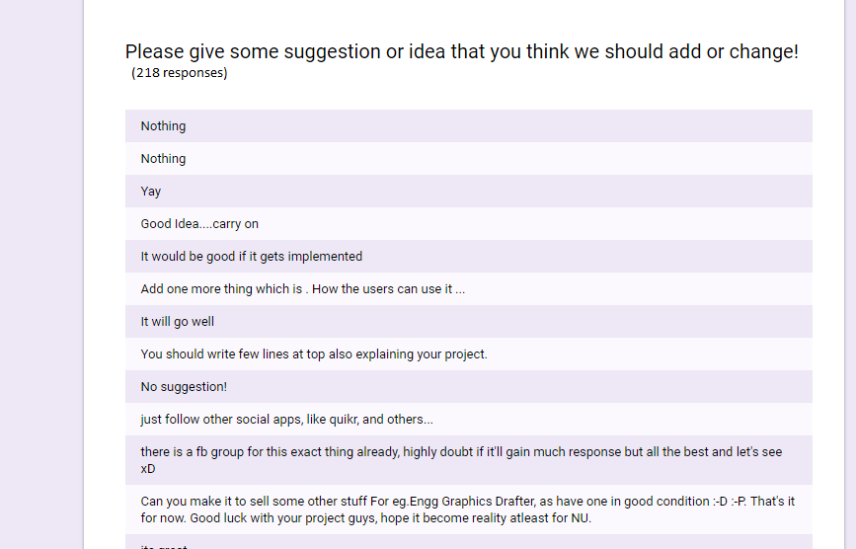

**Feasibility report**

**Product**: The product is meant to act as a platform where users can get information about the product that they want to buy or deposit information about the product they want to sell, so that if they want to do away with their old product at a certain price lesser than the original ,they can do so ,on the other side the buyer can see the necessary details of the reusable product that they want to buy and obtain the contact information from our web application such as the name, hostel name, phone number and email address, thereby easing the process of communication.

**Technical Feasibility:** the proposed system shall be built using various tools like HTML/CSS Javascript, bootstrap on the client side and implementing the server side using PHP , Mysql , and Ruby on rails. Necessary care and attention will be given to ensure proper and efficient technical implementation by regular testing and debugging

**Social Feasibility:** This application once implemented will affect the way people buy or sell things . It will promote the message of reusability in the minds of the people and also give them a chance to earn money by the means of putting their unused or no longer used belonging on sale on this platform

**Economic Feasibility:** The system will not only benefit the buyer and the sellers but also the owners of the web application as an increasing traffic on the web app or more number of downloads will lead to more advertisements on the web app and the linked website through google adsense or others ,but still some maintenance and hosting borne by the owner.

**Market research:** similar products or web applications have not been implemented till date ,this idea is relatively new and therefore has good prospects of being successful in future market

**Alternative solutions :** The use of quikr and Olx, these two can be used but our website (collegemart) mainly focuses on college students, their needs, the daily items they use as they progress down the academic lane, our web app can be thought of as similar to the above mentioned but it is more college centric and localized and therefore it serves it small but powerful purpose of catering to the needs of a smaller mass and therefore it implementation is worthwhile as compare to the above two.