CollegeMart Software Design Specification

1.0 Introduction
1.1 Purpose of this document
The purpose of this document is to elucidate the details of our software and to provide a high-level design framework around which to build our online reusable items inventory.
The Software Design Specification (SDS) document will have two major releases:
- Version 1 focuses on specifying a high-level view of the architecture of our system, and on the interaction between the user and the system.
- Version 2 focuses on detailing a low-level view of each component of the software and how the components interact with each other.

1.2 Scope of the development project
The project which we are developing is an online inventory which will provide the details of the items to the users and make their search hassle free , it also allows the users to put up an item on our web portal ,open to the view of potential buyers ,thereby giving the user the opportunity to part away with their reusable items in a profitable way. The project portrays an altogether new approach of “reusability” .This software will work on windows, smartphones and tabs
Synchronization: We will design and implement server software to serve as an interface between the user and the Database.
1.3 Definitions, acronyms, and abbreviations
- GUI - Graphical User Interface
- PC - Personal Computer (desktop or laptop)
- HTML-Hypertext Markup Language
- CSS-Cascading Stylesheets
- XML-Extensive markup language
- AJAX-Asynchronous javascript and XML

1.4 References
Not Applicable

1.5 Overview of Document
The System architecture description section is the main focus of version 1 of this document. It provides an overview of the system's major components and architecture, as well as specifications on the interaction between the system and the user.
The Detailed description of components section will be the main focus of version 2 of this document. It will describe lower-level classes, components, and functions, as well as the interaction between these internal components.
In section 4, we detail the steps that we are taking to focus on code reuse in this software, and we explain our motives for doing so.
Section 5 lists the major decisions we had to make when designing our system, and why we made the choices we did.
The Pseudocode section will provide pseudocode in order to clarify the intended operation of certain components.

2.0 System architecture description

2.1 Overview of modules / components
The system has been designed keeping scalability and extensibility in mind We are taking great care in designing a framework which can be updated easily. Many of the anticipated changes to our system in future phases will only require adding new types of data and changing the user presentation code to make use of these new data. The framework we have designed will only require "plugging in" these new types of data without refactoring the logic that passes the data over the network, retrieves and updates the database, etc. The components/modules have been carefully prepared giving details at whatever depth possible so as to ensure proper documentation methods and guidelines are followed. For now the there are three basic, logical components of the system the Database engine , the client application and the server application

2.2 Structure and relationships
Database Engine
- Existing open source software: Mysql
- Hosts the backend database which is used for central data storage.
Server Application
- Implemented in PHP
- Provides methods and procedures that can be invoked remotely by a client application via the server procedure proxy.
  - Retrieve project data.
  - Update project data.
  - Generate reports.
- Central process which can make all decisions that arise due to the distributed nature of this application.
  - For instance, when a client wishes to update a project, there may be conflicts that need to be resolved if another client has updated the same project.
  - The server can coordinate conflict resolution with the client application (which can ask the user questions, if necessary).
Client Applications
- Implemented in HTML,CSS,JAVASCRIPT,JQuery,Bootstrap etc.
- Contains all presentation logic.
- Interacts exclusively with the user.
- Communicates with the server application

3. Detailed description of components

3.1 Component template description

This section is not part of your design. It is the pattern you will use to describe the components given in subsections 3.2 - 3.n. Each part of the template will be identified by a label. Here in 3.1, you must briefly explain the purpose of each point. To make the presentation clear, use a table or bullet list. You may adapt the template suggested below to your particular needs (although deviations from the suggested template should be minimal and well motivated).

3.2 Component

3.2.1 Component Overview

The following bulleted outline provides a basic overview of the purpose and architecture of our system’s major components. The tables in the remainder of section 3 will provide more details on each component:

3.2.1.1 Database: We are using database which contain tables to represent various item’s data.

3.2.1.2 Class Library: The class library will contain the various classes that are a part of this project that provide for the different functionalities that we have incorporated in the web service we are providing:
I) Buyer: the buyer of the products that will be uploaded in the website which will basically be secondhand products.

II) Uploader: the uploader is also a customer to us who wants to sell their secondhand items and will upload these items on our website.

III)Admin: the admin will be a user to the admin website that we will have and he will look after everything on the website like the stocks of the products, number of users etc.

IV)Items: this class will have all the items that are uploaded to our website and their different properties like price, how old it is, owner etc.

3.2.1.3 Server Application: Server application will the application that will be on the same system as the database. The client software will connect to the server software to send and retrieve data.

3.2.1.4 Client Application; Client Application is the software that the clients or customers will connect to and it will be sitting on the customers’ system and it will be used to send and receive data from the server.

4.0 Reuse and relationships to other products

4.1 PHP and PHP tools

From the beginning of over project development we set a goal to make use of any existing code so that we can avoid wasting of time duplicating other’s works. We also decide to use freeware solutions and open source wherever possible.
Because we are creating web application, it is possible to use open source technologies in each area (we are considering our university as a base as for now). First we decide to implement our code in PHP because it is free and allows us run on a wide range of browser and operating system. Then we choose one server like AWS free tier (Amazon web services).

4.2 Database and Reporting
With these decisions in place, we needed a database on which to store our records. We use MYSQL in PHP.

5.0 Design decisions and tradeoffs

5.1 PHP/Ruby on Rails Debate
The first issue we encountered when we started working as a group was whether to use PHP or Ruby on Rails for developing the back-end of our web portal. Two people among three were in favor of PHP as it is more widely used and is being used since a long time and one member of the group is highly experienced with working in PHP. So we ended up deciding PHP as our back-end language.

5.2 Three Tier Design
Deciding how to judiciously divide the project between all team members was another design issue. We finally decided on a 3 tier design, which is an application program organized into three major parts, each of which is distributed to different places in a network.
The three parts are:
- The client application
- The admin application
- The database and programming related to managing it
A 3-tier application uses the client/server computing model. With three tiers or parts, each part can be developed concurrently by a different team of programmers. Because the programming for a tier can be changed or relocated without affecting the other tiers, the 3-tier model makes it easier for an enterprise or software packager to continually evolve an application as new needs and opportunities arise. Existing applications or critical parts can be permanently or temporarily retained and encapsulated within the new tier of which it becomes a component. This design idea was very appealing to our team, especially for portability purposes. Reference http://searchdatabase.techtarget.com on 3 Tier design.

5.3 Schedule
As a team being in the same college at the time of the development of this project it was easy for us to manage our schedules and synchronize our schedule and work at the same time so that everything is done consistently.

6.0 Pseudocode for components

The following code is the code for loading the home page of the online store:
__________________________________________________________
<?php
/**
* Register basic autoloader that uses include path
*/
use Magento\Framework\Autoload\AutoloaderRegistry;
use Magento\Framework\Autoload\ClassLoaderWrapper;

/**
* Shortcut constant for the root directory
*/
define('BP', dirname(__DIR__));

define('VENDOR_PATH', BP . '/app/etc/vendor_path.php');

if (!file_exists(VENDOR_PATH)) {
throw new \Exception(
'We can\'t read some files that are required to run the Magento application. '
. 'This usually means file permissions are set incorrectly.'
);
}

$vendorDir = require VENDOR_PATH;
$vendorAutoload = BP . "/{$vendorDir}/autoload.php";

/* 'composer install' validation */
if (file_exists($vendorAutoload)) {
$composerAutoloader = include $vendorAutoload;
} else {
throw new \Exception(
'Vendor autoload is not found. Please run \'composer install\' under application root directory.'
);
}

AutoloaderRegistry::registerAutoloader(new ClassLoaderWrapper($composerAutoloader));

// Sets default autoload mappings, may be overridden in Bootstrap::create
\Magento\Framework\App\Bootstrap::populateAutoloader(BP, []);

The following code is for bootstrap:
___________________________________________________________

<?php
/**
* Environment initialization
*/
error_reporting(E_ALL);
#ini_set('display_errors', 1);

/* PHP version validation */
if (!defined('PHP_VERSION_ID') || !(PHP_VERSION_ID >= 50005 && PHP_VERSION_ID < 50700 || PHP_VERSION_ID === 70002 || PHP_VERSION_ID === 70004 || PHP_VERSION_ID >= 70006)) {
if (PHP_SAPI == 'cli') {
echo 'Magento supports PHP 5.6.5, 7.0.2, 7.0.4 and 7.0.6 or later. ' .
'Please read http://devdocs.magento.com/guides/v1.0/install-gde/system-requirements.html';
} else {
echo <<<HTML
<div style="font:12px/1.35em arial, helvetica, sans-serif;">
<p>Magento supports PHP 5.6.5, 7.0.2, 7.0.4 and 7.0.6 or later. Please read
<a target="_blank" href="http://devdocs.magento.com/guides/v1.0/install-gde/system-requirements.html">
Magento System Requirements</a>.
</div>
HTML;
}
exit(1);
}

require_once __DIR__ . '/autoload.php';
require_once BP . '/app/functions.php';

/* Custom umask value may be provided in optional mage_umask file in root */
$umaskFile = BP . '/magento_umask';
$mask = file_exists($umaskFile) ? octdec(file_get_contents($umaskFile)) : 002;
umask($mask);

if (empty($_SERVER['ENABLE_IIS_REWRITES']) || ($_SERVER['ENABLE_IIS_REWRITES'] != 1)) {
/*
* Unset headers used by IIS URL rewrites.
*/
unset($_SERVER['HTTP_X_REWRITE_URL']);
unset($_SERVER['HTTP_X_ORIGINAL_URL']);
unset($_SERVER['IIS_WasUrlRewritten']);
unset($_SERVER['UNENCODED_URL']);
unset($_SERVER['ORIG_PATH_INFO']);
}

if (!empty($_SERVER['MAGE_PROFILER'])
&& isset($_SERVER['HTTP_ACCEPT'])
&& strpos($_SERVER['HTTP_ACCEPT'], 'text/html') !== false
) {
\Magento\Framework\Profiler::applyConfig(
$_SERVER['MAGE_PROFILER'],
BP,
!empty($_SERVER['HTTP_X_REQUESTED_WITH']) && $_SERVER['HTTP_X_REQUESTED_WITH'] == 'XMLHttpRequest'
);
}

date_default_timezone_set('UTC');

___________________________________________________________

7.0 Appendices

Use Case Diagram

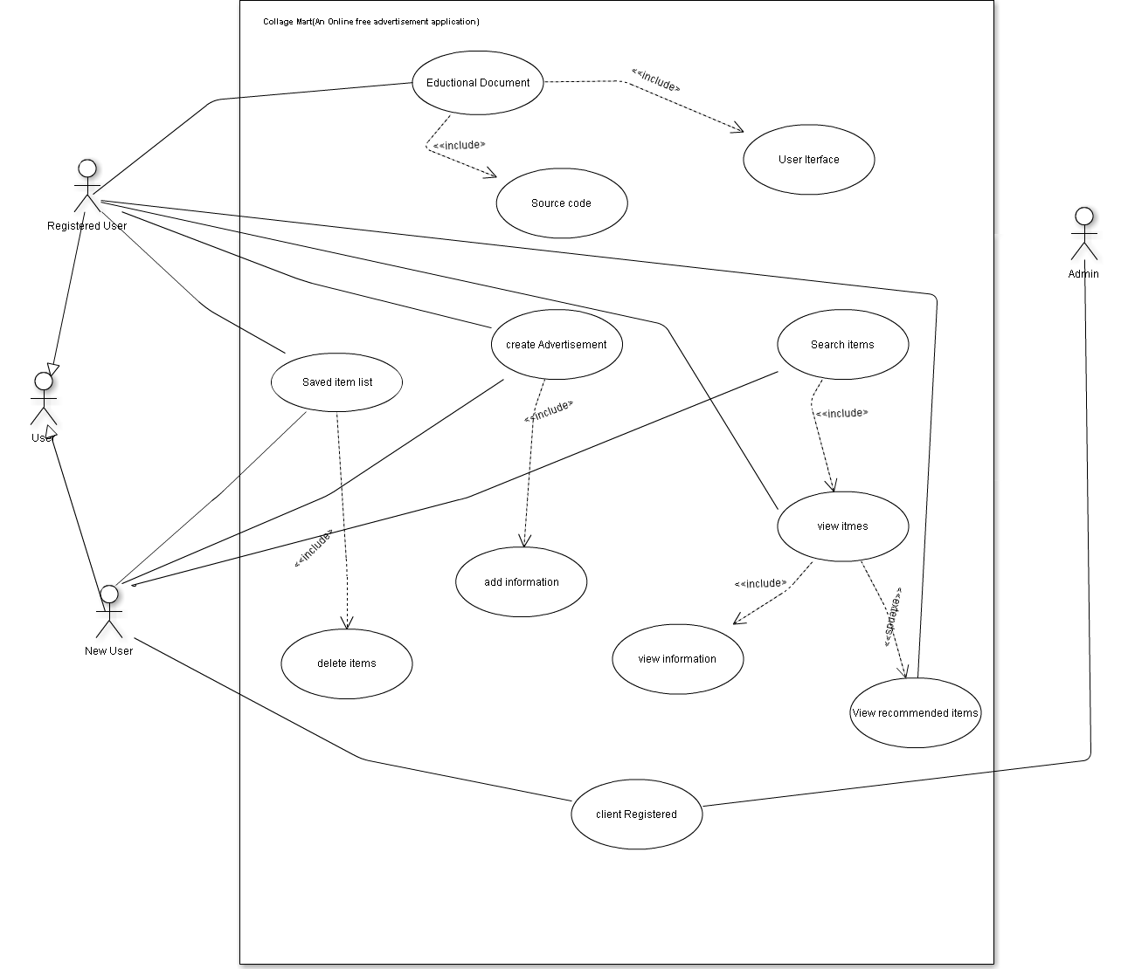

SDS component template
3.2.1.1 Database
Identification | Database
Type | Module
Purpose | Provides means of data management and storage for the server software.
Function | Takes SQL QUERY and UPDATE commands from the server software, and stores the data according to those commands.
Subordinates | - User  - user_id*  - contact_no  - user_name  - user_address  - user_postalpin  - user  - Item  - item_id*  - item_catagory  - itme_name  - item_cost  - item_cond  - Admin  - admin_id*  - admin_name  - admin_skills  - Educational_Doc  - doc_type  - doc_name  * table primary key
Dependencies | An administrative user must perform database setup functions, adding and modifying the structure of tables so that the server software can store the data as appropriate.
Interfaces | Apart from administrative setup, all modification of the database items will be performed via JDBC by the server application. The Reporting application will read the database through JasperReports to generate reports.
Resources | Our project tracker will connect to the database using JDBC connectivity. Once the server gets a request for a certain data type from a client it will look up the table that is associated with the requested object, then parse the restriction clause and create a valid SQL statement. Once it has generated a valid SQL statement, the server will connect to the database, execute the query and get a java ResultSet back. At this point, it will convert the ResultSet to the Object that was requested by the client and send it back to the client via Sockets and ObjectStreams over the network.  A client may also send an updated object to the server, in this case it will convert to a Set and then do an UPDATE to the database. This is a basic database call so it should not take longer than 1 second from start to finish.
Processing | SQL QUERY will come from the client in the form of Object.getAll(String("condition1 = condition2 and condition3 = condition 4"))  SQL UPDATE will come from the client in the form Object.update();
Data | The data in the database will be filled by the server except for the cases stated above. We will use valid SQL statements called within Java through JDBC to execute these commands. In every case we will either get a ResultSet (for queries), a working return code or a SQLException if the command does not work for any reason. We will handle these exceptions according to their type.

3.2.1.2 Class Library
Identification | CollegeMart.DataObjects
Type | Package
Purpose | Provides data structures for the server and clients.
Function | This is simply a package of classes. Each class has a set of accessor and mutator methods as well as logic for retrieving, inserting, updating, and deleting data from the database.
Subordinates | - The Class Library includes the following classes, all of which implement the general DataObject interface  - buyer  - uploader  - Items  - admin
Dependencies | The Server software and the Client software use the class library to store and retrieve data. The Server software relies on the database logic being present in every DataObject in order to load and store data from the database. .
Interfaces | All classes in the class library will implement the abstract class (or interface) DataObject, which has the following interface:  DataObject implements Serializable  {  private boolean dirty;  private int id;  private DateTime downloadDate;  private DateTime uploadDate;  public boolean isDirty ();  public DateTime getDownloadDate();  public DateTime getUploadDate();  private static HashMap fieldToColumn;  public static List getAll (Connection conn, String filter);  public static void put (Connection conn, DataObject obj);  public static void delete (Connection conn, int id);  protected static String makeSqlWhereClause (String filter);  }
Resources | The resources for the class library will be PHP-Mysql connectivity or the mysqli class in PHP.
Processing | The processing of the classes will vary from different class to class.
Data | The data in the classes will vary depending on each class.

3.2.1.2.1 Buyer
Identification | CollegeMart.DataObjects.Buyer
Type | Class
Purpose | Represents a project and encapsulates all the data related to the buyer
Function | The buyer will have the following data items as are there in the entity’s database schema as well:  - Buyer_id  - buyer_name  - buyer_batch  - buyer_room
Subordinates | The buyer will not have any subordinate
Dependencies | As a DataObject, this class relies on that interface definition. As an instance of Entity, this class relies on that class definition
Interfaces | Account, items, price
Resources | None
Processing | None
Data | Information related to the buyer.

3.2.1.2.2 Uploader

Identification | CollegeMart.DataObjects.Uploader
Type | Class
Purpose | Represents a project and encapsulates all the data related to the buyer
Function | The Uploader will have the following data items as are there in the entity’s database schema as well:  - Uploader_id  - Uploader_name  - Uploader_batch  - Uploader_room
Subordinates | The Uploader will not have any subordinate
Dependencies | As a DataObject, this class relies on that interface definition. As an instance of Entity, this class relies on that class definition
Interfaces | Account, items, price, number of items
Resources | None
Processing | None
Data | Information related to the uploader

3.2.1.2.3 Admin

Identification | CollegeMart.DataObjects.Admin
Type | Class
Purpose | Represents a project and encapsulates all the data related to the buyer
Function | The admin will have access to all the information of the web portal and he will be managing everything and keeping a check too. He will just have an Admin_name and Admin_id.
Subordinates | Everything
Dependencies | As a DataObject, this class relies on that interface definition. As an instance of Entity, this class relies on that class definition
Interfaces | Everything
Resources | None
Processing | None
Data | Every Information

3.2.1.2.4 Items

Identification | CollegeMart.DataObjects.Items
Type | Class
Purpose | Represents a project and encapsulates all the data related to the buyer
Function | The items will have the following data items as are there in the entity’s database schema as well:  - item_id  - item_name  - item_age  - item_owner
Subordinates | The item will not have any subordinate
Dependencies | As a DataObject, this class relies on that interface definition. As an instance of Entity, this class relies on that class definition
Interfaces | Buyer, uploader, owner, price, age
Resources | None
Processing | None
Data | Information related to the items.

3.2.1.3 Server Application

Identification | Collegemart .Server
Type | Subprogram, package
Purpose | The server program will run on the same machine as (or at least have access to) the database engine. It is the program that the client applications connect to and communicate with to retrieve and synchronize project data and to run reports.
Function | The server continuously listens on a known port for client connections. It creates a new thread to handle each connection.
Subordinates | The server will rely on the class library outlined above.
Dependencies | The server depends on the database engine. It relies on the implementation of the DataObject classes in the class library. The client applications rely on the server to retrieve and synchronize project data and to run reports.
Interfaces | The server will listen on a predefined TCP/IP port. It will coordinate with the Server Procedure Proxy (which sits on the client side) and use Java’s ObjectStream along with the serializable DataObjects in the class library to pass information across the network. There are two basic methods that the server will expose:  List getAll (Class type, String filter);  void put (DataObject obj, DateTime ifOlderThan);  The first method will retrieve from the database all DataObjects of the given type and with the given filter string applied. A filter string has the exact same syntax and semantics as a SQL WHERE clause, except the object's field names are used instead of column names. The second method inserts the given DataObject into the database on the condition that the object which is currently stored in the database is older than the ifOlderThan parameter.
Resources | As previously mentioned, the server will use the TCP/IP network protocol, relying on Java's Socket and ServerSocket classes to do this. It also relies on Java's ObjectStream class and Java's serialization mechanism.
Processing | The exposed methods are described in the Interfaces sub-section.
Data | The server uses the Ingres database engine to store data, and is ignorant to the specific logic utilized to load, store, and manipulate the data. The server acts only as a communication device between the clients and the database.

3.2.1.4 Client Application

Identification | Collegemart Client
Type | User Interface
Purpose | Provide a user access to data stored locally or on a database.
Function | - Logs a user into the system, and attempts to connect to a specified server.  - When possible uploads any changes that have been made locally since the last successful server connection. In some cases, there may be conflicts between local and remote data, and the client will provide a means for conflict resolution through user interaction.  - Allows the user to see a list of items and menu on the web application  - Allows the user to create add new items to the web app  - Allows the user to inspect and change the details of the product  - Allows a user to report error or malfunctions
Subordinates | 1) The Login Screen - provides a level of security for the project data  - Inputs  - User Name  - Password  - Server Settings  - Outputs  - Status of the login attempt  - Presents the next form based on connection status and server authentication  2) The Overview Screen - Shows the user details ,content and menu available and provides access to other screens.  3) The Maintenance Screen - Shows details related to the project and provides means for modifying them.  - Inputs  - Any data related to the selected project  - Ability to request the creation of new Action Items, Costs, or notes  - Ability to request the saving of modified items  - Outputs  - All data related to the selected project  - The Action Items, Costs, and Notes which have been created for this project  4) The Time/Cost Entry Screen - Allows the user to report on their activities and costs related to a project  - Inputs  - Start Time  - End Time  - Project  - Cost  - Comment  - Outputs – None
Dependencies | This component will interact closely with the Server Procedure Proxy for the retrieval of project data. The gui will create and pass around an instance of the Server Procedure Proxy class and use it to get and put data on the server. Such server calls will be synchronous, so there will be no timing issues for the client to consider.  The Client will use various data classes found in the Class Library. Data from the Server Procedure Proxy will be packaged into one of these classes, and the Client can then access that data through the public methods of the appropriate class. These classes also provide the Client with a handy way to save the data locally (as do all java classes).
Interfaces | The Client uses Swing classes for interaction with the user.  Uses the Server Procedure Proxy for interaction with a server.
Resources | The Client will not have any significantly CPU- or memory-intensive tasks--however, normal overhead associated with Swing components is to be expected in both cases.  Much of the project data to be queried will be accessed on a remote database.
Processing | The server is designed in such a way as to efficiently manage the requests made by the client
Data | A list kept on the disk as a serialized List of objects, loaded into memory in the same format. Such a list will, of course, initially be empty.  Associated data kept on the disk as a serialized List of Objects, of any of several formats, loaded into memory in the same format. Initially empty.  A list of user names and passwords encrypted on disk using javax.crypto.

