Software Requirements Specification
for
College Mart (A online free advertisement application)
Version 1.0 approved
Prepared by Anay yadav
NIIT UNIVERSITY
18-sept-2016
Table of Contents
Table of Contents ii
Revision History ii
1. Introduction 1
1.1 Purpose 1
1.2 Document Conventions 1
1.3 Intended Audience and Reading Suggestions 1
1.4 Product Scope 1
1.5 References 1
2. Overall Description 2
2.1 Product Perspective 2
2.2 Product Functions 2
2.3 User Classes and Characteristics 2
2.4 Operating Environment 2
2.5 Design and Implementation Constraints 2
2.6 User Documentation 2
2.7 Assumptions and Dependencies 3
3. External Interface Requirements 3
3.1 User Interfaces 3
3.2 Hardware Interfaces 3
3.3 Software Interfaces 3
3.4 Communications Interfaces 3
4. System Features 4
4.1 System Feature 1 4
4.2 System Feature 2 (and so on) 4
5. Other Nonfunctional Requirements 4
5.1 Performance Requirements 4
5.2 Safety Requirements 5
5.3 Security Requirements 5
5.4 Software Quality Attributes 5
5.5 Business Rules 5
6. Other Requirements 5
Appendix A: Glossary 5
Appendix B: Analysis Models 5
Appendix C: To Be Determined List 6

Revision History
Name | Date | Reason For Changes | Version

Introduction
The introduction of the SRS provides complete overview of the entire SRS with everything i.e. scope, purpose, definitions, abbreviations, acronyms, references and overview of SRS. The aim of this doc. is to analyze and collect and give an in-depth explanation of the complete Online Free Advertising software system by defining the problem statement in detail. It also concentrates on the capabilities required by stakeholders and their needs while defining high-level product features. The detailed requirements of the Online Free Advertising are provided in this document.

Purpose
The purpose of this document is to gather and analyze all different ideas that have come up to define this system, its requirements with respect to users. Also, we shall predict and sort out how we hope this product will be used in order to gain a better understanding of the project, outline concepts that may be developed later, and document ideas that are being considered, but may be discarded as the product develops.
In short, the purpose of this SRS document is to provide a detailed overview of our software product, its parameters and goals. This document describes the project's target audience and its user interface, hardware and software requirements. It defines how our client, team and audience see the product and its functionality. Nonetheless, it helps any designer and developer to assist in SDLC processes.

Document Conventions
This document follows MLA Format. Bold-faced text has been used to emphasize section and sub-section headings. Highlighting is to point out words in the glossary and italicized text is used to label and recognize diagrams.

Intended Audience and Reading Suggestions
This document is to be read by the development team, the project managers, marketing staff and documentation writers. Our stakeholders, company manufacturing associated hardware, company providing embedded operating system, The SRS has been organized approximately in order of increasing specificity. The developers and project managers need to become intimately familiar with the SRS. Others involved need to review the document as such:
Overall Description
System features
External Interface Requirements
Nonfunctional and Functional Requirements

Product Scope
Primarily, the scope pertains to the OLA for marketing this project live. It focuses on the stakeholders and application which allow for online sales of used items.
The OLA has features that enable any person to post any advertisement of his items which is used by him. And the OLA also enables any person to communicate with anyone. Refer to the project scope document for further information.

References
- IEEE Software Engineering Standards Committee, “IEEE Std. 830-1998, IEEE Recommended Practice for Software Requirements Specifications, October 20, 1998.
- Feldt R, ”re_lecture5b_100914”, unpublished.

Overall Description

Product Perspective
The product is supposed to be an open source, under the GNU general Public License. It is a web based system implementing client-server model.
The OLA system provides simple mechanism for users to share the items which they want to sell and to see the used items which they want to purchase at a cheap rate. And get the details about the products or items

Product Functions
The OLA contains the following key features:
- Cross platform support: Offers operating support for most of the known and commercial operating systems.
- Registration: If the customer wants to publish an advertisement then he/she must registered unregistered user can’t go to the advertisement library.
- Login: Customer logins to the system by entering valid user id and password.
- Search: search is simply local search engine based on keywords.
- Logout: after surf the product the customer will logged out.
- Report Generation: After seeing all the items the user can save the items by clicking on save button for further requirement. And the system generate Email and send to the user’s mail box.
- 7. Feedback: Allow user to submit his issues to the admin in case any problem occurred in posting the advertisement.

- 8. Technical Issues: This system will work on client-server architecture. It will require an internet serve and which will be able to run PHP application. The system should support some commonly used browser such as Google Chrome etc.

User Classes and Characteristics
The users of the Online Free Advertisement system, based on their roles, are customers (users) and the admin (owner). These users are identified based on their experience and technical expertise.
- Admin: The administrator is the owner of this online free advertisement system. One must have a basic understanding of computers and the internet as well as prior knowledge for operating the eclipse, Java programming language, PHP programming language and SQL. The admin is responsible for maintaining all the documents required for the system.
- Users: The users of this online free advertisement system are all customers who would shop to test the application. These users are anyone with shopping experience and they know how to post an advertisement online. They must have basic understandings about computers and the internet. The users should be able to perform the following functions using this system:
- View, browse, and select a category on the home page.
- View, add, and update items on their profile.
- Delete any add posted by them only.
- Check out the items from the application.
- Sign in/login using a username and password.
- Place the advertisement.

Operating Environment
This is a web based system and hence will require the operating environment for a client and server GUI. This will be operating in windows.

Design and Implementation Constraints
The main constraints are:
- Hardware Limitations: The minimum hardware requirement for the system is 128MB of RAM and a 32-MB hard-disc drive.
- Accessibility: Initially, the software should be available as a desktop as a desktop application for a small set of users to test.
- Others: The application should be built using Java and JavaScript inscribed in HTML.
Design Constraint:
This section lists the design requirements for the online free advertisement system.
- DC01: The user interface (UI) must have specific fonts and font size. The system shall matches the font sizes used for all the pages of the application.
- Software System Quality Attribute
- Integrity
- QA01: The authorized user shall be allowed to access the online free advertisement application.
- QA02: Based on the user type, the online free advertisement system shall provide a user specific interface.
- Availability
- QA03: The system shall be made available to the user/ administrator year round.
- Robustness
- QA04: The system shall be able to save items to saved items.

User Documentation
For user documentation and information, please consult section 3: External Interface Requirements and attached user manual.

Assumptions and Dependencies
The assumptions and dependencies are as follows:
- It is assumed that the hardware designed will work correctly with the third-party operating system and the developed software.
- One assumption about the product is that it will always be used on mobile phones that have enough performance.
- Another assumption is that the camera component in all mobiles phones to take pictures of the item which user wants to publish an advertisement.
- The system is dependent on the availability of an Apache Tomcat Server to run.
- We assume that system user adhere to the system’s minimum software and hardware requirements.

External Interface Requirements

User Interfaces
The two interface types found in the online free advertisement application as follows:
User Interface: Users are able to view the home page of the online free advertisement application, browse the different categories, browse information regarding any items and add new items in any suitable categories.
Admin Interface: The admin is able view the user’s information that was entered during posting an advertisement in database.

Hardware Interfaces
The online free advertisement application shall provide minimum hardware requirements. The following hardware configurations are required for a PC using the online free advertisement application:
- Pentium processor, i3, i5, i7.
- 32 MB of free hard-drive space.
- 128 MB of RAM.

Software Interfaces
This section lists the requirements that are needed to run the system efficiently. The operating system needed for the system to run effectively, the interface to run the application, the driver for running Java web applications, the integrated development environment to develop the application, and the third-party tool used for editing purposes are as follows:
- Operating System: Windows (Vista/Windows 7) or MAC OS.
- Web Brower: Internet Explorer (8.0 and above), Mozilla Firefox (3.0 and above), or Google Chrome.
- Drivers: Java Runtime Environment.
- Integrated Development Environment: Eclipse Juno or Apache Tomcat.
- Third-Party Tool: Microsoft Word.

Communications Interfaces
The communication between the different parts of the system is important since they depend on each other. However, in what way the communication is achieved is not important for the system and is therefore handled by the underlying operating systems for web application.

System Features
This subsection contains the requirements for the OLA. These requirements are organized by the features discussed in the vision document. Features from vision documents are then refined into use case diagrams and to sequence diagram to best capture the functional requirements of the system. All these functional requirements can be traced using tractability matrix.

Educational Purpose
4.1.1 Description and Priority
The main purpose of this OLA application is to teach computer science students the basics of the Java, JavaScript, and HTML programming languages along with the concepts of web-application designing.
4.1.2 Stimulus/Response Sequences

4.1.3 Functional Requirements
- FR01: The students shall be able to view the source code for the entire application.
- FR02: The students shall be able to, individually, view and understand the code for all pieces on the UI.
- FR03: The students shall be able to debug the application’s source code using Firebug, which is an online tool to inspect, edit, and monitor HTML, CSS, and JavaScript requests directly on the web

User: View Categories and items

Description and Priority
The users shall be able to see the home page of the OLA application when they first run the program. The users shall be able to view the different categories, select categories, browse through the items in each category, and add items for ADD. The users shall be able to view more information about each item.

4.2.2 Functional Requirements
- FR04: The users shall be able to view the categories on the application’s home page.
- FR05: The users shall be able to view items in different categories.
- FR06: The users shall be able add items for ADD.
- FR07: The users shall be able to view more information about an item.
- FR08: The users shall be able to browse through the available items.

User: View Saved Items:

Description and Priority
After the first run of the application, the users shall be able to see their designated home page. After browsing through the items and adding items to the shaved items, the users should be able to view the items in the Saved Items category. The users shall be able to delete items from the saved items.
4.2.2 Functional Requirements
- FR09: The users shall be able to view the items added to the saved items list.
- FR010: The users shall be able to continue viewing items .
- FR011: The users shall be able to delete items from the saved items list.

Login/User Authentication

Description and Priority
No description as such.

4.2.2 Functional Requirements
- FR012: The users shall login or register using the user authentication form.
- FR013: The users shall not login or register if the information is incomplete or invalid.

User: Place Advertisement

Description and Priority
The users can post an advertisement on his profile.

4.2.3 Functional Requirements
- FR014: The users shall place an ADD by completing the information in the advertisement form.
- FR015: The users shall not be able to place an advertisement if the information in the advertisement form is invalid or incomplete.

Admin: View User Information

Description and Priority
The admin can see the database and can changes in the UI.

4.2.2 Functional Requirements
- FR016: The administrator shall be able to view all the users’ information that place the advertisement form.
- FR017: The administrator shall be able to delete items from the main page of the OLA application.

Other Nonfunctional Requirements

Performance Requirements
This section lists the performance requirements expected from the OLA application.
- PR01: The users shall be able to add an item for the advertisement in fewer than 5 sec.
- PR02: The users shall be able to view information about the items in fewer 5 sec.
- PR03: The users shall be able to save the items in the saved list for further view in 5 sec.
- PR04: The navigation between pages shall take fewer than 5sec.
- PR05: The application shall be able to do a validation check on the information provided in the user-authentication from and the place-advertisement form to avoid false or incomplete information.

Safety Requirements
<Specify those requirements that are concerned with possible loss, damage, or harm that could result from the use of the product. Define any safeguards or actions that must be taken, as well as actions that must be prevented. Refer to any external policies or regulations that state safety issues that affect the product’s design or use. Define any safety certifications that must be satisfied.>

Security Requirements
- The system use SSL in all transactions that include any confidential customer information.
- The system must automatically log out all customers after a period of inactivity.
- The system should not leave any cookies on the customer’s computer containing the user’s password.
- The system’s back-end servers shall only be accessible to authenticated admin.
- Sensitive data will be encrypted before being sent over insecure connections like the internet.

Software Quality Attributes
The system provides storage of all database on redundant computers with automatic switchover.
The backup of the database is continuously maintained and updated to reflect the most recent changes.
The system should be available at all times, meaning the user can access it using a web browser.
The application is HTML and scripting language based. So the end-user part is fully portable and any system using any web browser should be able to use the features of the system, including any hardware platform that is available or will be available in the future.
An end-user can use this system on any operating systems, either it is Windows or Linux.

Business Rules

we are going to link the web application to Google adsense, due to traffic in our website and hopefully advertisements will occur, generating revenue.

Other Requirements
For information regarding functional requirements, refer to section 4: System Features. Each feature has its requirements listed alongside the feature information. Special requirements for each system feature are also mention in section 4. There are no additional Functional requirements.
Appendix A: Glossary
Admin: Administrator, he has the authority to add/delete users, grant permission.
UML: Unified Modeling Language.
HTTP: Hypertext Transfer Protocol.
OLA: Online free advertisement.
PHP: Hypertext Preprocessor.

Appendix B: Analysis Models
Use Case Diagram
User actor use our web app to make an advertisement online for free of cost. And he/she can also see the advertisement posted by some other users.
Top level use cases are View Items, Saved items, Create new advertisement and Client Register.
View Items use case can be used by the user as top level use case if user only wants to find out and see some advertisement of any product.
Saved Items use case can be used by the user if he/she are our older users who wants to see their saved item’s advertisement for future contact to the owner of the product. It can also be used as a part of View items use case.
Create new advertisement use case can be used by the users both who are new or older ones, they can create an advertisement by filling an advertisement form and uploading the photo of that product.
Client Register use case allows customers to register on the web app
Expect for the user actor there are one more actor Admin.
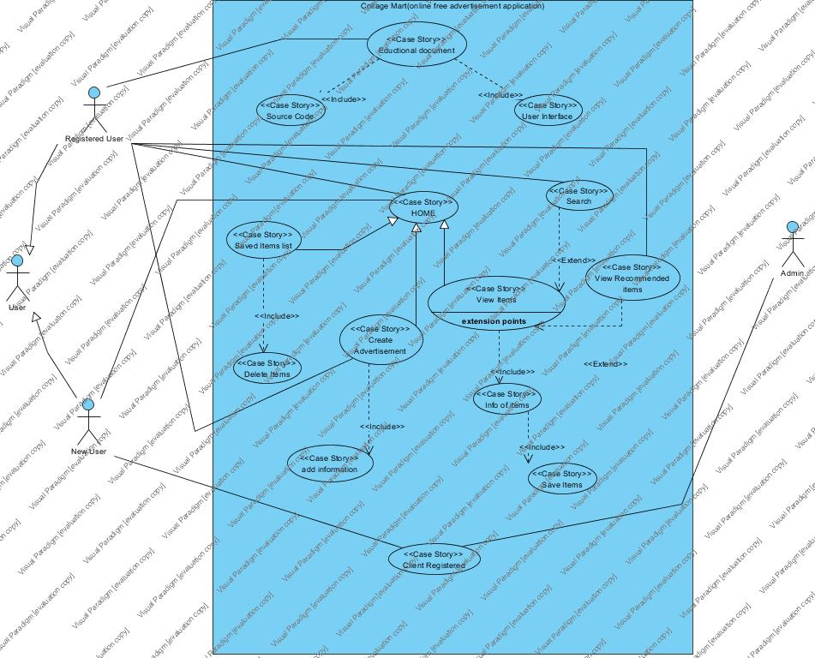

View items use case is extended by several optional use case – user may search for items, view items recommended for him/her, save items in the saved list. All these use case are extended use case.
Customer Authentication use case included in View Recommended Items and Add to save list because both require the users to be authenticated.
ER Diagram
The ER diagram of Collage Mart (an online free advertisement application) is below:
Problem Statement
CollegeMart is a website made for intra-college sale/purchase of used books and utilities among the students of a college. Anyone who wants to use our service will first have to create an account on our website. The account will have information such as name, enrollment number, date of birth, email id, phone number. Every account holder will belong to a particular semester having a sem number. Each semester will further have a set of courses and each course will have a prescribed book. Also, to locate a student, every account holder will give information about their hostel name, floor and room number.
The website has a special feature called bounty which keeps track of the number of orders of every account holder and gives special privileges after a particular threshold. As an additional feature, the website will also deliver new books and new utilities. Therefore, both, books and utilities will be divided into two parts, new and old. Product will have information such as name, Product number, Type Each first hand and second hand will have information of the conditions and transaction which are been used to it has been. Both, books and utilities will have a sell price and a cost price and the resulting discount percentage. Also, the website will have different payment methods such as debit card, credit card, net banking, cash on delivery and in person payment. We will also keep a track of how many transaction an old book or utility has undergone, i.e., how many times it has been transferred from a student to another. We also have included system of the feedback were you can give your so according we can change as according to your feedback in the near future generation. It will also have the price of product were you can buy the product by any payment either the use of credit card or cash or net banking or debit card.

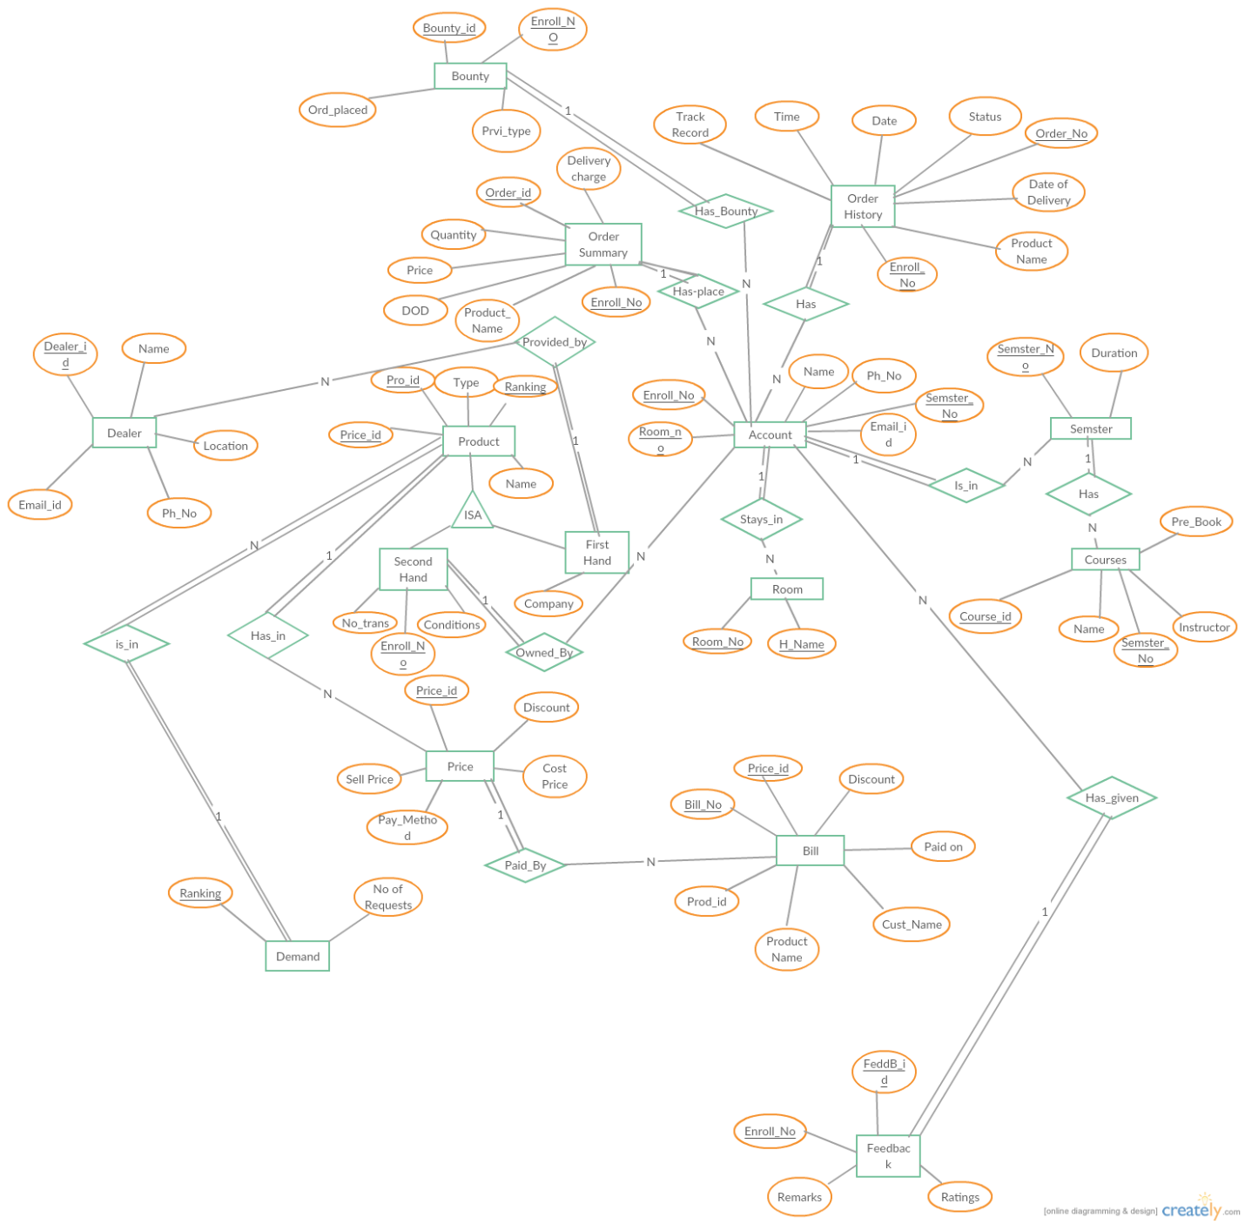

Appendix C: To Be Determined List
<Collect a numbered list of the TBD (to be determined) references that remain in the SRS so they ca be tracked to closure.>

