SOFTWARE TESTING

We have done the testing of our web application using the software WAPT. We have covered all the aspects of web application testing like performance test, bandwidth usage, response time, error reporting etc.

- Performance Testing :

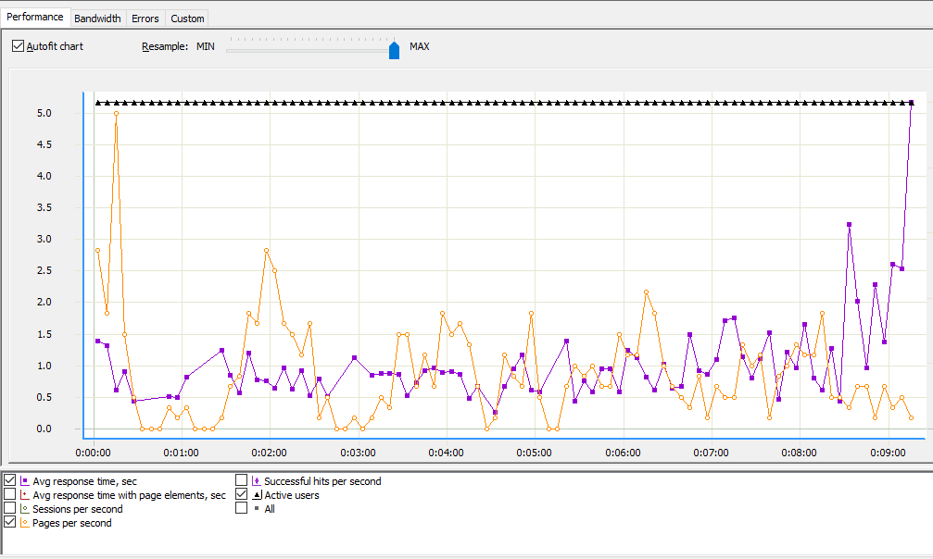

- Bandwidth Usage:

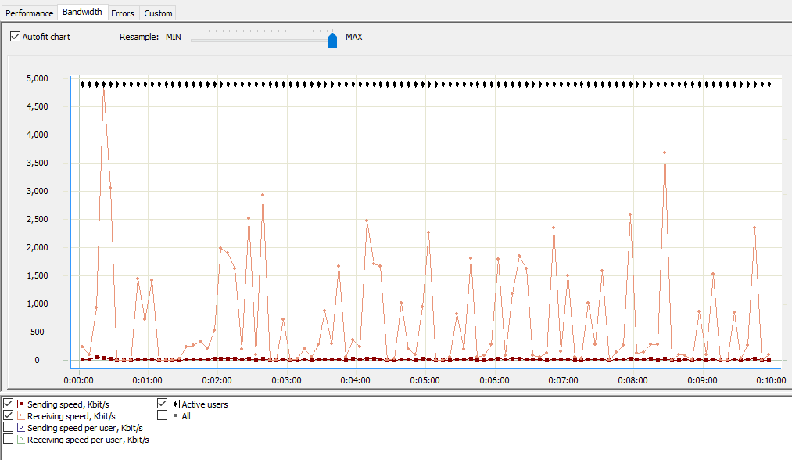

- Error Reporting:

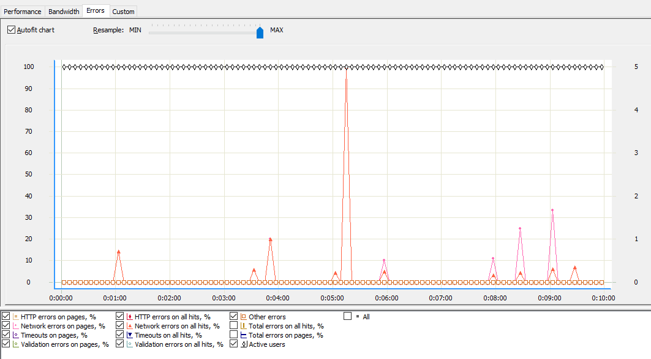

- Complete Summary Report :

