**Minutes Of Meeting With the Customer**

**for**

**Startup Initiative NU**

**Version 1.0 approved**

**Ankush Prabhakar**

**U101114FCS219**

Minutes of Meetings with Customer

The project involves fulfilling the requirements and meeting with 3 different types of users for the service. They are:

1. The Placement Cell (NU-CIC)
2. The Entrepreneurship Cell ( NU E-Cell)
3. The Students of NU.

NU - CIC

Our service aims at providing as much relevant materials as we can to enable the students of NU to be better prepared for Job Interviews during campus placements.

To do this we were in constant contact with NU - CIC who provided us with the data and constructive inputs. Mr. Jaffar Ansari,Ms. Geetica Rastogi and Ms. Bhumika Sharma from the placement cell helped us greatly in our initiative.

NU E-Cell

In our meeting with the NU E-Cell head Mr. Manoj Kumar, helped us by providing relevant in-campus start-ups info. that was crucial for the project. He also gave us positive criticism and even offered to provide his help in integrating the website along-with Moodle.

The Students

The students help was the most important part that made the website possible today. We constantly went to them for their inputs on the idea, the ease of use, their suggestions and UI.

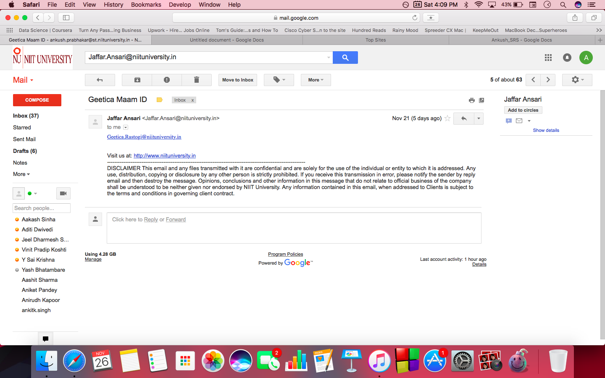

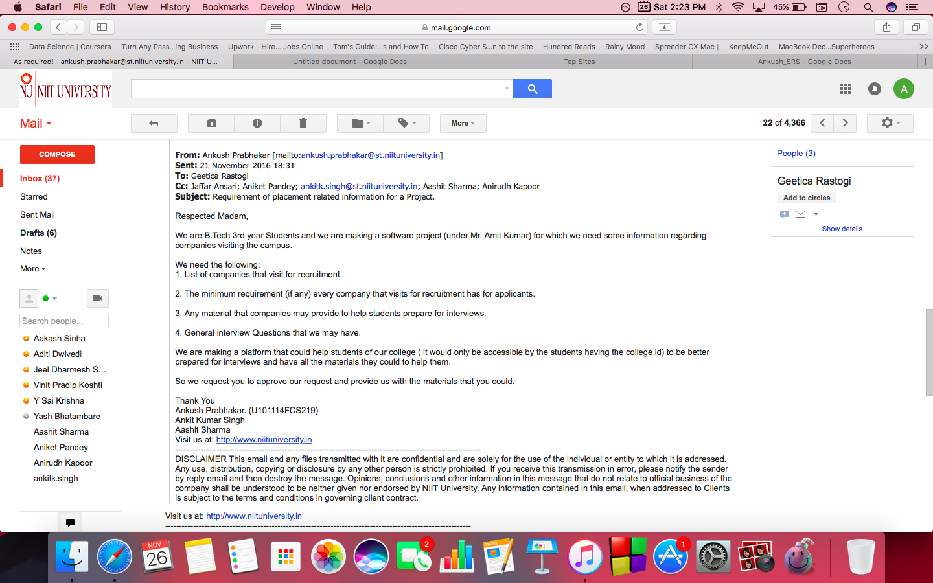

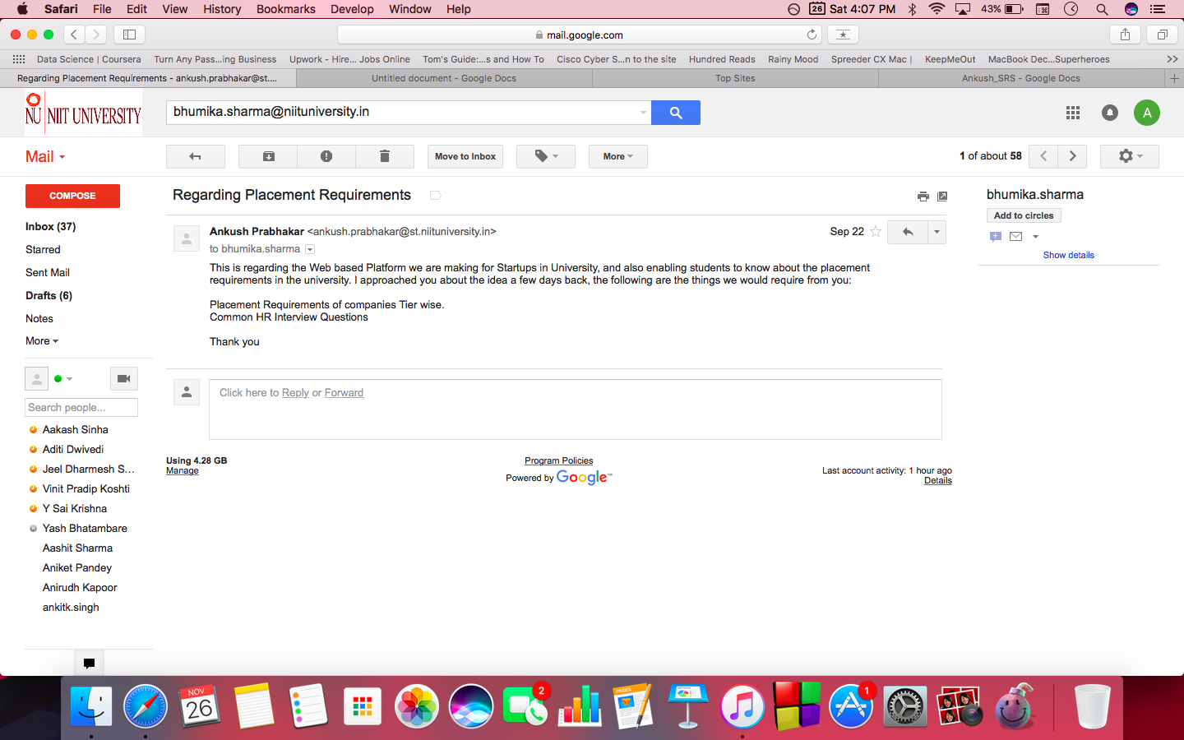

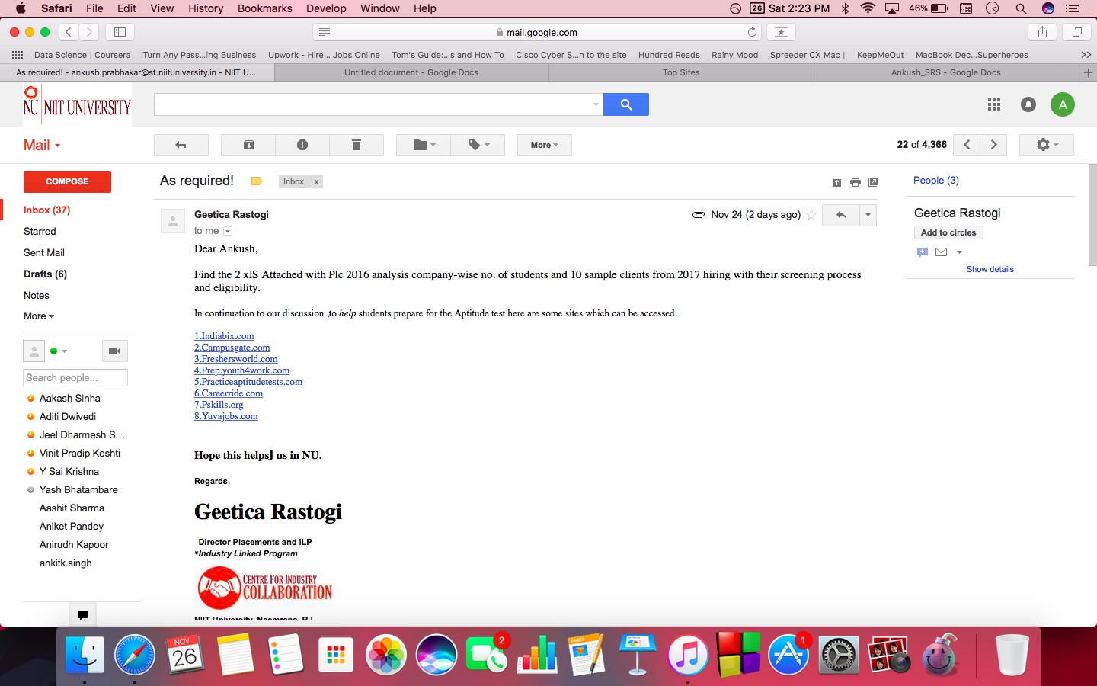

Video Link Of our interaction with Mr.Jaffar Ansari

[link here](https://vimeo.com/user59616070/videos).