**Software Requirements Specification**

**for**

Startup Initiative NU

**Version 1.0 approved**

**ANKUSH PRABHAKAR**

**U101114FCS219**

**Table of Contents**

**Table of Contents**

**Revision History**

**1. Introduction**

1.1 Purpose

1.2 Document Conventions

1.3 Intended Audience and Reading Suggestions

1.4 Product Scope

1.5 References

**2. Overall Description**

2.1 Product Perspective

2.2 Product Functions

2.3 User Classes and Characteristics

2.4 Operating Environment

2.5 Design and Implementation Constraints

2.6 User Documentation

2.7 Assumptions and Dependencies

**3. External Interface Requirements**

3.1 User Interfaces

3.2 Hardware Interfaces

3.3 Software Interfaces

3.4 Communications Interfaces

**4. System Features**

4.1 System Feature 1

4.2 System Feature 2 (and so on)

**5. Other Nonfunctional Requirements**

5.1 Performance Requirements

5.2 Safety Requirements

5.3 Security Requirements

5.4 Software Quality Attributes

5.5 Business Rules

**6. Other Requirements**

**Appendix A: Glossary**

**Appendix B: Analysis Models**

**Appendix C: To Be Determined List**

**Revision History**

|  |  |  |  |
| --- | --- | --- | --- |
| **Name** | **Date** | **Reason For Changes** | **Version** |
|  |  |  |  |
|  |  |  |  |

# **Introduction**

## **Purpose**

The internet Web based software fulfills # main purposes.

1. A platform which lets startups connect/hire interested students as interns based on their skillset and experience. This shall be fulfilled
2. Allow students to find a co-founder for their startup or any help relating to their startup (Like guidance from concerned faculty).
3. Allow students to access vital information regarding placements, interviews and their recruitment criteria.

## **Document Conventions**

Important and concerning matters have been jotted down in BOLD text.

JavaScript:

Django:

HTML5

## **Intended Audience and Reading Suggestions**

The intended audience is university faculty, students, testers and marketing staff. There are no specific reading suggestions for this document. And its moreover , any reader may choose for himself.

## **Product Scope**

This web-based software has 3 main features:

1. **A platform which lets startups connect/hire interested students as interns based on their skillset and experience**

Experience before graduating from university is what every company looks for nowadays. We aim to connect students and in-campus startups. Likewise, many startups are looking for skilled engineering students to help them out. This gap is what this software intends to bridge.

It also aims to improve the entrepreneurial spirit in University.

###### **Allow students to find a co-founder for their startup or any help relating to their startup:**

It is very critical to find a cofounder and even more so to get help from experienced members of this college. This is what this software intends to help an entrepreneurial student do.

###### **Allow students to access vital information regarding placements, interviews and their criteria:**

The benefits of this software feature are students getting better knowledge of the criteria relating to placements and interviews, the types of questions asked and the minimum requirements for different companies that visit the campus, thus increasing the chances of a student getting a job immensely. It also aims to enable students with recruitment information helping them plan accordingly beforehand.

## **References**

No references

# **Overall Description**

## **Product Perspective**

This document contains the description of a software solution for solving 3 critical issues faced by university students: Help university students in placement interviews, providing a platform to meet cofounders and seek help for startup and Bridging the gap between startups and students seeking internship opportunities.

The website will have a user log-in system (both native and social network log-ins) and would have the feature of user profiles, wherein the users can display their skills , job experience ,startups and other related information.

It will have a notification feature for various types of user-notifications.

Along with this, it’ll also feature Direct-Messaging feature for inter-user communication and email notifications on the registered mail.

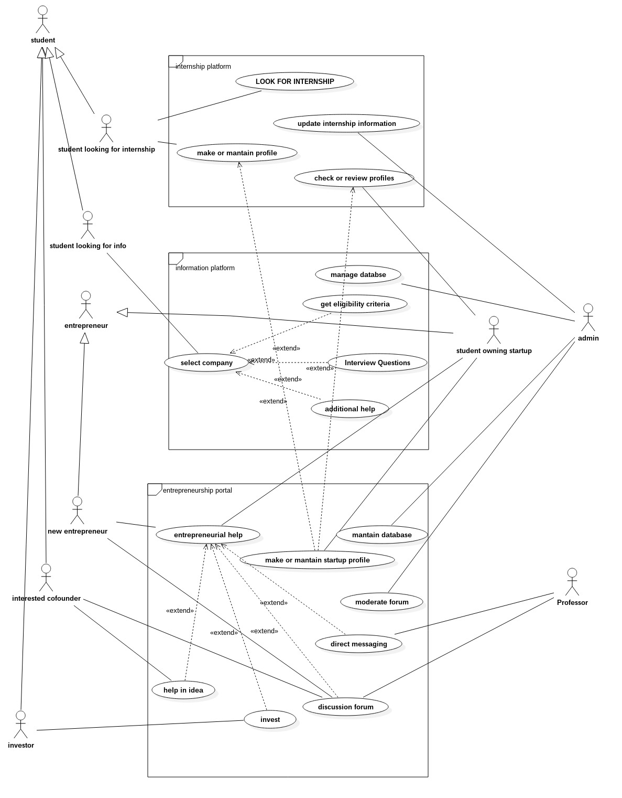

|  |  |  |
| --- | --- | --- |
| Use Cases | Objects | Description |
| UC1 | Make/maintain Profile | Create or edit profile details of the user |
| UC2 | Select company | Company regarding which user needs info. about. |
| UC3 | entrepreneurial help | All the help a user needs to create a new startup |
| UC4 | Look for Internship | Allows user to search from the list of live internships |
| UC5 | Update Internship info | update the details of the internship |
| UC6 | CHECK OR REVIEW PROFILE | check profile details of users |
| UC7 | get eligibility criteria | Allows user to get the eligibility criteria for jobs at listed companies |
| UC8 | Interview question | Allows user to browse interview question asked at different company interviews |
| UC9 | additional help | Allows user to ask for additional help |
| UC10 | make or maintain startup profile | startup owners can create maintain profiles of their firms wherein they can also view profiles of students |
| UC11 | HELP IN IDEA | a person willing to be a cofounder of an entrepreneurial startup, can now start interacting with his co immediately |
| UC12 | INVEST | enables a willing investor to invest in a startup of his choice |
| UC13 | DISCUSSION FORUM | a common platform for sharing knowledge. |
| UC14 | DIRECT MESSAGING | teachers and students can directly message each other regarding a doubt/problem. |
| UC15 | Maintain Database | the administrator constantly needs to alter the information there in the database to keep it afloat. |
| UC16 | invest | enables a willing investor to invest in a startup of his choice |

## **Product Functions**

As aforementioned, this product has 3 main features:

1) Provide help to university students for placement interviews

2) Provide a platform for university students to find cofounders and seek help for startup

3) Bridging the gap between startups and students seeking internship opportunities

**Major Functions of the website:**

1. Authenticate and Login user to the website.
2. Enable new users to register to the Website.
3. Enable a registered user to change his password in case She/he forgets Hers/his password.
4. Enable a registered user to view his/her profile. Additional information viz. questions asked by him and answers posted by him are also displayed.
5. Enable a registered user to update his profile which includes her/his location, skills and profile picture.
6. Enable a user to view available internships.
7. Enable a logged in user to add skills.
8. Enable a logged in user to Add a Start-up profile.
9. Enable a logged in user to Directly message a faculty with questions regarding the startup.

## **User Classes and Characteristics**

There are 3 major classes of users : the first is the student , second the faculty and lastly the administrator of the system.

It is necessary for the user to have a basic knowledge of operating the internet and have an access to it.

The administrator is expected to be familiar with the interface of the tech support system.

## **Operating Environment**

Chrome,Firefox,IE and Tor or any other modern browser supporting HTML5 and Javascript.

No External Hardware Needed

## **Design and Implementation Constraints**

This system is provisioned to be built on the Django framework which is highly flexible. Decision regarding which database to use should be taken considering the fact that data being exchanged or stored is large, and the appropriate data management system will yield efficient performance.

Proper Maintenance of Servers and Separate Database for Log File.

## **User Documentation**

No user documentation required.

## **Assumptions and Dependencies**

## This software depends on the type and version of browser being installed in the system i.e. The browser version being used must have HTML5 and Javascript support.

# **External Interface Requirements**

## **User Interfaces**

Each interactive part of software is made to be understandable and efficient for user. The software will be kept light so it does not take time to load and can handle large number of users properly

The following Standard function will be Included on Each Screen:

1. Contact Administrator
2. Report an Issue
3. FAQs

## **Hardware Interfaces**

A working Computer. The software will perform optimally with a System having 1 gb or more Ram and Intel Core2duo Processor or better.

FTP and HTTp are required in functioning of our software.

## **Software Interfaces**

Front End: JS and CSS

Back End: Django

Database: Mongo DB

## **Communications Interfaces**

When the task is fully created an e-mail should be sent to the customer with detailed information about the module.

Whenever a Direct message is received by a user an email should be sent to notify.

# **System Features**

# *Using this , a student may:*

# *look for internships.*

# *May get an overview , idea of companies visiting the university and their recruitment notices.*

# *Pupils aiming towards their own startups shall now have a platform to interact with those interested in supporting/financing.*

# *The “entrepreneurship help” platform shall solely deal with entrepreneurs who already have a startup functioning.*

# This will be to link teachers , tutors , mentors and entrepreneurs , to increase the availability and free flow of knowledge.Other Nonfunctional Requirements

***Feature 1 : a***

*Feature aims to extract knowledge from conventional internship providers for students as well as to have the flexibility of being accessed by the providers as well to choose and recruit students best fit for their job.*

*A similar flexibility is provided to the students as well , who may choose from a variety of employers , whom to work with.*

*Priority : 9 (High)*

*Being the backbone of the entire software, this is most needed.*

*Cost of development: medium*

*Risk : low*

*Benefit : considerable*

*Penalty: yet to be determined*

**Sequence of user actions:**

**Functional Requirements**:

* + 1. Java Runtime Environment
    2. Internet Browser
    3. Operating System
    4. MS .net Framework
    5. CISCO PEAP module
    6. MS Visual Cpp 2005 redist.

***Feature 2: Placements platform***

*Feature is going to be another very interesting component of our software package.This will primarily be dealing with campus placements and industry practices.*

*This feature shall contain 3 main sub features , as we may call them , namely:  
 1.) Aptitude/General question sets.*

* + 1. *Tutorials/Expert advice from volunteering teachers/coaches.*
    2. *Recruiting companies, Eligibility Criteria vise.*

***Feature 3: Startups platform***

*This feature aims at helping students who have come up , or wish to come up with start ups of their own.*

*The most adventurous thing that has been planned about this component is that it shall allow students owning startups , to create/maintain a profile of their companies. Further, it shall also allow the owner to view the profiles of students interested in working as interns in their startups.*

*This feature provides functionality to two types of users , ones who have already come up with start ups, and the ones who wish to do the same in near future.*

* + 1. *The forum enables the idea of the start up to be circulated through out the members.*
    2. *Members interested in refining/investing in the idea may come foreward and contact the person who conceived it.*
    3. *The forum also serves as a floor for all discussions, both in favour and against the idea, thus providing for a pre analysis , before actual execution.*

***Entrepreneurial Help:***

***T****his undoubtedly is the most salient feature of the startup's platform. This is going to enable students to interact with existing entrepreneurs, tutors and mentors, who can reinforce young ideas further with their experiences.*

Sequence of user actions:

***Tabulated form :***

|  |  |  |
| --- | --- | --- |
| Identifier | Short name | Short description |

|  |  |  |
| --- | --- | --- |
| Student looking for an internship | Internship platform | Allows users to maintain profiles that can be viewed by employers, for internships.  Allows users to choose from among different internships as well. |
| Student looking for information | Information platform | This feature allows the user , to search for a company they would like to work for.  Content is supposed to include practice tests , general interview questions, eligibility criteria, paycheck information, etc. |
| Student looking to conceive a startup/Entrepreneur with an existing startup | Entrepreneurship platform | This , is probably the most ambitious portion of our project.  This system aims to provide entrepreneurial help to people by facilitating both forum interaction and person to person profile interaction. Students , mentors , teachers can all be a part of the system , in addition to people interested in co -conceiving , or financing the startup. |

# **Other Requirements**

## 5.1 **Performance Requirements**

This portal will be hosted on a server that could provide decent response time. college students give short attention time , therefore a weak server will not be good enough for the application. The present college (www.moodle.niituniversity.in) portal is a nice example of fast response time.

* 32-bit OS.
* Intel Dual Core processor
* Atleast 512 MB RAM

## 5.2 **Safety Requirements**

No such safety requirement till now

## 5.3 **Security Requirements**

Copyright of the portal will be with the developers of the portal and niit university.

The website will be encrypted to ensure security.

For logical Security MD5 encryption will be used for Password Protection.

**5.4 Software Quality Attributes**

1. Easy to use Interface
2. history of Searched Data, that’ll help make the product robust.
3. Usage of Efficient algorithm.

**5.5 Business Rules**

1. Development Team - To make the Web Portal
2. Marketing Team - To spread awareness about the product in the Campus.
3. Penetration Tester - To find loopholes in the software so that it can be corrected.
4. Advertisement Team

**Appendix A: Glossary**

<Define all the terms necessary to properly interpret the SRS, including acronyms and abbreviations. You may wish to build a separate glossary that spans multiple projects or the entire organization, and just include terms specific to a single project in each SRS.>