HLIN – File Sharing app

TESTING

BLACKBOX TESTING

**Members:**

R.Logaprakash , M.Supraja , K.Priyanka , M.Manohar , C.H.Srikar.

**Lock Page**:

NONE and Network lock doesn’t have any input, Password Lock will accept any combination of password either simple or complex alphanumeric. So only Geolock takes input in this page (Latitude and longitude)

**Positive Scenario**

**Inputs**: Valid Geo latitude and longitude

**Desired Outputs**: Open file picker to select and send file

**Actual Output**: Opening file picker to select and send file

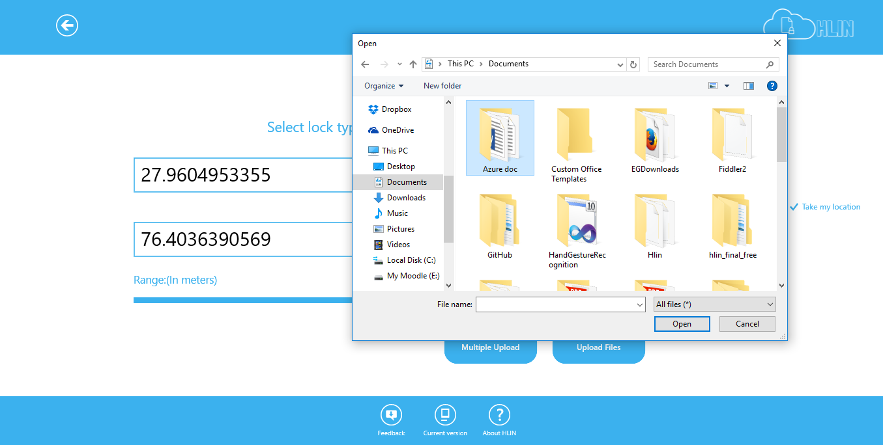

**Negative Scenario**:

**Inputs**: invalid Geo latitude and longitude

**Desired Outputs**: Show error dialog and ask user to retry

**Actual Output**: Showing error dialog and asking user to retry

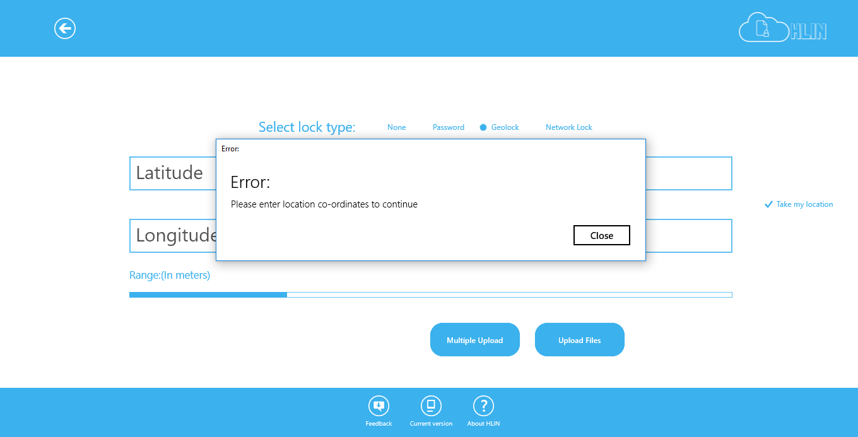

**TEST CASE STATE: Successful**

**Receive Page**:

**Positive Scenario**

**Inputs**: Valid Access key (Access key normally starts with prefix -HLIN) and password in case of password lock)

**Desired Outputs**: Download the respective file which the access key points to in the cloud

**Actual Output**: Downloading the respective file which the access key points to in the cloud

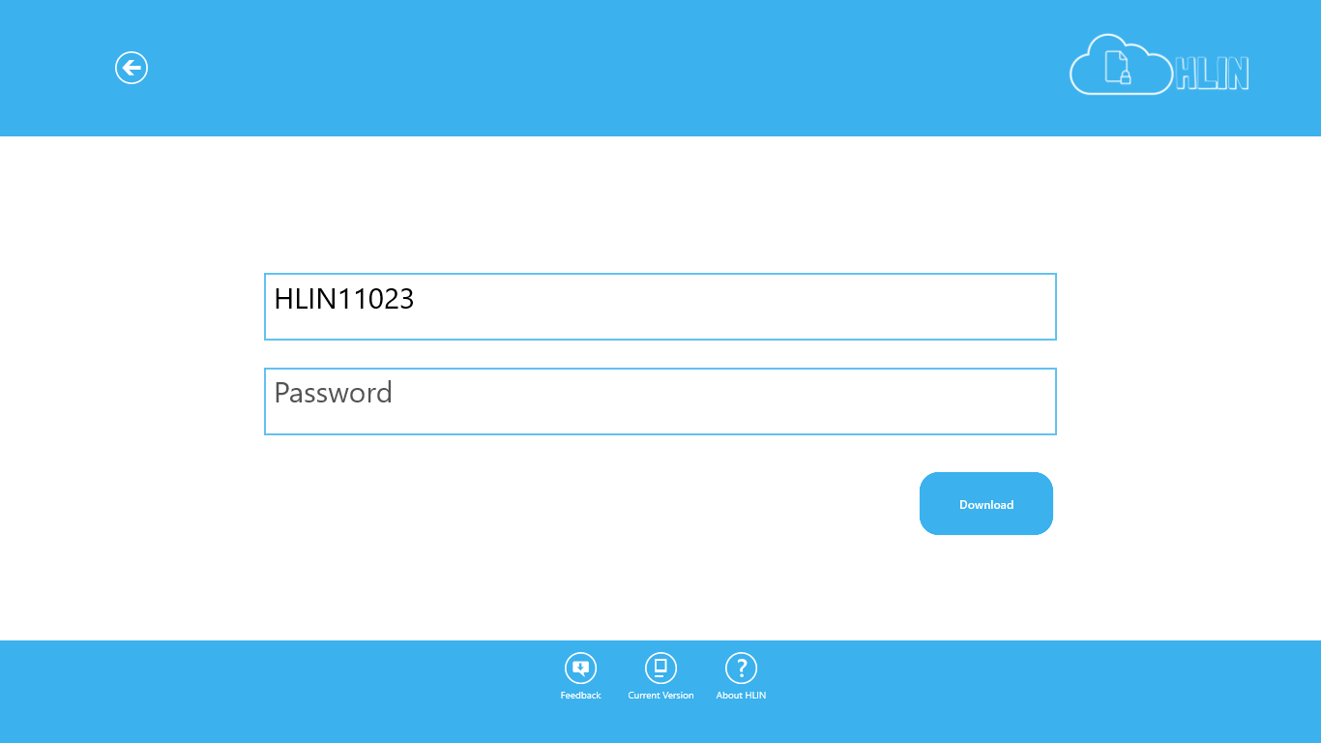

**Negative Scenario**:

**Inputs**: Invalid Access key or invalid password

**Desired Outputs**: Show error dialog and ask user to retry

**Actual Output**: Showing error dialog and asking user to retry

**TEST CASE STATE: Successful**

**Feedback Page**:

**Positive Scenario**

**Inputs**: Non-empty feedback

**Desired Outputs**: Send feedback to cloud

**Actual Output**: Sending feedback to cloud

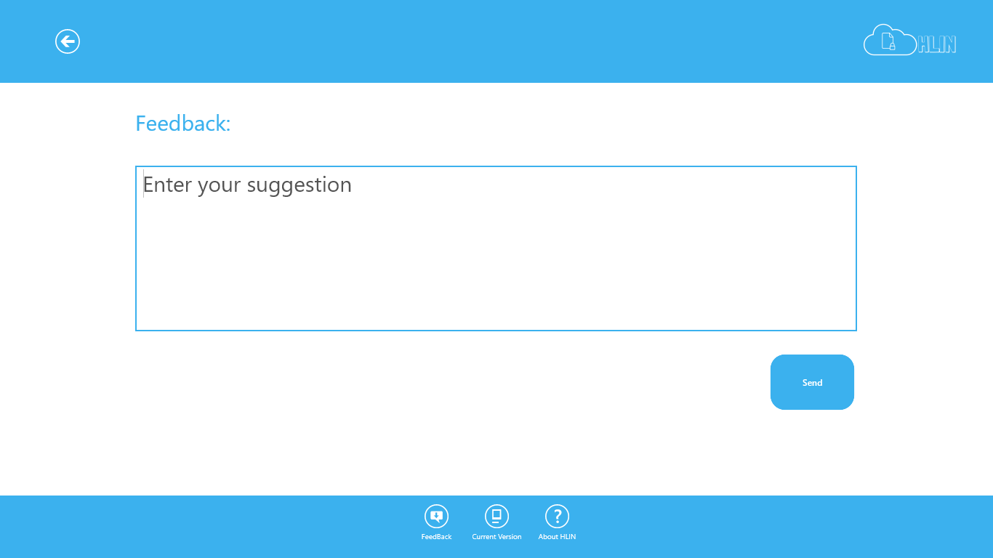

**Negative Scenario**:

**Inputs**: Empty feedback

**Desired Outputs**: Show error dialog and ask user to retry

**Actual Output**: Showing error dialog and asking user to retry

**TEST CASE STATE: Successful**