SOFTWARE DESIGN SPECIFICATION

1. INTRODUCTION

1.1) Purpose
This document intends to provide elaborative details and data flow for the software development and design process. The document lays down the design flow of how the software is being made through the use of class diagram, use case diagram and sequence diagram along with other required details.

1.2) Scope
The product being talked about in this document is a fest management android application, called as Festeve. The main purpose of this application is to build up a common space for both the fest organizers and the viewers or participants. The application is being developed due to an unorganized and incomplete details, in current apps, about a certain fest or its events to the students or audience. Therefore, there is a need for such a platform where the students can quickly get an access to details regarding these events going on around him/her. This way the problems faced by the students to actually dig out informations related to fests will just be cured, right in their hands, by downloading this simple and useful application. The fest organisers will also be benefited by the system as it would notify them instantly regarding new registrations, visitors, withdrawals etc and they will be able to manage accordingly.

1.3) Definitions, Acronyms, Abbreviations
- Festeve : Fest-events
- Fest-Feeds : Coming up stories about fests in various colleges
- Fest-Calendar : Calendar showing dates reserved for various fests.
- Admin : Fest Administrator (only 1 from a college)
- Back-end : Logic that makes a mere icon or system to work
- GUI : Graphical User Interfaces
- App : Application

1.4) References
- https://en.wikipedia.org/wiki/Software_architecture
- https://en.wikipedia.org/wiki/4%2B1_architectural_view_model
- https://en.wikipedia.org/wiki/Component-based_software_engineering
- http://research.cs.queensu.ca/home/ahmed/home/teaching/CISC322/F10/files/documentingArchitecture.pdf
- http://www.cs.utah.edu/~jamesj/ayb2005/docs/SDS_v2.htm#2.0 - MUST SEE

1.5) Overview of documents
The document puts forward a description regarding application’s major components and it’s architecture, along with the specifications on the interaction between the user and the system.
- Section 1 provides the description of our project as well as outlines the importance of this documentation.
- Section 2 describes system architecture with the help of a component based architecture design diagram and a class diagram to point out the relationships and structure. This section also forcuses on UI design of the system.
- Section 3 gives proper detailing of the components or subsystems of the application which was briefly outlined by the architecture design diagram.
- Section 4 lays out the core decision of reusability of some work and marks its relationship with the other tools or products.
- Section 5 points out the major decisions we had to take while designing our software and explains the reasons behind undertaking and implementing those decisions.
- Section 6 is the pseudocode section which provides pseudocode to clarify the desired operation of certain components.

2) SYSTEM ARCHITECTURE DESCRIPTION

2.1) Overview of modules / components

CLASS DIAGRAM

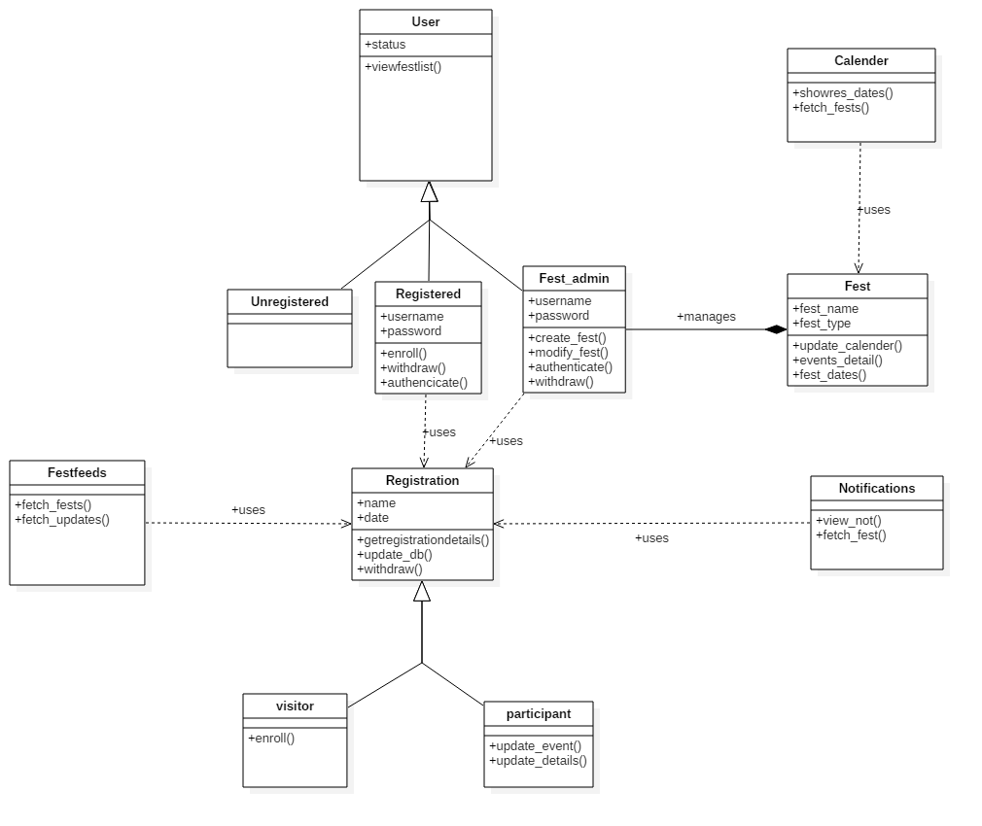
The flow of software design for our project is derived using class based architecture design wherein we have assigned a fully functioned subsystem having one main function and similar structure, appearance or coding structure into one component. Though there exists some dependency among the components but the overall functionality which each component performs is what distinguishes one another.
So here, we have summed all our features and functions of our app into different classes :
- User
  - Unregistered
  - Registered
  - Fest_admin

- Fest Registration
  - Visitor
  - Participant

- Fest Management -
- Fest-Feeds -
- Calendar -
- Notifications -

2.2) Structure and relationships
The structure of the class defines the cohesion of the system and the relationships among those classes determine the coupling in the system. So in order to achieve efficient system, we have come up with designing class in such a way as to have high cohesion and low coupling.

2.3) User interface issues
The application carries a rather simple Graphical User Interface (GUI) which makes it more deliverable and compact in nature. The User Interface in terms of features and utility varies with the essence of the kind of user interacting with our application.

The first basic app page which will be the same for every type of user, is the looking of the application while the interaction may be different.

Basic GUI components :

1) Header - The header (blue in colour) contains the very own app name – Festeve, on the left hand side and an icon for menu on the right hand side. This menu opens up a side activity space having various features and setting options. This also displays some important features which should not go unnoticed like notifications to registered users in the form of an icon on the right hand side at the top.

2) Tab – This consist of a a search bar with a search icon on it along with query suggestions written on it to help the users to know about what to type in or more specifically what can they search for.

3) Content Area – It is divided into two parts :-
- The top portion showcases a featured event or fest in the form of a rectangular block.
- The remaining portion which is scrollable in nature is the Fest-Feeds (similar in nature to news feeds) where each information about fests anywhere in the colleges will be shown.

4) Icons – Dedicated icons are designed for catchy or specialized functions. Our app has icons for search option, notification system, menu option and fest calendar.

3. DETAILED DESCRIPTION OF COMPONENTS

1. User Class

Identification | User
Type | A class
Purpose | Defines the user base of the app.  To differentiate between the type of users and classify each of them with their functions. This is done by using status property or attribute of the class
Function | The class performs functions like :  - signup() - lets user to sign up  - view_calendar() - lets user to view fest calendar  - search() - lets users to search for a fest
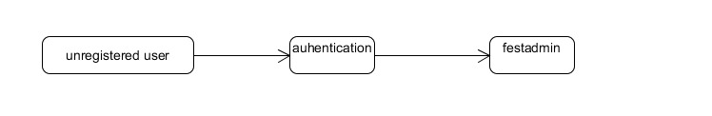

- Registration Class

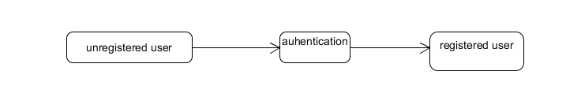
This class comprises of two sub class which are Participant class and Visitor class .
The Participant class deals with the users who want to enroll in an event of a fest whereas the Visitor class deals with the users who wants to attend the fest as audience

Identification | Registration
Type | Super Class
Purpose | This class comprises of two sub class which are Participant class and Visitor class .  The Participant class deals with the users who want to enroll in an event of a fest whereas the Visitor class deals with the users who wants to attend the fest as audience
Function | The class performs functions like :  - updatedb() - update the database  - withdraw() - lets user to withdraw from the fes  - getregistrationdetails() - fetch the registration detail

Identification | Visitor- sub class of Registration class
Type | Sub class
Purpose | Visitor class deals with the users who wants to attend the fest as audience
Function | The class performs functions like :  - sendrequest – sign up for a fest as a visitor

Identification | Participant - sub class of Registration class
Type | Sub class
Purpose | The Participant class deals with the users who want to enroll in an event of a fest
Function | The class performs functions like :  - updateevent() - update the event paricipant list  - update_details() - update the user profile detail
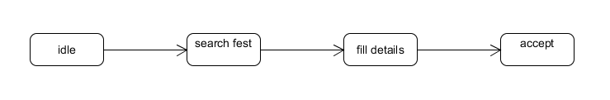

Participant enroll – state diagram

visitor -state diagram

3.Fest

Identification | Fest feeds
Type | A Class
Purpose | This Class is takes care of creating new fest and updating the related classes of the app , this class also manages the events , their dates and details
Function | The class performs functions like :  - update_calender – Update the date in the calender app so that the user can use the calender to view the fest dates in more friendly way  - event_details() - fetch the event details and update the Database  - fest_dates()- update the dates of events in database

Create fest
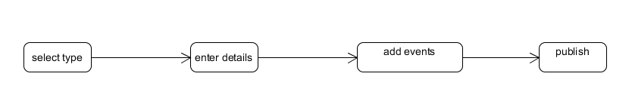

modify fest
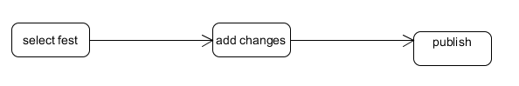

4.Notification

Identification | Notification
Type | A class
Purpose | This class manages the notification funtionality of our app.  This funtionality gives the real time changes made in the interested fest by the user .
Function | The class performs functions like :  - fetchfestst() - opens the app and fetch the fest when user tap the notification  - view_not() - shows the notification in more elaborated way

Notification
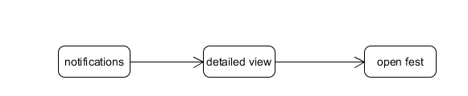

5.Calender

Identification | Calender
Type | A class
Purpose | This class auomatically update the calender in our app , each fest date will be marked in our app calender
Function | The class performs functions like :  - fetchfestst() - opens the app and fetch the fest when user tap the notification  - show_dates() - shows the fest dates in calender app

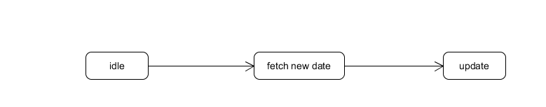

6. festfeeds

Identification | Fest feeds
Type | A class
Purpose | This class updates the feeds section related with activities regarding changes in fest
Function | The class performs functions like :  - fetchfestst() - opens the app and fetch the fest when user tap the notification  - fetch_updates() - update the feeds list

SEQUENCE DIAGRAMS FOR FEST ADMINISTRATOR

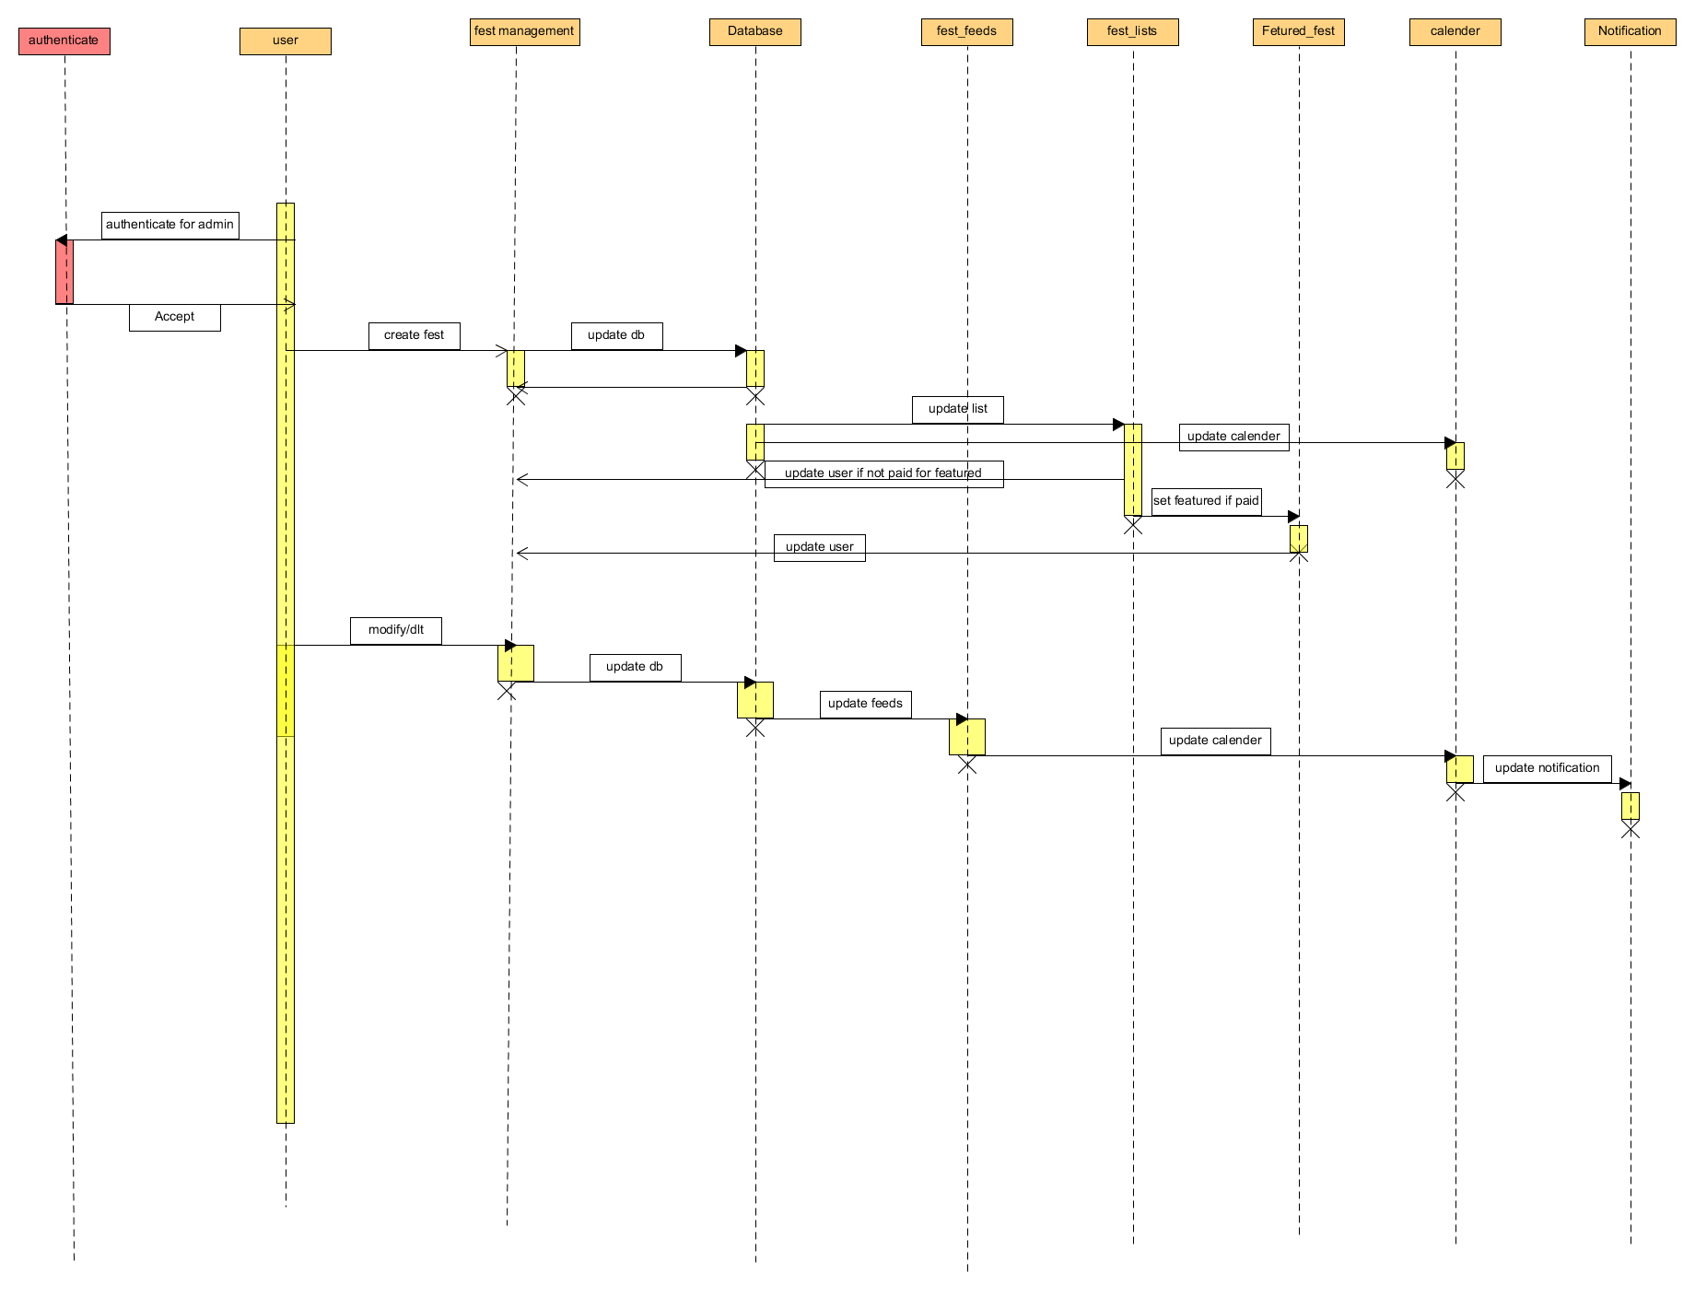

SEQUENCE DIAGRAM FOR REGISTERED USER

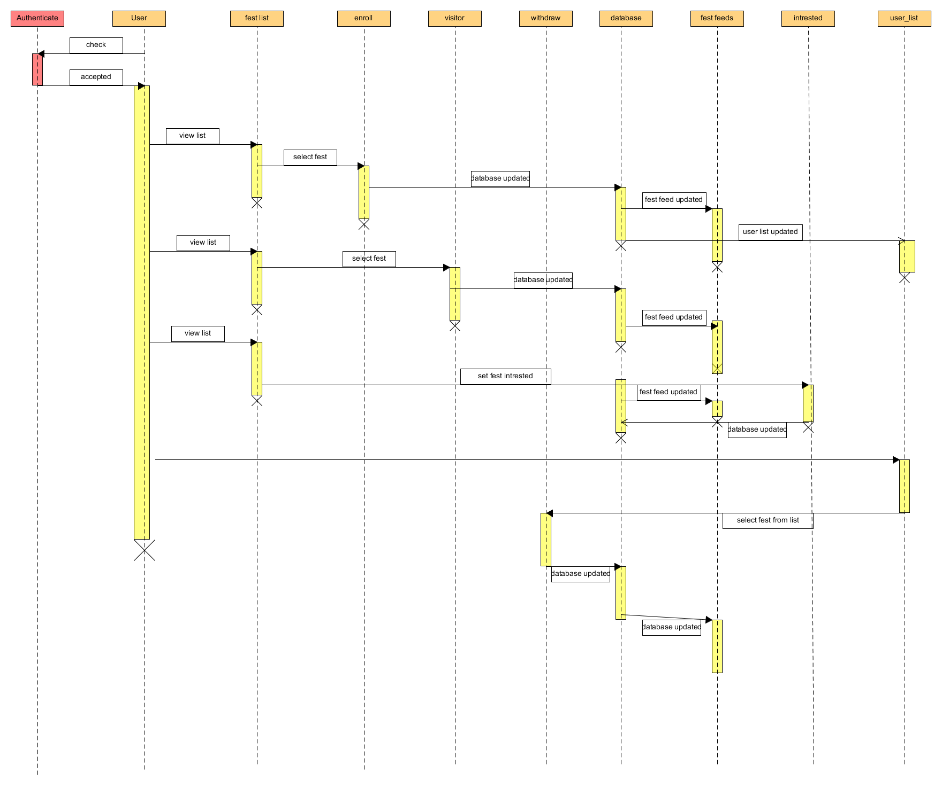

SEQUENCE DIAGRAM FOR SELECTING FEST

SEQUENCE DIAGRAM FOR UNREGISTERED USER
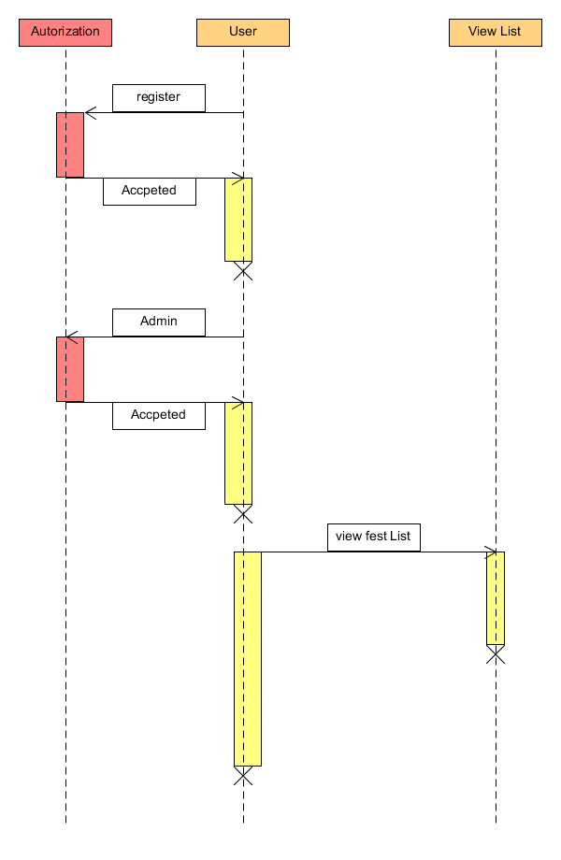

4. Reuse and Relationships to other Products
The project that we are doing is to make a common platform to organise , and promote a fest the modules which we are using are new and can be used in future updates as the modules are desinged intelligently . Through app the user can create a fest , enroll in an event , track the current changes and updates in their interested fest and events . In future the app can be used by the sponsors to sponsor fest

5.Design,Decision and Tradeoffs

6.Pseudocode for Components
- User
1.user opens the app
2.user can sign up as normal(registered user )or fest administrator
3.user can choose not to sign up
4.signup will authorize the user to use various functionality of the app

- Registration
1. User can choose whether he wants to participate or just be a visitor
2.the form will appear on screen .
3.database will be updated after the submssion
4.user festfeeds will be updated after the succesfull submission
5.end of activity
- Fest
1.the festadmin can create or modify fest in this activity
2.the activity start createfest()or modify_fest() depends on admin choice
3.user edit or add the events for fest
4.the after completion the database will be updated
5.the app calender will also add the fest date after the above process completes

4.fest feeds
1.this class will update the user feeds as soon as any change detected in intrested fest.
2.opens the fest when user taps the feed

5.Notifications
1.displays notification regarding changes
2.opens the app and page of the fest

6.Calender
1.stores the dates of fest monthwise

