**Software Requirements Specification**

**Smart Search Engine**

**Version 1.0 approved**

**Prepared by Vinit Koshti**

**NIIT University**

**Table of Contents**

**Table of Contents ii**

**Revision History ii**

**1. Introduction 1**

1.1 Purpose 1

1.2 Document Conventions 1

1.3 Intended Audience and Reading Suggestions 1

1.4 Product Scope 1

1.5 References 1

**2. Overall Description 2**

2.1 Product Perspective 2

2.2 Product Functions 2

2.3 User Classes and Characteristics 2

2.4 Operating Environment 2

2.5 Design and Implementation Constraints 2

2.6 User Documentation 2

2.7 Assumptions and Dependencies 3

**3. External Interface Requirements 3**

3.1 User Interfaces 3

3.2 Hardware Interfaces 3

3.3 Software Interfaces 3

3.4 Communications Interfaces 3

**4. System Features 4**

4.1 System Feature 1 4

4.2 System Feature 2 (and so on) 4

**5. Other Nonfunctional Requirements 4**

5.1 Performance Requirements 4

5.2 Safety Requirements 5

5.3 Security Requirements 5

5.4 Software Quality Attributes 5

5.5 Business Rules 5

**6. Other Requirements 5**

* 1. **Introduction**

This project is about creating a smart search portal. This project is created so that one can even search within the scanned documents,

As the knowledge is directly related to the skill of searching that’s useful and developing upon it.

So basically this project is an implementation of a smart search engine for courseware material and other documents

* 1. **Document Conventions –**

<<Any comments inside double brackets such as these are not part of this SRS but are comments upon this SRS example to help the reader understand the point being made. >>

In this SRS document is using Calibri font and will be using appropriate bullets for describing or pointing out different features of the product. Font size is 16 throughout the document. The headings are bold and the contents are italics. Several important phrases and words are underlined and bold defined for grabbing attention.

* 1. **Intended Audience and Reading Suggestion -**

This document is intended for both the stakeholders and the developers of the system it can be read by entrepreneurs, investors, product managers and users for gaining deep knowledge about what the product exactly does and knowing and recognizing its scope in the real market. Similarly developers can also read it as a reference and understand the frameworks used and use it with an innovation for themselves.

The reading suggestion would be to read every topic and sub-topic as each topic covers from the most fundamental element to the *detailing of the product. It also helps investors to see the potential of the product and invest on it.*

* 1. **Product Scope –**

This product is pretty much for everyone who wants to learn as we known that gaining knowledge is related to efficient searching and our smart search engine fulfill this requirement

Every field of study need an efficient search engine for its courseware and other documents and the other requirement is to search through the scanned documents.

* 1. References

<https://github.com/tesseract-ocr/tesseract/wiki/Documentation>

<https://lucene.apache.org/core/documentation.html>

<https://en.wikipedia.org/wiki/Elasticsearch>

<https://en.wikipedia.org/wiki/Tesseract>

other various sources.

Product Description:

2.1 Product Perspective

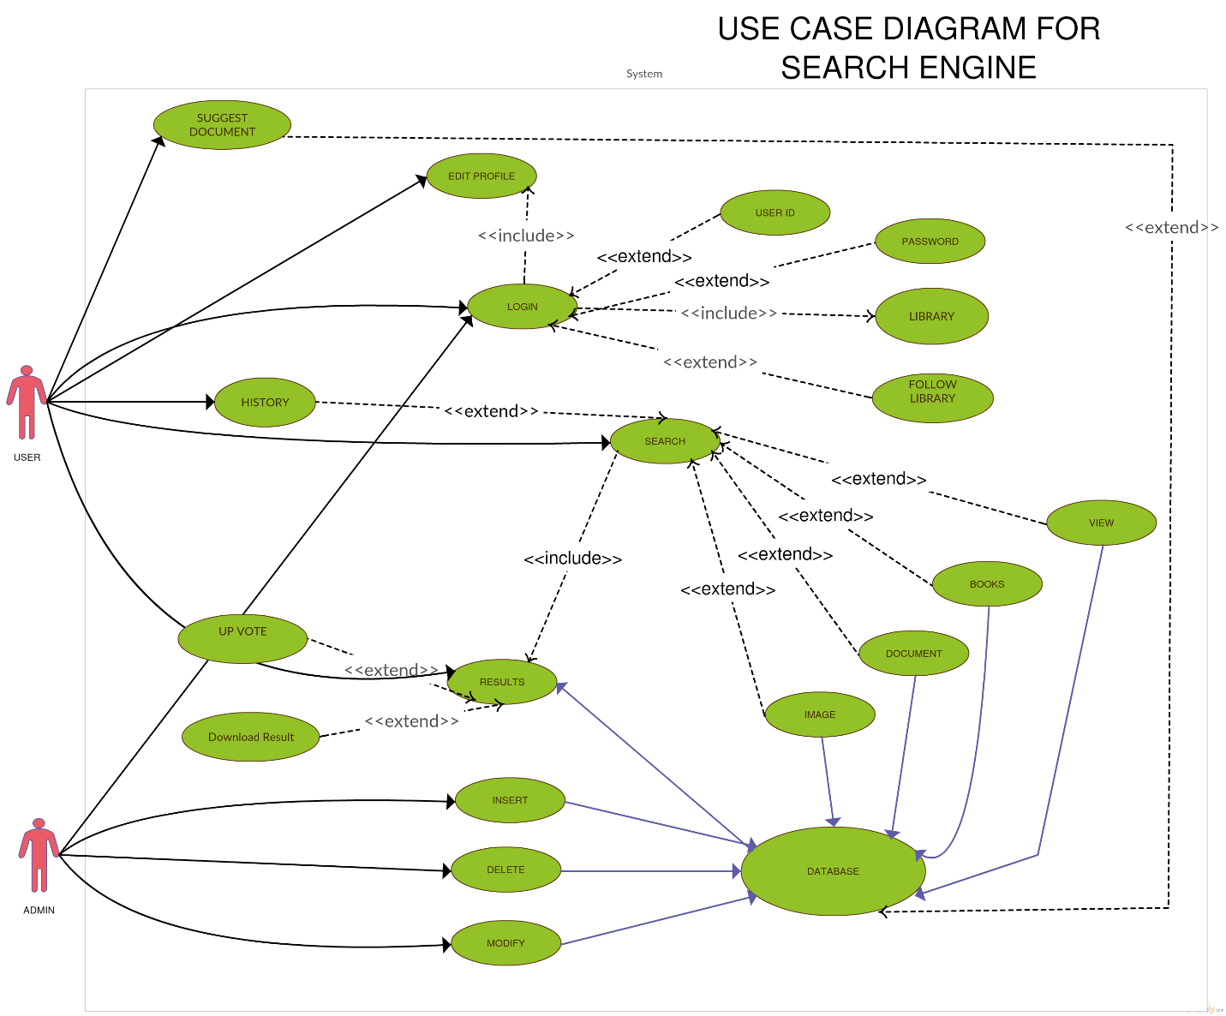

2.2 Product Function

It’s a simple Smart Search Engine the user can search through the courseware and other document and get result corresponding to the search, in result you would get link to download the file and you can then up vote the search file if you like the document.

2.3 **User Classes and Characteristics**

*There are two types of user classes-*

* *login User Class*
* *They are the users who can search for any problem and the results will be shown if available, for this class there is option of storing history and you can keep your downloaded documents together in your logged in account.*
* *Unregistered User Class*
* *They can only see the site as a guest user and will be asked to sign in, in order to access all the features. Like storing history and files.*

2.4 **Operating Environment**

*It is a web app hosted online, so it can be accessed by any user without being hindered by the type of OS he/she is using. User can access the site from any part of the world.*

* 1. **Design and Implementation Constraints**

*Cannot be discussed at this point of time, will come to known during development*

* 1. **User Documentation**

Will be updated

* 1. **Assumptions and Dependencies**

At present no assumption and dependencies

1. **External Interface Requirements**

**3.1 User Interfaces**

*The User interface is based on responsive design so that users can use the web app from any of their devices. Also the UI is very user friendly and interactive so that user finds no problem in looking up for any content.*

* 1. **Hardware Interfaces**

*This web app is hosted on the internet so there is no specific hardware interface or requirement needed. Moreover this web app has been designed in a responsive design so it adjusts itself well enough to be viewed and navigated on laptop, mobiles or tablets. User can use any browser like Chrome, Mozilla Firefox, Microsoft Edge, etc. to view the website. The best resolution is however enjoyed when viewed on a bigger screen.*

* 1. **Software Interfaces**
  2. **Communications Interfaces**

1. **System Features**
   1. **Search**

***Description and Priority***

*Any online user can search there query and he will be shown results based on up votes,*

*Priority – High.*

***Stimulation/Response Design***

*User writes query in the search box and press the search button.*

***Functional Requirement***

*When the user enters the site, he should have strong internet connectivity.*

* 1. ***Results***

***4.02.1 Description and Priority***

*After search results based on up votes relating to the query will be shown,*

*Priority – High.*

***4.02.2 Stimulation/Response Design***

*When the user enters the query and press search button, results will be shown below the search box with download links, if results do not fit in one page, hyperlink to another page will be present at the bottom.*

***4.02.3 Functional Requirement***

*No results will be displayed if the information about the query is not found, internet connectivity is must.*

* 1. ***login***
     1. ***Description and Priority***

*This user can login in his account to save his search history and save file in his account*

*Priority – Medium*

* + 1. ***Stimulation/Response Design***

*The user is provided with an option to login in the right top corner of the web portal*

* + 1. ***Functional Requirement***

*The user have to sign up to login.*

* 1. ***Suggest Documents.***
     1. ***Description and Priority***

*Any online user can also suggest document to index in the database for which he did not found the results.*

*Priority – low*

* + 1. ***Stimulation/Response Design***

*When the user didn’t find a result he will be shown a suggest a document box.*

* + 1. ***Functional Requirement***

*If no results are found.*

* 1. ***Edit Profile***
     1. ***Description and Priority***

*A login user will need this feature.*

*Priority – High*

* + 1. ***Stimulation/Response Design***

*The login user will be directed to edit profile page, on right top corner his login account will be shown.*

* + 1. ***Functional Requirement***

*User first need to sign up to edit his account.*

* 1. ***User-id*** 
     1. ***Description and Priority***

*The user need to verify his/her identity by providing with the User id*

*Priority – High*

* + 1. ***Stimulation/Response Design***

*When the user enters the credentials on the page, dynamic check of his user-id to take place.*

* + 1. ***Functional Requirement***

*User must have an account i.e. must have signed up.*

* 1. ***Password***
     1. ***Description and Priority***

*Once the user is registered, they can login to the website using user-id and password.*

*Priority – High*

* + 1. ***Stimulation/Response Design***

*Password inbox for entering password, when the user press the login button password verification takes place.*

* + 1. ***Functional Requirement***

*Sign up account*

* 1. *Follow Library*
     1. ***Description and Priority***

*The user can follow the library of any other user.*

* + 1. ***Stimulation/Response Design***

*From users profile one can visit the other users profile and can click follow button to follow there library.*

* + 1. ***Functional Requirement***

*Account sign up.*

* 1. *Library*
     1. ***Description and Priority***

*Library is where user can save the books and articles he found useful*

* + 1. ***Stimulation/Response Design***

*Whenever user is logged in and he download the file it is stored in the library.*

* 1. ***History***
     1. ***Description and Priority***

*The user have to login to backup his search history*

* + 1. ***Stimulation/Response Design***

*User can see search history by logging in his account*

* + 1. ***Functional Requirement***

*Account sign up.*

* 1. ***Download results***
     1. ***Description and Priority***

*The user after the search will be provided with downloadable links to their search results.*

* + 1. ***Stimulation/Response Design***

*When the user click the link the document is downloaded*

* + 1. ***Functional Requirement***

*Internet connection*

* 1. ***Up votes***
     1. ***Description and Priority***

*After the successful search the user can up vote the search result*

* + 1. ***Stimulation/Response Design***

*The search result with most up votes will be displayed first and if you find useful there is upvoter button in right of link.*

* + 1. ***Functional Requirement***

*Up vote button*

* 1. ***Document***
     1. ***Description and Priority***

*The user can filter the search result before search, he will have option like document, books, images*

***4.13.2Stimulation/Response Design***

*Select before search*

* + 1. ***Functional Requirement***

*Internet connection*

* 1. ***Books***
     1. ***Description and Priority***

*The user can filter the search result before search, he will have option like document, books,images.*

***4.14.2Stimulation/Response Design***

*Select before search*

***4.14.3 Requirement***

*Internet connection*

* 1. ***Image***
     1. ***Description and Priority***

*The user can filter the search result before search, he will have option like document, books, and image.*

***4.15.2Stimulation/Response Design***

*Select before search*

***4.15.3 Requirement***

*Internet connection*

* 1. ***View***
     1. ***Description and Priority***

*When the users do not want to download the result he can view the document.*

* + 1. ***Stimulation/Response Design***

*View button for stimulation*

* + 1. ***Functional Requirement***

*Internet connectivity*

* 1. ***Database***
     1. ***Description and Priority***

*The Database is the collection of indexed document, article, and books .*

* + 1. ***Stimulation/Response Design***

*Only admin can change or modify database*

* + 1. ***Functional Requirement***

*Memory*

* 1. ***Insert***
     1. ***Description and Priority***

*Insert operation on database*

* + 1. ***Stimulation/Response Design***

*Only admin can stimulate it.*

* 1. ***DELETE***
     1. ***Description and Priority***

*Delete operation on database*

* + 1. ***Stimulation/Response Design***

*Only admin can stimulate it.*

* 1. ***Modify***
     1. ***Description and Priority***

*Modify operation on database*

* + 1. ***Stimulation/Response Design***

*Only admin can stimulate it.*

|  |  |  |
| --- | --- | --- |
| *Identifier for Req.* | Short Name | *Short Description* |
| *4.01* | *SEARCH* | *User can search for any query*  *And can get result which*  *Are downloadable* |
| *4.02* | *RESULT* | *Results of search query*  *It can be document, image or books* |
| *4.03* | *LOGIN* | *Login to prepare your own library*  *And keep your search history and even*  *Follow other library* |
| *4.04* | *SUGGEST*  *DOCUMENT* | *If not found proper results so you can suggest documents on that topic* |
| *4.05* | *EDIT*  *PROFILE* | *Edit profile* |
| *4.06* | *USER-ID* | *For login* |
| *4.07* | *PASSWORD* | *For login* |
| *4.08* | *FOLLOW LIBRARY* | *User can follow other users library* |
| *4.09* | *LIBRARY* | *To keep your downloaded files in one place* |
| *4.10* | *HISTORY* | *Saved search history* |
| *4.11* | *DOWNLOAD*  *RESULT* | *Results will be in form of hyperlinks* |
| *4.12* | *UP VOTES* | *If found result useful you can up vote to improve user experience* |
| *4.13* | *DOCUMENTS* | *One of format that appear as a result of search*  *You can filter this before search.*  *So there will be doc results related to query* |
| *4.14* | *BOOKS* | *One of format that appear as a result of search*  *You can filter this before search*  *So there will be book results related to query* |
| *4.15* | *IMAGE* | *One of format that appear as a result of search*  *You can filter this before search*  *So there will be image results related to query* |
| *4.16* | *VIEW* | *No download just view* |
| *4.17* | *DATABASE* | *database* |
| *4.18* | *INSERT* | *Operation on database* |
| *4.19* | *DELETE* | *Operation on database* |
| *4.20* | *MODIFY* | *Operation on database* |