Software Requirements Specification
for
<Smart Search>
Version 1.0 approved
Prepared by <Jagrit kaushik - u101114fcs205>
<NIIT>
<17-09-16>
Table of Contents
Table of Contents ii
Revision History ii
1. Introduction 1
1.1 Purpose 1
1.2 Document Conventions 1
1.3 Intended Audience and Reading Suggestions 1
1.4 Product Scope 1
1.5 References 1
2. Overall Description 2
2.1 Product Perspective 2
2.2 Product Functions 2
2.3 User Classes and Characteristics 2
2.4 Operating Environment 2
2.5 Design and Implementation Constraints 2
2.6 User Documentation 2
2.7 Assumptions and Dependencies 3
3. External Interface Requirements 3
3.1 User Interfaces 3
3.2 Hardware Interfaces 3
3.3 Software Interfaces 3
3.4 Communications Interfaces 3
4. System Features 4
4.1 System Feature 1 4
4.2 System Feature 2 (and so on) 4
5. Other Nonfunctional Requirements 4
5.1 Performance Requirements 4
5.2 Safety Requirements 5
5.3 Security Requirements 5
5.4 Software Quality Attributes 5
5.5 Business Rules 5
6. Other Requirements 5
Appendix A: Glossary 5
Appendix B: Analysis Models 5
Appendix C: To Be Determined List 6

Revision History
Name | Date | Reason For Changes | Version

Introduction
- Our product is based on simplifying the hassle people make for the search of information.
- This software provides efficient search for the topic and makes it easy for our customers in a way to spend less time visiting many websites in search of data where they find same thing redundantly.

Purpose
- This is a web application designed for efficient unstructured search for data .

- People will have whatever they want at a single place .

- Our web application will provide an interface which will convert scanned documents into digital data such as text files which will further be added to database for efficient searching.

Document Conventions
- Headings - { Times , size = 18 , underlined , italics }
- content - { arial , size = 14 , italics }
- line spacing = 1.15
- left margin = 1.8 cm
- right margin = 1.8 cm

Intended Audience and Reading Suggestions
Target audience :

- Our product will initially focus on schools and universities . This will help students search the required documents of their courses in a sorted manner .

- Later on the product will be open to all who need the quick and sorted search for the information.

Product Scope
This web application provides benefits to the students and faculty , to easily retrieve the needed information searched by them in a managed order .
It also stores the previously searched data that will allow revisiting the file easier .
By increasing the student’s work efficiency and production the system will meet the student’s needs while remaining easy to understand and use.

References
- https://en.wikipedia.org/wiki/Tesseract_(software)

- https://github.com/tesseract-ocr

- https://en.wikipedia.org/wiki/Elasticsearch

- https://lucene.apache.org/core/

Overall Description

Product Perspective
This is product based on search which is frequently used in day to day life .
Everyone has google for searching but our product is different as it will be integrated with the moodle thus creating a perfect study environment for students.

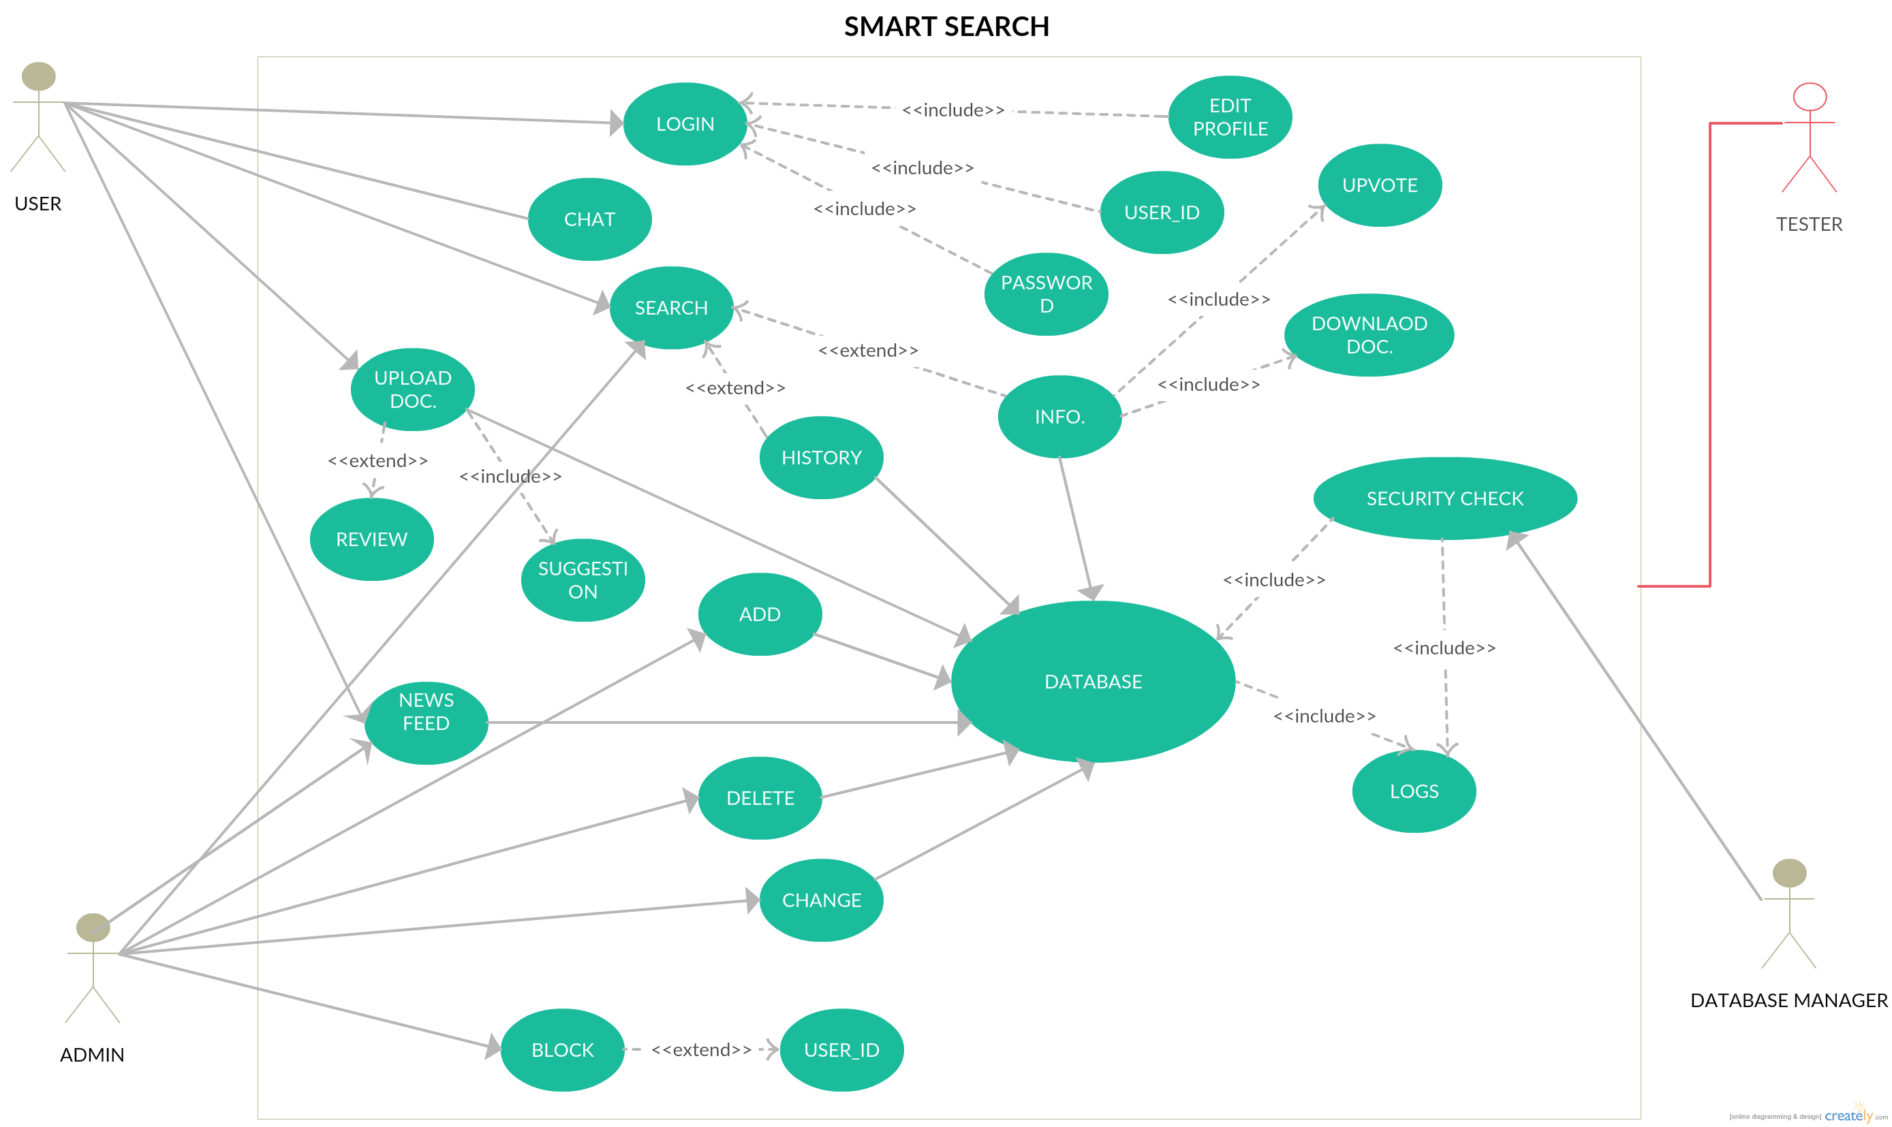
Reviews and logs are the part of software which ensures that the file uploaded if correctly reviewed is updated to our database .

Product Functions
- Implementation of elastic search .
- Integrated with framework to provide best environment for students.
- Included history to make revisiting faster .
- Proper inclusion of encryption that ensures security of documents.
- Enabled physical security .
- Maintenance of log files .
- Lists all valid documents when searched .
- Can be used to search a specific topic in a particular file
- keyword search listing all files with that topic .

User Classes and Characteristics
- The user must know how to use internet and be able to use a search engine.
- Login accounts provided to students.
- History of the searched documents.
- Chat box to discuss pros and cons about the documents.
- Reviews to see if the document is worth reading.
- Download option to download the desired document.
- Upvote to appreciate the document uploaded.
- User also has an option to upload a document.
- Add , remove or modify features given to admin . Admin can block some users from accessing the database.
- Main screen of our web application will contain uploaded documents of library books , scanned documents and documents uploaded by faculty and other information documents .
- This main screen will have a search listing the required documents .
- The complete look of these pages is discussed in next section .

Operating Environment
- The only requirement is a good Internet .
- There is no minimum requirements for running this web application .
- All kinds of browsers and operating system will easily support this .
- No external hardware needed .

Design and Implementation Constraints
- Difficult to integrate with working environment.
- Will require large amount of memory .
- Proper maintenance of servers .
- No such policy based restriction .
- Need to host the web application.
- Separate database for log file .

User Documentation
- As it is a web application there will be a help option available which contains basic working .
- A contact-us option which user can use in case of failure .
- No other physical documents available to user such as CD’s or user manual .

Assumptions and Dependencies
There are no assumed factors , it is just an implementation of search .

External Interface Requirements

User Interfaces
- Document library link on moodle that will take user to another web page , where list of documents are present and implementation of search is done .
- Search bar is present where keywords are entered by user .
- Upload button where user can upload a file he wants .
- Review section where uploaded document are given reviews .
- Contact-us section for help .
- Download option to download the searched document .
- Rating section to rate the content of file .

Hardware Interfaces
- No hardware restriction is present on our software . It can run on any device type .
- Proper queries will run between out database and application .
- This data in our software regarding each and every document will be fetched from database via calls that will be made by interface .
- FTP and HTTP are involved in the functioning of our software.
- Implementation of these protocols will make functioning of the software much more efficient .
- Inclusion of IDS and IPS.

Software Interfaces
- Product name – Smart search
- version 1.0
- integrated with moodle to provide good user interactive GUI .
- Use of elastic search to search efficiently between multiple documents.
- Use of tesseract for scanned documents .
- Protocols in use FTP , HTTP , IP etc.
- A library including scanned documents , pdf of books , other important documents.

Communications Interfaces
Email can be used as an option , when a new document is uploaded containing the same topic the user searched , he will get notified via email .This will be an automated mail sent when changes are made in our database . Also a message center can be implemented where the discussion takes place amongst the students . This might include feature of a group messaging where group having same interests are sharing information. For database security md5 encryption is in use . Proper penetration testing will be done for proper functioning of website. Protocols in use for mail can be POP3 , SMTP , IMAP etc .

System Features
This section explains functional features that might be present in our product :

System Features :
Request number : | Title | Description
1) | Login | Credentials are entered by user to login to the library interface where the docs. Are present .
2) | Edit profile | User has an option to edit his profile where he can change his information and make changes in his course content .
3) | search | User searches for desired documents from the database and has an option to download the document .
4) | upload | User can also add document to the database , but before adding it system checks on the content and reviews given by other users.
5) | reviews | System checks on the document uploaded by user and verifies with the help of reviews if the document can be added to the database .
6) | Admin | Admin can add ,delete or modify the data in the database.  He also has an option to block some users from accessing the database .
7) | Database log | Logs save the information of the changes made in the database . Helps as a security purpose and also restoring from the position where it was lest in any case of failure .

8) | Database security | Usage of IDS and other tools to protect the system as large amount of data is present which should always be in a secured condition.
9) | Testing | Testing is done by the tester over complete system .  He reports to the team if any fault is found in the system .
10) | Chat option | We might introduce a chat box where students will discuss about the pros and cons of a document the student has read .
11) | Upvote | This is a kind of rating given to the the document by the students .

12) | User-id | This is the id used to access the operating interface.
13) | News feed | Reports about the latest documents uploaded.
14) | history | Saves the history of the documents searched .
15) | Forget password | If the user forgets, their password,  then they can click forgot password  and set a new one from the  verification link provided through  mail or SMS.
16) | Information | This is the document that user or admin has searched for.
17) | Database | This stores every document stored on web app .
18) | Block | This is a feature given to admin to block a user accessing the database.
19) | suggestion | Suggestions are given by other users regarding the document.
20) | Delete , change | These entities provide user to delete or change a document in database .

Other features :
REQ. NO. | TITLE | DESCRIPTION
1) | Encryption | Use to secure data in database and other login features.
2) | MD5 , RSA | Types of encryption keys used.
3) | IDS and IPS | Intrusion detection and prevention of malicious users.
4) | Report | Removes the content not required and mails the user about it.
5) | E-mail | Changes made to the document or new document added is updated to user via mail.

Other Nonfunctional Requirements

Performance Requirements
- As there will be very large amount of data included , we need to make sure that we store our data from where the retrieval is fast and our data is in secured state .

- Cloud is the best option when secured big data is considered.

- Devices and server speed must be high to implement search in efficient time .

- Maintenance of logs is necessary .

- Regularly check on logs is important .

Safety Requirements
<Specify those requirements that are concerned with possible loss, damage, or harm that could result from the use of the product. Define any safeguards or actions that must be taken, as well as actions that must be prevented. Refer to any external policies or regulations that state safety issues that affect the product’s design or use. Define any safety certifications that must be satisfied.>

Security Requirements
- As data chunks are present , proper security of that physical device is to be taken care of.

- Therefore use of CCTV might help in case of physical intrusion and social engineering .

- For logical security MD5 encryption can be used for password protection .

- Presence of IDS , IPS .

Software Quality Attributes
- Image to text conversion .

- History of searched data , that will help in making the product robust .

- Easy to use interface .

- Usage of efficient algorithm.

Business Rules
- Developers – to make the web application .

- Marketing team – those who spread knowledge about the product and approach schools and universities .

- Penetration tester – one who finds loopholes in the product so that it can be corrected .

- Advertisement team

Appendix A: Glossary
<Define all the terms necessary to properly interpret the SRS, including acronyms and abbreviations. You may wish to build a separate glossary that spans multiple projects or the entire organization, and just include terms specific to a single project in each SRS.>

