Software Requirements Specification

for

Label Maker and Barcode Generator

**Version 1.0 approved**

**Prepared by**

**Nirali Sampat**

**NIIT University**

**16-09-16**

**Table of Contents**

**Table of Contents**

**Revision History**

**1. Introduction**

1.1 Purpose

1.2 Intended Audience and Reading Suggestions

1.3 Product Scope

1.4 References

**2. Overall Description**

2.1 Product Perspective

2.2 Product Functions

2.3 User Classes and Characteristics

2.4 Operating Environment

2.5 Design and Implementation Constraints

2.6 User Documentation

2.7 Assumptions and Dependencies

**3. External Interface Requirements**

3.1 User Interfaces

3.2 Hardware Interfaces

3.3 Software Interfaces

**4. System Features**

**5. Other Nonfunctional Requirements**

5.1 Performance Requirements

5.2 Safety Requirements

5.3 Security Requirements

5.4 Software Quality Attributes

**Revision History**

|  |  |  |  |
| --- | --- | --- | --- |
| **Name** | **Date** | **Reason For Changes** | **Version** |
| Label Printing and Barcode generating | 20-09-16 | Work is under progress | 1 |

# Introduction

## Purpose

The purpose of this document is to give a detailed description for the software Label Maker and Barcode Generator.

## Intended Audience and Reading Suggestions

The SRS is for the customer and developers who wish to understand this software.

## Product Scope

Label Maker and Barcode Generator software is an easy to use tool for various industries. The software will help the customer in designing a label or barcode according to their customizable needs. They will be able to save this design and print it so that it can be used on the products.

The software will provide the customer with the following benefits:

* Easy to use UI
* Universal usage/Ability to use on tablet, phones and laptops based on the Windows platform
* Save designs
* Sync designs to cloud storage
* Print designs
* Customize the design with images, changeable colours, fonts and texts

## References

IEEE Docs

# Overall Description

## Product Perspective

This SRS is about the new, self-contained product, version 1.0 of Label Maker and Barcode Generator.

## Product Functions

The user can do the following with the Label Maker and barcode Generator Software:

* Make Labels
  + Specify the number of rows and columns in the label
  + Write text in the label
  + Change the font of the text
  + Insert image in the label
  + Save the label to local drive or cloud storage
* Generate barcodes
  + **Barcode type**
  + Save barcode
* Print barcode/label with a connected or a wireless printer

## User Classes and Characteristics

The software is designed with customizable templates for the following 4 types of user:

1. Textile Industry
   1. Needs instructions for care
2. Fresh Food Industry
   1. Needs symbols for indicating the type of food
   2. Needs expiry date column compulsorily
3. Examination
   1. Needs uniquely identifiable barcodes
4. Footwear

All users should have basic knowledge of computers and be able to use it.

## Operating Environment

This software can be used in all Windows 10 platform based devices like computers, laptops, tablets and mobile phones.

## Design and Implementation Constraints

The software is limited to Windows 10 users currently. It will reach higher number of users when people will switch over to Windows 10.

## User Documentation

A detailed guide, “Guide to Label Maker and Barcode Generator” along with a video tutorial will be delivered to the users to make it easier for the users to understand the software easily.

## Assumptions and Dependencies

Currently there are no dependencies in the product. In case, we find dependencies later, we will include them.

# External Interface Requirements

## User Interfaces

TBD

## Hardware Interfaces

Supported Device Types:

|  |  |  |
| --- | --- | --- |
| **Laptops** | **Tablets** | **Mobile Phones** |
| All laptops that have Windows 10 Operating System. | * Huwaei Windows 10 Tablets * Asus Windows 10 Tablets * HP Windows 10 Tablets * Lenovo Windows 10 Tablets * Lenovo Windows 10 Tablets * Microsoft Windows 10 Tablets * NuVision Windows 10 Tablets * Samsung Windows 10 Tablets * Toshiba Windows 10 Tablets | * Lumia 1520 * Lumia 930 * Lumia 830 * Lumia 735 * Lumia 730 * Lumia 640XL * Lumia 640 * Lumia 635 * Lumia 540 * Lumia 535 * Lumia 532 * Lumia 435 * Lumia 430 |

## Software Interfaces

The Label Maker and Barcode Generator final product will interact with the following software:

* SQL Lite
* Visual Studio
  + Windows.UI
  + Windows.UI.XAML
  + Windows.UI.XAML.controls
  + Windows.UI.XAML.controls.primitives
  + Windows.UI.XAML.Media

# System Features

Use Case

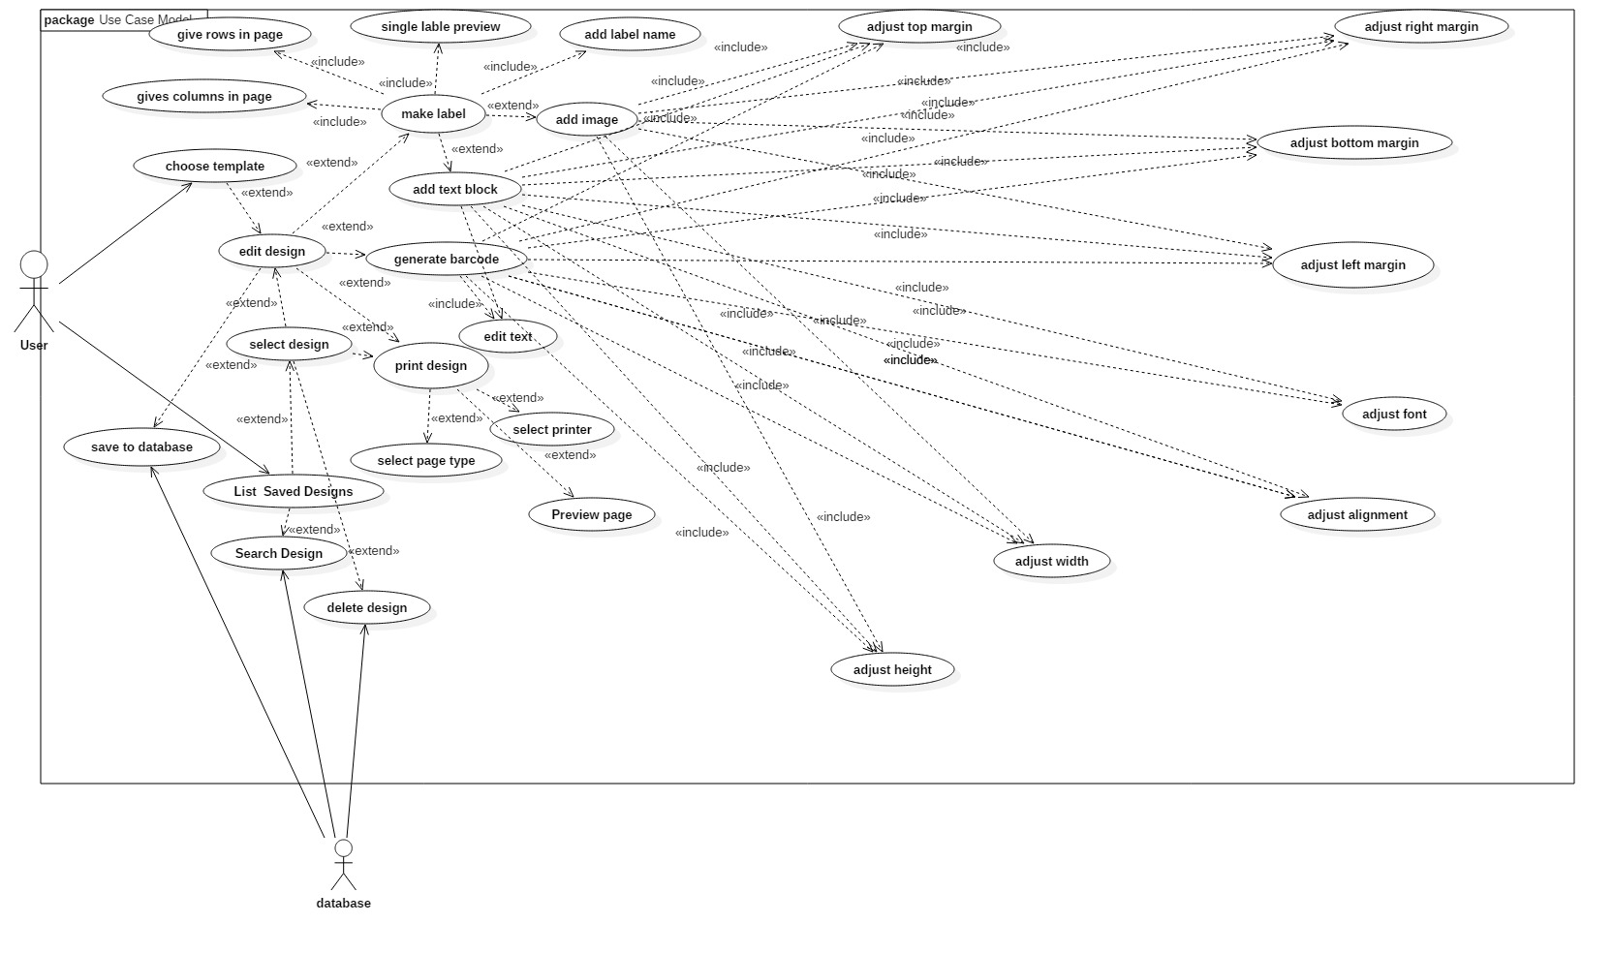

In this section, we will be giving details about the various features present in the software

**Functional Requirements**

|  |  |  |
| --- | --- | --- |
| **requirement number** | **Test Scenario ID** | **requirement description** |
| **1** |  | **input rows of labels in one page** |
| **TS_Rows_01** | **TS_R_01** | **increase the number of rows by 1** |
| **TS_Rows_02** | **TS_R_02** | **decrease the number of rows by 1** |
| **2** |  | **input text inside the rows in the label design** |
| **TS_RowsText_01** | **TS_RT_01** | **input text in rows** |
| **TS_RowsText_02** | **TS_RT_02** | **add row, do not input text** |
| **TS_RowsText_03** | **TS_RT_03** | **decrease the number of rows by 1 which has some text** |
| **3** |  | **input columns of labels in one page** |
| **TS_Columns_01** | **TS_C_01** | **increase the number of columns by 1** |
| **TS_Columns_02** | **TS_C_02** | **decrease the number of columns by 1** |
| **4** |  | **input image** |
| **TS_Image_01** | **TS_I_01** | **insert image in label design** |
| **TS_Image_02** | **TS_I_02** | **insert multiple images** |
| **TS_Image_03** | **TS_I_03** | **delete image from label design** |
| **5** |  | **barcode** |
| **TS_Barcode_01** | **TS_B_01** | **generate barcode** |
| **TS_Barcode_02** | **TS_B_02** | **generate multiple barcodes (incrementing)** |
| **TS_Barcode_03** | **TS_B_03** | **delete barcode** |
| **6** |  | **font** |
| **TS_Font_01** | **TS_F_01** | **change size of font** |
| **TS_Font_02** | **TS_F_02** | **change font** |
| **7** |  | **text alignment** |
| **TS_Alignment_01** | **TS_A_01** | **change alignmnet of text** |
| **8** |  | **Margin** |
| **TS_Margin_01** | **TS_M_01** | **change margins of the design** |
| **9** |  | **save design** |
| **TS_Save_01** | **TS_S_01** | **save design for later** |
| **TS_Save_02** | **TS_S_02** | **save design and print** |
| **TS_Save_03** | **TS_S_03** | **exit without saving** |
| **10** |  | **Print** |
| **TS_Print_01** | **TS_P_01** | **Print the design one page** |
| **TS_Print_02** | **TS_P_02** | **Print multiple copies of design** |

# Other Nonfunctional Requirements

## Performance Requirements

TBD.

## Safety Requirements

Provided by Windows Store.

## Security Requirements

Provided by Windows Store.

## Software Quality Attributes

* Portable
* Reliable
* Reusable
* Robust
* Correct
* Maintainable
* Compact