Minutes of Meeting

Label Printing and Barcode Generator

Team:

Priyanshu Bhatnagar

Rashika Bhargava

Nirali Sampat

Simran Malhotra

Orgainsation:

Advanced Software

Screenshots from mail conversations

1.Printing Function Addition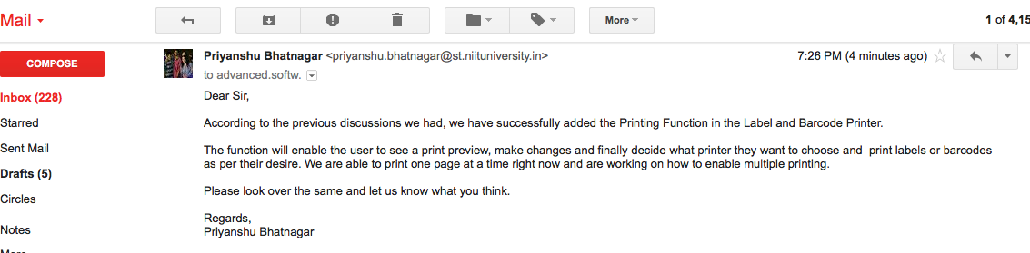

Reply from client

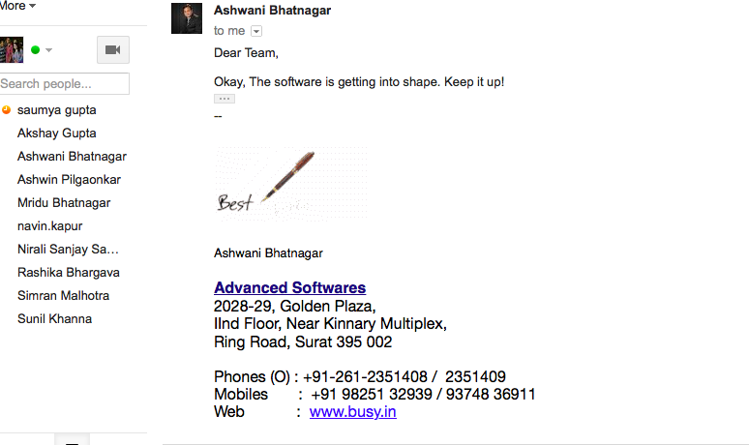

2.Barcode Implementation

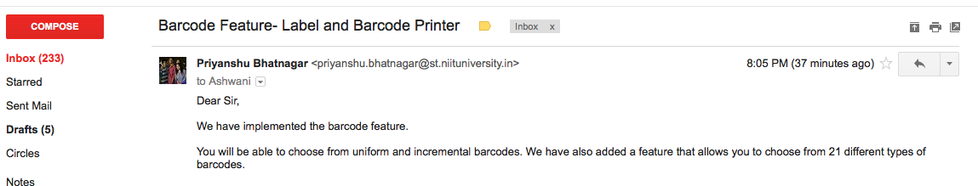

Reply from client

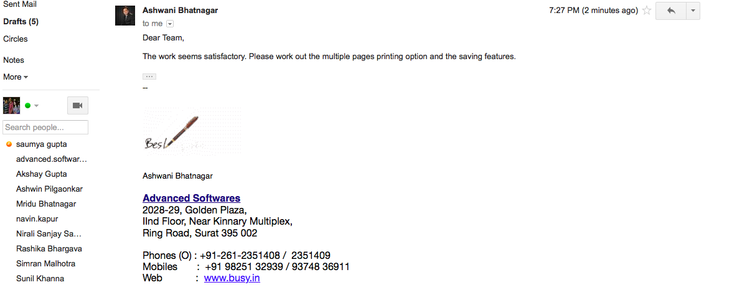

3. Final mail

