Software Coding Metrics

**Label Printing and Barcode Generator**

**Team: Priyanshu Bhatnagar**

**Rashika Bhargava**

**Nirali Sampat**

**Simran Malhotra**

We used Visual studio plugin to find Software Code Metrics Results. We found various results from the build. All the results are listed below:

Maintainability Index = 84

Cyclomatic Complexity (Aggregated) = 614

Depth of Inheritance = 7

Class Coupling = 162

Lines of Code = 1498

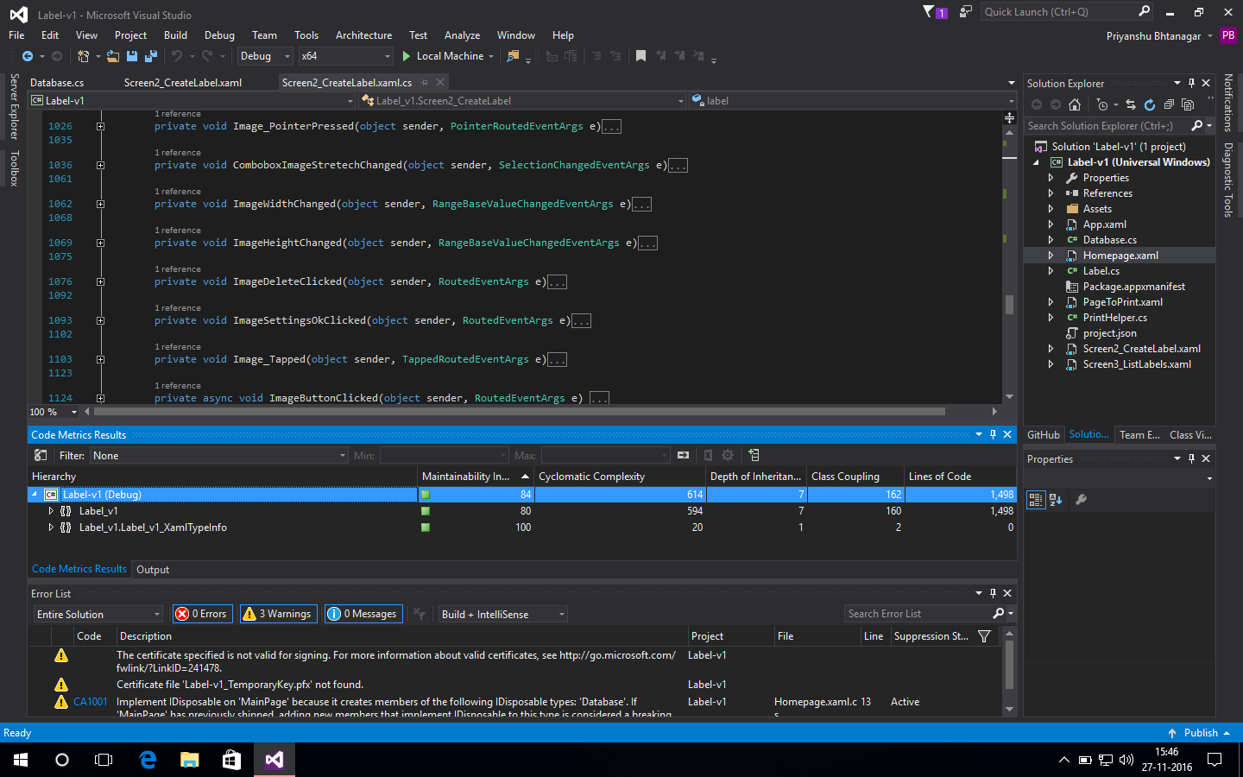

We have total of 170 functions and Events in our application. To find out Cyclomatic Complexity we divide Aggregated value of Cyclomatic Complexity with total number of functions.

Therefore, Cyclomatic complexity = 3.611764.