**Table of Contents**

**Table of Contents ii**

**Revision History ii**

**1. Introduction 1**

1.1 Purpose 1

1.2 Document Conventions 1

1.3 Intended Audience and Reading Suggestions 1

1.4 Product Scope 1

1.5 References 1

**2. Overall Description 2**

2.1 Product Perspective 2

2.2 Product Functions 2

2.3 User Classes and Characteristics 2

2.4 Operating Environment 2

2.5 Design and Implementation Constraints 2

2.6 User Documentation 2

2.7 Assumptions and Dependencies 3

**3. External Interface Requirements 3**

3.1 User Interfaces 3

3.2 Hardware Interfaces 3

3.3 Software Interfaces 3

3.4 Communications Interfaces 3

**4. System Features 4**

4.1 System Feature 1 4

4.2 System Feature 2 (and so on) 4

**5. Other Nonfunctional Requirements 4**

5.1 Performance Requirements 4

5.2 Safety Requirements 5

5.3 Security Requirements 5

5.4 Software Quality Attributes 5

5.5 Business Rules 5

**6. Other Requirements 5**

**Appendix A: Glossary 5**

**Appendix B: Analysis Models 5**

**Appendix C: To Be Determined List 6**

**Revision History**

|  |  |  |  |
| --- | --- | --- | --- |
| **Name** | **Date** | **Reason For Changes** | **Version** |
|  |  |  |  |
|  |  |  |  |

# Introduction

## Purpose

Police and other law enforcement agencies are dependent on highly professional and reliable crime scene technicians and investigators to uncover evidence that will prove justice and rightful information in a court of law. This system is a step to making task of citizens easier by registering their issues online through a fast working portal / server and bridging a gap b/w many people and police. This system also facilitates the police and investigators as it is a faster way for them to receive the details of various crimes taking place and saves time and speeds up the process as compared to the old register entry system. The system is completely online based platform.

## Document Conventions

Victims or the families can report the mishappenings but it becomes the duty of the police to prioritize each and every one of them.

## Intended Audience and Reading Suggestions

This SRS is intended for majorly 2 clients which will participate actively in this system .

* VICTIMS / CITIZENS / FAMILIES OF THE VICTIM
* POLICE / INVESTIGATORS /

The above two sects of the public are primarily going to be active while using this system as it is designed in a way to ease the reporting and findings of crimes. And to reach to faster solutions.

The document has been made keeping in mind various requirements of people and police hence it will be best for the reader to go through each and every detail mentioned in the SRS for a quicker understanding of the project and the methodology of its working.

## Product Scope

This online crime scene investigation system is a state of the art project as its been noticed in the many years that reporting of crimes and receiving of solutions to the problems occurring is a very lengthy and slow process. This system in no way would facilitate ground work but it would surely aim to bridge gaps between people and police. It would save time for the people and they will be able to specify each and every detail in a much more relaxed manner as their reporting is a private task, thanks to the online system that they can access through their systems sitting anywhere. It also helps them to check the status of their requests that they have made and that way stay much more updated.

For the police , it becomes a faster method to store and receive information and also the risk of loss of data is minimized to large extent. Police may even quickly search the requests put up.

## References

Google, Wikipedia . slide share , yahoo answers , quora, self knowledge.

# Overall Description

## Product Perspective

The online crime scene investigation is a completely new way to blend in the modern technologies with the system of people and police. This system in no way is a part of an already existing system as per my knowledge , although it just relates to the system of registering the crime scenes but in a modern way of using web based applications and portals to exchange and record information. It betters the old register entry system that’s being followed since ages.

## Product Functions

There are majorly two actors in the system , the police and the general public.

For the police the functions that’ll be available are:

● Login, logout system

● Feedback

● Status on/off

For the general public the functions that’ll be available are:

● Complaint registering option

● Status check

● withdraw

## User Classes and Characteristics

There are majorly 3 user classes:

* **Admin:** the admin can login/logout of the system. He can go through the complaints logged, update them, delete them and even prompt the other users. He can also delete as well as add users. He will have the complete information of all the accounts on the system.
* **Staff:** the staff can login/logout of the system. They can go through the complaints logged, update them, delete them and even prompt the other users. They can update the status of the complaints, close or renew them.
* **Public users:** they can login/logout of the system. They can go through their complaints logged, update them, delete them as well as check the status of their request put up.

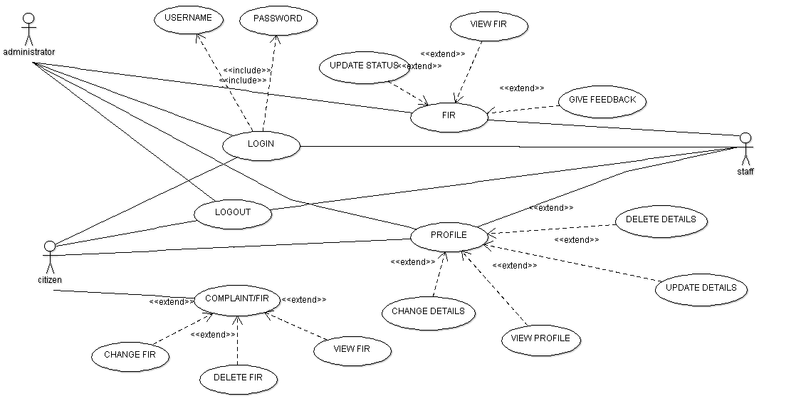

## Operating Environment

The system can work on any operating system as it’s an online based platform, hence the only minimum requirement is a great internet connection. The system supports Linux, windows, IOS, android based systems. It also supports all browsers for connectivity to the portal for reporting of crimes. The system can be accessed from any device for example, a tablet, phone, laptop, or a personal computer.

Additional components may include the modems, scanners, printers, external data storage devices, and docking stations

## Design and Implementation Constraints

## User Documentation

It’s an open to all system as it’s an online platform. Although when the user would login for the very first time he would be taken through a virtual tour of the website to get accustomed to the functions of the system. The tour can be taken anytime as there is a separate section for it. As such no user manual or document is provided. Still for the sake of the user a pdf will be available so that the user can read and understand the functioning, although the virtual tour is fairly enough to the needful.

## Assumptions and Dependencies

No assumptions taken as per my knowledge.

# External Interface Requirements

## User Interfaces

The systems UI is beautifully designed, and is easy to understand that is its user friendly.the home page contains Login, About Us, Feedback and Contact Us.  
if you are new to the site you would be directed to the sign up page and if youre and existing user clicking on the login would direct you to page asking for your username and password. The username and type of username is different for all the 3 classes of users; admins, staff, citizen. There after you will get many options as complaint registration, Update complaint, Delete complaint.

In Case of an admin you get options that are FIR, user details, add user, update user details , delete user and logout. Admin will have access and control over the systems database and will be able to even access user details. The user would also have one feature that will prove beneficial to them as they would be able to know their complaint status.

**3.2 Hardware Interfaces**

Processer: pentium4 32-bit or any processer that is better.

hard-disk: 40GB

RAM : 512 Mb or more.

## Software Interfaces

The system will have a very well layed out software interface that would be in use with many services simultaneously. There will be a well-defined database system for the vast application of complaints and crimes put up by the users. Software used is mongodb. For the web application we will use html, php, java script, j-query, css for the ui ux and backend programming. The sms system is a tie up with an online web application system for sending free sms to the users.

## Communications Interfaces

The system will be equipped with an automatic email system that would keep the user updated about his login sessions. The police will be able to contact the users separately also as the users would submit their email ids and phone numbers.

There will also be a sms service that would facilitate the communication between the people and the police. The addresses that the users would be mentioning while signing up, that will be used if any documents need to be sent or clues to be sent for verification, or client identity verification by the investigators / police officials.

**4. System Features**

**4.1 Sign Up**

This is the most basic step that is required by the users to access the site. They need to create an account on the site to access and to create submissions of the crimes and reports.

Sign up will include various attributes that need to be filled by the user inorder to create their accounts successfully

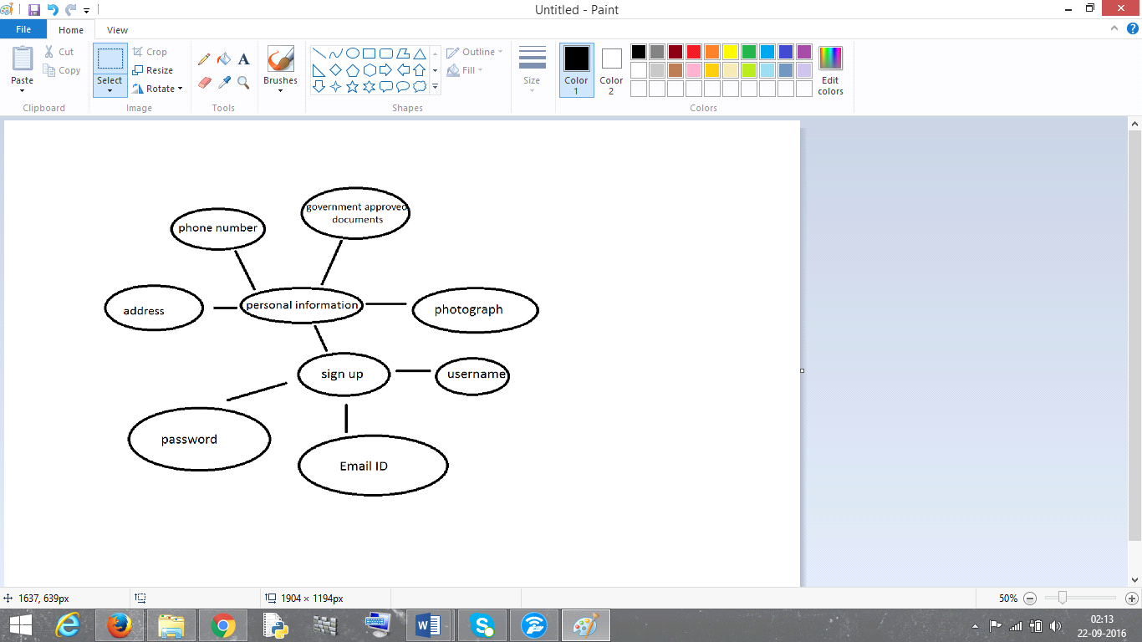

**4.1.1      Description and Priority**

For the Admin, he can do it within the database manually at the time database is being designed so that the security and safety is not hampered.

Priority is 9.

Initial Signup is mandatory for Staff Official or Citizen as they are the 2 major classes that will be interacting with one another. The citizens need to sign up to create an account to post all their complaints and report crimes. The official staff needs to sign up to create an account in order to access the request and complaints logged in by the users that is the citizens.

Priority is 9.

**4.1.2      Stimulus/Response Sequences.**

The Staff Official/Citizen will click on the sign up button inorder to create his/her account. They will be directed to a page that will ask for their username , email id , and password . once the 3 rows are filled up by the user. They will be prompted that the account was successfully made and then would be directed to another page that would require them to complete the last formality of the process to make their account active. They need to fill in their personal information that is address, phone number, government approved genuine documents softcopy in pdf format, and their latest photograph. This is for security reasons so that no fraud crime reports are put up and if they are action against the user may be taken.

**4.1.3      Functional Requirement**

Administrator can add users, delete their accounts, update various information on portal , as well as provide feedback to the processes and request put up by the people.

**4.2**        **Illegal Attempts**

Any attempt to steal, delete, change, crash, copy the documents without the users consent by any other user. Also deletion of account suddenly without specifying reasons.

**4.2.1    Description and Priority**

Accessing information of any other users by a citizen will be strictly uncalled for. Security and safety of data information online is very important. If this is hampered the citizen trying to access anyother account information that can cause trouble or deleting valuable evidences submitted or deleting documents , it can lead to imprisonment or a fine charges.

It is the task of the admin to make sure that no fraud activities are taking place and that the maintained documents in the database are not suddenly deleted. If they are the user must be prompted that his documents were deleted with a specific login date and time and when the documents were edited/deleted , this would be done via email sent to the user/citizen.

Priority is 9.

**4.2.2    Stimulus/Response Sequences**

If and person is trying to access the account , he or she if gets the password 3 times wrong wont be allowed to retry the password for 2 hours. After 2 hours if still the user enters the password 3 times wrong the account will be frozen by the admin automatically inorder to prevent any wrong happening.

There are 2 cases that arise:

* **Genuine case:** in this case there is no hacker and the citizen forgets his password, he will be prompted after the 3rd try that your account is being tried to access via a sms on his phone. And the user would need to answer some security questions inorder to receive request to change password.
* **Fraud case:** in this case there is a hacker who wishes to access the account for personal gains , he/she after getting 6th try wrong would be shown a warning signal which would freeze the account and that can be opened only via a special OTP (one time password ) that will be sent to the users phone. The account would be frozen and wouldn’t be able to open without proper verification which only the creator of the account would know as he/she would set questions to access account.

**4.3.3    Functional Requirement**

If the user is unable to open the account after so many tries then that account would be frozen and won’t open till the time correct verification is not done by the admin.

**4.3**        **Auto –Save**

Automatic saving of documents and information put up by the user.

**4.3.1    Description and Priority**

The autosave feature enables the user to have his/her documents saved automatically if the user shows no activity for a designated period of time. This would majorly act when user is filing his complaint online. He may take time to think and in that time there will be an auto save and auto backup of the data he has given till the very last sentence he would have written. Its also observed that a sudden power failure causes all data to eradicate , this auto save is designed to coverup that fault.

Priority is 10.

**4.3.2    Stimulus/Response Sequences**

the updation of the data as well as deletion of the data from users perspective will all be autosaved on the servers and updated in the databases part of the system. The user will keep getting informed by a small icon that would show autosave feature as a green tick mark that would blink or pop up as and when the autosave takes place.

**4.3.3    Functional Requirement**

                None

# Other Nonfunctional Requirements

## Performance Requirements

The most basic thing required is a proper internet connection as it’s an online portal and would not function without it. Moreover its open to all the people that are part of our nation hence there will be no disparity among people that is pretty valid in today’s date also. This system would help in reporting more number of crimes and wrong doings moreover the crime reporting’s submitted by any user, the user detail remains anonymous to the rest of the public except for the staff and admin. This would create better relations among people and would help to shape society into a much more peaceful place to live in.

## Safety Requirements

There isn’t any safety requirements except for the individual’s part of this site. They need to just stay updated about their accounts and requests, moreover they should not lose or forget passwords as it might freeze their accounts causing problems and inconvenience to the user.

## Security Requirements

The admin will have access to all the users’ information, staffs information and the database as he would be maintaining it. He can update the status of the request , prompt the staff as well as the user.