Software Requirements Specification

for

<Online Crime Investigation System>

Version 1.0 approved

Prepared by <Sujoy Roy>

<NIIT University>

<20-09-2016>

Table of Contents

Table of Contents

Revision History

1. Introduction

1.1 Purpose

1.2 Document Conventions

1.3 Intended Audience and Reading Suggestions

1.4 Product Scope

1.5 References

2. Overall Description

2.1 Product Perspective

2.2 Product Functions

2.3 User Classes and Characteristics

2.4 Operating Environment

2.5 Design and Implementation Constraints

2.6 User Documentation

2.7 Assumptions and Dependencies

3. External Interface Requirements

3.1 User Interfaces

3.2 Hardware Interfaces

3.3 Software Interfaces

3.4 Communications Interfaces

4. System Features

4.1 System Feature 1

4.2 System Feature 2 (and so on)

5. Other Nonfunctional Requirements

5.1 Performance Requirements

5.2 Safety Requirements

5.3 Security Requirements

5.4 Software Quality Attributes

5.5 Business Rules

Revision History

|  |  |  |  |
| --- | --- | --- | --- |
| **Name** | **Date** | **Reason For Changes** | **Version** |
|  |  |  |  |
|  |  |  |  |

# Introduction

We have planned to develop an online crime registration System.

## Purpose

The purpose of this Online crime Investigation System is crime detection and solving crime using Web Application.This System is to provide the facility to the citizens to register their complaint for a particular crime or criminal activity. In this Admin can update the whole details on their wish, admin can also view all the complains and can change the status of complaint. Citizens after login can lodge a complain to the police department.

## Document Conventions

In this documents certain words, headings are represented in the form of BOLD to identify the significance of that word. The following documents tells us about the behavior of our online Portal.

## Intended Audience and Reading Suggestions

In this Online Crime Investigation System Audience can be any citizen of our country, and also the police who will solve the registered complaint. This is mainly to register any criminal activity so it can be used by anyone. And further in SRS we have mentioned the description of our product and mentioned each and every key feature of our software. We have also mentioned what all we used to make this product, we have mentioned the hardware and software requirement. Further we have shown how our product works and what are its actors and on what all conditions it performs its task. We have also shown that how one requirement is dependent or related to the other requirement, So the best way to read this SRS is to first read its whole description which consists of all its services , functions, under what kind of environment does it work. Then after read its requirements (hardware and software), then go for its features and how does it work and then finally read about its performance, security requirements, its business rule, etc.

## Product Scope

Since we have got the permission from one of the officers from CBI who may use this product if this comes out to be a good one, and if so happened then people won’t find it difficult to register a complain and all you need to have is internet and you can lodge the complaint from anywhere. It’s helpful because in this product you don’t need to out anywhere since it is online so you can register complain from where you are and also you can update the status that weather the registered complaint is sorted or investigation is still going on.

## References

The reference used was the IEEE Std 830-1998 IEEE Recommended Practice for Software

Requirements Specifications.   
I also took help from many websites like:- Wikipedia, Quora,etc.

* <http://csetekquest.blogspot.in/2011/07/online-crime-investigation-system.html>
* http://seminar-projects.net/tags/abstract-for-online-crime-investigation-system

# Overall Description

## Product Perspective

The main aim of this product is to provide the facility to the customer to register their complaints regarding any crime or any criminal activity. Our product will also keep the track of complaints and as soon as the complaint is register the authorities will start investigating regarding that case.

Our system keeps the records saved and also maintain the privacy of a person.

Main benefit of our product is that a person need not go to a police station for registering complain, he/she can register complaint from where ever they are. This will mainly help in bridging the gap between the police and the victims.

## Product Functions

Our web application consists of 3 models which include Admin login, Citizen login and Staff Login. Each model has functions which are managed by the admin. The software can be accessed by the admin, faculty, Staff. The authorities will get notification as soon as you register a complaint and this will help police to start investigating the case as soon as possible.

## User Classes and Characteristics

Our Application mainly consists of 3 classes:-

1. Admin:- Admin is the one who will be responsible for maintaining the data on the app, basically he/she can add or delete the registered complaint and can also update the status in other words he has most of the powers in his hands for maintaining the data. The major access will be on his hands. He is the one who needs to update the status that weather the investigation is completed or still the process is going on. He can access to all the data registered in the system, he also has the access to the staff and citizen data what all complaint they registered. All the data can be stored in a database and will be fetched from there, but adding new citizens or staff or complaints will have to be maintained by the admin.
2. Citizen:- Citizen’s main work is to register the complaint and also to update the status, user can also give his/her feedback. This web application is mainly for citizens use so that they can register anyone’s complain without losing their privacy and without taking any kind of trouble.
3. Staff:- Staff people can also register their complain and also they can view, update and delete the FIR, they can also access the details of any registered citizen, any staff person, any registered criminal, any registered victim and at the same time they can also update the status.

## Operating Environment

The operating environment will include:-

This software will work on all kinds of operating system. We have planned to use Visual studio and for maintaining our database we have planned to use MySql.

## Design and Implementation Constraints

We will be having the following constrains:-

1. The time allotted for the project is limited so we have to complete the project before the end of this semester.
2. The web app can be used by any of the citizen in our country. The citizens and staff people before login need to sign up their account.

## User Documentation

We are going to provide an online portal to our customer in which will tell them how to use the software. The instructions for this portal will be self-explanatory so we don’t need any manual for explaining the working of this portal.

Moreover, a hard copy of the user manual with tutorial on how to use it will be provided to the customer so that they can function it smoothly.

## Assumptions and Dependencies

Assumptions:-  
1. We assumed that Admin has all the rights who has been given the right to access the details.  
2. We have also assumed that Staff has also the access to the details of User.

Dependencies:-  
1. Our software depends on the sign up criteria for the login details. So this software should be hack free and should have high security so that nobody except for the required people are able to get into the system and make changes.

# External Interface Requirements

## User Interfaces

Our portal’s UI is very attractive, user friendly(easy to use). In the Home page only it would consists of buttons like:- Login, About Us, Feedback and Contact Us.  
If you go to the Login Option you will get three options that are admin login, citizen login and staff login. If you enter in any of these then after you need to first login your account and if you are using it for the first time you need to create your account. Then after you will get many options as FIR registration, Update FIR, Delete FIR and Update Fir according to your credentials.

In Case that you are admin you get options that are FIR, View User details, Add User, Update user details , Delete user and Logout. Basically, admin has more power then any other as he can control the user details and also the database. Then after comes citizen in this after logging in you will get options like User details (Details of that particular user like people watch their own profile in facebook), FIR in which they can register FIR, then there is an option for FIR status in which you will get the update for the FIR you registered, then citizens also get the option to change their password.

## Hardware Interfaces

Some of the Hardware Interfaces which are used:- processer can be pentium4 32-bit or any processer which is launched after that. We require a hard-disk minimum of 40GB and RAM of 512 Mb or more.

## Software Interfaces

Some of the Software Interfaces which are to be used in this product are:- Any Windows OS or Linux, JavaScript in Scripting Language, Java in Programing Languages, JDBC, servlets and JS are used in case of Web apps, eclipse as a working platform, oracle 10g server for maintaining the database and tomcat 7.0 for deployment.

## Communications Interfaces

Some of the communications interfaces are:- Modem of 512 kbps and and we would require an internet connection. The user gives the feedback and through which the authorities can improve their system of working. Also we can connect phone to your account, you would get the details of each and every thing of your registered FIR. Mainly, there would be an SMS system to fulfill the communication gap between the user and the authorities.

# System Features

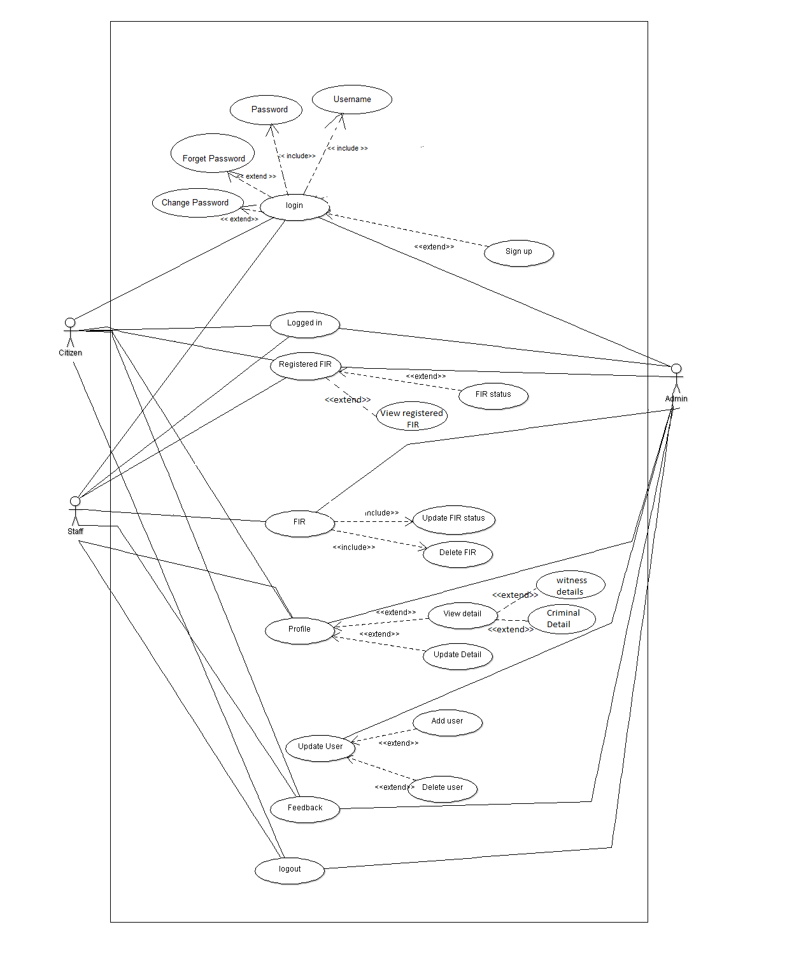

**Requirement Id**

|  |  |
| --- | --- |
| **Requirement Id** | **Requirement Id** |
| **Rid1** | **Login** |
| **Rid2** | **Add User** |
| **Rid3** | **View User Details** |
| **Rid4** | **Update User Details** |
| **Rid5** | **Delete User Details** |
| **Rid6** | **View Registered FIR** |
| **Rid7** | **Update FIR** |
| **Rid8** | **Delete FIR** |
| **Rid9** | **View FIR Status** |
| **Rid10** | **View Current FIR_Status** |
| **Rid11** | **Authentication** |
| **Rid12** | **Add Staff Details** |
| **Rid13** | **View Staff Details** |
| **Rid14** | **Update Staff Details** |
| **Rid15** | **Delete Staff Details** |
| **Rid16** | **View Citizen Detail** |
| **Rid17** | **Update Citizen Detail** |
| **Rid18** | **Delete Citize Detail** |
| **Rid19** | **Lodge an FIR** |
| **Rid20** | **View Lodged FIR** |
| **Rid21** | **Delete Lodged FIR** |

# Other Nonfunctional Requirements

## Performance Requirements

1. The System will help in registering your complaint from where you are, you just need to have an accesses to internet. This is for every citizen of our country who faces any criminal activity or watches any kind of crime taking place then he/she can register their complaint in this online portal and as soon as they register the complaint the authorities will get active and start investigating the case.
2. This basically helps in bridging the gap between the police and citizens. This is going to be very user friendly app so anyone won’t take much longer time to understand this system. Be it any person actors, cricketers or any normal people this is for everyone and also at the same time it maintains your privacy.

## Safety Requirements

As such there is no safety requirements, but to maintain your privacy you have to remember your password and you should not share your password to anyone.

## Security Requirements

In our portal only the admin is authorized to edit the database of the software. In order to enter the admin has to enter his credentials which will be unique and he is the only one who has the access to the details of every citizen and staff, he is the one who can watch the complaints of staff as well citizens.

## Software Quality Attributes

Availability:- The system will be made available to every citizen of our country, it is also for the staff people they can also lodge their complaints and it is also made available to admin who mainly works as server he is the one who maintains all the record and database, he is the one who has the access to all the people’s complaints and he can also view their details and edit their profile he can also add or delete the complaint and can update the status.

Reliability:- This System is reliable because the one who lodges the complaint his/her details are kept private. Their privacy is not reveled and this makes our portal more reliable to use because your details are kept private and the action against the crime registered also starts without any waste of time.

Usability: The usability of the system can be achieved by a user manual which we will provide within our portal itself and other instructions provided will be self-explanatory.

## Business Rules

The admin will play the most vital role. He will be responsible for maintaining the database and then using them further. The people who registered the complaint they will be benefitted as their issues will be sorted out as soon as possible.