**Project Feasibility Report-**

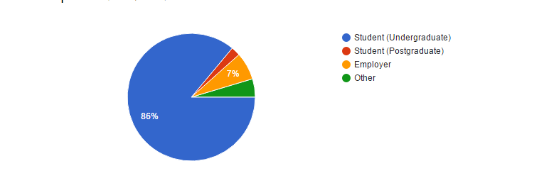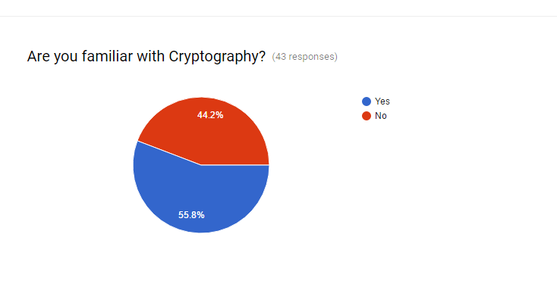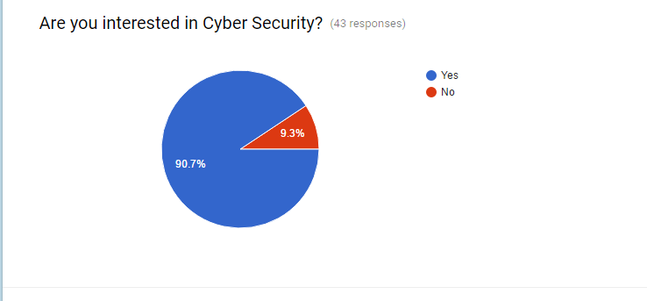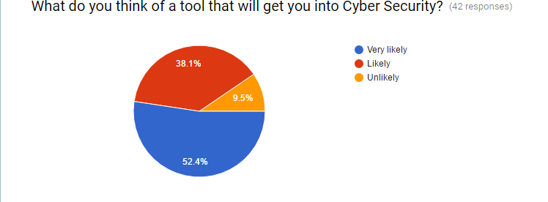

**2.1 Executive Summary**

Transferring file over a media has now become unsafe. Which spoil the privacy of the different user’s using transferring media for sending their file. User has to modify the data in such a way so that no other person can get the information from that. So we come up with an idea of modifying the user’s files and text message in an encrypted format using our encryption tool. Where user can learn the basics of cryptography and can also implement that.

**2.2 Software Feasibility**

The software required for making this software project and the platform required for the software to run are easily available online at a reasonable prices. To do this project, we need to implement different cryptography techniques into the tool.

**2.3 Time Feasibility**

The processes can be executed and run in real time, so the other thing we have to do is to establish a client-server method in the software, so that the client can send the server files and messages in an encrypted format. We can understand that the project can be done in a limited time and could be run in a real time system so that the time can be easily managed for the system.

**2.4 The Market**

This covers the wide range of people because many businesses require security for their organization. They want the people who can check their vulnerabilities in their website or in other things. Using this software any people having no prior knowledge of cryptography can learn that and also can see the working.

**2.5 Cost Feasibility**

This software will be freely available for everyone whosoever wants to download this software can download from our website because for making this software we will not require any type expensive software.