**Project Feasibility Report**

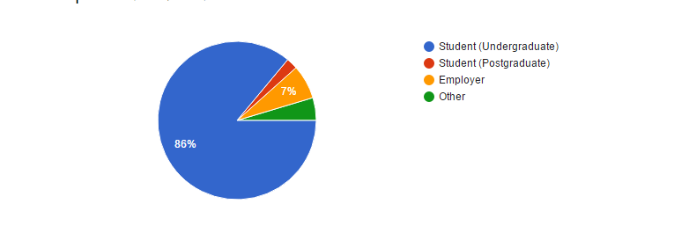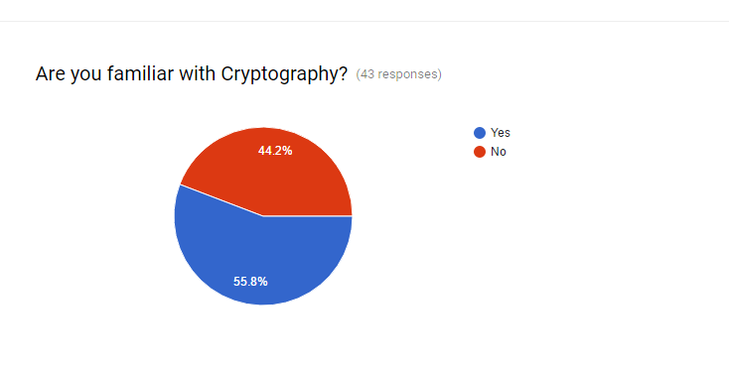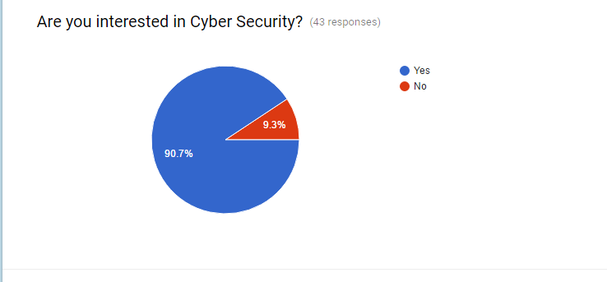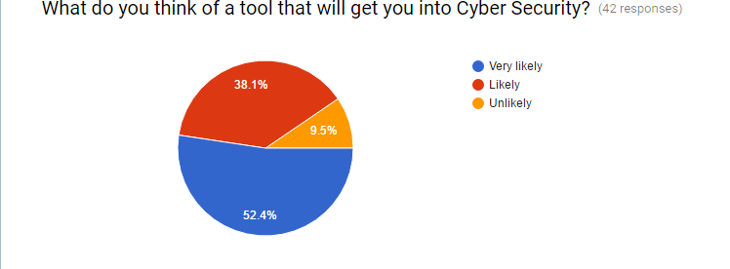

**2.1 Executive Summary**

Owing to the reason that transmission media are unreliable, so sharing or transmitting data in normal mode is normally unsafe. The data needs to be modified in such a way that, even though it can be read by any unauthorized user, the information can’t be extracted. So we have come up with the idea of sending files and text messages in an encrypted format using the encryption tool. This tool also helps us learn about the details of cryptography.

**2.2 Software Feasibility**

The software required for the implementation of this software project and the platforms required for this software to run, are readily available in the market at reasonable prices.

To do this project we, first need to implement the encryption algorithm and cope that with client server methodology. The project software can be done using JAVA language and it is feasible.

**2.3 Time Feasibility**

The algorithms can be implemented and run in real time, so the other thing we have to do is to establish a client-server method in the software, so that the client can send the server files and messages in an encrypted format. We can understand that the project can be done in a limited time and could be run in a real time system so that the time can be easily managed for the system.

**2.4 The Market**

The market for this type of software is abundant because everyone needs security for their information and with encryption techniques, data can be secured at a certain level. Also, anyone with no prior knowledge about cryptography can use this tool to learn about it and see its implementation.

**2.5 Cost Feasibility**

It can be implemented in a low cost and the requirements are not high, so the software production price would be significantly low. Thus the clients can afford this software, as it is inexpensive.