Software Requirements Specification
For
Encryption Tool
Version 2.0 approved
Prepared by Anshul Sharma
18/09/2016
Table of Contents
Table of Contents ii
Introduction 1
1.1 Purpose 1
1.2 Document Conventions 1
1.3 Intended Audience and Reading Suggestions 1
1.4 Product Scope 1
1.5 References 1
2. Overall Description 2
2.1 Product Perspective 2
2.2 Product Functions 2
2.3 User Classes and Characteristics 2
2.4 Operating Environment 2
2.5 User Documentation 2
3. External Interface Requirements 3
3.1 User Interfaces 3
3.2 Hardware Interfaces 3
3.3 Software Interfaces 3
3.4 Communications Interfaces 3
4. System Features 3
4.1 System Feature 1 4
5. Other Nonfunctional Requirements 6
5.1 Performance Requirements 6
5.2 Safety Requirements 6
5.3 Security Requirements 6
5.4 Software Quality Attributes 6
6. Other Requirements 7
Appendix A: Glossary 7
Appendix B: To Be Determined List 7

Introduction

Purpose
The purpose of this SRS document is to provide a detailed overview of our software product, its parameters and goals. This document is to provide the software requirement specification report for the Encryption tool and its requirements with respect to user. This document is to present a detailed description of the Cryptography. It will explain the purpose and features of the system, the interfaces of the system, what the tool will do.

Document Conventions

This SRS is written in font Arial of size 11(for descriptive part) 14(for Headings). The words like Encryption.

Decryption.

Cryptography.

HTML5.

CSS.

PHP

WAMP

Intended Audience and Reading Suggestions
This project is the college level project and is implementing under the guidance of college professors. This project is for general public and useful for everyone who have interest in Cyber Security and wants to learn about Cryptography techniques.

Product Scope
The purpose of software is to create convenient and easy to use tool where Different people from different background can learn about the Cryptography and make use of that for Security purpose. They can protect their sensitive data and transmit securely. Many IT companies use encryption for security purposes. Using encryption, they get the complete data protection, security across multiple devices, integrity maintained and ensure compliance.

References
- Cryptool.com
- Wikipedia.

Overall Description

Product Perspective
This document contains the problem statement of the current system. It also illustrates the needs and wants of the customers. The following SRS contains the detail product perspective from different users. It provides the detail product functions of our software with user characteristics permitted constraints, assumptions and dependencies and requirements subsets.

Product Functions
The main function of this software –
- To teach the user about different encryption and decryption techniques.
- User can use that techniques in encrypting and decrypting the data or file whatever user wants.
- User can go with our assignment if he is more interested in doing that because our assignment will help the user in brushing his/her knowledge.

User Classes and Characteristics
User of the system which is general public should be able to get the information based on their requirement. They can learn about the Cryptography techniques or can do some question which will be updated by the admin.
The user is expected to know about the Internet and be able to use a search engine. The main screen will have the search function where user can search different keyword. The user is expected to be Windows literate and to be able to use button, pull-down menus, and similar tools.

Operating Environment

The environment in which the software will operate is listed below- Client system
Operating system – Windows

User Documentation
We will provide the help manual on how to use the tool, where you can find different encryption/decryption technique and how you can implement that all will be showed in the manual.

External Interface Requirements

User Interfaces
In designing the UI (user interface) we will use some of the front end languages that is Client Side Scripting/Coding- Client Side Scripting is the type of code that is executed or interpreted by browsers.
The Client side technologies used are –
1- HTML5
2-CSS
3-JAVASCIPRT
4-JQUERY
We will also use Server Side Scripting language - PHP

Hardware Interfaces
Windows
The browser which support HTML5, CSS3.

Software Interfaces

Software used - Notepad++, WAMP

Operating system – Windows

Communications Interfaces
User can communicate with us on our website. User can post any question related to our tool.

System Features

System Feature 1
4.1.1 Description and Priority
This is the tool where user can learn about the Cryptography and implement that technique to encrypt and decrypt the data as well as can do some assignments. User can also ask questions. They can go to our website and can clarify from there. The user query will be answered by the admin.
This product is of medium priority because not every person is interested in Cyber Security. It should rate 7 out of 10 because there are many companies who wants the people which can handle the security issues in their website or something and make that company less vulnerable to Cyber Attack.
4.1.2 Stimulus/Response Sequences
First user will go to our website where user can download the Encryption tool and find the Cryptography techniques which generalize into Symmetric (Classic) and Symmetric (Model) and other things as well. User can start learning from any of the two (Classic and Model). Our tool Support the encryption and decryption of file or text data.
4.1.3 Functional Requirements
This section shows each actors and actions performed by them.

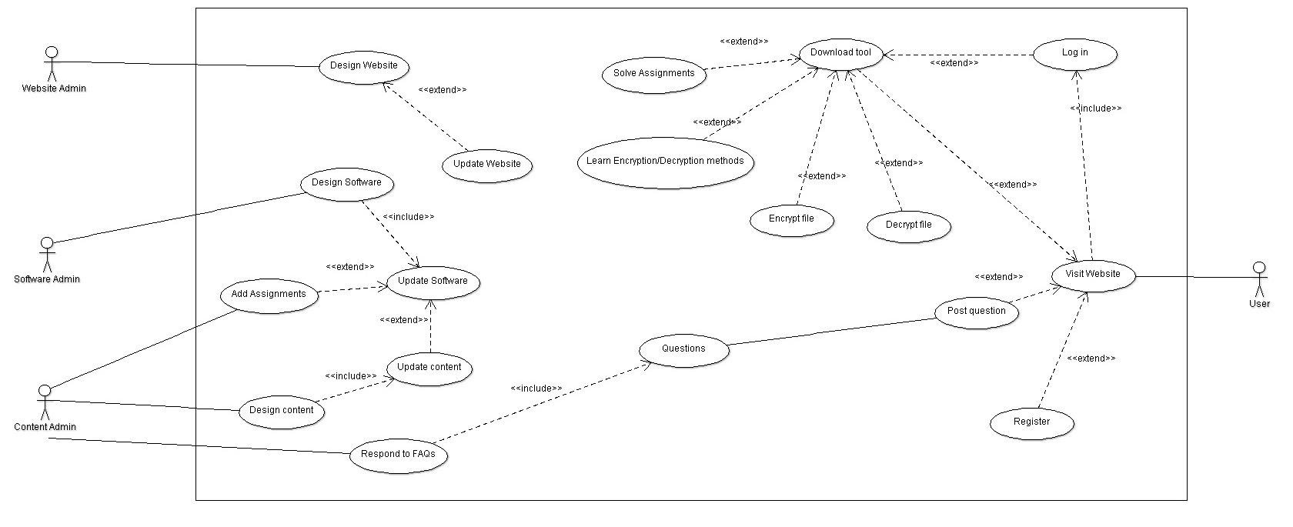

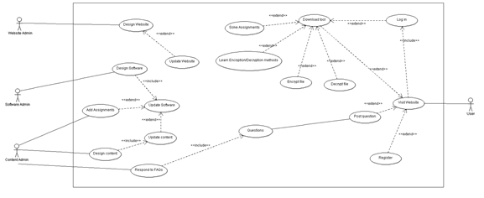

REQ_id | Req_Name | Description and Priority
R4.1 | Log In Phase | 4.1.1 Sign Up – This will be the first page where user must sign up to download our tool.  4.1.2 Log In – After Sign up user can log in our website.  4.1.3 Log Out- User must log out from the website.  4.1.4 Register- For Notification regarding the updation and FAQs user can register.
R4.2 | Content Improvisation | 4.2.1 Design Content- The information which will be added when designing the software.  4.2.2 Update Content- Further addition of information which could be according to the need of the user or if the content admin wants to add.  4.2.3 Assignment Addition- question which covers the encryption/decryption techniques so that user can know more about that.
R4.3 | Discussion Forum | 4.3.1 Ask Question- This handle the user queries where User post question related about the tool or in case of finding difficulty in assignments.  4.3.2 Respond to FAQs- For answering query content admin will be there who will give the answer to the user’s questions
R4.4 | Social Connect | 4.4.1 Design Social Content – make the social content like update or FAQs and post it on social media.  4.4.2 Update Social Content- keep in check the content that is to be posted on social media.  4.4.3 Visit Social Links- User can connect with us on social links (Facebook, twitter etc.)  4.4.4 Read Post- Our social admin will post information regarding updating of software so that user notify from there.  4.4.5 Post Review- User can give their opinion on social website if they like the changes done by the admin.
R4.5 | Develop Product | 4.5.1 Software Designing- This will be the first phase which will show that what this tool all about and how it works.  4.5.2 Software Update- Further addition can be done in software in case of bug or user found any difficulty in using the tool.  4.5.3 Designing Website- Website Admin design the user friendly web pages.  4.5.4 Website Update- check the functionality of website and keep update the website.
R4.6 | Encryption/Decryption | 4.6.1 Download Tool- This is the software which user can download from the website. This will teach the user about Encryption and Decryption.  4.6.2 Learn Encryption/Decryption- User can learn different techniques about encryption and Decryption.  4.6.3 Encrypt and Decrypt File- user can use any text file for encrypting and decrypting.  4.6.4 Solve Assignment – User Solve the assignment given by the Admin and ask question about that.

Other Nonfunctional Requirements

Performance Requirements
For this product there is no performance requirement because we are providing the software which will run on user side and for running that tool there is no specific requirement. User just need windows. But for the website user should have a browser that support HTML5 and CSS3.

Safety Requirements
The tool that we are providing is safe to use it will not affect anything regarding the user system.

Software Quality Attributes
Availability – Admin will be available to answer the queries of the user and in answering the question there will be less delays.
Maintainability – Our tool and Website will be updated if there is any type of error or the user find it’s difficult to use.
Usability – This product should satisfy the maximum number of customer needs.

Other Requirements
The Software has no other requirement other than the mentioned above.
Appendix A: Glossary
Term | Definition
Database | Collection of all the information monitored by this system.
Encryption | It is the conversion of electronic data into another form.
Decryption | Converting back the encrypted data in original form.
Software Requirements Specification | A document that completely describes all of the functions of a proposed system and the constraints under which it must operate. For example, this document.
Client side Scripting | Client Side Scripting is the type of code that is executed or interpreted by browsers.
User | The one who will use the product.
Cryptography | Art of converting data into coded form.
PHP | Server Side Scripting language
WAMP | Web development environment software
CSS3 | Cascading Style Sheet (CSS) is a style sheet language used for describing the presentation of a document written in markup language.
HTML5 | Hypertext Markup Language

Appendix B: To Be Determined List
- We take the Register part as TBD.
- Addition of Database.
- Make the Software run on Linux.

