ENCRYPTION PROJECT

SOFTWARE REQUIREMENTS SPECIFICATION

Prepared by

Anshuman Singh

NIIT University

17/09/2016

Table of Contents
Table of Contents ii
Introduction 1
1.1 Purpose 1
1.2 Document Conventions 1
1.3 Intended Audience and Reading Suggestions 1
1.4 Product Scope 1
1.5 References 1
2. Overall Description 1
2.1 Product Perspective 1
2.2 Product Functions 2
2.3 User Classes and Characteristics 2
2.4 Operating Environment 2
2.5 Design and Implementation Constraints 2
2.6 User Documentation 2
3. External Interface Requirements 3
3.1 User Interfaces 3
3.2 Hardware Interfaces 3
3.3 Software Interfaces 3
3.4 Communications Interfaces 3
4. System Features 3
4.1 System Feature 1 4
4.2 System Feature 2 (and so on) 4
5. Other Nonfunctional Requirements 4
5.1 Performance Requirements 4
5.2 Safety Requirements 5
5.3 Security Requirements 5
5.4 Software Quality Attributes 5
5.5 Business Rules 5
6. Other Requirements 5
Appendix A: Glossary 5
Appendix B: To Be Determined List 6

1 Introduction
1.1 Purpose

The purpose of this project is to help an individual how some of the more popular encrypting algorithms works. The system will allow the user to gain all the basic knowledge of encryption, user have to select an encryption method, and then he can have all the information regarding that encryption method. There will some assignment which will help the user to become more comfortable with the specific method.

1.2 Document Conventions

This SRS is written in font Arial of size 11(for descriptive part) 14(for Headings). The words like Encryption.

Decryption.

Cryptography.

HTML5.

CSS.

PHP
WAMP

1.3 Intended Audience and Reading Suggestions

This project is the college level project and is implementing under the guidance of college professors. This project is for general public and useful for everyone who have interest in Cyber Security and wants to learn about Cryptography techniques.

1.4 Scope

The scope of this project is limited to factors incorporated by the program itself. In the future, additional components may be added.

1.5 References

IEEE Software Engineering Standards Committee, “IEEE Std 830-1998, IEEE.
Cryptool.

Section 2: Overall Description

2.1 Product Perspective

This product is supposed to be open source, it is a web based and a tool which help its user cryptography. There will modules which help the user to learn things quickly, we will also include assignment for the user which will help the user to become more comfortable with the particular topic of the cryptography.

2.2 Product Function: The main function of this tool is to provide the basic knowledge and tutorials cryptography as well as if user wanted to encrypt/decrypt their file this will be also available.

2.3 User Classes and Characteristics

User of the system which is general public should be able to get the information based on their requirement. They can learn about the Cryptography techniques or can do some question which will be updated by the admin.
The user is expected to know about the Internet and be able to use a search engine. The main screen will have the search function where user can search different keyword. The user is expected to be Windows literate and to be able to use button, pull-down menus, and similar tools

2.4 Operating System

The software will run on every windows devises.

2.5 Design and Implementation Constraints

As we will take a file from user and encrypt in so we have to make an app in such a way that it should accept any file format.
As it’s a tools which will be available for free so software must be multilingual.
The program must not alter the state of the user’s system after closing. As far as security issues are concerned, no files on the user’s system are read or otherwise modified

2.6 User Documentation

As this is software for teaching the Cryptography so there is step to step guide for doing the tasks as well as there will some assignment for the better learning also.
The user have also the facility of encryption of their file with their own selected technique but for that they have to upload their file in a specified format.

3 External Interface Requirements

User interface has been specifically designed with their customers in mind, giving them convenience while they use the app such that they do not bother about how to use app.
The home screen offers a button to select that user want to learn or encrypt the file if user wanted to learn then user will be directed to the pages which teaches cryptography but if the user wanted to encrypt/decrypt the file then directed to different pages having menu with a list of methods that the app can performs. The user can select one of the options on the menu, and is taken to the respective screen, which will request a file for encryption/decrypt.

3.1 User Interfaces

The Client side technologies used are –
1- HTML5
2-CSS
3-JAVASCIPRT
4-JQUERY
We will also use Server Side Scripting language - PHP

3.2 Hardware

The system must run only on windows.

3.3 Software Interface

A graphical user interface is used to enhance usability and must be able to run on any display that supports 1024*768 resolution. In this tool user have all the options at the top like a navigation panel, which include file, edit view, and encrypt features.

3.4 Communications Interfaces

As mentioned earlier, the intended product to exploit existing Web service technologies to leverage existing infrastructures through building an overlay. The communication among software component would be performed through message passing over the IP network. From a technical point of view, TCP/IP will be used as the transport protocol, where each CDN server establishes a TCP connection to the network elements using a well-known port number. Messages can then be sent bi-directionally between the server and network elements. All messages consist of a fixed length-header containing the total data length and a request followed by a reply or an acknowledgement. Interaction among surrogates will be performed using HTTP or FTP. The communication between the different parts of the system is important since they depend on each other. However, in what way the communication is achieved is not important for the system and is therefore handled by the underlying operating systems for both the application and the web portal.

4.1 System Features

This system is highly needed this time as the Internet can be a very dangerous place. Imagine every message you thought was part of a private conversation was never private to begin with. Well, let us introduce the unsung hero of this fight against the invasion of our privacy - Encryption. We bring to you, a Web App that will teach you about the basics of Cryptography. This tool is for those of you who have no idea about Cryptography and want to understand what makes their life a little safer and a lot more private.
This app is not limited to provide the tutorial this app also encrypt/decrypt the file for the user, it has the high priority app as compared to the other apps.

4.2 Description and Priority

In today’s world first thing comes into a mind of a user is he is secure, security here does not meant for physically secure but means that his file and other data which he does not wanted to share with every one, so in that context this software is of high priority, it has so many benefits like a user can upload a file on server without any doubt of getting that file in wrong hand. If we talk in the context of cost the cost for maintenance and using both are low it’s an efficient tool.

Functional Requirement:
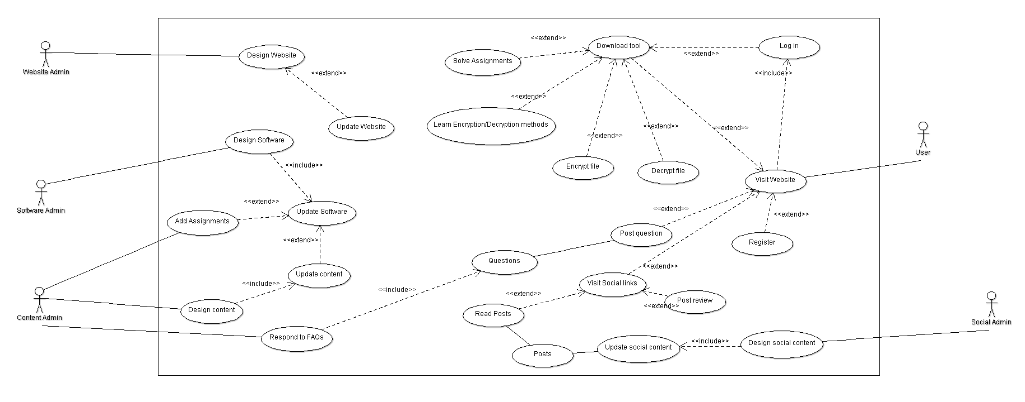

REQ_id(User) | Req_Name | Description and Priority
R4.1 | Log In Phase | 4.1.1 Log In – This will be the first page where user must login to download our tool.  4.1.2 Sign Up - The will help user to download the software because only registered user will able to download the tool  4.1.3 Log Out-This will help the user to logout his account.  4.1.4 Register-This will help user to register himself for the notification.
R4.2 | Content Improvisation | 4.2.1 Design Content-Construction of basic design of the content.  4.2.2 Update Content-Adding the new content for the user.  4.2.3 Assignment Addition-Addition of new assignment for the user for better understanding.
R4.3 | Discussion Forum | 4.3.1 Ask Question – User can ask any type of doubt.  4.3.2 Respond to FAQs- Answer will be provided to the user’s questions.
R4.4 | Social Connect | 4.4.1 Design Social Content –Design of the content for the social media by the Social Admin.  4.4.2 Update Social Content-Addition of the new content by the Social Admin  4.4.3 Visit Social Links-User can visit the social media sites which help him to be aware of new content going to add.  4.4.4 Read Post-User can read the post posted by Social Admin.  4.4.5 Post Review – Review by the user on the post by the social admin.
R4.5 | Develop Product | 4.5.1 Software Designing-Designing of software by the software admin.  4.5.2 Software Update-Software update will be provided by the software admin and user can download the update to access new content.  4.5.3 Designing Website-Software Admin design a website for the user so that user can download and get the access to the content.  4.5.4 Website Update-Updating the website for the better performance.
R4.6 | Encryption/Decryption | 4.6.1 Download Tool – User can download the tool after login to website.  4.6.2 Learn Encryption/Decryption – User can learn the various encryption/decryption method once he login to the website.  4.6.3 Encrypt and Decrypt File – User can also can encrypt and decrypt the file once he login to the website.  4.6.4 Solve Assignment – For the better understanding of the content user can solve the assignment posted.

Other Nonfunctional Requirements

5.1 Security:
If the user chosen for the encryption and he uploaded the file so the security of the file is our concern.
5.2 Software Quality Attributes
5.3Adaptability:
The structure of the software is such that it will be so easy for the beginner to use.

5.4 Availability:
This software is free and can be easily download from the website.

5.5 Maintainability:
The cost for maintenance could be more as compare to the cost of production.

5.6 Usability:
It’s a software that can used by anyone who wanted to secure their file and is very user-friendly
Appendix A: Glossary

Term | Definition
Database | Collection of all the information monitored by this system.
Encryption | It is the conversion of electronic data into another form.
Decryption | Converting back the encrypted data in original form.
Software Requirements Specification | A document that completely describes all of the functions of a proposed system and the constraints under which it must operate. For example, this document.
Client side Scripting | Client Side Scripting is the type of code that is executed or interpreted by browsers.
User | Reviewer or Author.
Cryptography | Art of converting data into coded form.
PHP | Server Side Scripting language
WAMP

Appendix B:To be determined

Addition of database
Make software run on linux.

