Software Requirements Specification
for
<Distributor management system>
Version 1.0 approved
Prepared by <Sibin Kartik Tiwrai>
<DBMS>
<21 Sep 2016>
Table of Contents
Table of Contents ii
Revision History ii
1. Introduction 1
1.1 Purpose 1
1.2 Document Conventions 1
1.3 Intended Audience and Reading Suggestions 1
1.4 Product Scope 1
1.5 References 1
2. Overall Description 1
2.1 Product Perspective 1
2.2 Product Functions 2
2.3 User Classes and Characteristics 2
2.4 Operating Environment 2
2.5 Design and Implementation Constraints 2
2.6 User Documentation 2
2.7 Assumptions and Dependencies 2
3. External Interface Requirements 2
3.1 User Interfaces 2
3.2 Hardware Interfaces Error! Bookmark not defined.
3.3 Software Interfaces 3
3.4 Communications Interfaces 3
4. System Features 4
4.1 System Feature 1 4
4.2 System Feature 2 (and so on) 4
5. Other Nonfunctional Requirements 4
5.1 Performance Requirements 7
5.2 Safety Requirements 8
5.3 Security Requirements 8
5.4 Software Quality Attributes 8
5.5 Business Rules 8
6. Other Requirements 8
Appendix A: Glossary 8
Appendix B: Analysis Models Error! Bookmark not defined.
Appendix C: To Be Determined List Error! Bookmark not defined.

Revision History
Name | Date | Reason For Changes | Version

Introduction

Purpose
The purpose of this document is present the description of our customized software Distributor. It explain the purpose and features of our software .This intend to work for both the stakeholders and the developer of our system software.

Document Conventions
The format of this SRS is very simple and main focus will on general topics of our software or a specific kind of interest and issue were user faces the problem.

Intended Audience and Reading Suggestions
This customized software so the were customer can understand easily the website and as the function are not complex and user friendly for the user.

Product Scope
This customized software were our main target audience is the distributors to get there product in specific amount of time. The software will have the database which will link with the system of the software and it will have the feature of all the function were user use and the complexity will be low .This scope is to make ease of doing business and making system transparent the system so that supplier may know the status of the product.

Reference
http://www.cse.chalmers.se/~feldt/courses/reqeng/examples/srs_example_2010_group2.pdf

Overall Description

Product Perspective
We are making the older system into newer one like in the sense we are making the system into a paper- less work and transparent. It will also provide viewing the information of the Distributor customized system software.

Product Functions
It has the 9 pages were first page there will dashboard were the user can go to any use any feature for his own convinces as there will be bill book which keep on the track of all the products.It also provide the warehouse management function, supply management,bill books,ledges etc.

USE Case Diagram-

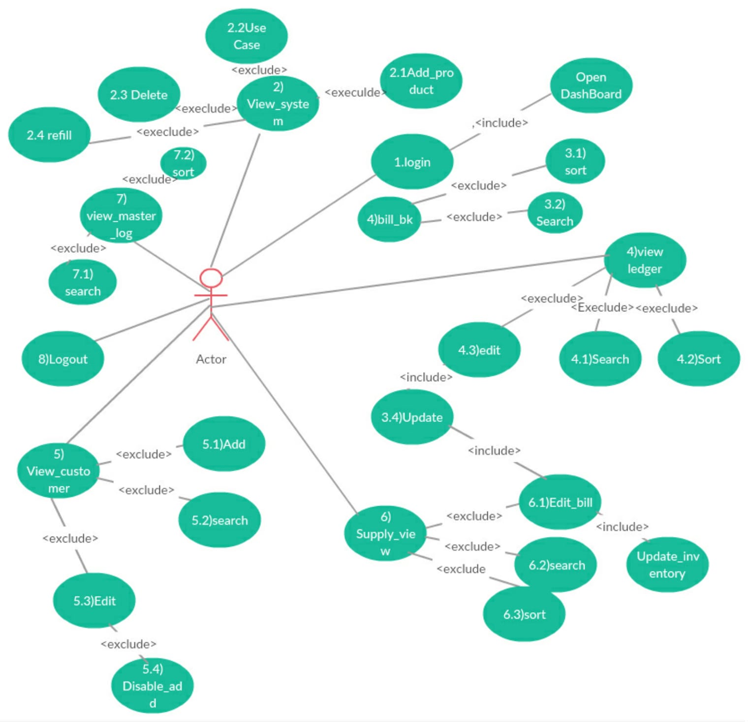

User Classes and Characterstic-Distributors customized software, were our target audience would be the distribution of the product and the supplier of the system in it.It will have only one user which will enroll in our website of the system

Operating Environment-It is a web portal were it will be link with database of our software. This product can be view by any of the web browser(Google Chorme,Mozilla,Opera etc).

Design and Implementation Constraints
Till now we have no kind of constraints.

User Documentation
It will interact with the system of computer and PCs were they can go on the website of the computer system. The website can be used for the information of the product. There are other criteria of the website were user can search for it and it can also have the different criteria
Of the products in tit.

Assumptions and Dependencies
Since it is Customized software were we don’t any kind of the extra documentation as you see in the in the section of the system feature which will be enough for the this software

External Interface Requirements

User Interfaces
A user of the software should see the log-in page when he/she opens the application, . If he not register in the page then should do first to register on the website and create the Username and password otherwise he can login with the Gmail account, he/she should be able to see the search page directly when the application is opened. Here the user chooses the type of search he/she wants to do it as per his/her choice. Every user should have a profile page were he can change his username and password. Also, the user can set software as his own mother tongue language .It allows the user to sort the results according to price, product name, distance, product type and quality. Each result item includes information about the supplier, a link to the supplier web-page and an information link, which provides a more detailed description of the Product.

Hardware Interface-
RAM-1 GB
Disc Space -400mb
Processor-intel i3 with 2.93 Ghz+H55

Software Interfaces
To communicate with other suppliers we will have keep the track record in the system which show the user that how it keep the track of the distribution of the products to the suppliers of how much it has been supplied to the product to the consumer. operating system will be using in the software would be Windows 8.1.Communication with it will be of C# and

Communications Interfaces
The transmission of the data we can use the point to point link of the data so that sender can send any information to the reciver to the other and send signal of the data.TCP/IP protocol for sending the messages as the form of the packets and sending them from the source to the destination unit.HTTP protocol It exist multiple data link.

System Features

System Feature 1

4.1.1 Description and Priority
Each customer has their own set of attributes, which may change over time. A record of them should be maintained, with updates done wherever necessary.
4.1.2 Stimulus/Response Sequences
Stimulus : A customer has changed their address
Response : The software will consider the updated address and fill in the same while typing the bill
4.1.3 Functional Requirements
TBA

Backup Features-

Description and Priority
In case the user’s system crashes, broken, or simply unable to function, then the user can log on to another system and enter their login id and password and retrieve their information, which is stored on a cloud server.
4.1.2 Stimulus/Response Sequences
Stimulus: Computer suddenly switches off due to no power
Response : All the work done by the user is already saved in Cloud. So, The user can charge the PC and continue with their work.

Stimulus: Computer does not open due to (other) hardware or software issues
Response : User can log on to another PC with this software and continue working.

4.1.3 Functional Requirements
TBA

Track Employee Tasks and Performance
4.1.1 Description and Priority
Keeps record of what all tasks are assigned to employees, in which area, on what date and so. Also keeps record of performance of employees, which can be tracked over a time period (start date and end date user-customizable) .
4.1.2 Stimulus/Response Sequences
Stimulus : Which employee went to Bandh Nagar last week?
Response : Open the “Employee” tab from the Dashboard. From there, type the particulars and obtain the data.

Stimulus : One employee has been performing poorly.
Response : User sees employee’s performance has been dropping since last week. Summons the employee, asks him the reason. Turns out he has fever. Given medical leave. Increase in employee satisfaction.

Stimulus : One employee brought good orders today.
Response : It turns out, the employee has been working hard and bringing the majority of the orders. On seeing good performance, rewards employee with incentive. Increase in employee satisfaction and encourages good performance.

4.1.3 Functional Requirements
TBA

Inventory Management
4.1.1 Description and Priority
For any distributor, inventory is one part where things have to be managed carefully. There is stock coming in, going out, new additions, as well as products being expired or spoiled by rodents or bacteria. The Inventory Management has been designed keeping all these issues in hand.
4.1.2 Stimulus/Response Sequences
Stimulus : 3 cartons of oil get expired.
Response : User enters them as “expired”. Software records them separately. The user can see if the frequency of spoilage is high and take necessary action.

Stimulus : Sales of dhara oils is increasing. Decision - whether to order more or not.
Response : User checks dhara oil records, made a lot more easier by the computerized method, and finds 100 cartons already in stock. More can result in spoilage. Decides against ordering.
4.1.3 Functional Requirements
TBA

Add Bills
4.1.1 Description and Priority
This, as the name suggests, is for adding bills of confirmed orders. The user has to just type the name, and other details, such as shop address, are filled automatically (except when there are more than one shops). The software uses information from the database to eliminate redundant choices and therefore keep the bill virtually error free.
4.1.2 Stimulus/Response Sequences
Stimulus : Customer wants 2 cartons of 1L refined oil bottles. There are 1.5l, 2L, an 5L bottles available, but 1L bottles are out of stock.
Response : When the user types refined oil, it will show 1L in red which implies out of stock and will give a warning before finalizing the bill. If the user still chooses to go with it, than no matter what the user had typed, the bill will show 0 bottles.

Stimulus : While typing the bill, user mistakenly types the old address, which is not to be used now (human error).
Response : Software will give a warning before finalizing the bill, and hence helps remove a human error.
4.1.3 Functional Requirements
TBA

Bill Book
4.1.1 Description and Priority
Bill Book is user read-only file kept for keeping track of what all orders have been done till date. The Bill book can be sorted and searched, but not modified.
4.1.2 Stimulus/Response Sequences
Stimulus : User wants to check bills till now for setting discount schemes targeting high order customers.
Response : User can simply go to the bill book and sort the bills by their amount, and can set discount schemes accordingly.

Stimulus : Customer refuses to have ordered a certain product.
Response : User can see it in the Bill Book and check whether the customer is saying the truth or lying.
4.1.3 Functional Requirements
TBA

Ledger
4.1.1 Description and Priority
“Ledger” keeps a record of all the active bills i.e. bills whose orders have been delivered but the money hasn’t come yet, or the payment is partial, which happens lot in distributor markets. These records are obviously editable, and when the bill has been cleared, the record implicitly goes to the Bill Book and is removed from th Ledger. A reminder can also be set for collection of the due amount.
4.1.2 Stimulus/Response Sequences
Stimulus : Customer paid only half of the bill. The order was delivered 3 weeks back.
Response : User had earlier entered the reminder as 3 weeks. A notification comes, reminding the user to collect their money from the customer.

Stimulus : Customer is asking for a big order.
Response : User checks the Ledger and sees that this customer already has a huge amount due. Takes decision accordingly.

4.1.3 Functional Requirements
TBA

Other Nonfunctional Requirements

Performance Requirements-
The performance of the software will be Usable, Supporitive, will not lag in the system , Reliabilty and minimal number of redudancy .It will complete the system of the updating in the system of the database. Each and every function will be available to the user to work on the system of the function in it. All the function will be performed by system of the software unless the no other changes in the system are changed by the user.

Safety Requirements-

The safety of the software will be up to the use of the user as he as to take care of the system to software in it and we will give option of the create password of its own but they have take care of that password must not be disclose to the other Or any other kind of the misuse.

Security Requirements-

Same as section 4.9

Software Quality Attributes
Avaliabilty-All functions will be available to the user to perform on the customized software.
Reliabity-The system will provide the password to the user so that it can’t no other third party would not interfare in the database of the system to.It will also provide the user to update system time to time it can add more feature to the system of the data.
Supportive-Minimum complexity would be there so that user feel no difficulty to use the software.
Interfacing-It must be able make a better communication between the system of the software and the database.

Business Rules
Our rule to make better software on the basis of the requirement of the customer and completing the priorities of the customer at specific amount of time

Other Requirements
They will be backup for our system requirements as if there any default come since customized software of the system. Hardware requirements like keyboards mouse, were we can use the LAN cable, Electricity and all other things etc.

Appendix A: Glossary
User: The person who want looks you use analysis the work of the software.
Reader: Anyone which reads our site to read articles.
Database: It is collection of the interrelated data and database basically record keeping system.
Software Specfiaction Requirements: Which gives all details of the functionality of the system software.
Field : different types of functionality of the system.
Member: part of that project software.
Stakeholder: Any person who use interested to do something new in the project.

.

