IEEE STANDARD 1016: Software Design Specification

The Software Design Specification Outline
1. Introduction

1.1 Purpose of this document
This Document is a written description of our software product – Distributors business management software, it gives a low level description of the software, with insight to design and structure of components in order to give the reader overall guidance to the architecture of the software project.

1.2 Scope of the development project
This is the era of digitization, where everything from shops to communication to businesses are being done on the computer, replacing older pen-and-paper systems, which were inefficient, and prone to inaccuracy due to data being prone to human error. This software is a replacement of such a system currently in use by distributors across, with enhanced features such as employee performance, profit calculations, inventory management and a lot more.

1.3 Definitions, acronyms, and abbreviations
No acronyms or abbreviations used, all definitions are common terms
1.4 References
- https://www.toptal.com/freelance/why-design-documents-matter
- Software engineering a practitioner’s approach Roger.S.Pressman
- IEEE 1016 standard format
- ADD MORE IN END

1.5 Overview of document
In the following sections we outline the software product in higher detail. We will start with defining the key features that will be implemented. Next, we will discuss the constraints that will be imposed upon the software and the quality ranges, in other words, the robustness, fault tolerance and usability of the software product amongst other things. In The precedence and priority section we will comment on the most important functionalities that the software product must have and the integrity of the sales system.
In The following sections will discuss all other product requirements, such as, performance requirements, platform requirements and environmental requirements. Lastly, we will comment on the documentation requirements, such as, user manuals, online help & support, installation and packaging.

2. System architecture description

2.1 Overview of modules / components

Module No | Module Name | Functions/Features in Module
1 | Main Window | mainWindow
2 | Login | loginPage
3 | Home Page | changeUserPasswordPage ; aboutPage
4 | Warehouse | warehousePage ; addProduct ; refillProduct ; updateProduct
5 | Bill Book | billBookPage ; newBillPage ; billDetailPage
6 | Customer | customerPage ; addCustomerPage ; editCustomerPage
7 | Supply | supplyPage ; supplyBillSelectedPage
8 | Ledger | ledgerPage ; ledgerBillSelectedPage
9 | Master Log | masterLogPage

2.2 Structure and relationships
(Diagram in another file)

2.3 User interface issues (*)

- Error messages are displayed when

- Invalid User ID and Password.
- In [ Bill Book->New Bill ] :
----- If Store name Or Product name doesn’t exist.
----- Product Quantity is zero.
- In [Warehouse->New Product/Refill/Update] :
----- Product name already exist.
----- Price and Quantity per box is zero.
- In [Customer->New Customer/Edit Customer ] :
----- If Customer already exist.
----- Mobile number less than 10 digit.

-
- Upload and Refresh Data

Data can be updated to cloud whenever any change is made. Refreshing of data is automatic – data refresh, i.e. cross-checking of data with server and updation of the missing details, is a triggered action (just after the upload is done), so the user doesn’t need to do it twice.

3) Consistency in the command-Consistency of the command should employed throughout.
- Standard buttons - The buttons “Back” and “Home” will appear on every screen except the dashboard.

- Upload and Print Button - The upload button will be available only on screens where information is being added (and not just viewed). The print command can be given from required pages (available in offline mode only).

- Layout - The options/choices of a particular screen will be displayed on the top, starting from left. A search bar will appear on the upper-right corner of the screen. Data shown or to be entered will follow. The Dashboard will have the main actions (eg: add a customer, view bill book, view ledger, etc).

- Top - On the top will be a banner stating the business’s name and/or logo.

4) Informative Feedback-For each and every operator there should be a operator feedback so that the we can improve it time by time but it happens user don’t specify the id of their feedback

3. Detailed description of components

3.1 Component template description

Identification | Main Window
Type | Module
Function | Base design of the software, Dashboard, display business banner
Subordinates | mainWindow
Dependencies | -
Interfaces | -

Identification | Login
Type | Module
Function | Logging in, Dealing with incorrect user credentials
Subordinates | loginPage
Dependencies | -
Interfaces | Log in

Identification | Home Page
Type | Module
Function | Basic welcome
Subordinates | changeUserPasswordPage ; aboutPage
Dependencies | -
Interfaces | Buttons: About, Change Username/Password

Identification | Warehouse
Type | Module
Function | Inventory Management - includes adding, removing, and refilling products
Subordinates | warehousePage ; addProduct ; refillProduct ; updateProduct
Dependencies | Calls addMasterLog
Interfaces | Buttons : addProduct , refillProduct , updateProduct

Identification | Bill Book
Type | Module
Function | Adding and storing Bills
Subordinates | billBookPage ; newBillPage ; billDetailPage
Dependencies | Calls addMasterLog
Interfaces | Buttons: billBookPage , newBillPage , billDetail

Identification | Customer
Type | Module
Function | Maintains Customer Database.
Subordinates | customerPage ; addCustomerPage ; editCustomerPage
Dependencies | Calls addMasterLog
Interfaces

Identification | Supply
Type | Module
Function | Keeping track of bills to be supplied
Subordinates | supplyPage ; supplyBillSelectedPage
Dependencies | Calls addMasterLog
Interfaces | Buttons: supply , supplyBillSelected

Identification | Ledger
Type | Module
Function | Keeping track of which customer has not made payments/made partial payments
Subordinates | ledgerPage ; ledgerBillSelectedPage
Dependencies | Calls addMasterLog
Interfaces | Buttons: ledger , ledgerBillSelected

Identification | Master Log
Type | Module
Function | Used for keeping track of all activities in the software
Subordinates | masterLogPage
Dependencies | -
Interfaces | Buttons: masterLog

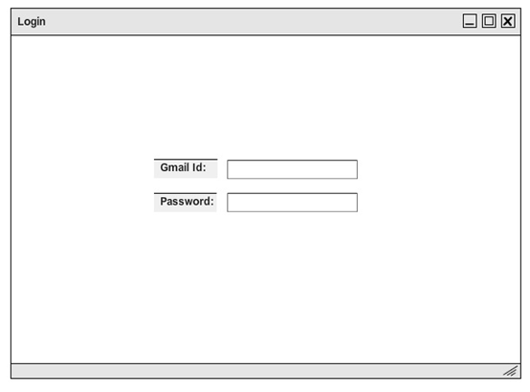

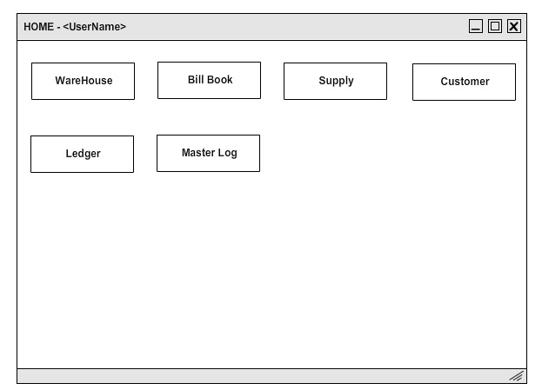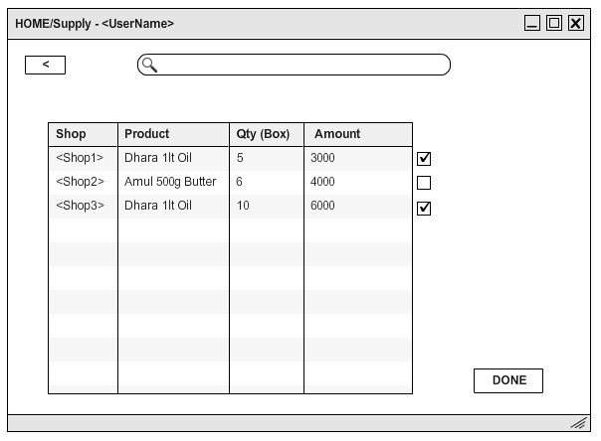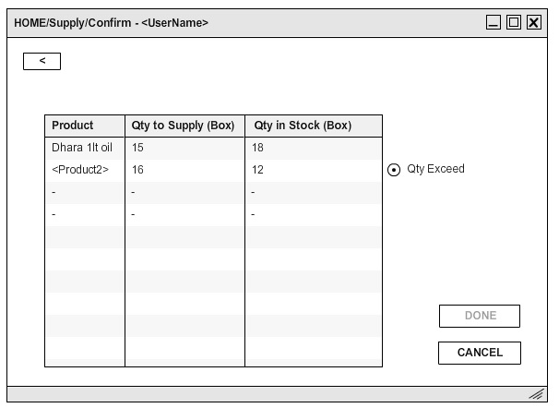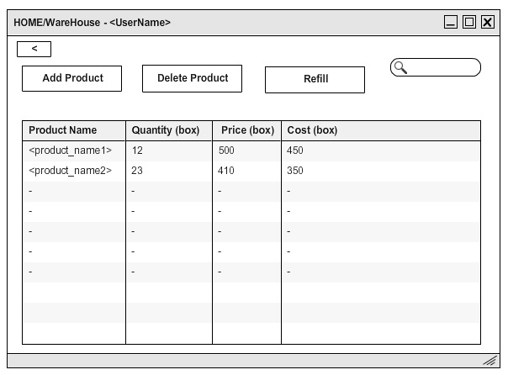

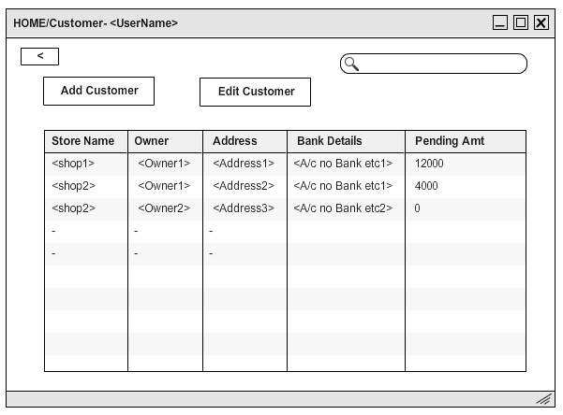

4.0 Reuse and relationships to other products
The product has been developed from scratch, thus it does not use any of the works previously done. Moreover, in order to avoid any errors and unauthorized access to data via unethical methods, the number of third party apps and templates have been kept to a minimum. However, we have opted to use the current version of MySQL as our database, due to its simplicity and being the largest open source and most widely used database, there are few chances of data getting in wrong hands. However, in the interest of making the software more attractive and user-friendly, we have kept open the possibility of a few open source software which can help develop the software at a faster rate such as electron, which can be used to make the software platform independent. However, as due to large sums of money involved, we have given more priority to the security and robustness of the system, and decided to not keep applications and templates by small brands and free lancers due to the possibility of errors and backdoors. Such applications effect the software's robustness negatively and thus it was decided in favor of developing direct connections and less user friendly tools to keep security intact.

5.0 Design decisions and tradeoffs
- Continuous Upload - The upload button is for uploading the data on cloud storage. One might ask, why is there is separate button for it? It will be very convenient if all the data gets uploaded the moment it is saved on their PC. This option, though very appealing, had to be dropped, because a continuous connection to the internet can be hacked more easily, compared to it being done at selective times. Also, the client does not have a full time internet connection. Keeping these 2 things (security and client resources) in mind, the idea of continuous upload was dropped for the meanwhile.
- Login with email id - Instead of a user name, the user logs in with their email id. The email id registration has been done so keeping in mind that the best way to inform a person about whether their account is being hacked, is by their email. But since the target audience consists of mostly middle aged people, who might not want to be bothered much by complex technology, we have kept things as simple as possible.
- Separate Log for separate options - The idea of a separate log for separate options was thought of to keep records near the place where their data originated from - within the sub-options of every choice on the dashboard itself. The problem with this choice was that if the user wanted to see the log of Inventory and Supply together, then this would not be possible, and keeping a separate option alongside will increase redundancy. To counter the above, a Master Log is maintained, where one has the option of sorting and filtering logs as per their choice.
- Bill Book maintaining canceled orders - The canceled orders are maintained in the Bill Book with the sole purpose of emulating the real-life version of the process.
- Expiry option in Warehouse - Products can expire after being kept in godowns for a long time. They have to be handled separately, but the real life possibility in this near to zero, hence no option (currently).
- Separate side panel on supply - The side panel would help a lot while the user calculates orders to be supplied for the day, but keeping that option would have reduced the space we had for displaying the various columns of the orders, and hence made it quite intangible looking and mixed up.
- Automatic expiry calculation - From this service, the software by itself calculates the expiry dates of products and warns the user. This function could not be implemented due to lack of availability of proper hardware with the client.

6.0 Pseudocode for components

LoginButton_Click()
{
Xname = getfromdatabase(username);
Xpass = getfromdatabase(password);

If(xname == usernametextbox.Text && xpass == passwordtextbox.Text)
{
changePage(new homepage());
}
Else
{
MessageBox(“Wrong UserID or Password”);
}
}

CUSTOMER :

addCustomerButton_Click()
{
If(!checkinDB(newcustomerbox.Text) & mobile = 10digits & address != null)
{
addinDB(customer details);
}
Else
MessageBox(“Invalid data”);

}

editCustomerButton_Click()
{
If(checkinDB(customrtextbox.Text) & mobile = 10digits & address != null)
{
EditinDB(product details);
}
Else
MessageBox(“Invalid data”);

}

WAREHOUSE

addnewproduct_click()
{
If(!checkinDB(newProducttextbox.Text) & amt !=0 & price != 0)
{
addinDB(product details);
}
Else
MessageBox(“Invalid data”);
}

refillproduct_click()
{
If(checkinDB(newProducttextbox.Text) & newstock != 0)
{
Stock = old + newstock;
EditinDB(product details with new stock);
}
Else
MessageBox(“Invalid data”);
}

BILL BOOK

Newbill_click()
{
If(checkinDB(Products_list) & checkinDB(customername) & list.count != 0)
{
addinDB( bill_details with status created);
}
Else
MessageBox(“Invalid data”);
}

SUPPLY

Supplybutton_click()
{
If(stock has enough items to fulfill supply)
editinDB(change status of bill to supplied);
else
Message(“Not enough Stock”)
}

Cancelbill_click()
{
editinDB(change status of bill to canceled);
}

LEDGER

Payamt_Click()
{
If(amt < due)
{
Due = due – amt;
EditinDB(Change due amt = due);
}
Else if(amt == due)
{
Due = 0;
EditinDB(change due to 0 and status to completed);
}
Else
Message(“Payment cannot exceed due amt”);
}

*Mentioned pseudocode is for the main functions that access Database…
functions like billbooktab_click() which navigates page to billbook page are not mentioned with other validation functions.

**all edit , add functions executes “addinDB(log_table, with info of the action performed)”

** billbook, supply, customer, warehouse, log, ledger Page when loaded executes following fuction:
Loaded()
{ datagrid.data = gettable(“table_name”,”<optional/condition>”); }

