Software Requirements Specification
for
Distributor’s Business Management Software
Version 1.0 approved
Prepared by Sakshi Jain, Samaksh Singhal, Sibin Kartik Tiwari, Shivam adav, Tanushree Tumane, Yash Bhatambare
NIIT University
21 Sep ‘16
Table of Contents
Table of Contents ii
Revision History ii
1. Introduction 1
1.1 Purpose 1
1.2 Document Conventions 1
1.3 Intended Audience and Reading Suggestions 1
1.4 Product Scope 1
1.5 References 1
2. Overall Description 2
2.1 Product Perspective 2
2.2 Product Functions 2
2.3 User Classes and Characteristics 2
2.4 Operating Environment 2
2.5 Design and Implementation Constraints 2
2.6 User Documentation 2
2.7 Assumptions and Dependencies 3
3. External Interface Requirements 3
3.1 User Interfaces 3
3.2 Hardware Interfaces 3
3.3 Software Interfaces 3
3.4 Communications Interfaces 3
4. System Features 4
4.1 Customer database 4
4.2 Backup Features 4
4.3 Track Employee Tasks and Performance 4
4.4 Inventory Management 4
4.5 Add Bills 4
4.6 Bill Book 4
4.7 Ledger 4
5. Other Nonfunctional Requirements 4
5.1 Performance Requirements 4
5.2 Safety Requirements 5
5.2 Security Requirements 5
5.3 Software Quality Attributes 5
5.5 Business Rules 5
6. Other Requirements 5
Appendix A: Glossary 5
Appendix B: Analysis Models 5
Appendix C: To Be Determined List 6

Revision History
Name | Date | Reason For Changes | Version

Introduction

Purpose
Welcome! This is the SRS document for the software version 1.0. This SRS document covers the purpose, requirements, safety and security, and the basic technicalities and functionalities of the product.

Document Conventions
Headings and subheadings are highlighted by bold, with headings being of font 18 and the sub headings 14. Lower headings are underlined. The text is written in 11 (Times New Roman).

Abbreviations/Short Forms used:
- UI - User Interface
- HTTP - Hyper Text Transfer Protocol
- TCP/IP - Transfer Control Protocol/Internet Protocol

Intended Audience and Reading Suggestions
This SRS is designed to be used by project managers, developers, marketing staff, testers, and users. The SRS, for all readers, would be best read in its original order, from Overall Description to External Interface Requirements, extending to special features and non functional requirements. References would be found in section 1.5.

Product Scope
See 2.1

References
http://www.microtoolsinc.com/Howsrs.php

http://www.pages.drexel.edu/~sga72/docs/SRSwithUseCases.pdf

http://www.slideshare.net/copo7475/inventory-management-system-16598132

http://www.cse.chalmers.se/~feldt/courses/reqeng/examples/srs_example_2010_group2.pdf

file:///C:/Users/test/Downloads/Requirements%20Document.pdf

file:///C:/Users/test/Downloads/inventorymanagementsystem-130218032715-phpapp02.pdf

Overall Description

Product Perspective
This is the era of digitization, where everything from shops to communication to businesses are being done on the computer, replacing older pen-and-paper systems, which were inefficient, and prone to inaccuracy due to data being prone to human error. This software is a replacement of such a system currently in use by distributors across, with enhanced features such as employee performance, profit calculations, inventory management and a lot more.

Product Functions
The product must allow the user to
- Add bills
- Manage Inventory
- Maintain a customer database
- Track employee tasks and performance
- Have a record of pending and paid bills (Ledger)
- Have a separate read-only Bill Book (for record and taxation purposes)

Use Case Diagram

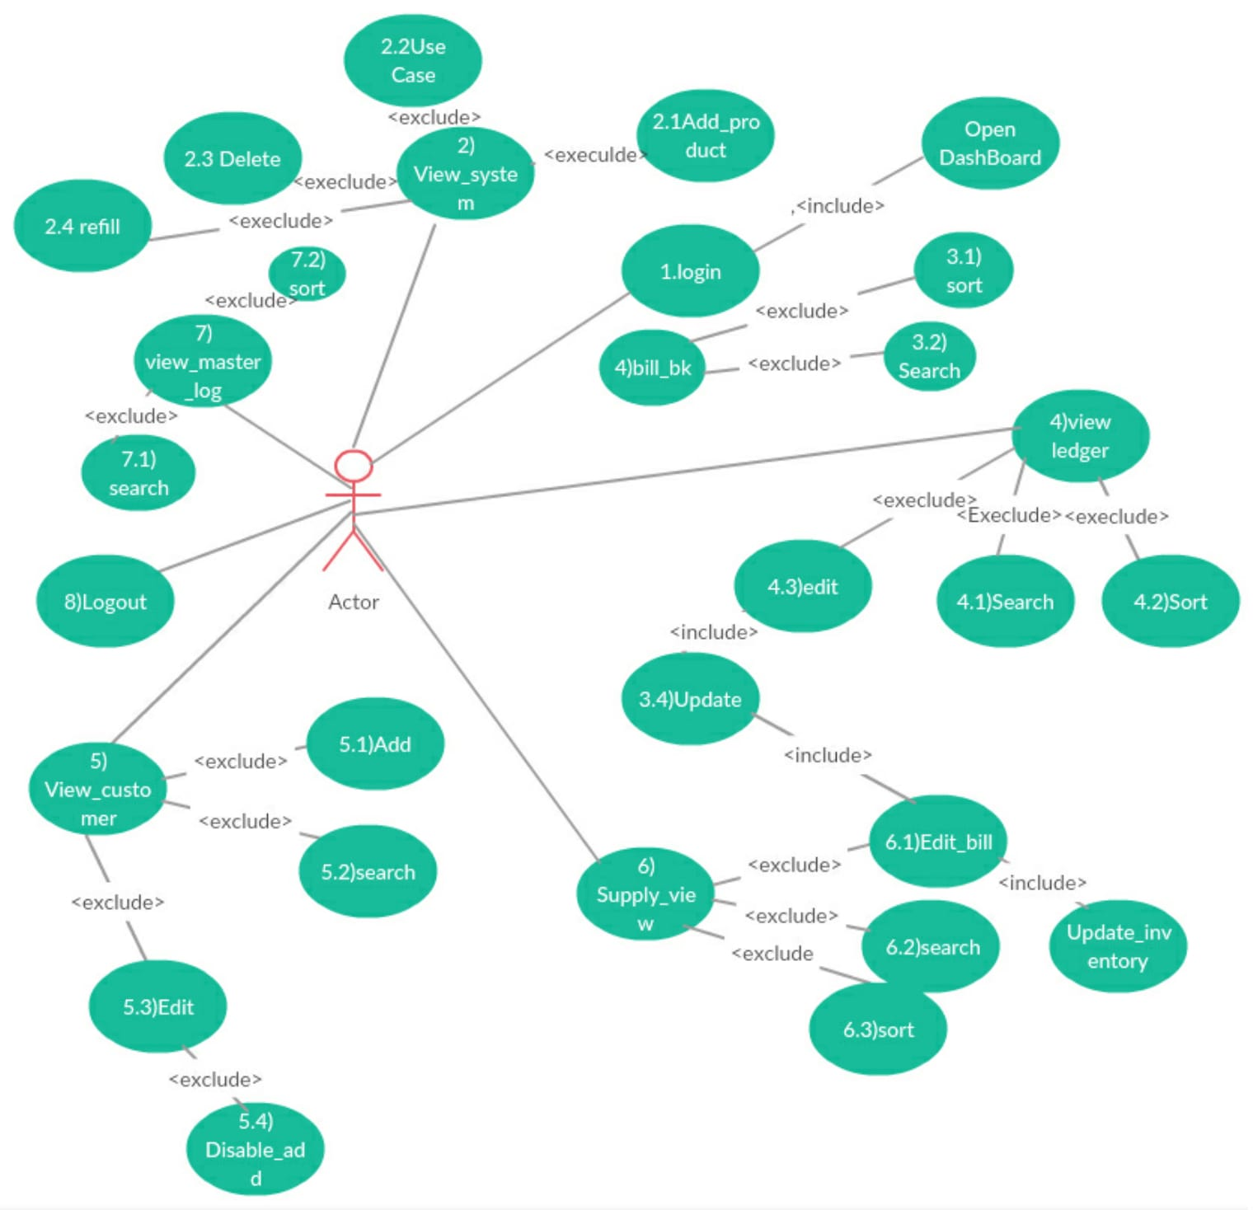

User Classes and Characteristics
This is a customized software, the target audience being product distributors, the products belonging to FMCG (Fast Moving Consumer Goods) - high volumes, low contribution margins, extensive distribution networks and high stock turnover. We classify them according to their type of products.

- Edibles
Edibles, products meant for intake. They have a smaller shelf life, hence importance is to be given on their expiry/best before dates, as consumption of spoiled products can be dangerous. In addition, these kind of products are also prone to spoilage or attacks by rodents, insects, bacteria, and other elements, which reduce their quality. These happenings are not very rare and have to be considered. They can be further categorized as:
- Edible Oils
- Dairy Products (milk, ghee, curd, ice-cream)
- Grains and Cereals
- Bakery Products
- Home and Personal Care or Non Edibles
Home and Personal care items for a large share of FMCG products, and are also some of the highest grossing. The items range from home cleaners and detergent soaps to oral care and personal hygiene to body creams and various beauty products.

Among these, our focus is on the edible products, with priority focus on the edible oils sector.

Operating Environment

The software is designed to work on all versions of windows 7 and above. It will work on all Desktop PCs and Laptops. There will be no downloads required apart from the software itself.

Design and Implementation Constraints
This software is a single user software. The login can be done only using email-id and password. There has to be extreme accuracy and no scope for error or intrusion (by malicious hackers), since it is money and reputation of the user. Data should be accessible (and at the same time uploadable) quickly without taking much time. The UI has to be extremely user friendly since the users may not be from a very “IT-sound” background and a complex UI will work against them, causing them to sometimes enter invalid or redundant data, and lowering consumer satisfaction . Programming would be done in “comment then code” fashion, design conventions standard. We have to use c# since we designing using dot net framework. The software would be maintained by the team.

User Documentation
A user’s manual, stating the working of the software, the User Interfaces, the hardware and software requirements, etc will be delivered along with the product. There will be support given from the team for the setup of the software. Any queries, doubts, or problems about the software can be mailed and the team will see that it is considered appropriately.

Assumptions and Dependencies
This project is going to be programmed from the ground, and therefore there is not going to be any third party code used in the software. The UI will be designed using WPF (Windows Presentation Foundation).

From the user’s side, it is assumed that the user has sufficient memory and processing speed to support the software. Also, the user should have basic knowledge of computers, enough to operate the system on their own. A stable net connection (with atleast 0.5 mbps speed) is minimal. The user should also have a email account and be familiar with the ways of sending and receiving messages via the Internet.

External Interface Requirements

User Interfaces
Error messages display

To prevent errors as much as possible, drop down menus would be used which will take their options from the customer, salesman, and inventory databases. However, in cases of error still (invalid data, leaving bill in middle) will first generate a warning message, following which the user decides their course of action to be followed.

Upload and Refresh Data

Data can be updated to cloud whenever any change is made. Refreshing of data is automatic - data refresh, i.e. cross-checking of data with server and updation of the missing details, is a triggered action (just after the upload is done), so the user doesn’t need to do it twice.

User Display Specifications

- Standard buttons - The buttons “Back” and “Home” will appear on every screen except the dashboard.
- Upload and Print Button - The upload button will be available only on screens where information is being added (and not just viewed). The print command can be given from required pages (available in offline mode only).
- Layout - The options/choices of a particular screen will be displayed on the top, starting from left. A search bar will appear on the upper-right corner of the screen. Data shown or to be entered will follow. The Dashboard will have the main actions (eg: add a customer, view bill book, view ledger, etc).
- Top - On the top will be a banner stating the business’s name and/or logo.

Hardware Interfaces
Data used is of mainly 3 types - integer, character array, and boolean
Communication Protocols - TCP/IP

Recommended
- Ram - 1 GB
- Disk space (excluding data size) - 500 mb
- Processor - Intel i3
- Protocols used - HTTP, TCP/IP

Software Interfaces
- Operating System - Windows 7 or higher
- MS Sql should be installed

Communications Interfaces
- TCP/IP for transfer of data - We require a fixed connection where the server and client will need to communicate with each other, and TCP does just the same. It establishes connections, and once its done, data can be sent bidirectionally. It is suited for applications which require high reliability.

- HTTP Communication Standards - HTTP uses existing persistent connections for better performance. While pipelining makes multiple access easier, no command/response flow (one command, one response) minimizes extra round trips. HTTP also does automatic compression to ensure that more information can travel in less data.

- Physical Link - Since the only networking required is between the server and client with a single point of control, the Internet is the only medium to be used.

System Features

Login
4.1.1 Description and Priority
The Login page is the first page the user sees. The user logs in with their unique email id and password, which leads them to the Dashboard. Entering the wrong credentials will redirect the user to the same page. Maximum no of tries allowed are 5, following which an incorrect password would be considered a hack attempt.
4.1.2 Stimulus/Response Sequences
Stimulus : User entered correct credentials.
Response : User will be directed towards their corresponding dashboard..

Stimulus : User entered incorrect credentials for the 6th time.
Response : Software will close, sending a mail to the id about a possible hack attempt, and that account will be locked (to be opened by an OTP).
4.1.3 Functional Requirements
TBA

Maintain customer database
4.2.1 Description and Priority
Each customer has their own set of attributes, which may change over time. A record of them should be maintained, with updates done wherever necessary. There should also be records of different shops owned by the same customer, as well as a check on which shops have closed, so that even by mistake, an order should not be passed to it.
4.2.2 Stimulus/Response Sequences
Stimulus : A customer has changed their address
Response : The software will consider the updated address and fill in the same while typing the bill.

Stimulus : A customer has opened a new store.
Response : The software will see that there are 2 addresses, and will ask which one to use during billing and other things.
4.2.3 Functional Requirements
TBA

Backup Features
4.3.1 Description and Priority
In case the user’s system crashes, broken, or simply unable to function, then the user can log on to another system and enter their login id and password and retrieve their information, which is stored on a cloud server.
4.3.2 Stimulus/Response Sequences
Stimulus: Computer suddenly switches off due to no power
Response : All the work done by the user is already saved in cloud. So, The user can charge the PC and continue with their work.

Stimulus: Computer does not open due to (other) hardware or software issues
Response : User can log on to another PC with this software and continue working.

4.3.3 Functional Requirements
TBA

Track Employee Tasks and Performance
4.4.1 Description and Priority
Keeps record of what all tasks are assigned to employees, in which area, on what date and so. Also keeps record of performance of employees, which can be tracked over a time period (start date and end date user-customizable) .
4.4.2 Stimulus/Response Sequences
Stimulus : Which employee went to Bandh Nagar last week?
Response : Open the “Employee” tab from the Dashboard. From there, type the particulars and obtain the data.

Stimulus : One employee has been performing poorly.
Response : User sees employee’s performance has been dropping since last week. Summons the employee, asks him the reason. Turns out he has fever. Given medical leave. Increase in employee satisfaction.

Stimulus : One employee brought good orders today.
Response : It turns out, the employee has been working hard and bringing the majority of the orders. On seeing good performance, rewards employee with incentive. Increase in employee satisfaction and encourages good performance.

4.4.3 Functional Requirements
TBA

Inventory Management
4.5.1 Description and Priority
For any distributor, inventory is one part where things have to be managed carefully. There is stock coming in, going out, new additions, as well as products being expired or spoiled by rodents or bacteria. The Inventory Management has been designed keeping all these issues in hand.
4.5.2 Stimulus/Response Sequences
Stimulus : 3 cartons of oil get expired.
Response : User enters them as “expired”. Software records them separately. The user can see if the frequency of spoilage is high and take necessary action.

Stimulus : Sales of dhara oils is increasing. Decision - whether to order more or not.
Response : User checks dhara oil records, made a lot more easier by the computerized method, and finds 100 cartons already in stock. More can result in spoilage. Decides against ordering.
4.5.3 Functional Requirements
TBA

Add Bills
4.6.1 Description and Priority
This, as the name suggests, is for adding bills of confirmed orders. The user has to just type the name, and other details, such as shop address, are filled automatically (except when there are more than one shops). The software uses information from the database to eliminate redundant choices and therefore keep the bill virtually error free.
4.6.2 Stimulus/Response Sequences
Stimulus : Customer wants 2 cartons of 1L refined oil bottles. There are 1.5l, 2L, an 5L bottles available, but 1L bottles are out of stock.
Response : When the user types refined oil, it will show 1L in red which implies out of stock and will give a warning before finalizing the bill. If the user still chooses to go with it, than no matter what the user had typed, the bill will show 0 bottles.

Stimulus : While typing the bill, user mistakenly types the old address, which is not to be used now (human error).
Response : Software will give a warning before finalizing the bill, and hence helps remove a human error.
4.6.3 Functional Requirements
TBA

Bill Book
4.7.1 Description and Priority
Bill Book is user read-only file kept for keeping track of what all orders have been done till date. The Bill book can be sorted and searched, but not modified.
4.7.2 Stimulus/Response Sequences
Stimulus : User wants to check bills till now for setting discount schemes targeting high order customers.
Response : User can simply go to the bill book and sort the bills by their amount, and can set discount schemes accordingly.

Stimulus : Customer refuses to have ordered a certain product.
Response : User can see it in the Bill Book and check whether the customer is saying the truth or lying.
4.7.3 Functional Requirements
TBA

Ledger
4.8.1 Description and Priority
“Ledger” keeps a record of all the active bills i.e. bills whose orders have been delivered but the money hasn’t come yet, or the payment is partial, which happens a lot in distributor markets. These records are obviously editable, and when the bill has been cleared, the record implicitly goes to the Bill Book and is removed from the Ledger. A reminder can also be set for collection of the due amount.
4.8.2 Stimulus/Response Sequences
Stimulus : Customer paid only half of the bill. The order was delivered 3 weeks back.
Response : User had earlier entered the reminder as 3 weeks. A notification comes, reminding the user to collect their money from the customer.

Stimulus : Customer is asking for a big order.
Response : User checks the Ledger and sees that this customer already has a huge amount due. Takes decision accordingly.

4.8.3 Functional Requirements
TBA

Other Nonfunctional Requirements

Performance Requirements
There are no such performance requirements. The software will work the same and work to its maximum capacity in the recommended interfaces itself (see 3.2).

Safety Requirements
Following features to be taken care of:
- Entries given in Warehouse are to be entered carefully, since once typed, then can be updated only by adding Bills or in Spoilage.
- Once a Bill is cleared, it cannot be deleted.

In normal usage, there won’t be any data loss, damage, or any harm that could result from this product. Still, as an exception, in case of data loss due to system issues, the data can be retrieved by another system using the login id and password. In case of forgot password option, a mail will be sent to the registered id,and from there the user will be directed on their own.

Safety Requirements
The software doesn’t take responsibility on corruption of data due to lack of email security, or in case of password not being kept confidential, leading to an intruder accessing the software and corrupting the data. The software will not be responsible for losses to the distributor.

Software Quality Attributes
- Correctness - The software successfully digitizes the pen-and-paper work of distributors.
2. Reliability - It computer accurately every time.
3. Efficiency - The software runs fast, using optimized coding, technologies and protocols mentioned above.
4. Maintainability - The software is fixed. It can be enhanced in its capabilities (eg: including barcode), and extended to work on other hardware systems (eg: mobile)
5. Usability - The software is made very user friendly and can be run by the average user without much effort.
6. Robustness - Using CSS, it handles bad data appropriately.

Business Rules
There is only a single point of control, which is done by the owner (or the person designated to operate the software by the owner). However, the user can also log on to their account from another system which has the software.
Appendix A : Glossary
Backup- a copy of a file or other item of data made in case the original is lost or damaged.
User - The owner or the person operating the software
Intruder - Anyone who is wrongfully trying to access data
Digitization - converting from pen-and-paper mode to computer
Optimized Code - Reduced code with better efficiency
Appendix B : To Be Determined List
TBD references in points 4.1.3, 4.2.3, 4.3.3, 4.4.3, 4.5.3, 4.6.3, 4.7.3, 4.8.3

