Software Requirements Specification
for
<Distributor’s Business Management Software (DBMS)>
Version 1.0 approved
Prepared by <Samaksh Singhal>
<NIIT University>
<21st September, 2016>
Table of Contents
Table of Contents ii
Revision History ii
1. Introduction 1
1.1 Purpose 1
1.2 Document Conventions 1
1.3 Intended Audience and Reading Suggestions 1
1.4 Product Scope 1
1.5 References 1
2. Overall Description 2
2.1 Product Perspective 2
2.2 Product Functions 2
2.3 User Classes and Characteristics 2
2.4 Operating Environment 2
2.5 Design and Implementation Constraints 2
2.6 User Documentation 2
2.7 Assumptions and Dependencies 3
3. External Interface Requirements 3
3.1 User Interfaces 3
3.2 Hardware Interfaces 3
3.3 Software Interfaces 3
3.4 Communications Interfaces 3
4. System Features 4
4.1 System Feature 1 4
4.2 System Feature 2 (and so on) 4
5. Other Nonfunctional Requirements 4
5.1 Performance Requirements 4
5.2 Safety Requirements 5
5.3 Security Requirements 5
5.4 Software Quality Attributes 5
5.5 Business Rules 5
6. Other Requirements 5
Appendix A: Glossary 5
Appendix B: Analysis Models 5
Appendix C: To Be Determined List 6

Revision History
Name | Date | Reason For Changes | Version

Introduction

Purpose
The purpose is to create a handy tool in the form of software which will digitalize the working of a distribution business and help the owner to have a good grip on his business, by efficient reporting system which can equip the owner with real-time stats of his outstanding stock and revenue.
Our one of the major purpose is to deliver the product to the target customer which will create or will give the customer a competitive advantage over their competitors.

Document Conventions
The document will strictly follow the flow of priority .i.e. the topic above will be more important than the lower ones. Recommended font size is strictly followed all over the document i.e. heading will be times 14 and body will be Arial 11. Minimum redundancy is also tried to be obtain in this file.

Intended Audience and Reading Suggestions
The document is intended for all the stakeholders, users, marketing staff, project managers, Developers and testers. The rest of the SRS contains a brief description and scope of our project like how is it useful and its working etc. The document is therefore organized in a sequential pattern for the ease of the reader. Reading the document sequence wise is suggested from my point of view.

Product Scope
The software provides an Interface for the Distributors business providing them the facility of Inventory Management, Customer and sales management, Billing, and Account management. The Objective of the software is to improve efficiency, reduce redundancy, and improve security. The goal is to help the user manage the business more efficiently without wasting time on searching and managing files.

References
http://www.microtoolsinc.com/Howsrs.php

http://www.pages.drexel.edu/~sga72/docs/SRSwithUseCases.pdf

http://www.slideshare.net/copo7475/inventory-management-system-16598132

Overall Description

Product Perspective

The origin of product specified in the SRS is a replacement of existing system.
Existing System: Everything is managed by the owner manually on pen and paper.
Proposed System: Digitalize the working of the system this will be like a tool to manage the business efficiently.
It is very difficult for the manager to manage all the activities efficiently on pen paper this software will not only boost the efficiency of the business but also the productivity of the people associated will increase.

Product Functions
Use Case:

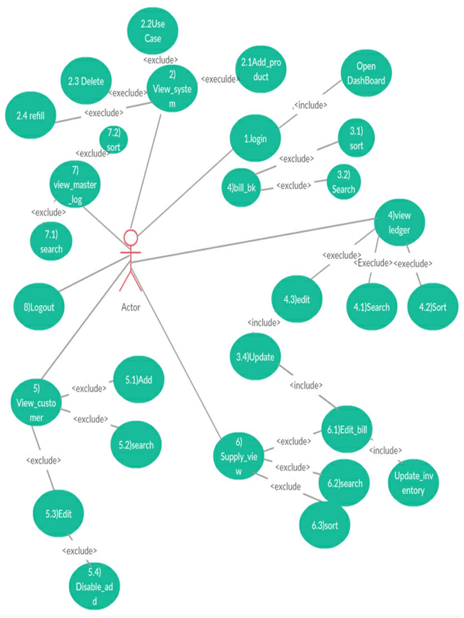

User Classes and Characteristics
Distributor’s software is customized software, the target customer being product distributors, the products belonging to FMCG (Fast Moving Consumer Goods). We classify them according to their type of products.

- Consumable goods
Products meant for intake. Importance is to be given on their expiry/best before dates, as consumption of spoiled products can be dangerous. In addition, these kind of products are also prone to spoilage or attacks by rodents, insects, bacteria, and other elements, which reduce their quality. These happenings are not very rare and have to be considered. They can be further categorized as:
- Edible Oils
- Dairy Products (milk, ghee, curd, ice-cream)
- Grains and Cereals
- Bakery Products
- Home and Personal Care or Non Edibles

Among these, our focus is on the edible products, with priority focus on the edible oils sector.

Operating Environment
Distributors Software is designed to work on all versions of windows 7 and above, on Desktop PCs and Laptops. There will be no downloads required apart from the software itself.

Design and Implementation Constraints
There is no need for login of software itself because the software will be on manager’s personal computer or the PC on workstation which will be having a password of its own, but for advanced security we are giving an option of login to the user.
The login can be done only using email-id and password. There is no scope for error or intrusion (by malicious hackers) because the software does not need network access, since it is money and reputation of the user we have to make system more robust. Data should be quickly without taking much time. The UI has to be extremely user friendly since the users may not be from a very “IT-sound” background and a complex UI will work against them, causing them to sometimes enter invalid or redundant data, and lowering consumer satisfaction . The software would be maintained by the team.

User Documentation
A user’s manual, stating the working of the software, the User Interfaces, the hardware and software requirements, etc. will be delivered along with the product. There will be support given from the team for the setup of the software. Any queries, doubts, or problems about the software can be mailed and the team will see that it is considered appropriately.

Assumptions and Dependencies
The database we will be using can cause the SRS to be changed a little bit for example if we use MS SQL it has to be downloaded on the system before the software is installed on the machine.
The UI will be designed using WPF (Windows Presentation Foundation).

From the user’s side, it is assumed that the user has sufficient memory and processing speed to support the software. Also, the user should have basic knowledge of computers, enough to operate the system on their own. The user should also have a email account and be familiar with the ways of sending and receiving messages.

External Interface Requirements

User Interfaces
- Standard buttons - The buttons “Back” and “Home” will appear on every screen except the dashboard.
- Upload and Print Button - The upload button will be available only on screens where information is being added (and not just viewed). The print command can be given from required pages.
- Layout - The options/choices of a particular screen will be displayed on the top, starting from left. A search bar will appear on the upper-right corner of the screen. Data shown or to be entered will follow. The Dashboard will have the main actions (e.g.: add a customer, view bill book, view ledger, etc.).
- Top - On the top will be a banner stating the business’s name and/or logo.

ERROR Handling: software should give appropriate message when an error have occurred error should not cause any discrepancies in data.

Hardware Interfaces

Recommended
- Ram - 1 GB
- Disk space (excluding data size) - 500 mb
- Processor - Intel Dual core and above

Software Interfaces
Operating System ------- is successfully supported in Windows 7 and above versions.
2. Database done using MySQL in MySQL server
3. UI using (tool) WPF (Windows Presentation Foundation)
4. Communications using C#.
6. Cloud technologies used for storage (backup) google drive.

Communications Interfaces
In our proposed system server and client resides on the same system so there is a inter computer communication. But for the purpose of security we are having database backup file on google drive in case of system crash it will help.
Email id - required for login to the software (along with the password). An id is unique for an account i.e. the relationship between them is one-to-one. Following that, if the user forgets the password, the email id is going to serve as the person’s recognition.

System Features

Maintaining database
4.1. A Description and Priority
Each customer has their own set of attributes, which may change over time. A record of them should be maintained, with updates done wherever necessary. There should also be records of different shops owned by the same customer, as well as a check on which shops have closed, so that even by mistake, an order should not be passed to it.
4.1. B Stimulus/Response Sequences
Stimulus: A customer has changed their address
Response: The software will consider the updated address and fill in the same while typing the bill.

Stimulus: A customer has opened a new store.
Response: The software will see that there are 2 addresses, and will ask which one to use during billing and other things.
4.1. C Functional Requirements
TBA

Backup
4.2. A Description and Priority
In case the user’s system crashes, broken, or simply unable to function, then the user can log on to another system and enter their login id and password and retrieve their information, which is stored on a cloud server.
4.2. B Stimulus/Response Sequences
Stimulus: Computer suddenly switches off due to no power
Response: All the work done by the user is already saved in cloud. So, the user can charge the PC and continue with their work.

Stimulus: Computer does not open due to (other) hardware or software issues
Response: User can log on to another PC with this software and continue working.

4.2. C Functional Requirements
TBA

Inventory Management
4.3. A Description and Priority
For any distributor, inventory is one part where things have to be managed carefully. There is stock coming in, going out, new additions, as well as products being expired or spoiled by rodents or bacteria. The Inventory Management has been designed keeping all these issues in hand.
4.3. B Stimulus/Response Sequences
Stimulus: 3 cartons of oil get expired.
Response: User enters them as “expired”. Software records them separately. The user can see if the frequency of spoilage is high and take necessary action.

Stimulus: Sales of dhara oils is increasing. Decision - whether to order more or not.
Response: User checks dhara oil records, made a lot more easier by the computerized method, and finds 100 cartons already in stock. More can result in spoilage. Decides against ordering.
4.3. C Functional Requirements
TBA

Add Bills
4.4. A Description and Priority
This, as the name suggests, is for adding bills of confirmed orders. The user has to just type the name, and other details, such as shop address, are filled automatically (except when there are more than one shops). The software uses information from the database to eliminate redundant choices and therefore keep the bill virtually error free.
4.4. B Stimulus/Response Sequences
Stimulus: Customer wants 2 cartons of 1L refined oil bottles. There are 1.5l, 2L, an 5L bottles available, but 1L bottles are out of stock.
Response: When the user types refined oil, it will show 1L in red which implies out of stock and will give a warning before finalizing the bill. If the user still chooses to go with it, than no matter what the user had typed, the bill will show 0 bottles.

Stimulus: While typing the bill, user mistakenly types the old address, which is not to be used now (human error).
Response: Software will give a warning before finalizing the bill, and hence helps remove a human error.
4.4. C Functional Requirements
TBA

Bill Book
4.5. A Description and Priority
Bill Book is user read-only file kept for keeping track of what all orders have been done till date. The Bill book can be sorted and searched, but not modified.
4.5. B Stimulus/Response Sequences
Stimulus: User wants to check bills till now for setting discount schemes targeting high order customers.
Response: User can simply go to the bill book and sort the bills by their amount, and can set discount schemes accordingly.

Stimulus: Customer refuses to have ordered a certain product.
Response: User can see it in the Bill Book and check whether the customer is saying the truth or lying.
4.5. C Functional Requirements
TBA

Ledger
4.6. A Description and Priority
“Ledger” keeps a record of all the active bills i.e. bills whose orders have been delivered but the money hasn’t come yet or the payment is partial, which happens a lot in distributor markets. These records are obviously editable, and when the bill has been cleared, the record implicitly goes to the Bill Book and is removed from the Ledger. A reminder can also be set for collection of the due amount.
4.6. B Stimulus/Response Sequences
Stimulus: Customer paid only half of the bill. The order was delivered 3 weeks back.
Response: User had earlier entered the reminder as 3 weeks. A notification comes, reminding the user to collect their money from the customer.

Stimulus: Customer is asking for a big order.
Response: User checks the Ledger and sees that this customer already has a huge amount due. Takes decision accordingly.

4.6. C Functional Requirements
TBA

Other Nonfunctional Requirements

Safety Requirements
In normal usage, there won’t be any data loss, damage, or any harm that could result from this product. Still, as an exception, in case of data loss due to system issues, the data can be retrieved by another system using the login id and password. In case of forgot password option, a mail will be sent to the registered id, and from there the user will be directed on their own.

The backup of the software will be always there on google drive of the registered user.

Software Quality Attributes
- Correctness - The software successfully digitizes the pen-and-paper work of distributors.
2. Reliability - It computer accurately every time.
3. Efficiency - The software runs fast, using optimized coding, technologies and protocols mentioned above.
4. Maintainability - The software is fixed. It can be enhanced in its capabilities (e.g.: including barcode), and extended to work on other hardware systems (e.g.: mobile)
5. Usability - The software is made very user friendly and can be run by the average user without much effort.

Business Rules
There is only a single point of control, which is done by the owner (or the person designated to operate the software by the owner). However, the user can also log on to their account from another system which has the software.

