Software Requirements Specification
for
Distributors Business Management Software
Version 1.0 approved
Prepared by Yash Bhatambare
NIIT
18/19/16
Table of Contents
Table of Contents ii
Revision History ii
1. Introduction 1
1.1 Purpose 1
1.2 Document Conventions 1
1.3 Intended Audience and Reading Suggestions 1
1.4 Product Scope 1
1.5 References 1
2. Overall Description 2
2.1 Product Perspective 2
2.2 Product Functions 2
2.3 User Classes and Characteristics 2
2.4 Operating Environment 2
2.5 Design and Implementation Constraints 2
2.6 User Documentation 2
2.7 Assumptions and Dependencies 3
3. External Interface Requirements 3
3.1 User Interfaces 3
3.2 Hardware Interfaces 3
3.3 Software Interfaces 3
3.4 Communications Interfaces 3
4. System Features 4
4.1 System Feature 1 4
4.2 System Feature 2 (and so on) 4
5. Other Nonfunctional Requirements 4
5.1 Performance Requirements 4
5.2 Safety Requirements 5
5.3 Security Requirements 5
5.4 Software Quality Attributes 5
5.5 Business Rules 5
6. Other Requirements 5
Appendix A: Glossary 5
Appendix B: Analysis Models 5
Appendix C: To Be Determined List 6

Revision History
Name | Date | Reason For Changes | Version

Introduction

Purpose
The purpose of this document is to present a detailed description of the Distributors management Software. It will explain the purpose and features of the system, the interfaces of the system, what the system will do, the constraints under which it must operate and how the system will react to external environment. This document is intended for both the Owner and the developers of the system.

Document Conventions
Any highlighted words have higher significance, bold and bigger font words are headings and subheadings. And every requirement statement has its own priority

Intended Audience and Reading Suggestions
This document is intended for stakeholders, users, project managers, testers as well as developers of the System. The documents explains the purpose and features of the system, the functions and the operations. Read the document sequentially for ease of understanding.

Product Scope
The software provides an Interface for the Distributors business providing them the facility of Inventory Management, Customer and sales management, Billing, and Account management. The Objective of the software is to improve efficiency, reduce redundancy, and improve security. The goal is to help the user manage the business more efficiently without wasting time on searching and managing files.

Overall Description

Product Perspective
This product is a replacement for existing systems like marg, the old file system where redundancy, security and efficiency are major issues. It provides an ease to understand interface for fast and reliable service.

Product Functions
The software provides various services like
- Inventory Management,
- Customer and sales management,
- Billing, and
- Account management

USE CASE:

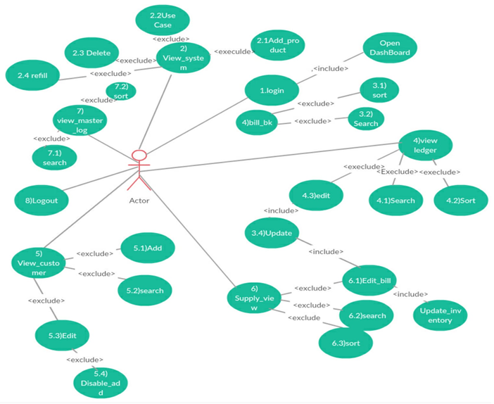

User Classes and Characteristics
The products that belong to Fast Moving Consumer Goods. We classify them according to –

Edibles, products which can be consumed. They have a small shelf life, hence importance is to be given on their expiry dates. In addition, these kind of products also tend to spoil or attacks by rodents, insects, bacteria, and other elements, which reduce their quality. These happenings are not very rare and have to be considered. They can be further categorized as:

- Edible Oils
- Fast food like chips/biscuits, etc
- Dairy Products (milk, ice-cream)
- Bakery Products

Home and Personal care items for a large share of FMCG products, and are also some of the highest grossing. The items range from home cleaners and soaps to oral care and personal hygiene and various beauty products.

Operating Environment
The Software supports windows 7 and above operating system.

Design and Implementation Constraints
The software has to be reliable and accurate because of involvement of money and for playing the part of backbone of the company, security has to be considered seriously any unauthorized access could lead to huge loss for the company. UI should be user friendly with fast performance so that the system is up to date with the data. Providing a backup option is necessary because any data loss caused by hardware failure or any reason is unacceptable.

User Documentation
A User manual will be provided with the product, which contains information on using the software,
Maintaining the scar, there will be support given from the team for any query of the software.

External Interface Requirements

User Interfaces
The user interface has been specifically designed with their users and stakeholders in mind, giving them convenience while they confirm their order. The UI makes sure at every point, that the user spends most of the time using the device rather than figuring out how to use it. The home screen or Dashboard offers menu with a list of functions that the device performs. The user can select one of the options on the menu, and is taken to the respective screen. Every screen displays the menu on the bottom. The user can click on any one of the options and is taken to the

Hardware Interfaces
Data used is of mainly 2 types – integer and character array.
Recommended
- RAM - 1 GB
- Disk space – 1 GB
- Processor - Intel core2 duo

Software Interfaces
- Operating System - Windows 7 or higher
- Most likely (MS SQL) should be installed (database not yet decided)
- (not yet discussed)

Communications Interfaces
- Internet Connection for Backup of data which can be used in case of data loss in local system.

System Features

Add Bills
4.1.1 Description and Priority
This, as the name suggests, is for adding bills of confirmed orders. The user has to just type the name, and other details, such as shop address, are filled automatically (except when there are more than one shops). The software uses information from the database to eliminate redundant choices and therefore keep the bill virtually error free.

4.1.2 Stimulus/Response Sequences
Stimulus: Customer wants 3 packs of 1L refined oil bottles. There are 1.5l, 2L, an 5L bottles available, but 1L bottles are out of stock.

Response: When the user types refined oil, it will show 1L in red which implies out of stock and will give a warning before finalizing the bill. If the user still chooses to go with it, than no matter what the user had typed, the bill will show 0 bottles.

Stimulus: While typing the bill, user mistakenly types the old address, which is not to be used now (human error).
Response: Software will give a warning before finalizing the bill, and hence helps remove a human error.

Login
4.1.1 Description and Priority
The Login page is the first page the user sees. The user logs in with their unique email id and password, which to the Dashboard. Entering the wrong credentials will redirect the user to the same page. Maximum no of tries allowed are 5, which an incorrect password would be considered a hack attempt.
4.1.2 Stimulus/Response Sequences
Stimulus: User entered correct credentials.

Response: User will be directed towards their corresponding dashboard..

Stimulus: User entered incorrect credentials for the 6th time.
Response: Software will close, sending a mail to the id about a possible hack attempt, and that account will be locked (to be opened by an OTP).

Inventory Management
4.1.1 Description and Priority
For any distributor, inventory is one part where things have to be managed carefully. There is stock coming in, going out, new additions, as well as products being expired or spoiled by rodents or bacteria. The Inventory Management has been designed keeping all these issues in hand.
4.1.2 Stimulus/Response Sequences
Stimulus: 3 cartons of oil get expired.

Response: User enters them as “expired”. Software records them separately. The user can see if the frequency of spoilage is high and take necessary action.

Stimulus: Sales of Mahakosh oils is increasing. Decision - whether to order more or not.
Response: User checks Mahakosh oil records, made a lot easier by the computerized method, and finds 50 cartons already in stock. More can result in spoilage. Decides against ordering.

Other Nonfunctional Requirements

Performance Requirements
For good performance keep the system virus free, use minimal background apps. System must have the recommended specification as mentioned in above topics.
(also refer to topic 3)

Safety Requirements
Following features to be taken care of:

- Entries in Inventory should be accurate, since once typed, then it can be updated only by adding Bills or in Spoilage.

- Once a Bill is created, it cannot be deleted.

Security Requirements
- Need a Gmail account for login and for backing up data in server.

Software Quality Attributes
1. Reliability
2. Efficiency
3. Maintainability
4. Usability

Business Rules
The business rule of our business is to develop an efficient and reliable software with easy to use interface for user’s satisfaction.

Other Requirements
Appendix A: Glossary
DBMS – Distributors Business Management Software

