IEEE STANDARD 1016: Software Design Specification

The Software Design Specification Outline
1. Introduction

1.1 Purpose of this document
This Document is a written description of our software product – Distributors business management software, it gives a low level description of the software, with insight to design and structure of components in order to give the reader overall guidance to the architecture of the software project.

1.2 Scope of the development project
This is the era of digitization, where everything from shops to communication to businesses are being done on the computer, replacing older pen-and-paper systems, which were inefficient, and prone to inaccuracy due to data being prone to human error. This software is a replacement of such a system currently in use by distributors across, with enhanced features such as employee performance, profit calculations, inventory management and a lot more.

1.3 Definitions, acronyms, and abbreviations
TO BE DONE IN END

1.4 References
- https://www.toptal.com/freelance/why-design-documents-matter
- Software engineering a practitioner’s approach Roger.S.Pressman
- IEEE 1016 standard format
- ADD MORE IN END

1.5 Overview of document
In the following sections we outline the software product in higher detail. We will start with defining the key features that will be implemented. Next, we will discuss the constraints that will be imposed upon the software and the quality ranges, in other words, the robustness, fault tolerance and usability of the software product amongst other things. In The precedence and priority section we will comment on the most important functionalities that the software product must have and the integrity of the sales system.
In The following sections will discuss all other product requirements, such as, performance requirements, platform requirements and environmental requirements. Lastly, we will comment on the documentation requirements, such as, user manuals, online help & support, installation and packaging.

2. System architecture description

2.1 Overview of modules / components
Module1 – Introduction - Login() ; Open_DashBoard()

Module2 – Inventory – Add_Product() ; Delete_Product() ; Refill_Product() ; Expired_Product() ; Edit_Product() ; Use_Product()

Module3 – Bill Book – Add_Bill() ; Search_Bill()

Module4 – Ledger – Search_Ledger() ; Edit_Ledger() ; Sort_Ledger()

Module5 – Customers – Add_Customer() ; Edit_Customer() ; Search_Customer()

Module6 – Supply – Edit_Bill_Supply() ; Search_Supply() ; Sort_Supply()

Module7 – Master Log – Search_MasterLog() ; Sort_MasterLog() ; Edit_MasterLog()

Module8 – Logout – Logout();

2.2 Structure and relationships
Make clear the interrelationships and dependencies among the various components. Structure charts can be useful here. A simple finite state machine can be useful in demonstrating the operation of the product. Include explanatory text to help the reader understand any charts.

2.3 User interface issues

1) Error messages display
To prevent errors as much as possible, drop down menus would be used which will take their options from the customer, salesman, and inventory databases. However, in cases of error still (invalid data, leaving bill in middle) will first generate a warning message, following which the user decides their course of action to be followed.

2) Upload and Refresh Data
Data can be updated to cloud whenever any change is made. Refreshing of data is automatic – data refresh, i.e. cross-checking of data with server and updation of the missing details, is a triggered action (just after the upload is done), so the user doesn’t need to do it twice.

3) Consistency in the command-Consistency of the command should employed throughout.
- Standard buttons - The buttons “Back” and “Home” will appear on every screen except the dashboard.

- Upload and Print Button - The upload button will be available only on screens where information is being added (and not just viewed). The print command can be given from required pages (available in offline mode only).

- Layout - The options/choices of a particular screen will be displayed on the top, starting from left. A search bar will appear on the upper-right corner of the screen. Data shown or to be entered will follow. The Dashboard will have the main actions (eg: add a customer, view bill book, view ledger, etc).

- Top - On the top will be a banner stating the business’s name and/or logo.

4) Informative Feedback-For each and every operator there should be a operator feedback so that the we can improve it time by time but it happens user don’t specify the id of their feedback

3. Detailed description of components

3.1 Component template description

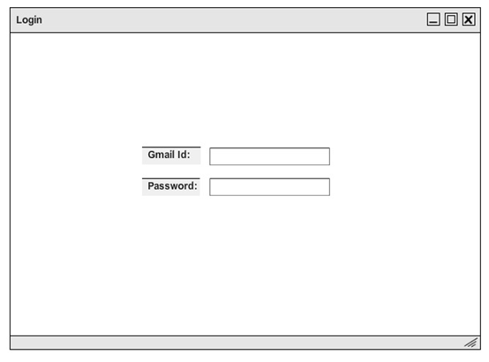

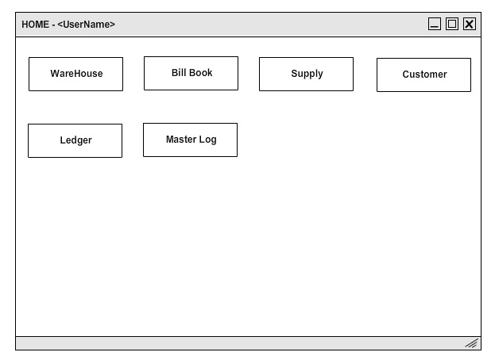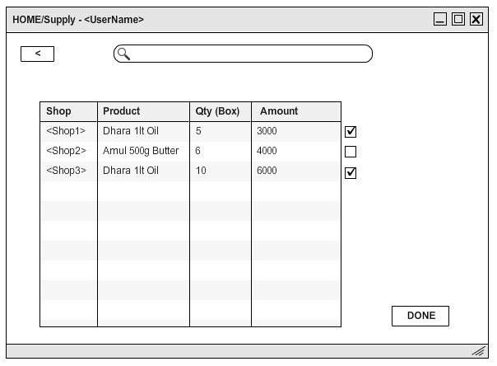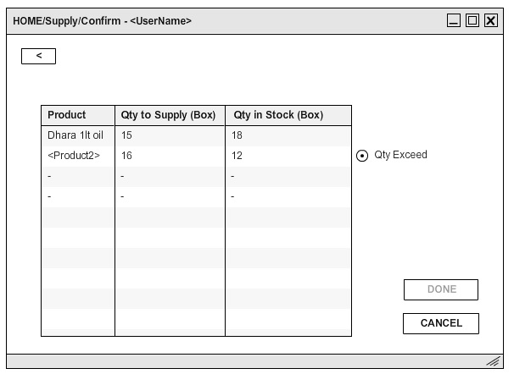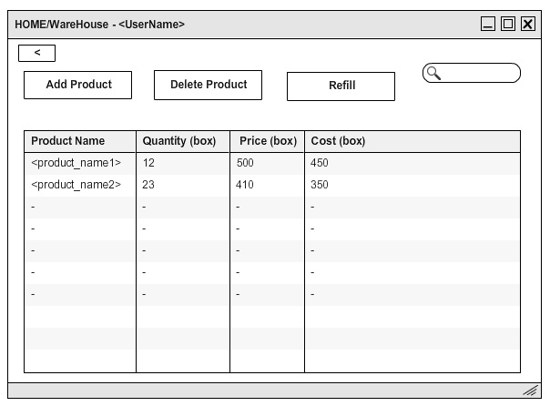

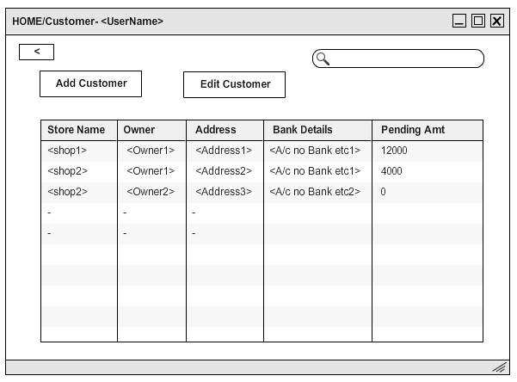

4.0 Reuse and relationships to other products
The product has been developed from scratch, thus it does not use any of the works previously done. Moreover, in order to avoid any errors and unauthorized access to data via unethical methods, the number of third party apps and templates have been kept to a minimum. However, we have opted to use the current version of MySQL as our database, due to its simplicity and being the largest open source and most widely used database, there are few chances of data getting in wrong hands. However, in the interest of making the software more attractive and user-friendly, we have kept open the possibility of a few open source software which can help develop the software at a faster rate such as electron, which can be used to make the software platform independent. However, as due to large sums of money involved, we have given more priority to the security and robustness of the system, and decided to not keep applications and templates by small brands and free lancers due to the possibility of errors and backdoors. Such applications effect the software's robustness negatively and thus it was decided in favor of developing direct connections and less user friendly tools to keep security intact.

5.0 Design decisions and tradeoffs
- Upload Button - The upload button is for uploading the data on cloud storage. One might ask, why is there is separate button for it? It will be very convenient if all the data gets uploaded the moment it is saved on their PC. This option, though very appealing, had to be dropped, because a continuous connection to the internet can be hacked more easily, compared to it being done at selective times. Also, the client does not have a full time internet connection. Keeping these 2 things (security and client resources) in mind, the idea of continuous upload was dropped and replaced with the upload button.
- Login with email id - Instead of a user name, the user logs in with their email id. The email id registration has been done so keeping in mind that the best way to inform a person about whether their account is being hacked, is by their email. The target audience consists of mostly middle aged people, who might not want to be bothered much by complex technology, and keep things as simple as possible.
- Separate Log for separate options - The idea of a separate log for separate options was thought of to keep records near the place where their data originated from - within the sub-options of every choice on the dashboard itself. The problem with this choice was that if the user wanted to see the log of Inventory and Supply together, then this would not be possible, and keeping a separate option alongside will increase redundancy. To counter the above, a Master Log is maintained, where one has the option of sorting and filtering logs as per their choice.
- Bill Book maintaining canceled orders - The canceled orders are maintained in the Bill Book with the sole purpose of emulating the real-life version of the process.
- Expiry option in Warehouse - Many times products expire after being kept in godowns for a long time. They have to be handled separately, hence the option.
- Address Disable option - In case, the user by mistake, or out of habit, my enter the previous address of a relocated shop. To prevent this, we have the option of disabling an address (in Customer tab).
- Separate side panel on supply - The side panel would help a lot while the user calculates orders to be supplied for the day, but keeping that option would have reduced the space we had for displaying the various columns of the orders, and hence made it quite intangible looking and mixed up.
- Automatic expiry calculation - From this service, the software by itself calculates the expiry dates of products and warns the user. This function could not be implemented due to lack of availability of proper hardware with the client.

6.0 Pseudocode for components

7.0 Appendices (if any)

SDS component template
The template given below suggests a reasonable structure for giving a thorough
description of each component described in Part 3 of the SDS. The specific
information depends in part on the design approach. Your team must adapt this
template to your needs and describe it in section 3.1 of your SDS.

Identification | The unique name for the component and the location of the  component in the system.
Type | A module, a subprogram, a data file, a control procedure, a class, etc
Purpose | Function and performance requirements implemented by the design component, including derived requirements. Derived requirements are not explicitly stated in the SRS, but are implied or adjunct to formally stated SDS requirements.
Function | What the component does, the transformation process, the specific inputs that are processed, the algorithms that are used, the outputs that are produced, where the data items are stored, and which data items are modified.
Subordinates | The internal structure of the component, the constituents of the component, and the functional requirements satisfied by each part.
Dependencies | How the component's function and performance relate to other  components. How this component is used by other components. The other components that use this component. Interaction details such as timing, interaction conditions (such as order of execution and data sharing), and responsibility for creation, duplication, use, storage, and elimination of components.
Interfaces | Detailed descriptions of all external and internal interfaces as well as of any mechanisms for communicating through messages, parameters, or common data areas. All error messages and error codes should be identified. All screen formats, interactive messages, and other user interface components (originally defined in the SRS) should be given here.
Resources | A complete description of all resources (hardware or software) external to the component but required to carry out its functions. Some examples are CPU execution time, memory (primary, secondary, or archival), buffers, I/O channels, plotters, printers, math libraries, hardware registers, interrupt structures, and system services.
Processing | The full description of the functions presented in the Function subsection. Pseudocode can be used to document algorithms, equations, and logic.
Data | For the data internal to the component, describes the representation method, initial values, use, semantics, and format. This information will probably be recorded in the data dictionary.

