Software Requirements Specification

for

ERP Development

Version 1.0 approved

Prepared by Shashank Kumar Pawar

Rohan Mendiratta

Shraddha Patil

Pushkar Nagpal

Organization: Angels Planet

15th September 2016

Table of Contents

Table of Contents ii

Revision History ii

1. Introduction 1

1.1 Purpose 1

1.2 Document Conventions 1

1.3 Intended Audience and Reading Suggestions 1

1.4 Product Scope 1

1.5 References 1

2. Overall Description 2

2.1 Product Perspective 2

2.2 Product Functions 2

2.3 User Classes and Characteristics 2

2.4 Operating Environment 2

2.5 Design and Implementation Constraints 2

2.6 User Documentation 2

2.7 Assumptions and Dependencies 3

3. External Interface Requirements 3

3.1 User Interfaces 3

3.2 Hardware Interfaces 3

3.3 Software Interfaces 3

3.4 Communications Interfaces 3

4. System Features 4

4.1 System Feature 1 4

4.2 System Feature 2 (and so on) 4

5. Other Nonfunctional Requirements 4

5.1 Performance Requirements 4

5.2 Safety Requirements 5

5.3 Security Requirements 5

5.4 Software Quality Attributes 5

5.5 Business Rules 5

6. Other Requirements 5

Appendix A: Glossary 5

Appendix B: Analysis Models 5

Appendix C: To Be Determined List 6

Revision History

|  |  |  |  |
| --- | --- | --- | --- |
| **Name** | **Date** | **Reason For Changes** | **Version** |
|  |  |  |  |
|  |  |  |  |

# Introduction

## Purpose

This is an SRS for an ERP (Enterprise Resource Planning) Software. This ERP will enable the organization to use a system of integrated applications to manage their daily business activities and automate many of their back office functions related to Technology, Service and Human Relations. This report covers all the features and requirements of our system like the Interface, Features, Hardware and Software. The scope of this product is limited to the company operating this as the functions of the software will be specifically tuned the requirements of the company. The report below is an overview of the features, hardware and software requirements, and other such basic needs of the system. The ERP system that will be made has a limited scope as it caters to the company’s demands only.

## Document Conventions

SRS – Software Requirement Specification

UI – User Interface

ERP – Enterprise Resource Planning

OS – Operating System

LAN – Local Area Network

PC – Personal Computer

## Intended Audience and Reading Suggestions

Keeping in mind the huge fashion industry in today’s generation, this document has been written to cater to readers from various backgrounds. Students and professors can address this document for research and learning purposes, the employees of the respective company can refer to this document to understand the software better and learn its functions. The Marketing Staff will be able to identify the key areas they can focus on to generate maximum profits. The software developers can refer this document for better understanding of the backend of the software for future development.

## Product Scope

This software is being developed to address the following issues:

1)      Purchase of raw material

2)      Maintaining inventories and issuing to concerned departments.

3)      Maintaining sale & purchase invoices

4)      Keeping a record of finished and unfinished goods.

5)      Record keeping of workers & wages.

This will help in saving time as all the above work will be automated and saved in a system hence there will be a record of everything to refer back in the future.

## References

Wikipedia and other miscellaneous sources.

# Overall Description

## Product Perspective

This product is a new self-contained product which will be utilizing predesigned modules which will be incorporated into the product to cater to specific requirements of the manufacturer. The ERP will also have a database to store the data. The ERP system will support the manufacturing and exporting business model and will help make the company’s working more regulated and structured.

## Product Functions

Login into accounts

Complete Inventory & Accounts

Sales and Dispatch

Purchase

Ordering

Taxes

Production

Inventory Reports

Employee Records & Wages

## User Classes and Characteristics

The product will be used by the Head of the various departments to access Employee Information, Product Inventory related data. The Managers would also be able to access the details and they’ll be given editing rights too. The Sales People and other low level staff will have access only to the purchase modules and they’ll be given rights to edit only on a need to know basis.

## Operating Environment

The application will be web-based and can be accessed through the any laptop running Windows.

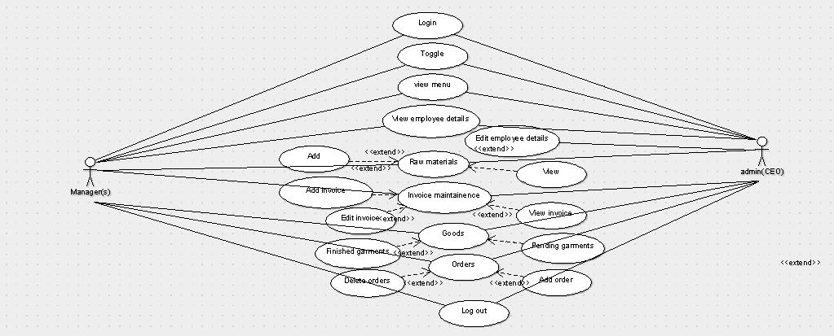

## Design and Implementation Constraints

We will be using basic MySQL and other similar languages. Bits of other third party apps may be used to support the system.

## User Documentation

The documentation that’ll be delivered with the software is a small user manual that’ll briefly explain the basic functionalities and uses of the software.

## Assumptions and Dependencies

* The inventory details are accurate.
* There is internet availability at the facility.
* The computers mostly use windows based OS(s).
* The company requirements are clear and cut as conveyed.

# External Interface Requirements

## User Interfaces

The user interface is simple and easy to use. Keeping in mind the diversity of the people using it, the UI will be designed in such a way that, the company will find it very easy to explain the usage of the software using a live demo of the software in play. The Software will have various buttons and functions which will be self-explanatory. While delivering the software to the company, a demo will be organized for the Top-Level Management regarding the usage of the software and its various modules. The first interface is the log-in screen for the registered users. This is where the user will have a specific Username and Password so that they can gain access to the available database and modify it. Next are the modules. You can choose which operations you would like to view and are able to update any of the categories displayed in the columns.

## Hardware Interfaces

The software will run on the local network of the company. The user needs to have a PC with Windows OS version 8.1 or higher. The work environment should have LAN cables or a Router so as to connect all the PCs on the same network. A reliable power source is a must for unhindered functioning of the software.

## Software Interfaces

This software will utilize a database to store the data. The software being developed will be composed of modules which is an open source entity. Only the admin has the rights to edit the employee details. When the manager or an admin logs into the ERP, the personal information page will greet them. This page will have all the details of the user.

The data flowing into the system is composed of information regarding the raw materials, the goods, and the other employee details. The employee details will be composed of their personal data and also information regarding their wages. The information regarding the wages will only be available to the admins.

## Communications Interfaces

The system would notify users via Email when the products are out of stock in the inventory. The wages of the employees would be communicated to them via Email, and SMS. The production of the stock and the service requirement would be notified via communication to the user. The software will communicate with the database when the data is being entered.

# System Features

The services provided by the software are as follows:

* Toggling between modules
* Ability to view the menu
* View employee details
* Edit employee details
* View info regarding raw materials
* Editing the info regarding the raw materials
* Managing the invoices of all major transactions
* Handling records of finished and unfinished goods/garments
* Keeping track of orders by adding and removing them

## Toggling between modules

4.1.1 Description and Priority

Move between the other service modules available.

4.1.2 Stimulus/Response Sequences

This feature is accessible only after the user logs on.

4.1.3 Functional Requirements

Functional requirements are as follows:

REQ1: admin login

REQ2: manager login

## Ability to view the Menu

4.2.1 Description and Priority

Viewing the menu. The user interface that’s visible after logging in.

4.2.2 Stimulus/Response Sequences

This feature is accessible only after the user logs on.

4.2.3 Functional Requirements

Functional requirements are as follows:

REQ1: admin login

REQ2: manager login

## View Employee Details

4.3.1 Description and Priority

Viewing the employee details. This is accessible to both the admins and the lower level managers.

4.3.2 Stimulus/Response Sequences

This feature is accessible only after the user logs on, and toggles to the respective module.

4.3.3 Functional Requirements

Functional requirements are as follows:

REQ1: admin login

REQ2: manager login

## View info regarding raw materials

4.4.1 Description and Priority

You can view information regarding the raw materials in stock and pending raw materials.

4.4.2 Stimulus/Response Sequences

This feature is accessible only after the user logs on, and toggles to the respective module.

4.4.3 Functional Requirements

Functional requirements are as follows:

REQ1: admin login

REQ2: manager login

REQ3: Toggle Module

## Editing the info regarding the raw materials

4.5.1 Description and Priority

You can edit the information regarding the raw materials in stock and pending raw materials.

4.5.2 Stimulus/Response Sequences

This feature is accessible only after the user logs on, and toggles to the respective module.

4.5.3 Functional Requirements

Functional requirements are as follows:

REQ1: admin login

REQ2: manager login

REQ3: Toggle Module

## Managing the invoices of all major transactions

4.4.1 Description and Priority

Editing the employee details. This is accessible ONLY to the admins. The rights to edit the employee details have been given to the admin only keeping in mind the right to privacy

4.4.2 Stimulus/Response Sequences

This feature is accessible only after the user logs on, and toggles to the respective module.

4.4.3 Functional Requirements

Functional requirements are as follows:

REQ1: admin login

REQ2: manager login

REQ3: Toggle Module

# Other Nonfunctional Requirements

## Performance Requirements

The optimum working environment for the software is where all the managers and the admins can work simultaneously from different parts of the office and achieve the target. Since the ERP is completely web-based, it needs to be quickly accessible and smooth to run. It should allow the users to access the various information with ease, and should display everything in a clear and concise manner. The separate features mentioned above should run well with the ERP and should be integrated in a seamless fashion.

## Safety Requirements

The data should be backed up, in case, any unfortunate incident happens and the critical data gets wiped out.

The data might get infected by some malware or adware on the internet, and hence specific security measures should be taken.

## Security Requirements

For the privacy and security of the data, there will be specific user ids allotted to every employee and rights to vie and edit sensitive information will only be given to top level Employees only.

The data in the ERP must be encrypted to the general users as it contains data which is critical to the operation of the company. Each level of access should be accessible to the correct person only, so that the company hierarchy remains intact and in place along with the product information.

The users will be registering to the ERP system, and their login credentials have to remain encrypted, so that no other member can access their information. The employee wage must remain confidential and should not be accessible to other members of the same access level, while being accessible to the managers so that they can monitor the wages.

## Software Quality Attributes

<Specify any additional quality characteristics for the product that will be important to either the customers or the developers. Some to consider are: adaptability, availability, correctness, flexibility, interoperability, maintainability, portability, reliability, reusability, robustness, testability, and usability. Write these to be specific, quantitative, and verifiable when possible. At the least, clarify the relative preferences for various attributes, such as ease of use over ease of learning.>

## Business Rules

There should be a troubleshooting team in place to handle the working of ERP.

A team should be in place to make sure all the complaints and queries are taken care of.

The notifications that the ERP will send will be automated.

The products manufactured will be updated by the person in-charge only, and should not be handled by anyone else.

# Other Requirements

<Define any other requirements not covered elsewhere in the SRS. This might include database requirements, internationalization requirements, legal requirements, reuse objectives for the project, and so on. Add any new sections that are pertinent to the project.>

Appendix A: Glossary

<Define all the terms necessary to properly interpret the SRS, including acronyms and abbreviations. You may wish to build a separate glossary that spans multiple projects or the entire organization, and just include terms specific to a single project in each SRS.>

Appendix B: Analysis Models

<Optionally, include any pertinent analysis models, such as data flow diagrams, class diagrams, state-transition diagrams, or entity-relationship diagrams.>

Appendix C: To Be Determined List

<Collect a numbered list of the TBD (to be determined) references that remain in the SRS so they can be tracked to closure.>