**Project Name: Marauders**

**Minutes of Meetings with Customer**

**On calls**

|  |  |  |  |  |
| --- | --- | --- | --- | --- |
| Date | Duration | Time | Discussion | Conclusion |
| 22nd September 2016 | 10 mins 4 secs | 13:30 | Introduction of group members and discussion of project topics | Next on-call meeting scheduled |
| 24th September 2016 | 20 mins 2secs | 17:25 | Discussion of project requirements. | Finalization of modules being included. |
| 27th September 2016 | 10 mins 8 secs | 20:03 | Choosing the languages and software that we would be using to create the software. | Decided that we would be using Phonegap and Xampp. |
| 28th September 2016 | 5 mins 4 secs | 18:12 | Received customer feedback about SRS document and were asked to make changes | Changes were to be implemented and then sent. |
| 8th October 2016 | 15 mins 2 secs | 17:24 | Discussion about the design document and how the application should look like. | Requirements finalized |
| 16th October 2016 | 8 mins 6 secs | 17:30 | Received feedback of SDS document. | Were asked to proceed with the coding |
| 24th October 2016 | 20 mins 4 secs | 13:05 | The main modules required were the Leave application and the attendance system and were asked to finish them first. | Deadline for the presentation of The UI fixed. |
| 7th November 2016 | 9 mins 36 secs | 13:01 | Received feedback regarding the UI | Asked to make changes. |
| 15th November 2016 | 4 mins 35 secs | 15:48 | Updating the client | Fixing the date of delivery of the project. |
| 25th November 2016 |  |  |  |  |

**Email Correspondence**

**First correspondence**

**21st September 2016**

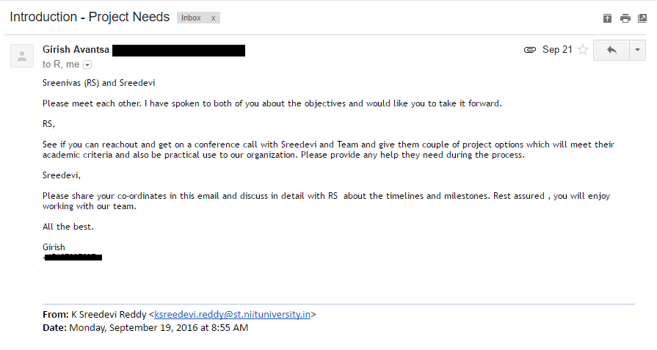

**22nd September 2016**

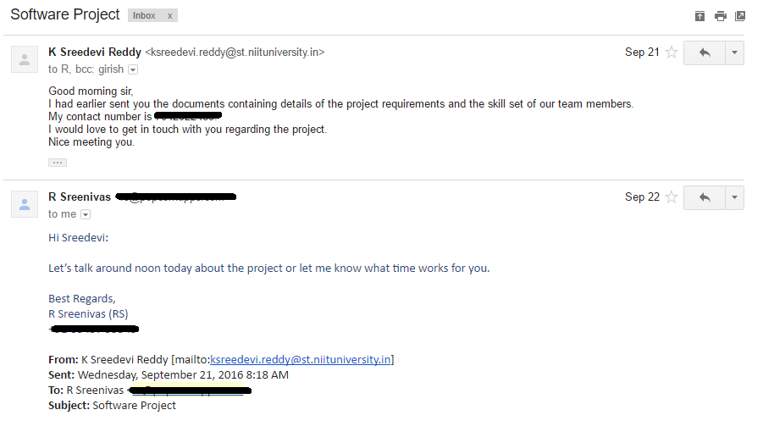

**22nd September 2016**

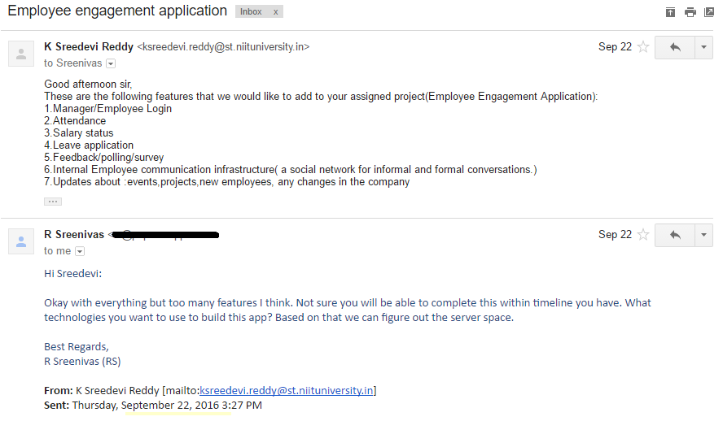

**26th September 2016**

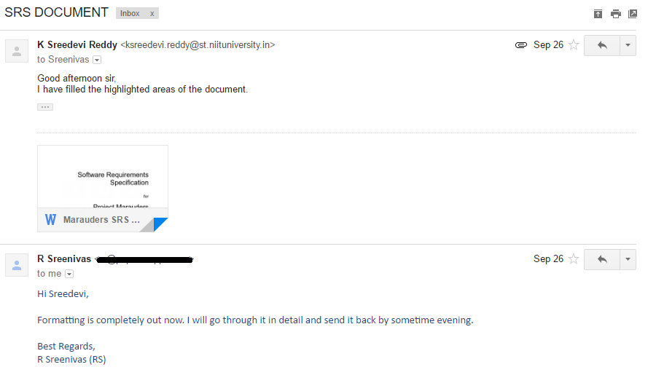

**27th September 2016**

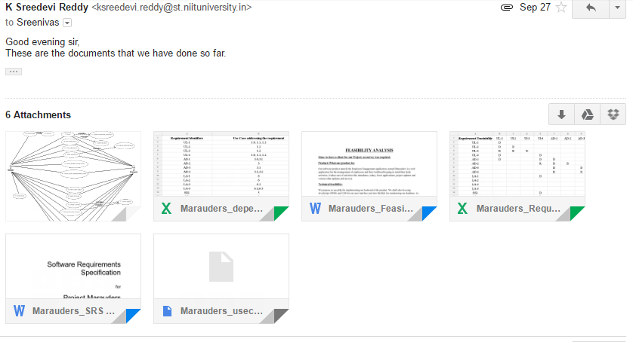

**13th November 2016**

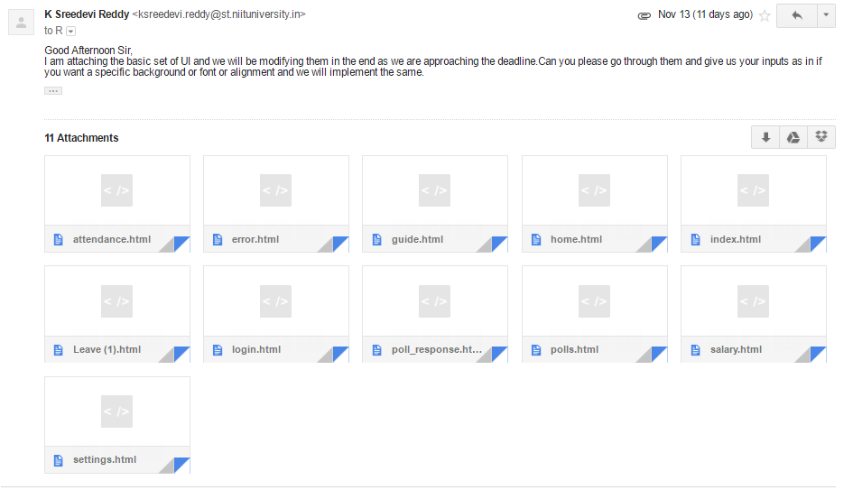

**Acknowledgement:**

**Signature.**