TESTING FOR EXAM CELL SYSTEM WEB APP

Prepared by:
Taniya
Pranavi
Rama
Sai Krishna Revanth
Vineel

Introduction:

Generally,testing is done to find the faults in the software but testing does not assure that there are no faults in the software.Generally there are two types of testing: 1.Module testing
2.Integration testing

- Module testing:

Testing the modules of a program individually and we will generate the test cases using Black box testing and white box testing.

Black box testing ( Functional testing ): Generating the test cases based on the functionalities of the software.Here the internal structure of the program is hidden while generating the test cases.

White box testing ( Structural testing): Generating the test cases based on the structure of the program. Here the internal structure of the program is taken into the account while generating the test cases.

- Integration testing:

Testing the integrated set of modules and here also we will generate the test cases using black box and white box testing.

In the document we mentioned the module testing by using the test case generated by the black box testing.

Module testing:

Black box test cases:

- Module 1 -> Log in -> Submit :

Test Case | Function | Type
Test Case 1 | Submit | Valid Arguments(All fields)
Test Case 2 | Submit | Invalid Arguments (Discrete fields)
Test Case 3 | Submit | Invalid Arguments (All fields)

Description: Submit function will take the input from the user and will help user to reach the Home page.

Test approach : Testing should be done on all the operating systems like Android,IOS and windows.

Test Inputs: Username and Password
Eg: (user1 – 1234, user2 – abed).

Test Results:
Result:Success and no bugs were found.
Output:
- Function is warning the user with appropriate messages when user will enter the inappropriate details.
- Function will help the user to reach the appropriate page after entering the appropriate details.

Screen shot:
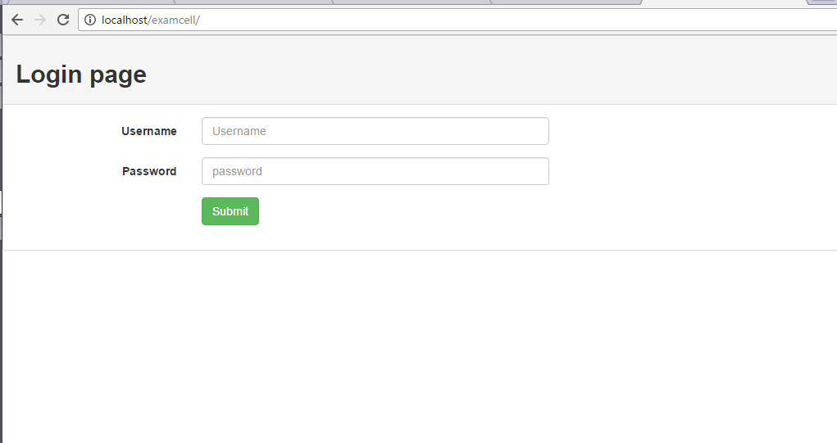

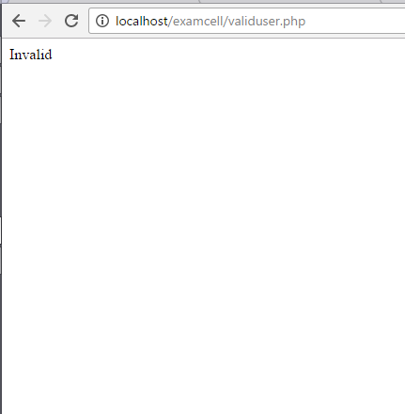

Module 2 -> Student -> checkbox_display:

When the user will click on the student button,then appropriate check boxes should be displayed .

Result: Success.

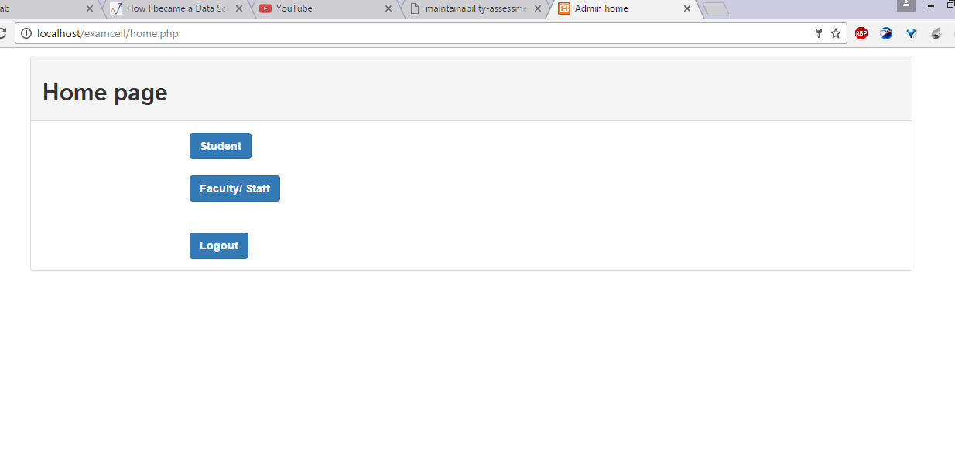

Module 3 -> Student ->submit:

Test Case | Function | Type
Test Case 1 | Check_function | Select the check boxes
Test Case 2 | Check_function | Will not select check-boxes.

Description: course codes are represented in the form of check boxes and admin have to select check box and then click submit button so that the seating allotment of the students in that respective course is alloted and then he will be directed to the appropriate page.

Test approach: Testing should be done on all the operating systems like Android,IOS and windows.

Test inputs:
Selecting the check boxes provided in the respective page by the user.

Test Results:
Success
No bugs were found.

Module 4 -> Faculty -> checkbox_display

When the user will click on the faculty/invigilator button,then appropriate check boxes should be displayed .

Result:
Success

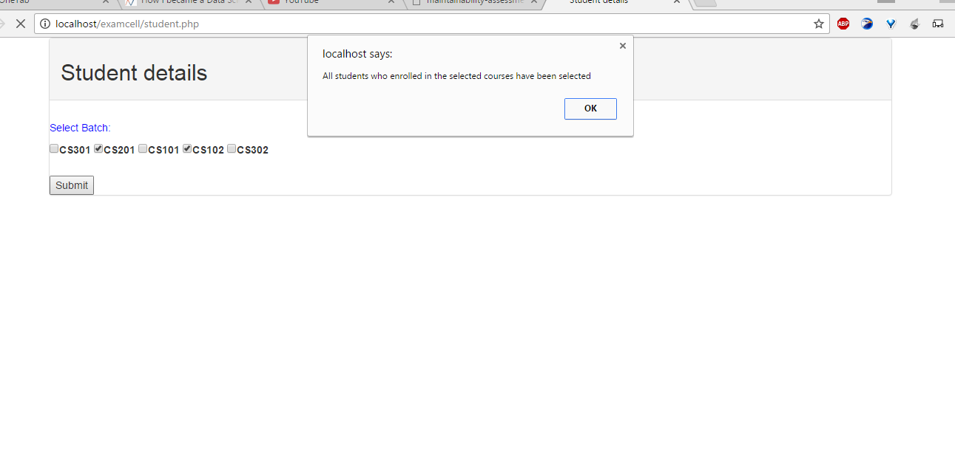

Module 5 ->Faculty ->submit

Test Case | Function | Type
Test Case 1 | Check_function | Select the check boxes
Test Case 2 | Check_function | Will not select check-boxes.

Description: course codes are represented in the form of check boxes and admin have to select check box and then click submit button so that the invigilation schedule of the faculty/invigilators in that respective course is displayed and then he will be directed to the appropriate page.

Test approach: Testing should be done on all the operating systems like Android,IOS and windows.

Test inputs:
Selecting the check boxes provided in the respective page by the user.

Test Results:
Success
No bugs were found.

