INVENTION DISCLOSURE FORM

Applicant Name-Nikhil Saini
Applicant Address-CGC Jhanjeri

- Particulars of Inventors

Mr./Ms/Dr. | Name (Full) | Department | Designation | Mobile No. | Email | Postal Address
Mr. | Nikhil Saini | CSE-Apex | Student | 7814061899 | 2401002030@cgcjhanjeri.in | CGC Jhanjeri
Mr. | Puneet Goyal | CSE-Apex | Student | 9888295938 | 2401002112@cgcjhanjeri.in | CGC Jhanjeri

- Provide a brief descriptive title of the invention: “A Machine Learning-Based System for Predicting Diseases from Patient Symptoms.”

- Summary of the invention: The invention relates to a computer-based system designed to predict possible diseases using patient-reported symptoms. The proposed system utilizes machine learning algorithms to analyze symptom data and identify patterns associated with various diseases. Users input their symptoms through a digital interface, and the system processes the information using a trained predictive model to generate probable disease outcomes. This approach assists in early detection and preliminary diagnosis, helping individuals seek timely medical consultation. The system aims to improve healthcare accessibility by providing quick, data-driven insights and reducing dependency on manual preliminary assessments while supporting healthcare professionals with an efficient decision-support tool.

- Detail description of the invention:

  - Problem the invention is solving: Many individuals experience difficulty in identifying potential diseases based on early symptoms due to limited medical knowledge and delayed access to healthcare professionals. Traditional diagnosis often requires physical consultation, which can be time-consuming, costly, and sometimes inaccessible, especially in remote areas. As a result, early symptoms are frequently ignored or misinterpreted, leading to delayed treatment and worsening health conditions. Additionally, healthcare systems face heavy workloads, making preliminary screening challenging. The invention addresses this problem by providing an automated system that analyzes user-reported symptoms and predicts possible diseases, enabling quick preliminary assessment, improving awareness, and supporting early medical consultation and better healthcare decision-making.

  - General Utility/application of the invention: The invention can be widely used in healthcare applications to assist individuals in identifying possible diseases based on their symptoms. It can be integrated into mobile applications, web platforms, and hospital management systems to provide quick preliminary health assessments. The system helps users gain early awareness of potential health conditions and encourages timely medical consultation. It can also support healthcare professionals by acting as a decision-support tool during initial patient screening. Additionally, the invention is useful in telemedicine services, remote healthcare monitoring, and public health platforms, improving accessibility to basic diagnostic support and enhancing overall efficiency in healthcare delivery systems.

  - Advantages of the invention disclosing about the increased efficiency/efficacy :
    - Faster Preliminary Diagnosis
The system quickly analyzes user symptoms and predicts possible diseases within seconds, reducing the time required for initial health assessment.
    - Improved Healthcare Accessibility
It allows users to check possible health conditions anytime through a digital platform, making basic diagnostic support available even in remote areas.
    - Support for Medical Professionals
The system assists doctors by providing preliminary predictions, helping them focus on accurate diagnosis and treatment more efficiently.
    - Early Disease Detection
By analyzing symptoms at an early stage, the system encourages users to seek timely medical advice, which can help prevent the worsening of diseases.
    - Efficient Data Analysis Using Machine Learning
The invention uses machine learning algorithms to analyze large symptom datasets, improving prediction accuracy and system efficiency over time.

  - Best way of using the invention as well as possible variants: The best way to use the invention is through a user-friendly web or mobile application where users can input their symptoms into the system. The system processes the entered data using machine learning algorithms and compares it with trained datasets to predict possible diseases. The results provide users with preliminary health insights and recommend seeking professional medical advice if necessary. The invention can also be integrated into hospital management systems, telemedicine platforms, and healthcare applications. Possible variants include incorporating additional patient data such as age, medical history, and lifestyle factors to improve prediction accuracy and provide more personalized health assessments.

  - Working of invention along with Drawing, schematics and flow diagrams if required with complete explanations

System Components :
- User Symptom Input:
The user enters their symptoms through a web or mobile interface, selecting from a list or typing the symptoms they are experiencing.
- Data Preprocessing:
The system processes the input data by cleaning, organizing, and converting the symptoms into a format suitable for analysis by the prediction model.
- Symptom Feature Mapping:
The entered symptoms are mapped to predefined features in the trained dataset, allowing the system to compare them with known disease patterns.
- Machine Learning Model Processing:
The processed data is fed into a trained machine learning algorithm that analyzes the symptom patterns to predict possible diseases.
- Disease Prediction Generation:
The system generates a list of probable diseases based on the analyzed symptom data and model predictions.
- Result Display to User:
The predicted diseases and related information are displayed to the user through the interface for preliminary health awareness.
- Recommendation for Medical Consultation:
The system advises users to consult a healthcare professional for proper diagnosis and treatment based on the predicted results.
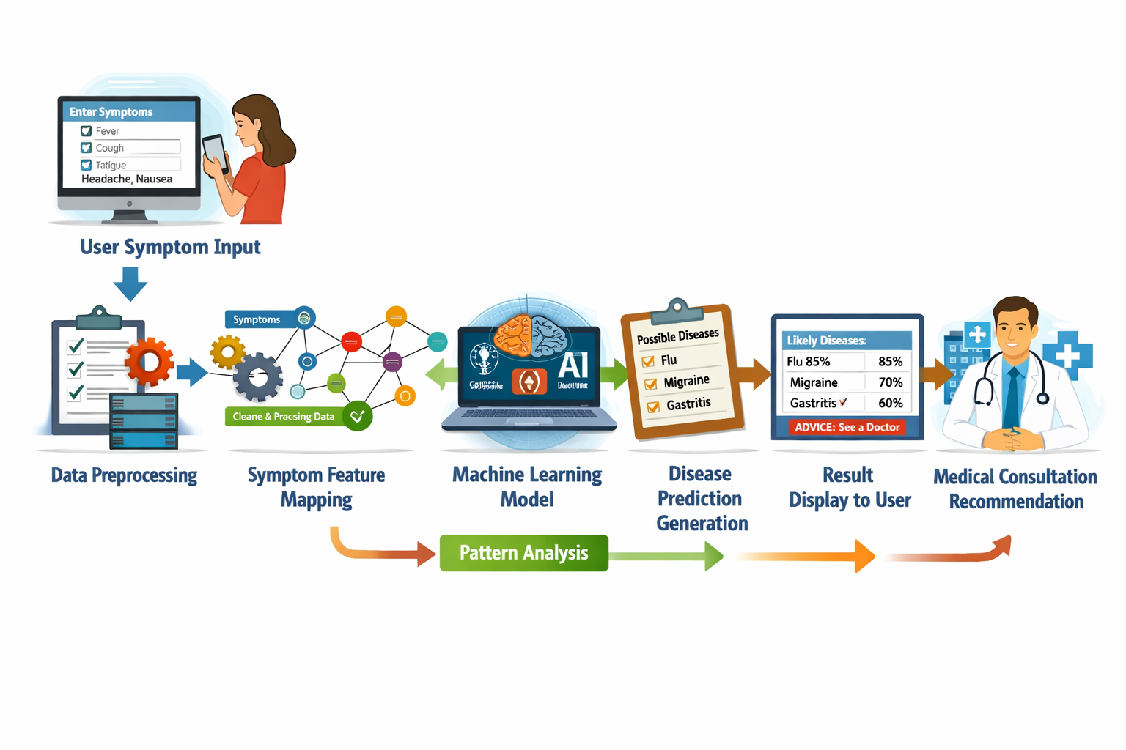

- Have you conducted Primary Patent Search?

NO

- Existing state-of-the-art and prior arts: (Brief background of the existing knowledge/product/process in the market)
Various digital health systems and applications have been developed to assist in preliminary disease identification based on symptoms. Many existing platforms use rule-based methods or basic machine learning models to analyze symptoms and provide possible disease suggestions. These systems aim to improve healthcare accessibility and support early health awareness.
Some advanced cases have introduced additional features:
- Artificial Intelligence and Deep Learning Integration
Advanced systems use AI and deep learning algorithms to analyze complex symptom patterns, improving the accuracy of disease prediction.
- Integration with Electronic Health Records (EHR)
Some platforms connect with patient health records to consider medical history, enabling more personalized and accurate predictions.
- Telemedicine Support
Modern systems allow users to directly consult doctors through telemedicine services after receiving initial symptom-based predictions.
- Real-Time Health Monitoring
Certain applications integrate wearable devices to continuously monitor health parameters such as heart rate or temperature for better disease assessment.
Despite these developments, many systems still face limitations in prediction accuracy, data availability, and accessibility. Continuous improvements in machine learning models and healthcare data integration are required.
The proposed invention builds upon existing technologies by providing a more efficient symptom-based prediction system, aiming to enhance early disease detection and support faster preliminary healthcare decision-making
- List out the known ways about how others have tried to solve the same or similar problems? Indicate the disadvantages of these approaches. In addition, please identify any prior art documentation or other material that explains or provides examples of such prior art efforts.

S. No. | Existing state of art | Drawbacks in existing state of art | Overcome (how your invention is overcoming the drawback)
1 | Traditional symptom checker systems based on rule-based algorithms. | These systems often provide limited accuracy because they rely on fixed rules and cannot learn from new data. | The proposed invention uses machine learning algorithms that learn from large datasets and improve prediction accuracy over time.
2 | Online medical information platforms where users manually search symptoms. | Users may misinterpret medical information, leading to incorrect self-diagnosis and confusion. | The invention automatically analyzes symptoms and provides structured disease predictions, reducing the chances of misinterpretation.
3 | Healthcare consultation requiring direct visits to hospitals or clinics. | Physical consultations can be time-consuming, costly, and sometimes inaccessible in remote areas. | The invention provides a quick digital symptom-based prediction system that helps users get preliminary health insights before consulting a doctor.

- List the Technical features and Elements of the invention along with the Description of your invention from start to end.
Component | Function
1. User Interface | Provides a platform where users can enter their symptoms and interact with the system through a web or mobile application.
2. Symptom Input Module | Collects and records the symptoms provided by the user for further processing and analysis.
3. Data Preprocessing Module | Cleans, organizes, and converts the input symptom data into a structured format suitable for machine learning analysis.
4. Symptom Dataset | Contains historical symptom and disease data used to train and validate the prediction model.
5. Machine Learning Model | Analyzes the processed symptom data and identifies patterns to predict possible diseases..
6. Prediction Engine | Generates the list of probable diseases based on the model’s analysis of the input symptoms.
7. Result Display Module | Presents the predicted diseases and related recommendations to the user in an understandable format.

Description of the Invention from Start to End

Step : 1. User Symptom Input
- Users access the system via a web or mobile application.
- They select or type the symptoms they are experiencing.
Step : 2. Data Preprocessing
- The system cleans and organizes the entered symptom data.
- Converts text or selections into a structured format compatible with the prediction model.
- Handles missing or ambiguous inputs to ensure accurate analysis.
Step : 3. Symptom Feature Mapping
- Each input symptom is mapped to corresponding features in the trained dataset.
- Assigns weights or importance to symptoms based on historical data patterns.
- Ensures alignment between user input and the predictive model’s requirements.
Step : 4. Machine Learning Model Analysis
- The preprocessed and mapped data is fed into the trained machine learning algorithm.
- The model compares input patterns with historical symptom-disease datasets.
- Probable diseases are scored based on likelihood and symptom correlation.
Step : 5. Disease Prediction Generation
- The system generates a ranked list of possible diseases.
- Each predicted disease is accompanied by probability scores or confidence levels.
Step : 6. Result Display and Recommendations
- The results are displayed to the user in a clear, easy-to-understand format.
- The system recommends consulting a healthcare professional for further evaluation.

- List out the features of your invention which are believed to be new and distinguish them over the closest technology.

Feature | Description
1. Symptom-Based Input | Allows users to enter or select their symptoms through a user-friendly interface for analysis.
2. Machine Learning Prediction | Uses trained algorithms to analyze symptom patterns and predict possible diseases with accuracy.
3. Probability Scoring | Assigns likelihood scores to each predicted disease to indicate confidence levels in the prediction.
4. User Guidance & Recommendations | Provides advice on consulting healthcare professionals or taking preventive measures based on predictions.
5. Data Preprocessing | Cleans, organizes, and converts user input into a format suitable for analysis, improving prediction reliability.
6. Integration with Health Records | Optional feature to consider patient history, age, or lifestyle factors for more personalized predictions.

Closest Technology | Limitations | How This Invention Is Different
Rule-Based Symptom Checkers | Limited accuracy; cannot learn from new data or evolving symptoms. | Uses machine learning algorithms that continuously improve accuracy by learning from large datasets.
Online Medical Information Portals | Users interpret data manually, leading to misdiagnosis or confusion. | Automatically analyzes symptoms and provides structured, ranked disease predictions to reduce errors.
Basic Mobile Health Apps | Provide generic advice without considering symptom patterns or probabilities. | Offers probability-based predictions and personalized recommendations for early disease detection.
Telemedicine Platforms | Require prior consultation with doctors; preliminary symptom analysis is limited. | Provides instant symptom-based preliminary disease predictions before professional consultation, saving time and improving accessibility.

- Has the invention been built or tested or implemented? If so, please provide the particulars of the first time it was successfully built or implemented (when, where, by whom, and evidence of this event including written or on-line pointers to documentary evidence):All testing details\

NO

- Briefly state when and how you first conceived this idea?

The idea originated while observing how people struggled to recognize potential diseases from common symptoms, often delaying medical consultation. Limited access to healthcare and lack of symptom awareness inspired the concept of a digital system to provide preliminary disease insights efficiently.

I envisioned using machine learning to analyze symptom patterns from large datasets, generating probable disease predictions. This approach aims to improve early detection, reduce misdiagnosis, and assist both individuals and healthcare professionals in making informed, timely healthcare decisions, especially in areas with limited medical access.

- Have you sold, offered for sale, publicly used or published anything related to this invention? If yes, please briefly explain the dates and circumstances. List those individuals to whom you have revealed your invention. Were non-discloser documents signed prior to discloser in each case? Please state any deadlines of which you may be aware for filing an application on this invention.

No

- Include any reasons that your invention would not have been obvious to someone of average skill in the art.

NA

- Additional comments by inventor (if you want to give more details out of scope of this IDF).
NA

- Drawings/Flowchart/Table

NA

