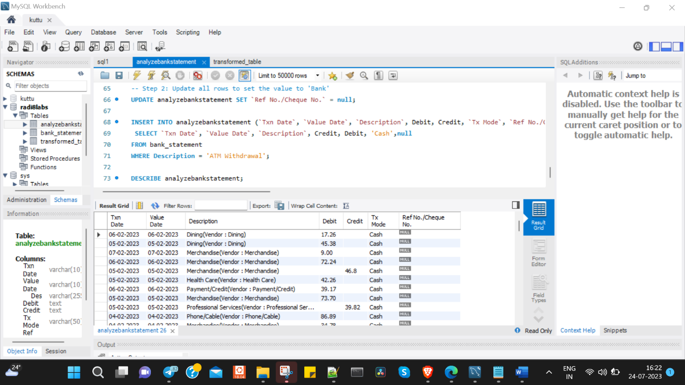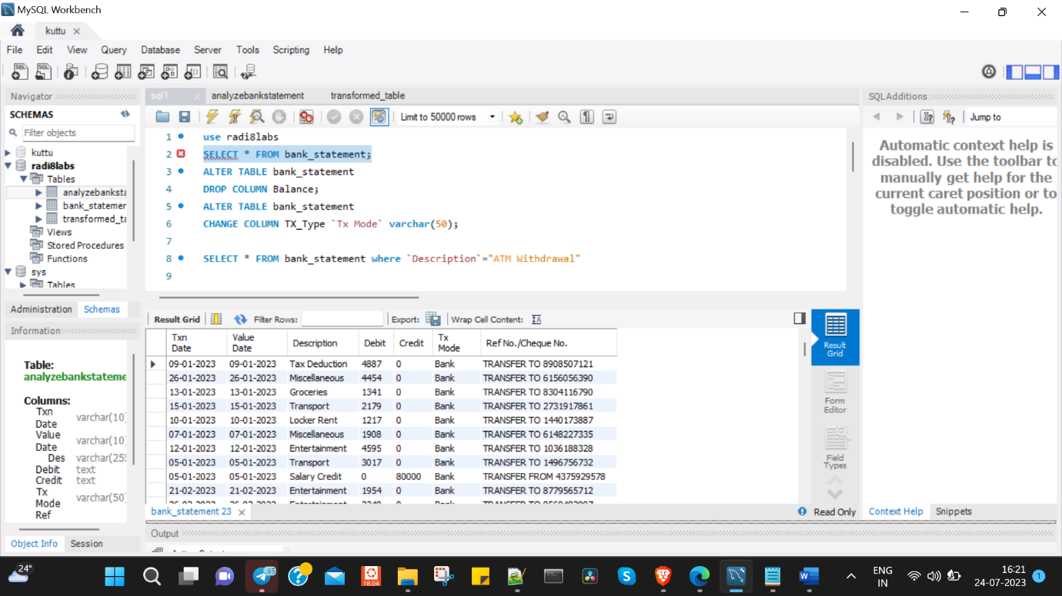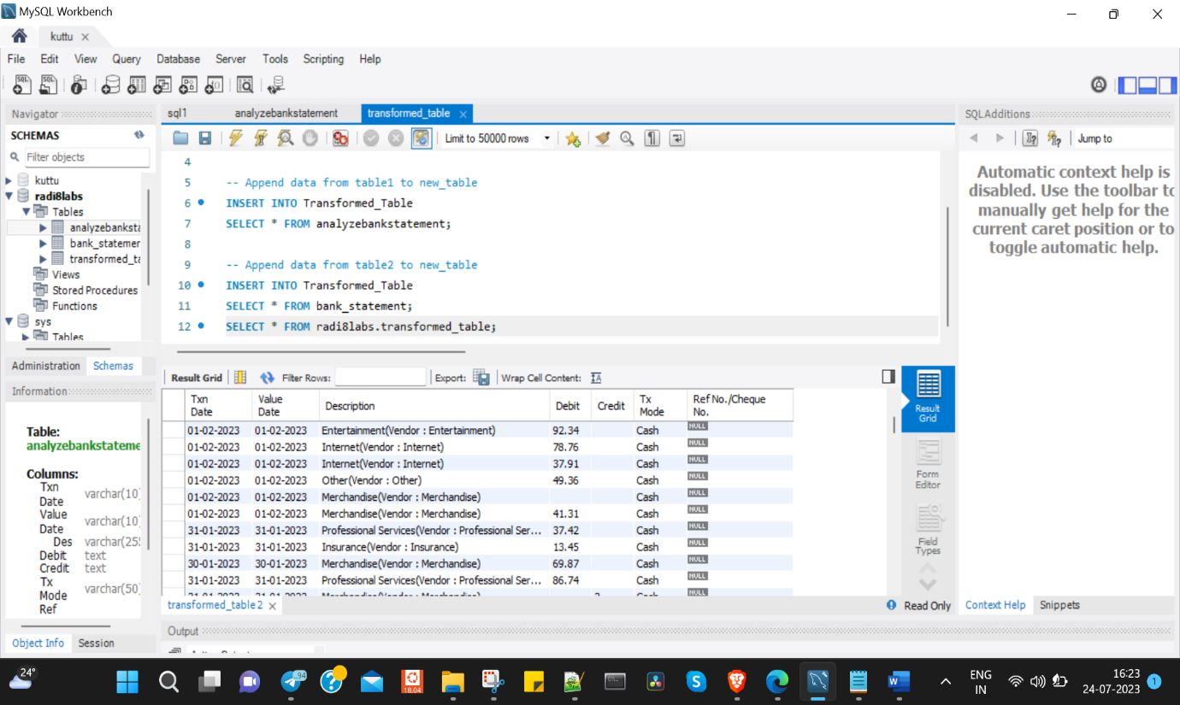

Cleaned and organized dataset inMySQL shown in the above pictures.(MySQL queries attached in the zip file)

1.bank_statement table after transformation

2.analyzebankstatement after transformation

3.final transformed table after appending bank_statement with analyzebankstatement

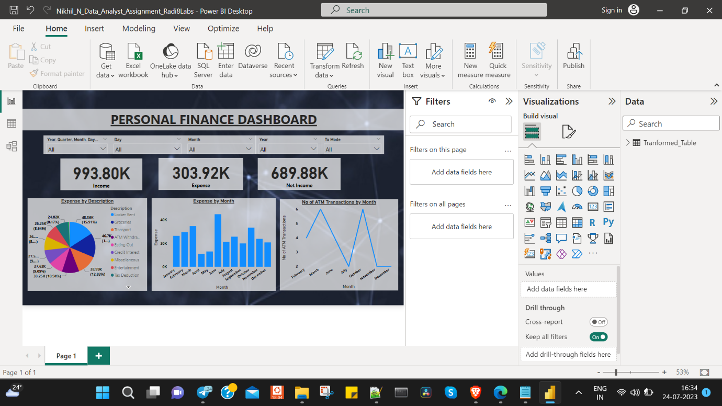

Financial Analysis Dashboard:The financial analysis dashboard presents a visual representation of various financial metrics and trends.(.pbix file attached in the zip file)