#Q1 Provide the list of markets in which customer "Atliq Exclusive" operates its business in the APAC region.
SELECT DISTINCT market
FROM dim_customer
WHERE customer="Atliq Exclusive" AND region="APAC";

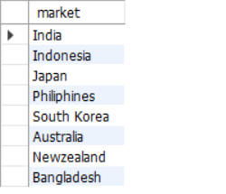

#Q2 What is the percentage of unique product increase in 2021 vs. 2020? The final output contains these fields: unique_products_2020, unique_products_2021 & percentage_chg.
WITH unique_products_20 AS (
SELECT count(distinct product_code) as unique_products_2020
FROM FACT_SALES_MONTHLY
where fiscal_year= 2020
),
unique_products_21 as (
select count(distinct product_code) as unique_products_2021
from fact_sales_monthly
where fiscal_year= 2021
)
select
t1.unique_products_2020,
t2.unique_products_2021,
round((t2.unique_products_2021- t1.unique_products_2020)*100/ t1.unique_products_2020,2) as percentage_chg
from
unique_products_20 t1,
unique_products_21 t2;

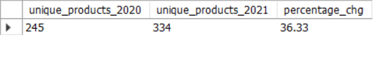
#Q3
select
segment,
count(distinct(product_code))as product_count
from dim_product
group by segment
order by product_count desc;

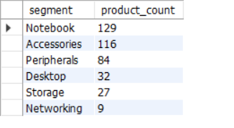

#Q4
with cte1 as (
select p.segment, count(distinct sm.product_code) as product_count_2020
from dim_product p
join fact_sales_monthly sm
on p.product_code= sm.product_code
where sm.fiscal_year= 2020
group by p.segment),
cte2 as (
select p.segment as segment_, count(distinct sm.product_code) as product_count_2021
from dim_product p
join fact_sales_monthly sm
on p.product_code = sm.product_code
where sm.fiscal_year= 2021
group by p.segment),
cte3 as (select *, (product_count_2021- product_count_2020) as difference
from cte1 c1
join cte2 c2
on c1.segment= c2.segment_
)
select segment, product_count_2020, product_count_2021, difference
from cte3
order by difference desc

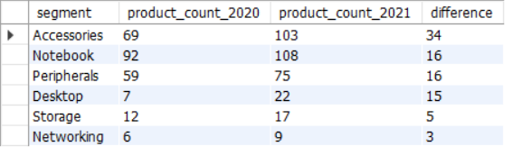

#Q5
select
p.product_code, p.product, mc.manufacturing_cost
from dim_product p
join fact_manufacturing_cost mc
on p.product_code= mc.product_code
where mc.manufacturing_cost= (select max(manufacturing_cost) from fact_manufacturing_cost)
or mc.manufacturing_cost = (select min(manufacturing_cost) from fact_manufacturing_cost)
order by manufacturing_cost desc;
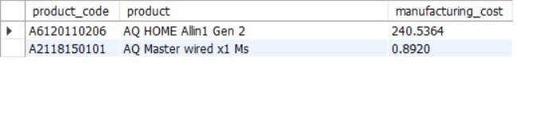
#Q6
select
pid.customer_code, dc.customer,Round(AVG( pid.pre_invoice_discount_pct),4) as average_discount_percentage
from fact_pre_invoice_deductions pid
join dim_customer dc
on pid.customer_code= dc.customer_code
where fiscal_year= 2021 and market='India'
group by customer_code, customer
order by average_discount_percentage desc limit 5
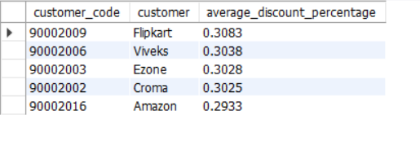
#Q7
select
MONTHNAME(sm.date) as month_,
sm.fiscal_year,
round(sum((gp.gross_price*sm.sold_quantity)),2)as Gross_sales_amount
from fact_sales_monthly sm
join fact_gross_price gp
on
sm.product_code=gp.product_code and
sm.fiscal_year=gp.fiscal_year
join dim_customer c
on c.customer_code= sm.customer_code
where customer= 'Atliq Exclusive'
group by month_, sm.fiscal_year
order by sm.date asc;
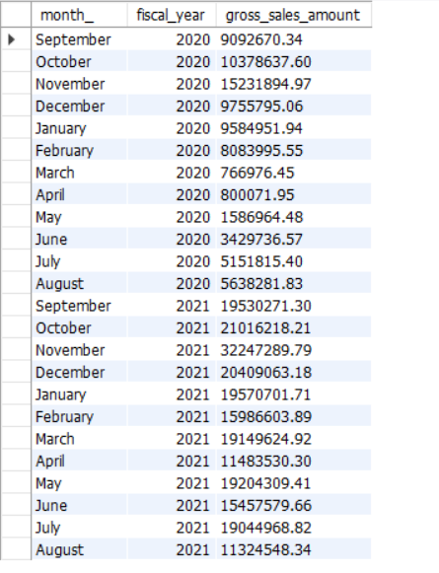

#Q8
with cte as (select
month(date) as m_, sum(sold_quantity) as tsq
from fact_sales_monthly
where fiscal_year = 2020
group by m_)
select
CASE
WHEN m_ IN(9,10,11) THEN "q1"
WHEN m_ IN(12,1,2) THEN "q2"
WHEN m_ IN(3,4,5) THEN "q3"
ELSE "q4"
END as quarters , sum(tsq) as total_sold_quantity
from cte
group by quarters
order by total_sold_quantity desc;

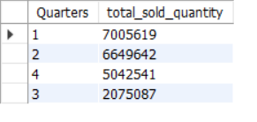
#9
with cte as (select
c.channel,
round(sum((gross_price*sm.sold_quantity)/1000000),2) as gross_sales_mln
from fact_sales_monthly sm
join fact_gross_price gp
on sm.product_code=gp.product_code and
sm.fiscal_year= gp.fiscal_year
join dim_customer c
on c.customer_code= sm.customer_code
where sm.fiscal_year= 2021
group by channel)
select
channel,gross_sales_mln,
ROUND((gross_sales_mln/sum(gross_sales_mln) over())*100,2) as percentage
from cte
order by gross_sales_mln desc;
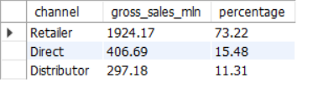
#Q10
with cte as ( select sm.product_code,p.product,
p.division, sum(sm.sold_quantity) as total_sold_quantity, sm.fiscal_year, rank() over(partition by p.division
order by sum(sm.sold_quantity)desc)as rank_order
from fact_sales_monthly sm
join dim_product p
on p.product_code= sm.product_code
where fiscal_year= 2021
group by p.division,sm.product_code,p.product )
select
division, product_code, product, total_sold_quantity,
rank_order
from cte
where rank_order in(1,2,3);
