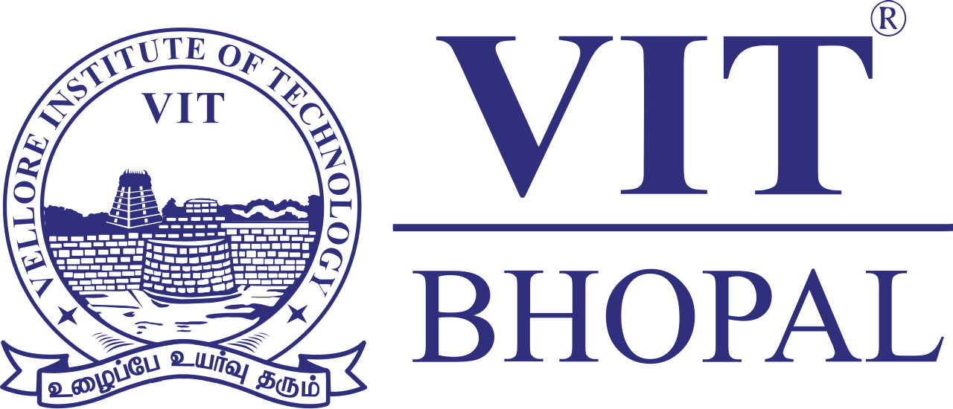

AI & ML Vityarthi Project Report

Name: Nikhil Kumar
Registration Number: 25BAI10465
Course: CSA2001 Fundamentals In AI & ML
Program: B. Tech Computer Science and Engineering

Student Performance Predictor

1. Introduction
This project focuses on predicting students' academic performance using machine learning techniques. The aim is to analyze how study habits such as study hours, attendance, and sleep hours influence marks.

2. Objective
The objective of this project is to build a predictive model using Linear Regression that can estimate student marks based on their study patterns.

3. Tools and Technologies Used
• Python
• Pandas
• Scikit-learn
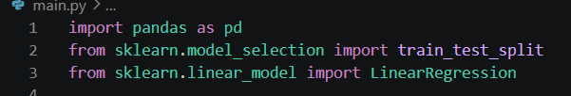

4. Dataset Description
The dataset contains the following attributes:
• StudyHours: Number of hours studied
• Attendance: Attendance percentage
• SleepHours: Average sleep hours
• Marks: Marks obtained
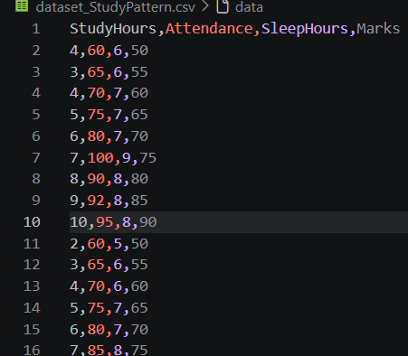

5. Methodology
The dataset is loaded and preprocessed using Pandas. The features (StudyHours, Attendance, SleepHours) are selected as input variables, and Marks is the target variable. The data is split into training and testing sets. A Linear Regression model is trained on the training data and evaluated on the test data.
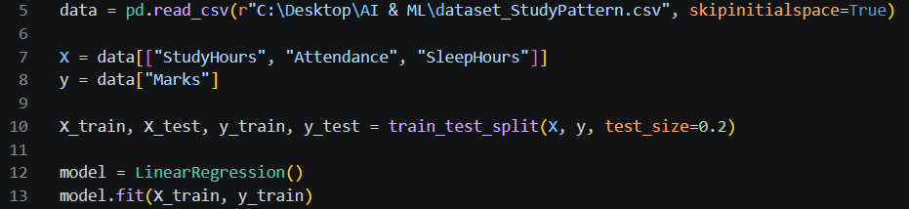

6. Implementation
The model is implemented using Scikit-learn's LinearRegression class. After training, the model predicts marks based on user input values for study hours, attendance, and sleep hours.

7. Results
The model provides an accuracy score based on test data and predicts marks for given inputs. The results demonstrate the relationship between study habits and academic performance. 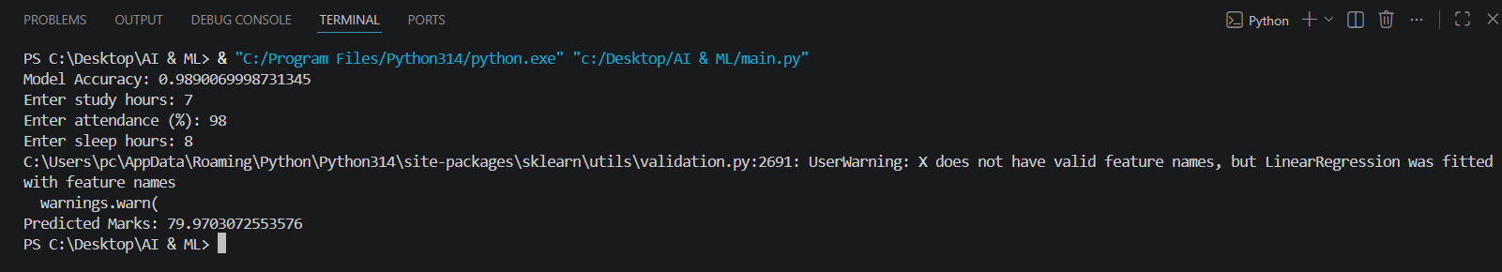

8. Conclusion
This project successfully demonstrates how machine learning can be used to predict student performance. Linear Regression provides a simple yet effective way to model the relationship between study patterns and marks.

9. Future Scope
• Use larger datasets for better accuracy
• Apply advanced algorithms like Random Forest
• Create a web-based interface
• Include graphical analysis

