**GIT-INTEGRATION**

1. LOGING TO SERVER YOU WANT TO INTEGRATE WITH GIT
2. THEN GO TO USER HOME
3. Cd ~
4. Pwd
5. Splunk/home
6. Do below command

**ssh-keygen**

cd .ssh

copy id_rsa.pub from server to settings and ssh keys in Gitlab

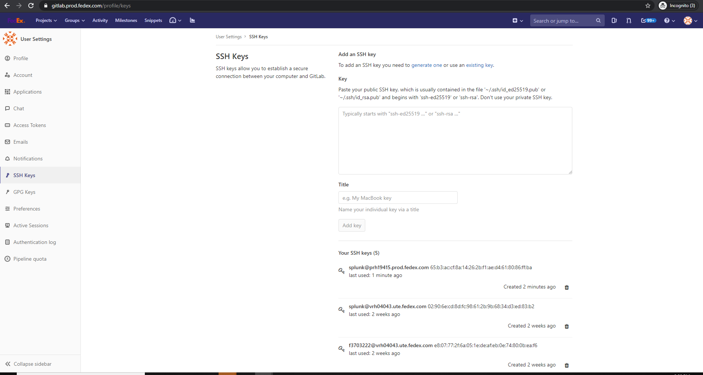

7. Then now server is integrated

8) go to repository and copy the clone https or ssh commands

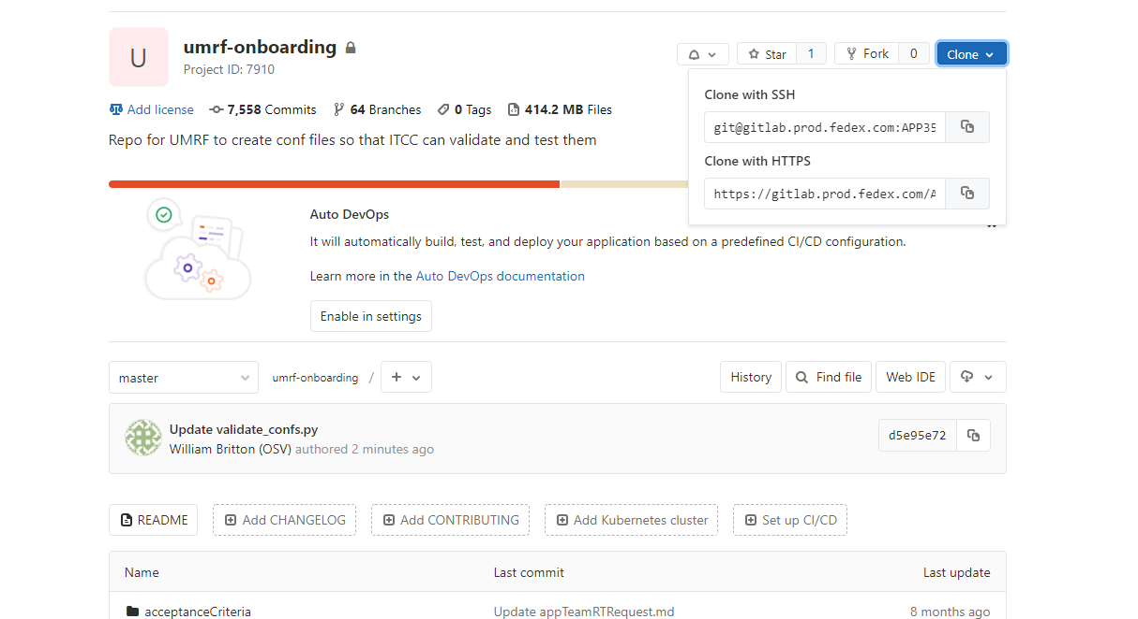

Now got to server and by going to the required location execute below command to pull the repo

**git clone git@gitlab.prod.fedex.com:APP3530768/test-deployment-server.git**

then the basic script

**#!/bin/bash  
#this script is a standalone for On-prem re-Deployment  
#please update deployment_indexes.txt (located in gitlab.prod.fedex.com:APP3530768/umrf-onboarding.git) with all the new app you want to deploy today  
#For pushing bundles from CM and Deployer, secondary scripts are being called for the .gitlab-ci.yml file.  
set -x**

**cd /tmp/  
git clone git@gitlab.prod.fedex.com:APP3530768/umrf-conf-file-validation.git  
git clone git@gitlab.prod.fedex.com:APP3530768/test-deployment-server.git  
cd umrf-conf-file-validation**

**for index in $(cat deployment_indexes.txt)  
do**

**cp -R /tmp/test-deployment-server/deployment-apps/$index\_* /opt/splunk/etc/deployment-apps/**

**done**

**echo delete git clone from /tmp  
rm -rf /tmp/umrf-conf-file-validation  
echo delete Deployment-Indexes  
rm /tmp/deployment_indexes.txt**

 This above script will pull the repo from git to tmp and copy all the required indexes and apps to deployment-apps.

Another sample script

cat prodGitlabsupportscript.sh

**set -x**

**me=`whoami`**

**if [ $me = "splunk" ]**

**then**

**echo "You are Logged in as Splunk!!!!"**

**exit 1**

**fi**

**cd /tmp**

**for index in $(cat deployment_indexes.txt)**

**do**

**sudo -u splunk cp -r /opt/devTest/test-deployment-server/deployment-apps/$index\_* /opt/Repo/gcp-prod-deployment-repo/deployment-apps**

**sudo -u splunk ls -ltr /opt/Repo/gcp-prod-deployment-repo/deployment-apps | grep $index**

**done**