IRIS

Things Accomplished :

Login Page : This would be the first screen initiated when the user opens the app.It would involve the user entering his email and password to login and undergo firebase authentication.

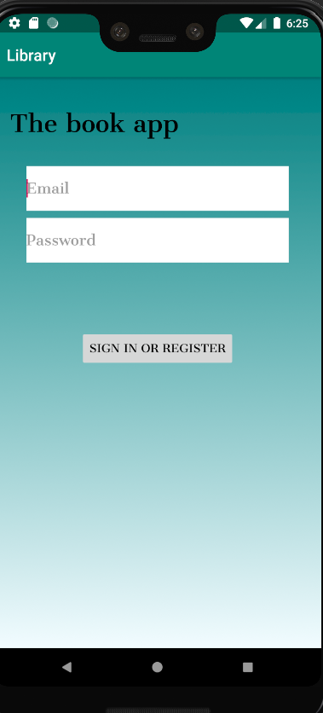

Authentication with firebase:The user would then be made to undergo authentication using firebase.

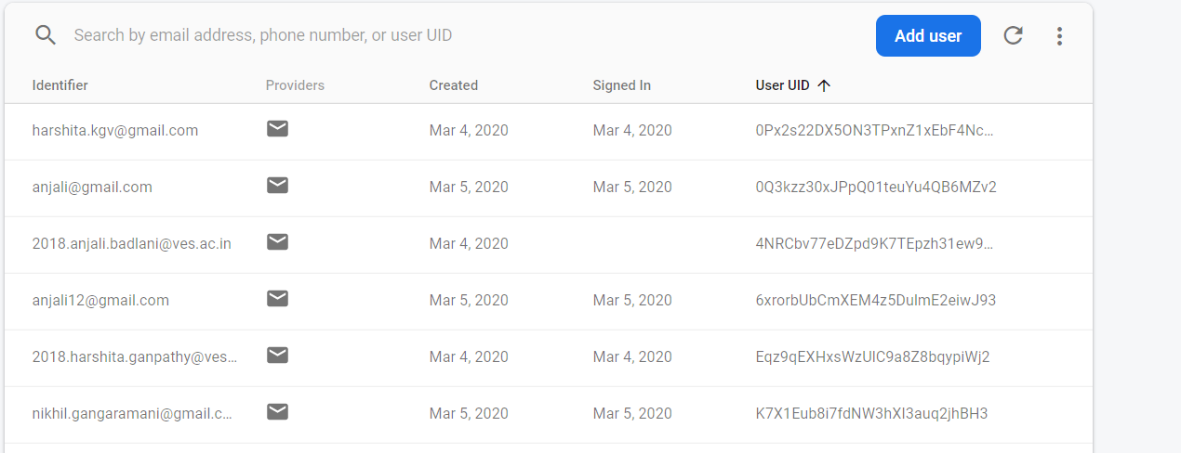

Menu page:The menu page would have options to access resources,Share books,access shared books,Resource section,discussion forum(yet to be implemented)

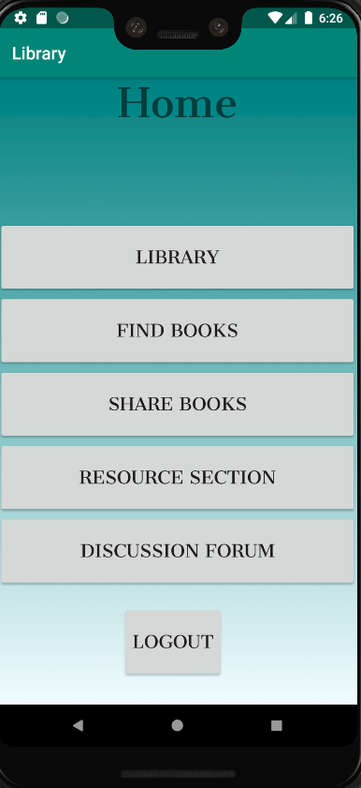

Share books:

The user can add books for sharing using the share books functionality,he would be prompted to enter the author name,edition,title,email id.

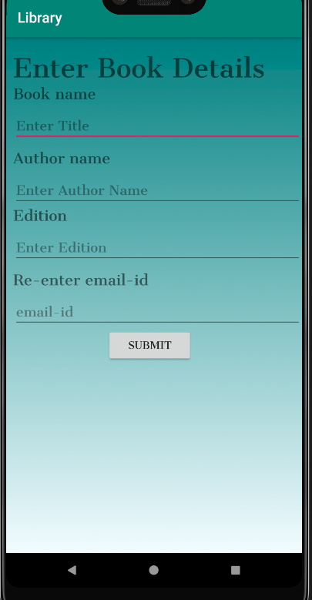

Access shared books:

The user can access shared books and request for sharing in this section.

Resource section:

This page can give access to academic resources.Including a drive which would give access to a set of handmade notes and other resources maintained by admin

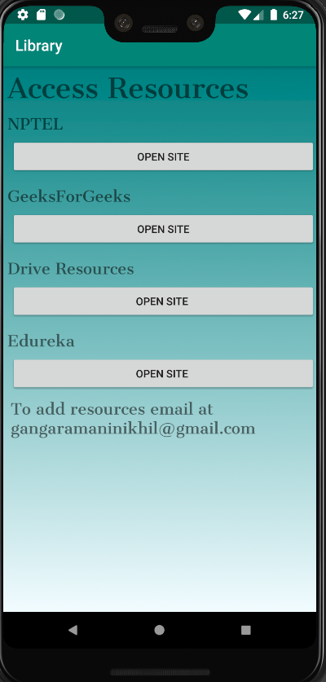

Things To Be Accomplished :

1. Discussion forum:

We plan to add a discussion forum where the user can post and discuss academic queries.

This would be supported by a strong community.

1. Library operations:

This would give user access to library books.