**1. Install Java**

**2. Download Apache Tomcat\***

1. Visit the official Tomcat website: [https://tomcat.apache.org/](https://tomcat.apache.org/)

2. Click on *Tomcat 10* (or your required version).

3. Under the *Core* section, download:

- ✅ *"64-bit Windows zip"* (Recommended for easy setup)

**3. Extract and Set Up Tomcat\***

1. Extract the downloaded .zip file to a preferred location, e.g., C:\Tomcat.

2. Your Tomcat directory structure should look like this:

C:\Tomcat

├── bin

├── conf

├── lib

├── logs

├── temp

├── webapps

├── work

└── LICENSE

**4. Set Environment Variables\***

1. Open *Command Prompt as Administrator*.

2. Set JAVA_HOME:

cmd

setx JAVA_HOME "C:\Program Files\Java\jdk-21"

3. Add Java to PATH:

cmd

setx PATH "%JAVA_HOME%\bin;%PATH%"

4. *Restart your system* to apply changes.

5. Verify:

cmd

echo %JAVA_HOME%

java -version

**\*5. Start Tomcat Server\***

1. Open *Command Prompt* and go to the Tomcat bin folder:

cmd

cd C:\Tomcat\bin

2. Run Tomcat:

cmd

startup.bat

3. If startup.bat closes immediately,

try:

cmd

catalina.bat run

**6. Access Tomcat in Browser\***

- Open a browser and visit:

http://localhost:8080

- If the *Tomcat welcome page* appears, the setup is successful! ✅

**7. (Optional) Change Default Port\***

If another service is using port 8080:

1. Open C:\Tomcat\conf\server.xml.

2. Find:

xml

<Connector port="8080" protocol="HTTP/1.1" />

3. Change 8080 to another port like 9090.

4. Restart Tomcat and access it at <http://localhost:9090>.

**## *Troubleshooting\***

If Tomcat doesn’t start:

✅ Check C:\Tomcat\logs\catalina.out for errors.

✅ Ensure JAVA_HOME is set correctly.

✅ Run netstat -ano | findstr :8080 to check if port 8080 is in use.

---

### *Done! 🚀*

Now, you can deploy web applications in C:\Tomcat\webapps\. Let me know if you need any help! 😊

* **Go to**

C:\apache-tomcat-9.0.102\conf\tomcat-users

Edit the file(tomcat-users)

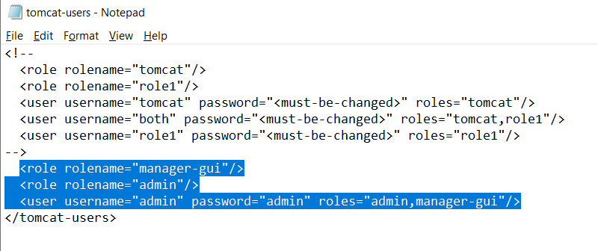

Save it

**Create the folder with those files as show In the pic**

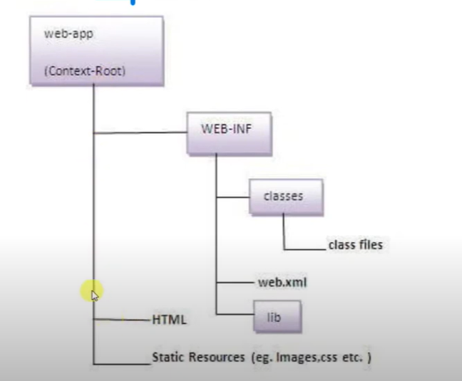

**Dump the folder in the**

C:\apache-tomcat-9.0.102\webapps

(I had create the folder name as servlet)

{C:\apache-tomcat-9.0.102\webapps\servlet\WEB-INF\classes}

Now its time to execute

1. Open *Command Prompt* and go to the Tomcat bin folder:

cmd

cd C:\apache-tomcat-9.0.102\bin

2. Run Tomcat:

cmd

startup.bat

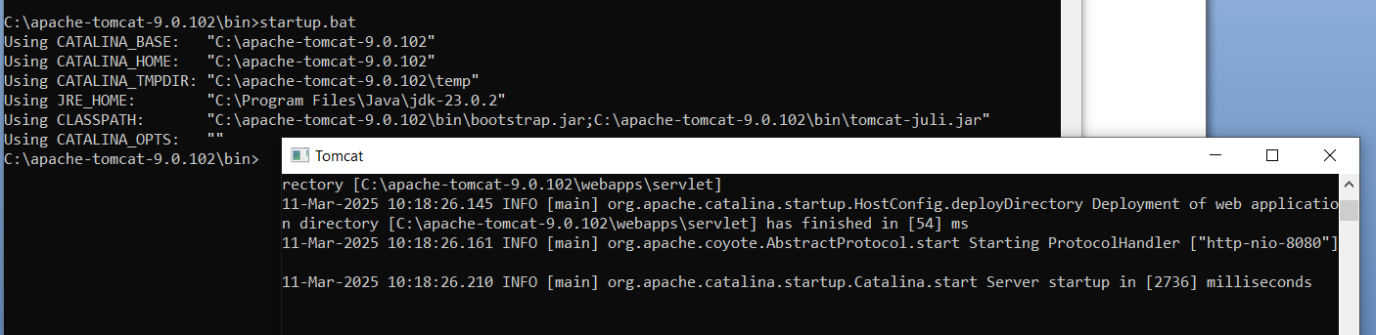

**Access Tomcat in Browser\***

- Open a browser and visit:

http://localhost:8080

- If the *Tomcat welcome page* appears, the setup is successful! ✅

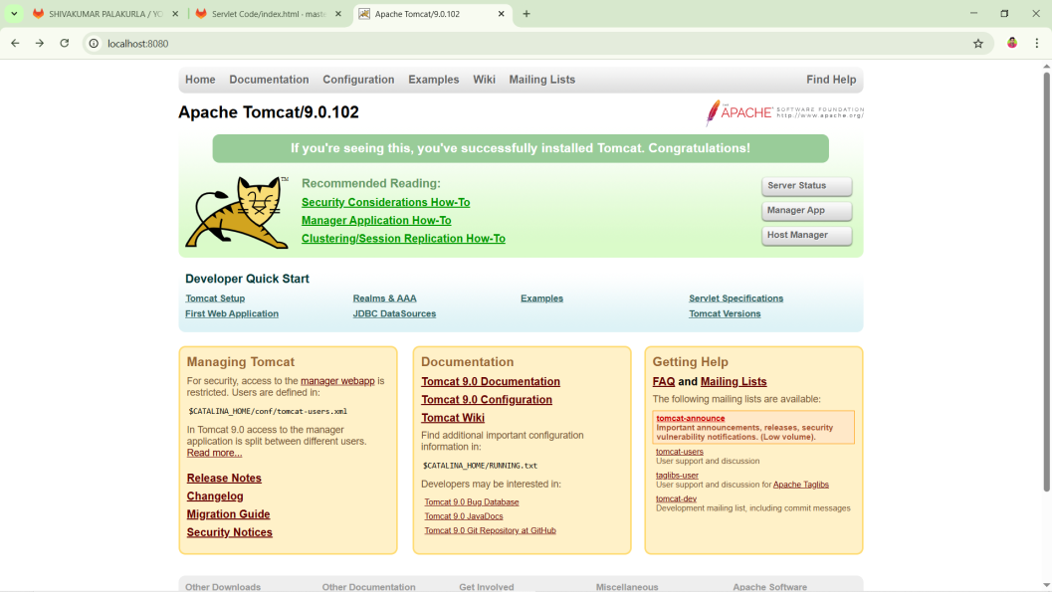

# Click on Manager app (optional)

**# Enter the user name and password (optional)**

**Next execute the javafile**

Execute this commend cmd

javac -cp "C:\apache-tomcat-9.0.102\lib\servlet-api.jar" TestServlet.java



Execute this commend in browser

<http://localhost:8080/servlet/>

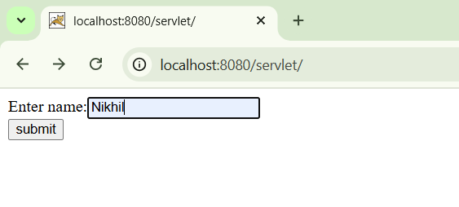

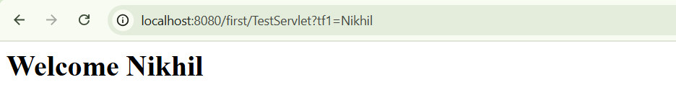

**------------------- -> (Or) we and execute in other way <- ---------------------**

By Deploying the file using the warfile

Steps to cteate war file.

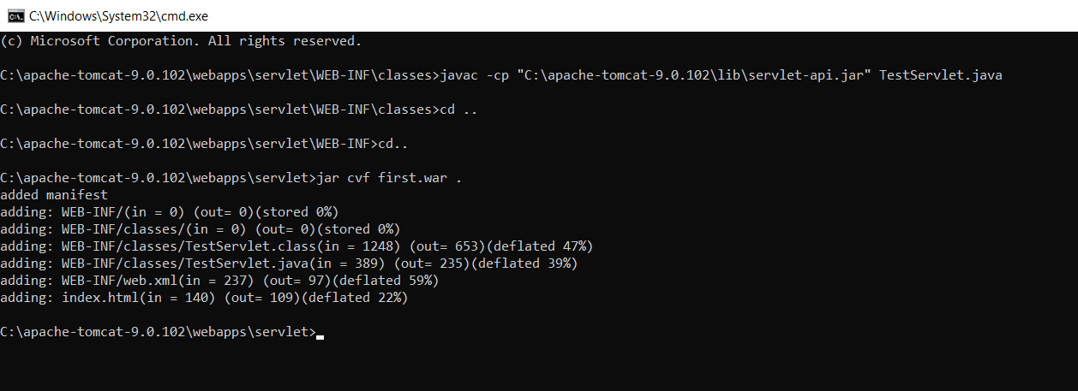

War file will be generated…..in your file location {first.war}

C:\apache-tomcat-9.0.102\webapps\servlet\{first.war}

Back to the browser

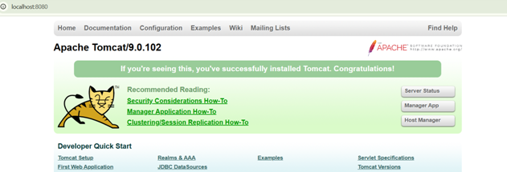

Click on Manager app

**Enter the user name and password**

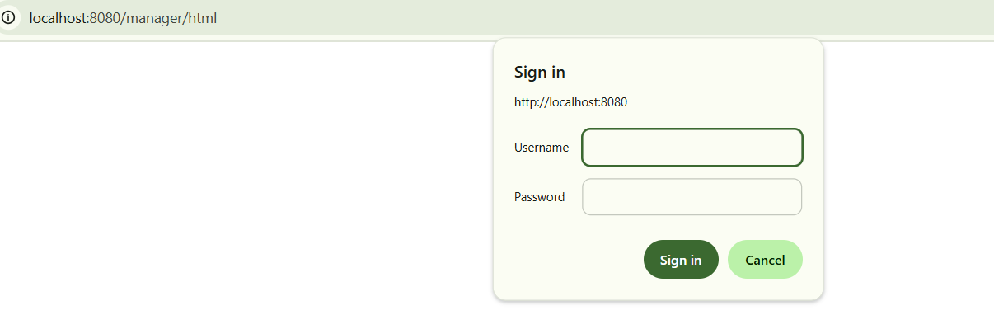

Next Select the generated war file

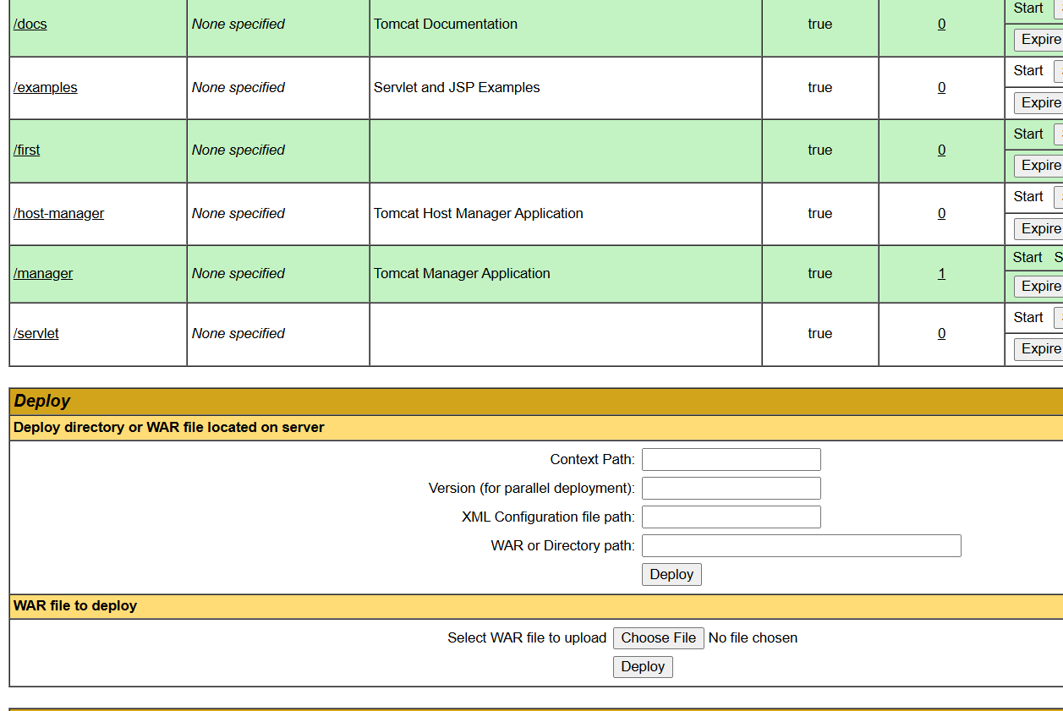

C:\apache-tomcat-9.0.102\webapps\servlet\{first.war} click on deploy



Now click on the /first It will execute

