**Name- Nikhil Bhoi , Roll No.- 121ME0449**

9f(i). Maximize z = 3x1 + 5x2

Subject to: x1 ≤ 4

x2 ≤ 6

3x1 + 2x2 ≤ 18

and x1, x2 ≥ 0.

Ans] i) Graphically :

From constraint ‘1’ :

| x1 | x2 |
| --- | --- |
| 0 | 4 |
| 4 | 0 |

From constraint ‘2’ :

| x1 | x2 |
| --- | --- |
| 0 | 8 |
| 3 | 0 |

From constraint ‘3’ :

| x1 | x2 |
| --- | --- |
| 0 | 3.5 |
| 5 | 0 |



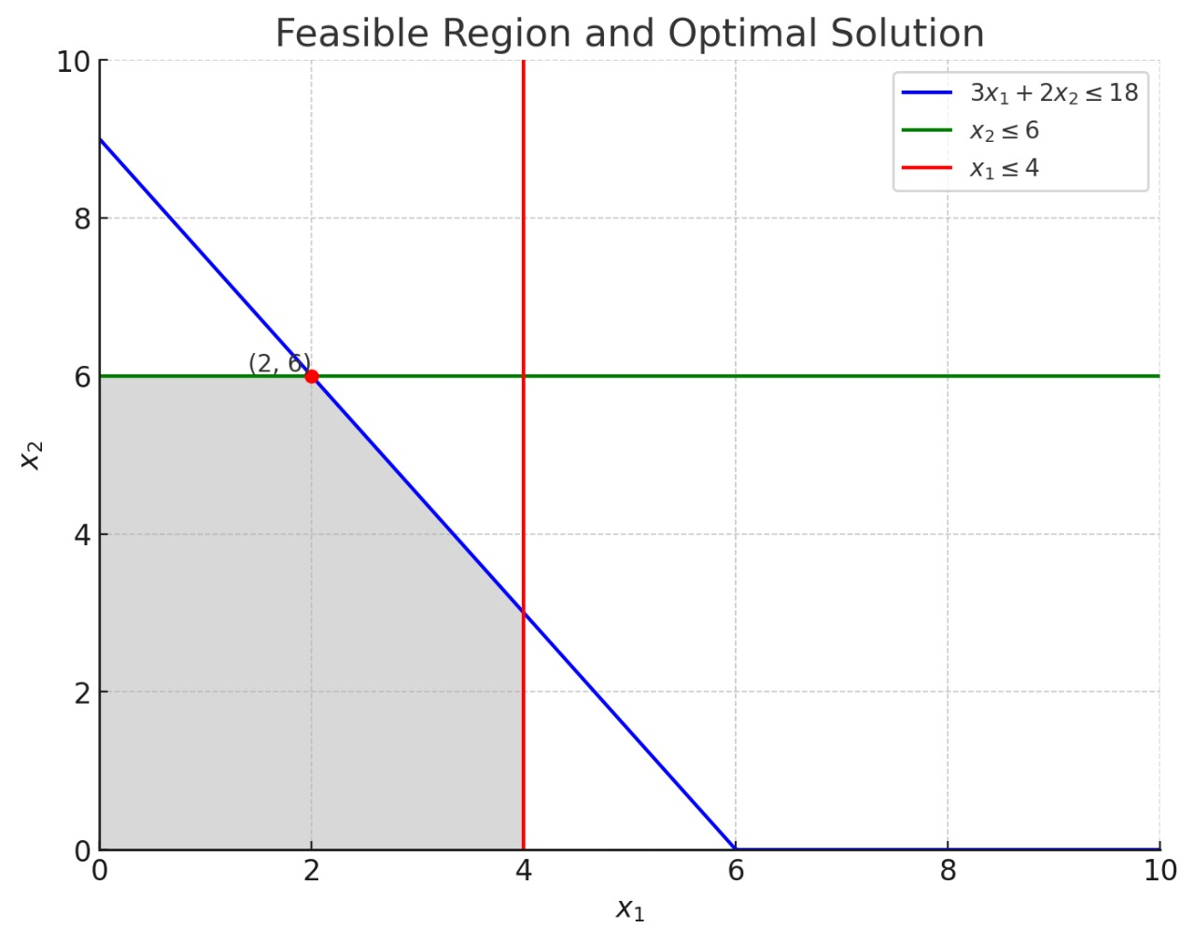

| Point | Profit z = 3x1 + 5x2 |
| --- | --- |
| O(0,0) | 3*0 + 5*0 = 0 |
| A(0,6) | 3*0 + 5*6 = 30 |
| B(2,6) | 3*2 + 5*6 = 36 |
| C(4,3) | 3*4 + 5*3 = 27 |
| D(3.5,0) | 3*3.5 + 5*0 = 10.5 |

Optimal solution is at B

where x1=2, x2=6

So, max profit z=36