1. NUnit-Handson

**Code Implementation:**

**Class1.cs**

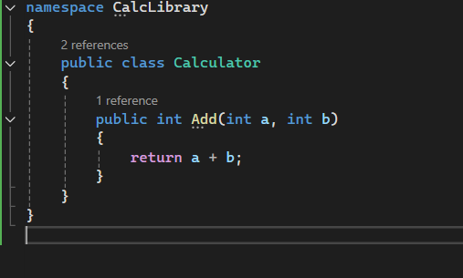

**Unit1Test.cs**

using NUnit.Framework;

using CalcLibrary;

namespace Nunit_CalculatorTests

{

[TestFixture]

public class CalculatorTests

{

private Calculator calculator;

[SetUp]

public void Setup()

{

calculator = new Calculator();

}

[Test]

public void Add_SimpleValues_ReturnsSum()

{

int result = calculator.Add(2, 3);

Assert.That(result, Is.EqualTo(5));

}

}

}

**Output:**

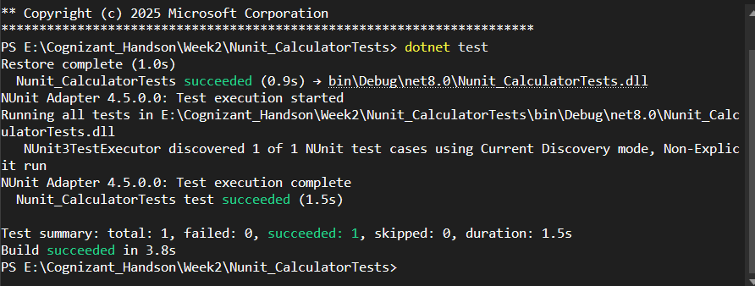

**1.Moq-handson**

IMailSender.cs

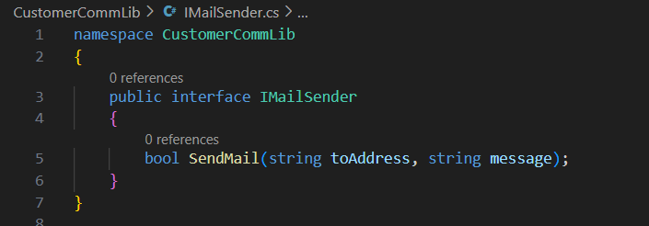

MailSender.cs

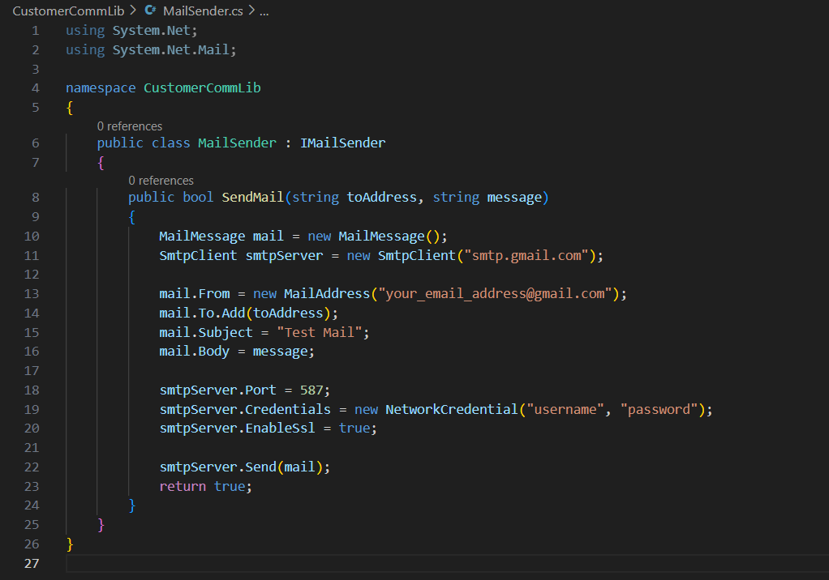

CustomerComm.cs

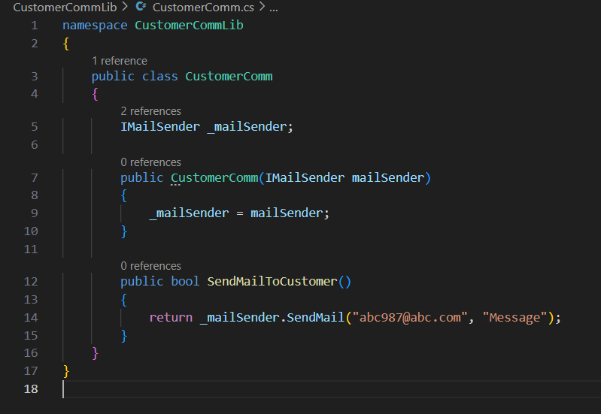

1. Write Test in CustomerComm.Tests

CustomerCommTests.cs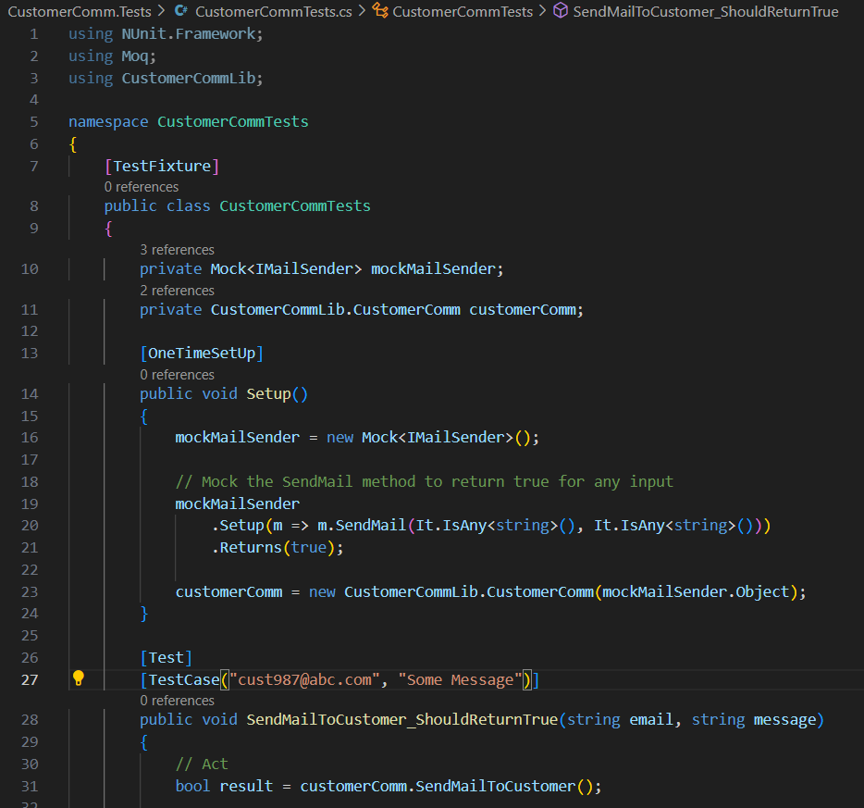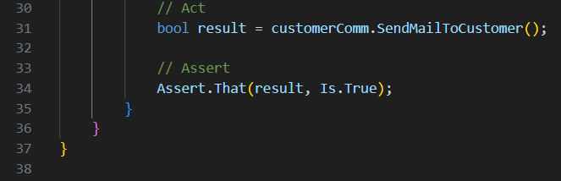

Output:

