**ASSIGNMENT (MODULE-5) HTML-5**

**NAME:- NIKUNJ SAVALIA MOBILE NO.:-8866610103**

1. **What are the new tags added in HTML5?**

* **<article> :-** Represents an independent piece of content of a document, such as a blog entry or newspaper article.
* **<aside > :-** Represents a piece of content that is only slightly related to the rest of the page.
* **<audio> :-** Defines an audio file.
* **<canvas> :-** This is used for rendering dynamic bitmap graphics on the fly, such as graphs.
* **<command> :-** Represents a command the user can invoke.
* **<embed> :-** Defines external interactive content or plugin.
* **<figure> :-** Represents a piece of self-contained flow content, typically referenced as a single unit from the main flow of the document.
* **<datalist> :-** Together with the a new list attribute for input can be used to make combo-boxes.
* **<details> :-** Represents additional information or controls which the user can obtain on demand.
* **<footer> :-** Represents a footer for a section and can contain information about the author, copyright information, etc.
* **<header> :-** Represents a group of introductory or navigational aids.
* **<hgroup> :-** Represents the header of a section.
* **<keygen> :-** Represents control for key pair generation.
* **<mark> :-** Represents a run of text in one document marked or highlighted for reference purposes, due to its relevance in another context.
* **<meter> :-** Represents a measurement, such as disk usage.
* **<nav> :-** Represents a section of the document intended for navigation.
* **<output> :-** Represents some type of output, such as from a calculation done through scripting.
* **<progress> :-** Represents a completion of a task, such as downloading or when performing a series of expensive operations.
* **<ruby> :-** Together with <rt> and <rp> allow for marking up ruby annotations.
* **<section> :-** Represents a generic document or application section.
* **<time> :-** Represents a date and/or time.
* **<video> :-** Defines a video file.
* **<wbr> :-** Represents a line break opportunity.

1. **How to embed audio and video in a webpage?**

**Embed audio webpage**

* To embed the audio in webpage use the <audio> tag.
* In <audio> tag add the path in src and controls section.

**Embed video webpage**

* To embed the video in webpage use the <video> tag.
* And add online video in web page directly use <iframe> tag.

**Ex.:-**

<body>

    <audio src="D:\tops\practice\Hello World(PagalWorld.com.se).mp3"controls></audio><br><br><br>

    <video src="pexels-camila-flores-16883440 (1080p).mp4"control loop width="560" height="315"></video><br><br><br>

    <iframe width="560" height="315" src="https://www.youtube.com/embed/RNEebzirc1M" title="YouTube video player" frameborder="0" allow="accelerometer; autoplay; clipboard-write; encrypted-media; gyroscope; picture-in-picture; web-share" allowfullscreen></iframe>

</body>

</html>

**Otput:-**

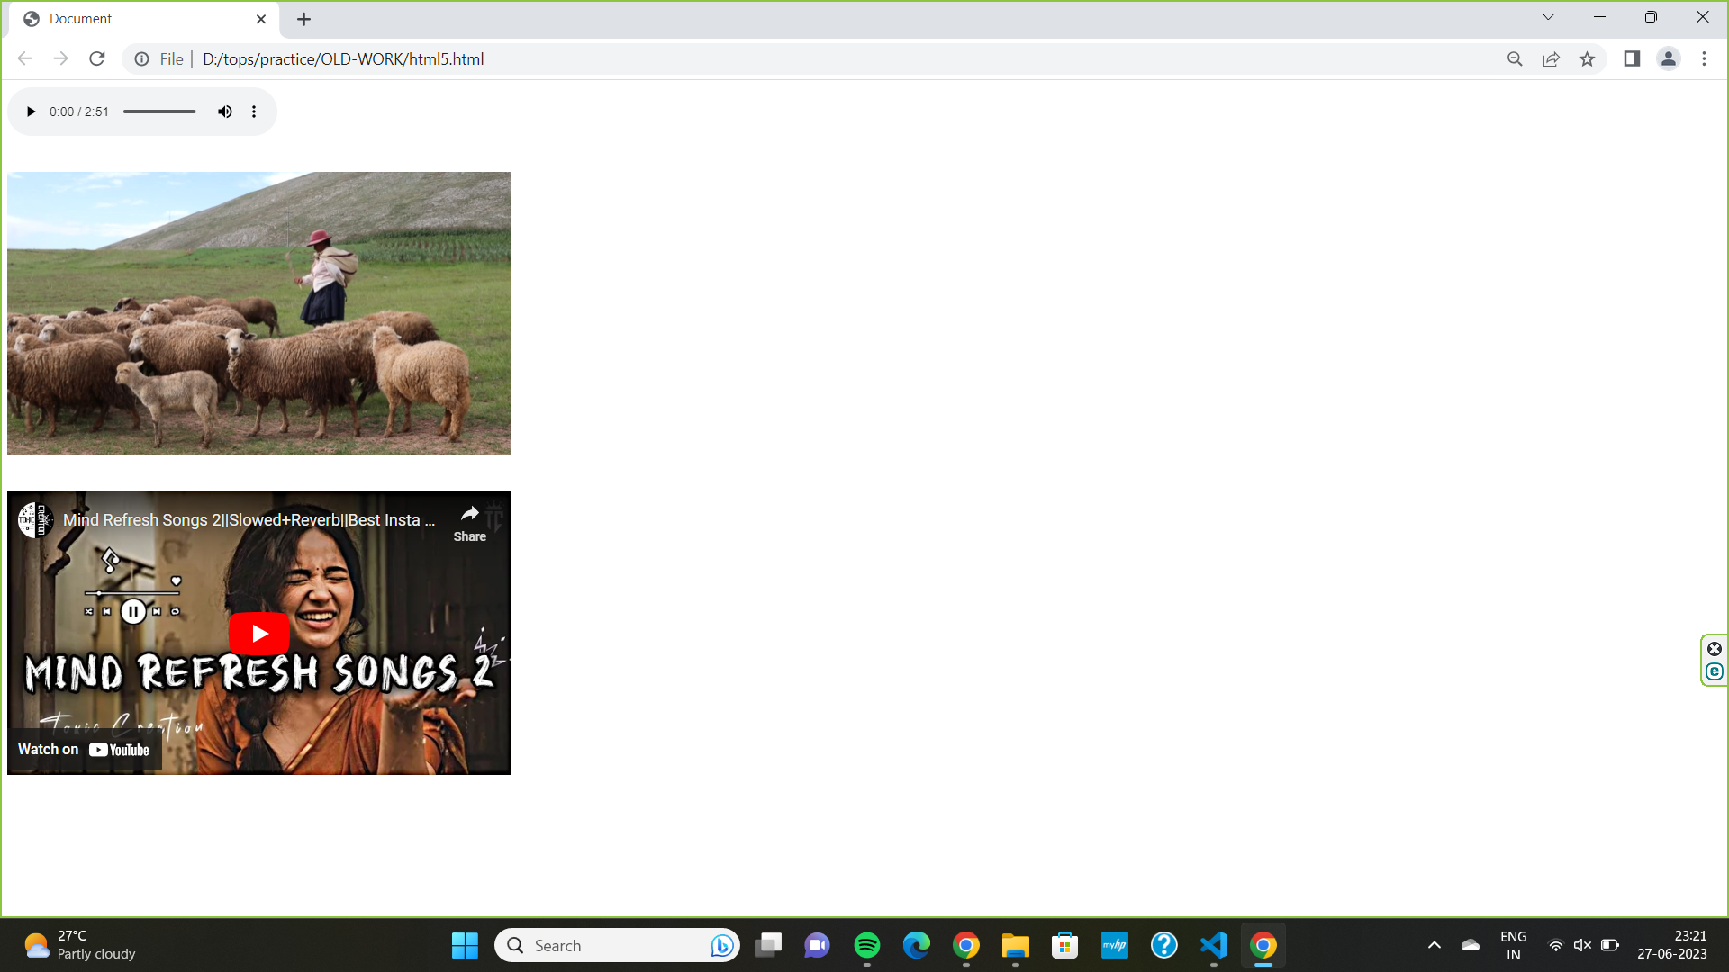

1. **Semantic element in HTML5?**
   * + HTML5 provides more semantic elements which make easy understanding of the code.
     + Semantic elements have a simple and clear meaning for both, the browser and the developer.
     + HTML there are some semantic elements that can be used to define different parts of a web page:
     + <article>
     + <aside>
     + <details>
     + <figure>
     + <footer>
     + <header>
     + <main>
     + <mark>
     + <nav>
     + <section>
     + <summary>
     + <time>

1. **Canvas and SVG tags**

|  |  |
| --- | --- |
| **CANVAS** | **SVG** |
| * Canvas is Script Language. | * SVG is Markup Language. |
| * It is use in Raster Graphics. | * It is use in Vector Graphics. |
| * Canvas had no file formats. | * SVG had .svg file format use for save the file. |
| * Canvas doesn’t support event Handler. | * SVG support event handler. |
| * Canvas had non-searchable. | * SVG is searchable. |
| * Canvas can be use hardware acceleration. | * SVG had not hardware acceleration. |
| * In Canvas must have reset for change the drawn shape. | * SVG can edit shape after drawing |
| * Single element similar to <img> in behavior. Canvas diagram can be saved to PNG or JPG format. | * Multiple graphical elements, which become the part of the page’s DOM tree. |