**Department for General Microbiology**

**University of Göttingen, Germany**

**http://genmibio.uni-goettingen.de/**

**CellPublisher**

**Documentation of version 1.0 of the software**

**Lope A. Flórez (lflorez@gwdg.de)**

Table of Contents

What is CellPublisher? 3

How this document is built 4

Features of CellPublisher v.1.0 4

System Requirements 5

Quick start guide 5

Download and test CellPublisher 6

Use CellPublisher with your own CellDesigner files 7

# What is CellPublisher?

CellPublisher makes CellDesigner diagrams navigable in a web browser. The resulting online diagrams remind a lot to Google maps; in fact, they are displayed using the same underlying software. Here is an example of a custom made CellPublisher map:

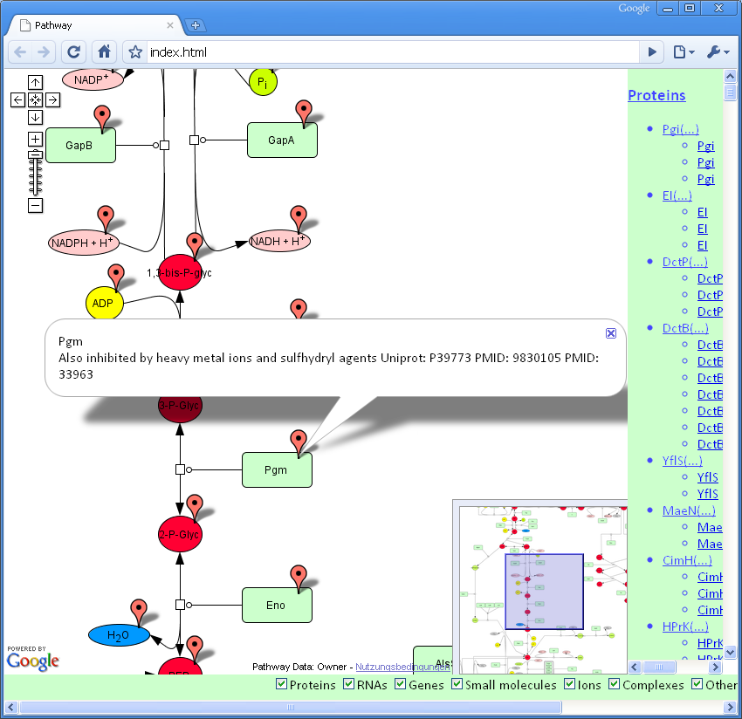

CellPublisher closes the gap between model creation/curation and model visualization/navigation. CellDesigner is arguably the best software available to generate and curate SBGN (Systems Biology Graphical Notation) compliant diagrams. With CellPublisher you can make these diagrams highly interactive and available to a wide audience.

CellPublisher is written in the Python programming language and creates all the necessary HTML, JavaScript, XML, and image files that compose a custom made Google map. After downloading the program, three further steps are all that is required:

* Tell CellPublisher where to find the CellDesigner SBML file, and a PNG representation of the diagram
* Set some settings and display parameters, such as the title of the HTML page and the owner of the image copyrights for the diagram
* Run the program and upload the resulting folder to your web server

The uploaded diagrams will become available immediately from any JavaScript enabled browser with access to your server.

## How this document is built

The sections “Systems Requirements” and “Quick start guide” of this document provide a step-by-step tutorial to creating a standard CellPublisher map. These are the chapters to refer to if you want to put your CellDesigner diagram online quickly.

If you are a programmer that wishes to expand the features of CellPublisher, please refer to the document named “Developer’s guide”. You can download it from <http://genmibio.uni-goettingen.de/CellPublisher/Files/Developers_guide.doc>.

# Features of CellPublisher v.1.0

With version 1.0 of CellPublisher you can:

* Create a custom Google map from your CellDesigner diagram. This includes:
  + Creating tiles for all zoom levels from a PNG image exported by CellDesigner
  + Creating all the JavaScript code needed to make a Google map from these tiles
* Create markers for this map. This includes:
  + Adding a marker to every species in the diagram.
  + Adding an info window that shows the species notes when the marker is clicked. If you have two types of notes for one species (e.g. protein notes that belong to every instance of this protein, and species notes that belong only to a particular state of the protein), the two types of notes will appear the info window.
* Wrap everything up in an HTML document. This includes:
  + Creating an HTML file with the structure of the page and the list of all scripts necessary
  + Creating a CSS file that determines the presentation of the HTML file
  + Creating JavaScript to interact with the map. To this point, these interactions include:
    - A list of all marked species, with a link to the marker
    - Checkboxes to show/hide certain types of species’ markers

# System Requirements

To use CellPublisher you require the following:

* Python

(CellPublisher has only been tested with Python 2.5). You can download Python here: <http://www.python.org/download/>

* CellDesigner

(CellPublisher has only been tested with CellDesigner v.4.0.1). You can download CellDesigner here: <http://www.celldesigner.org/download.html>

* A Google maps key

This key gives you permission to run the Google maps software in documents from your server. You can get more information on this key on the following page: <http://code.google.com/apis/maps/signup.html>

* A freely available web server

CellPublisher relies on the Google maps API (Application Programming Interface). This API only works on servers with public access (for more info, see the link about the Google maps API).

CellPublisher also relies on several third party modules. The following is required for Python:

* Python Imaging Library (PIL)

This is a freely available python library for the manipulation of images. CellPublisher works well with v.1.1.6. You can get the PIL here: <http://www.pythonware.com/products/pil/>

The other third party modules are encoded in JavaScript. They are not strictly required (i.e. you can configure CellPublisher so that they are not needed) but they enhance the user experience. All modules used are freely available, but it is required that you accept the terms and conditions of their use. The third party JavaScript modules, together with their license, can be found in the folder “src/JavaScript/thirdParty”.

# Quick start guide

This guide will assume that your system already meets all requirements mentioned above. The guide will first show you where to download the program and how to execute a test run. Next, it will guide you in the process of creating a map based on your own CellDesigner files.

The test run will convert a CellDesigner diagram about toll-like receptor signalling created by Oda & Kitano[1] to a CellPublisher map.

## Download and test CellPublisher

1. Download CellPublisher from <http://cellpublisher.uni-goettingen.de/>

In the page, search for the “Download” link and save “CellPublisher_v1.0.zip” in your computer. Then unpack this folder.

1. Explore the folder structure

The unzipped folder will contain three subfolders: “CellDesigner”, “src”, and “Result”.

* The **“CellDesigner files”** folder contains a CellDesigner file named “test.sbml” and a PNG image exported from that file (named “test.png”). This is the diagram that will be converted by CellPublisher in this part of the guide.
* The **“src”** folder contains all the source code. The only file that you need to change is the “settings.py” file, which you can find in the “src/Python/” folder. (In case you wish to revert to the original file, delete “settings.py”, make a copy of the file “settings.py.backup”, and rename it “settings.py”).
* After the program runs, you will find the folder to upload in the **“Results”** folder.

1. Enter your Google maps API key

As was mentioned in the “Systems Requirements” section, you will need an API key from Google in order to run the Google maps software in your website. This key is a long stretch of characters, like this:

ABQIAAAAdv_U95xs4olkboY4Zf62BQ1OHObilvMXQ55VwyQQiIHA0husDCGESYslr1w8ppIP7QsEZTRRndPet

Open the “settings.py” file in a text editor and paste *your* API key inside the quotes next to the variable GOOGLE_MAPS_KEY.

1. Run the program

From the command line (in Windows you can access the command line by going to the “Start” menu and selecting “Run...” >> “cmd”) access the “src” folder. Then type:

> python wrapper.py

1. Upload the result

You will find the folder named “test” in the “Results” folder. Upload all its contents to your server. Then visit the page “YOUR_URL/test/index.html”. You should be able to navigate the test CellDesigner file using your web browser.

## Use CellPublisher with your own CellDesigner files

If the previous test worked, you should be able to repeat the steps with your own CellDesigner file. Follow these steps:

1. Copy your CellDesigner file in the folder “CellDesigner files”.
2. Open the file with CellDesigner and select “File” > ”Export Image...”. Find the “CellDesigner files” folder and save the image in PNG format (by selecting “PNG Image files (.png)” from the menu).
3. Make sure there is no folder named after your CellDesigner file in the “Results” folder (e.g. if your CellDesigner file is called “myPathway.sbml” make sure there is no folder named “myPathway” in the “Results” folder).
4. Edit “settings.py”

In addition to entering your Google maps API key (see previous section), you will need to modify the following variables:

* PATH_TO_IMAGE: Change it to the name of your PNG image
* PATH_TO_SBML_FILE: Change it to the name of your CellDesigner file
* COPYRIGHT_OWNER: Add a notice on who created the CellDesigner diagram

1. Run the program from the command line (see point 4. from the previous section):

> python wrapper.py

1. Upload the resulting folder. The folder will be in the “Results” folder, and its name will be the same as the one of your CellDesigner file (see point 3.).

1. Oda,K. & Kitano,H. (2006) A comprehensive map of the toll-like receptor signaling network.   
   **Mol Syst Biol**, 2, 10.1038/msb4100057. Available at: http://dx.doi.org/10.1038/msb4100057