SEMESTER PROJECT REPORT

Hospital Patient Triage & Bed Allocator

Submitted To
Sir Hassan Ahmed
Submitted By
Nimrah Shahid 23F-0734
Saweba Gill 23F-0733
Saman Mahwash 23F-0656


Course
CL2006 – Operating Systems Lab

Department
National University of Computer & Emerging Sciences (FAST-NUCES)
Spring 2026

Table of Contents
SEMESTER PROJECT REPORT 1
Hospital Patient Triage & Bed Allocator 1
Submitted To 1
Course 1
Department 1
1. INTRODUCTION 6
2. OBJECTIVES 6
3. SYSTEM OVERVIEW 6
Admissions Manager 6
Patient Simulator 7
Shared Memory Ward 7
Nurse Threads 7
Scheduler Thread 7
Receptionist Thread 7
4. SYSTEM ARCHITECTURE 7
Components 7
Data Flow 7
Architecture Diagram 8
5. PHASE 1 – SHELL SCRIPTING & ENVIRONMENT SETUP 8
triage.sh 8
Priority Mapping 8
start_hospital.sh 9
stop_hospital.sh 9
Makefile 10
6. PHASE 2 – PROCESS MANAGEMENT & IPC 10
6.1 Process Management 10
fork() and execv() 10
SIGCHLD Handler 10
Concurrent Processing 10
6.2 Inter Process Communication 11
Anonymous Pipe 11
Named FIFO 11
FIFO Path 11
Shared Memory 11
Functions Used 11
7. PHASE 3 – THREADS & SYNCHRONIZATION 12
7.1 POSIX Threads 12
Receptionist Thread 12
Responsibilities 12
Scheduler Thread 12
Responsibilities 12
Nurse Threads 12
Responsibilities 12
7.2 Mutexes 12
Purpose 12
7.3 Condition Variables 13
Functions Used 13
7.4 Semaphores 13
Functions Used 13
8. PHASE 4 – MEMORY MANAGEMENT 13
8.1 Best-Fit Allocation 13
Other Strategies 14
8.2 Coalescing 14
8.3 Fragmentation Analysis 14
External Fragmentation Formula 14
External Fragmentation = (1− (Largest Free Block /Total Free Units)​) ×100 14
Internal Fragmentation 14
8.4 Paging Simulation 15
Page Size 15
Page Table Tracks 15
9. SCHEDULING ALGORITHMS 15
FCFS (First Come First Serve) 15
Priority Scheduling 15
Scheduling Metrics 15
10. TESTING & RESULTS 16
Test Case 1 16
Input 16
Expected Output 16
Actual Result 16
Test Case 2 16
Stress Test 16
Result 16
11. VALGRIND OUTPUT 20
Command 20
valgrind --leak-check=full ./admissions 20
Result 20
Output: 21
12. CHALLENGES & LESSONS LEARNED 21
Challenges Faced 21
Lessons Learned 21
13. INDIVIDUAL CONTRIBUTIONS 21
14. CONCLUSION 22
SELF-EVALUATION FORM 22
Semester Project Self-Evaluation Form 22
A. Group Details 22
Group Members 22
Project Title 22
B. Module Implementation Checklist 22
I. Shell Scripting & Environment 22
II. Process Management & IPC 23
III. Scheduling 23
IV. Threads & Synchronization 23
V. Memory Management 23
C. Reflection & Analysis 24
Synchronization Challenge 24
Memory Allocation Trade-offs 24
Known Bugs / Limitations 24
D. Individual Contributions 24
Nimrah Shahid 24
Saman Mahwash 24
Saweba Gill 24
E. Integrity Declaration 25

1. INTRODUCTION
The Hospital Patient Triage & Bed Allocator is a Linux-based Operating Systems semester project developed in the C programming language using POSIX system programming concepts. The project simulates the workflow of a real hospital emergency room where patients arrive with different severity levels and are assigned beds according to their medical condition.
The project integrates major operating system concepts including:
- Process Management
- Inter Process Communication (IPC)
- CPU Scheduling
- POSIX Threads
- Mutexes and Condition Variables
- Semaphores
- Shared Memory
- Memory Allocation Techniques
- Fragmentation Analysis
The system demonstrates how operating system concepts can be applied in real-world scenarios such as hospital management systems.

2. OBJECTIVES
The main objectives of this project are:
- To implement process creation using fork() and execv()
- To implement inter-process communication using pipes, FIFOs, and shared memory
- To simulate CPU scheduling algorithms
- To implement synchronization using mutexes, condition variables, and semaphores
- To simulate memory management techniques such as Best-Fit allocation
- To analyze internal and external fragmentation
- To develop a concurrent multi-threaded hospital management simulation

3. SYSTEM OVERVIEW
The project consists of the following major modules:

Admissions Manager
The admissions manager acts as the central controller of the hospital system. It manages patient queues, bed allocation, scheduling, synchronization, and patient process creation.

Patient Simulator
A separate child process is created for every patient using fork() and execv(). The patient simulator represents patient treatment and discharge.

Shared Memory Ward
The ward is implemented using shared memory. All bed information is stored inside the shared memory segment.

Nurse Threads
Nurse threads continuously monitor beds and release them after patient discharge.

Scheduler Thread
The scheduler thread allocates beds according to patient priority.

Receptionist Thread
The receptionist thread receives patient records from the triage script.

4. SYSTEM ARCHITECTURE

Components
- Triage Script
- Receptionist Thread
- Priority Queue
- Scheduler Thread
- Shared Memory Ward
- Nurse Threads
- Patient Processes

Data Flow
- Patient data is entered using triage.sh
- The receptionist thread receives the patient record
- The patient is added to the priority queue
- The scheduler allocates the best available bed
- A patient process is created using fork() and execv()
- The patient simulator performs treatment
- Discharge notification is sent through FIFO
- Nurse thread frees the bed

Architecture Diagram
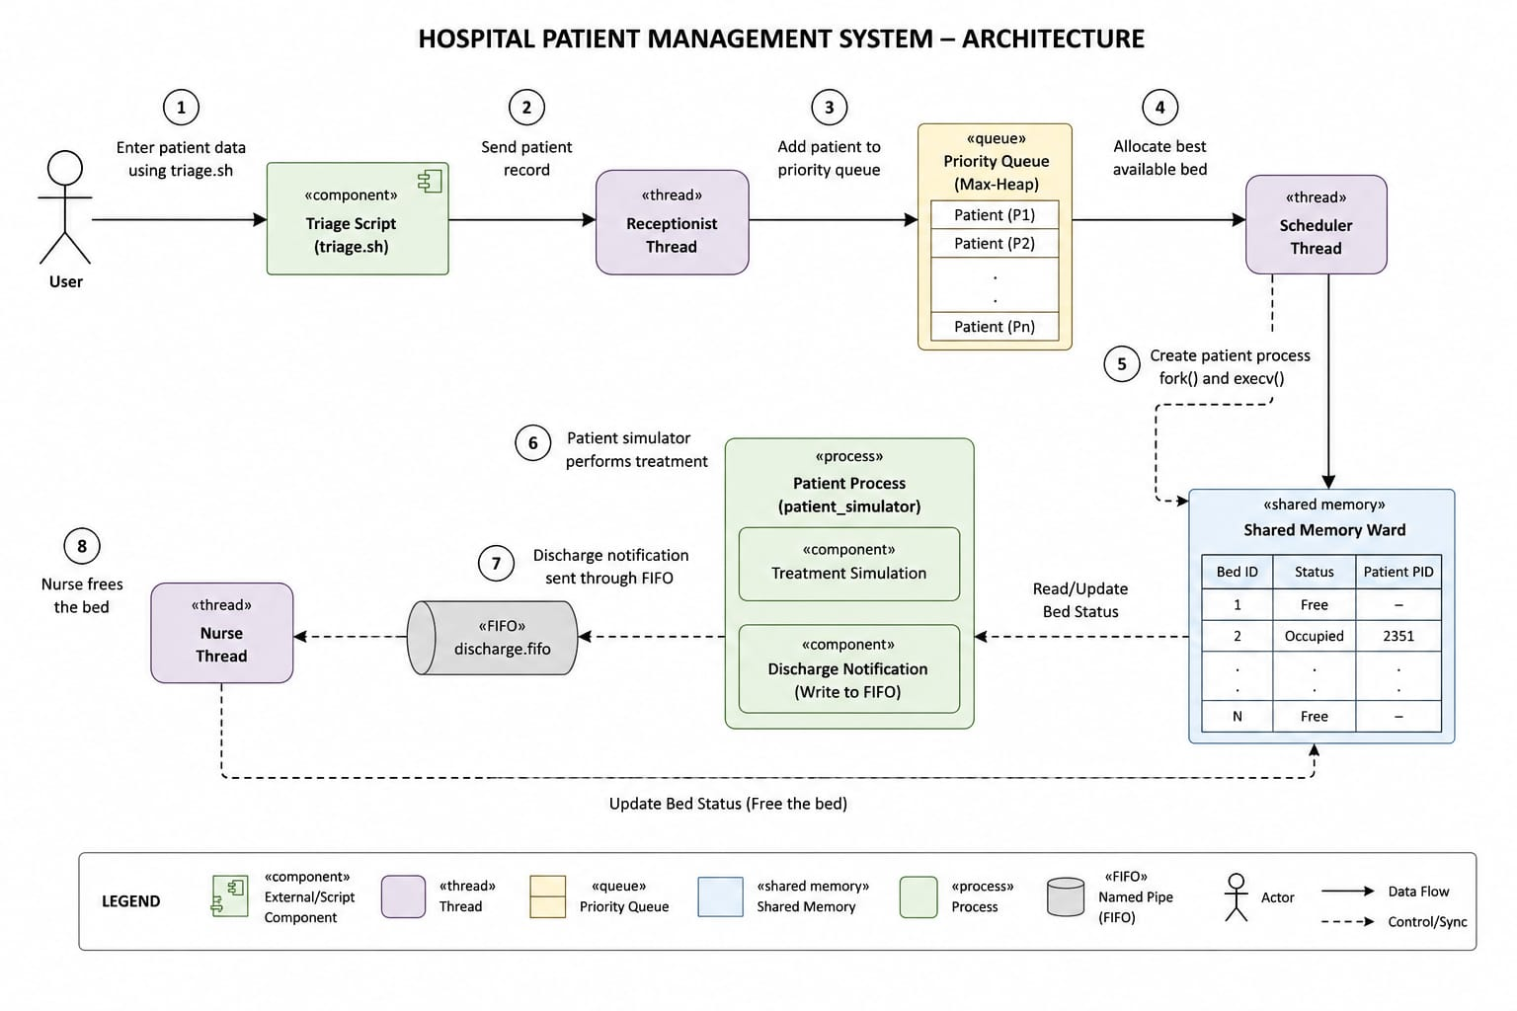

5. PHASE 1 – SHELL SCRIPTING & ENVIRONMENT SETUP

triage.sh
The triage shell script:
- Accepts patient name, age, and severity
- Validates input
- Calculates priority level
- Sends patient data to admissions manager

Priority Mapping
Severity | Priority
9–10 | 1
7–8 | 2
5–6 | 3
1–4 | 4

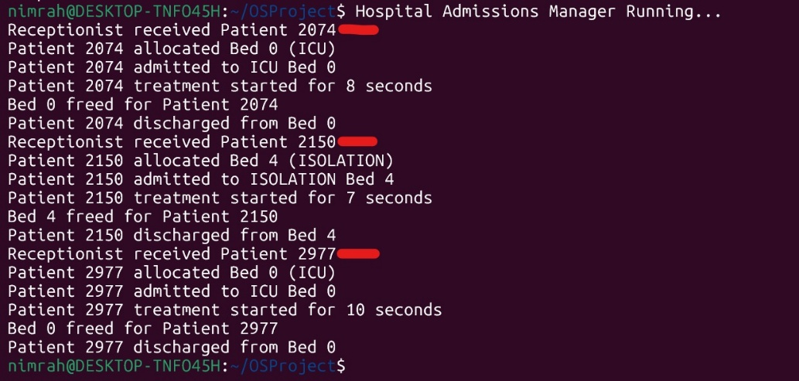

start_hospital.sh
This script:
- Compiles project files
- Starts the admissions manager
- Initializes logs
- Launches the hospital simulation

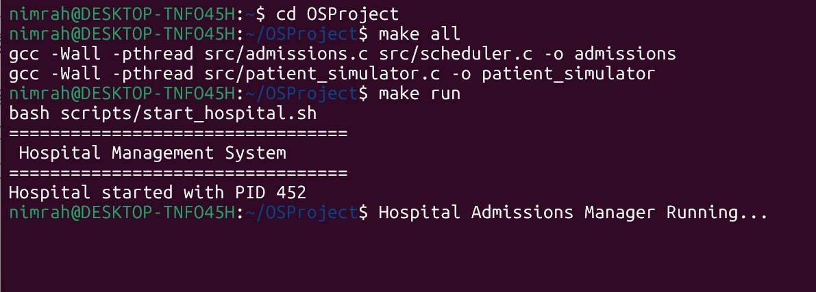

stop_hospital.sh
This script:
- Terminates hospital processes
- Removes FIFOs
- Cleans shared memory
- Prints shutdown message

Makefile
The Makefile supports:
- make all
- make run
- make clean
- make test

6. PHASE 2 – PROCESS MANAGEMENT & IPC

6.1 Process Management

fork() and execv()
For every admitted patient:
- fork() creates a child process
- execv() replaces the child process with patient_simulator

SIGCHLD Handler
The SIGCHLD signal handler automatically reaps zombie processes using:
waitpid(-1, NULL, WNOHANG);

Concurrent Processing
The system supports multiple concurrent patient processes.
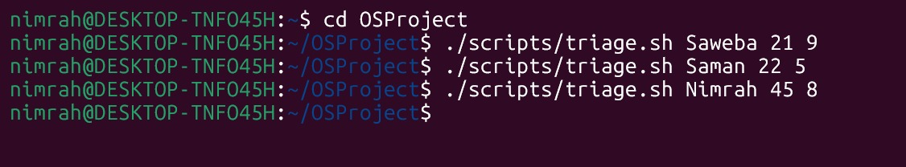

6.2 Inter Process Communication

Anonymous Pipe
Used between:
- triage.sh
- admissions manager

Named FIFO

FIFO Path
/tmp/discharge_fifo
Used for:
- Patient discharge notifications

Shared Memory
Shared memory stores:
- Bed allocation bitmap
- Bed information
- Patient assignment data

Functions Used
shmget()
shmat()
shmdt()
shmctl()

7. PHASE 3 – THREADS & SYNCHRONIZATION

7.1 POSIX Threads

Receptionist Thread

Responsibilities
- Reads patient records
- Enqueues patients

Scheduler Thread

Responsibilities
- Dequeues patients
- Allocates beds
- Creates patient processes

Nurse Threads

Responsibilities
- Monitor patient discharge
- Free occupied beds
- Signal scheduler thread

7.2 Mutexes
A mutex protects the shared ward structure:
pthread_mutex_lock()
pthread_mutex_unlock()

Purpose
- Prevent race conditions
- Ensure synchronized bed allocation

7.3 Condition Variables
Condition variables are used when:
- No suitable bed is available
- Scheduler thread waits
- Nurse thread signals after discharge

Functions Used
pthread_cond_wait()
pthread_cond_signal()
pthread_cond_broadcast()

7.4 Semaphores
Semaphores enforce the following capacities:
Bed Type | Maximum Capacity
ICU | 4
Isolation | 4

Functions Used
sem_wait()
sem_post()
Producer-consumer synchronization is also implemented using semaphores.

8. PHASE 4 – MEMORY MANAGEMENT

8.1 Best-Fit Allocation
The ward is modeled as contiguous memory.
Best-Fit allocation selects the smallest available partition that can satisfy the request.

Other Strategies
- First-Fit
- Worst-Fit

8.2 Coalescing
When a patient is discharged:
- Adjacent free partitions are merged
- External fragmentation is reduced

8.3 Fragmentation Analysis

External Fragmentation Formula

External Fragmentation = (1− (Largest Free Block /Total Free Units)​) ×100
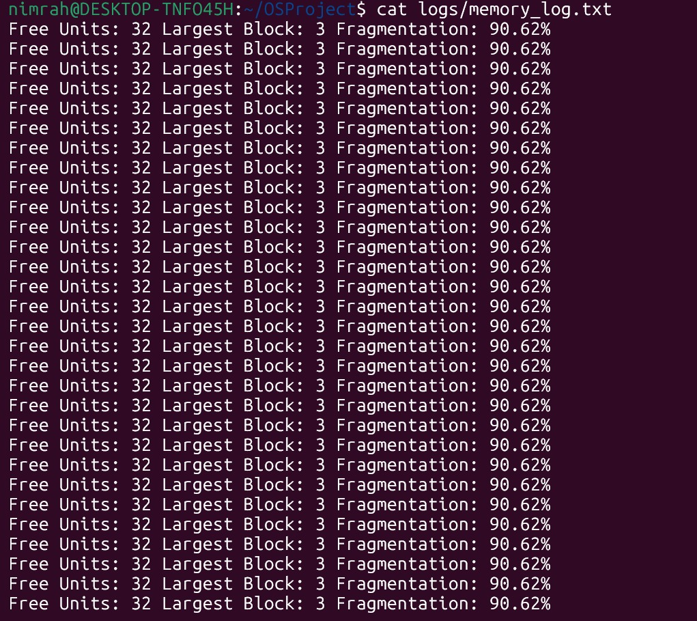

Internal Fragmentation
Internal fragmentation occurs when allocated memory contains unused space.

8.4 Paging Simulation
The ward is divided into fixed-size pages.

Page Size
- 2 Care Units

Page Table Tracks
- Page occupancy
- Patient ownership
- Internal fragmentation

9. SCHEDULING ALGORITHMS

FCFS (First Come First Serve)
Patients are executed in arrival order.

Priority Scheduling
Patients with higher medical priority are executed first.

Scheduling Metrics
- Waiting Time
- Turnaround Time
Logs are stored in:
logs/schedule_log.txt
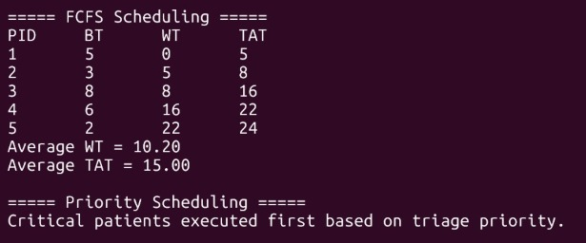

10. TESTING & RESULTS

Test Case 1

Input
./scripts/triage.sh Saweba 21 9

Expected Output
- Patient priority assigned
- ICU bed allocated
- Child process created

Actual Result
- Successfully executed
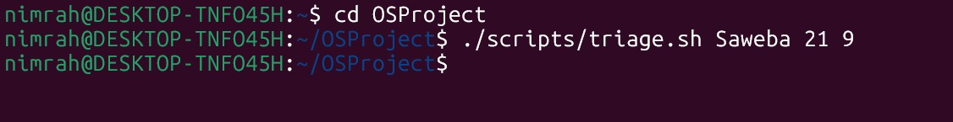

Test Case 2

Stress Test
make test

Result
- 20 concurrent patients handled successfully
- No crashes occurred
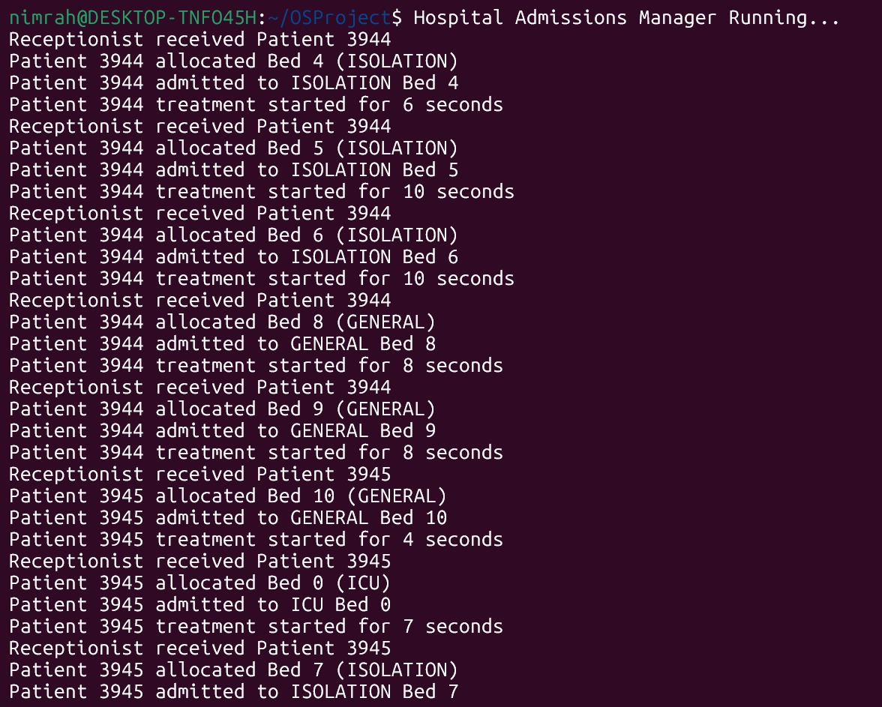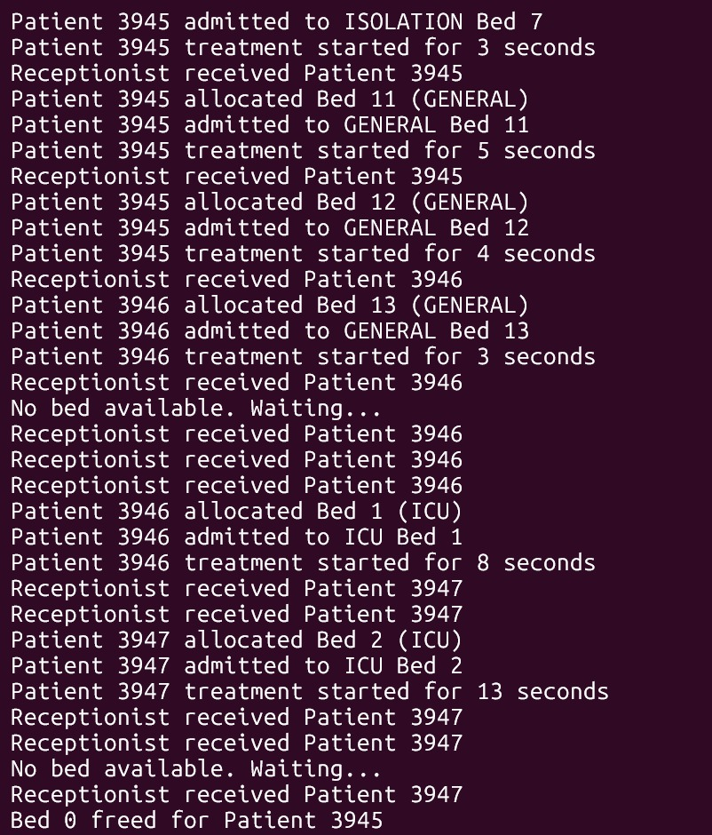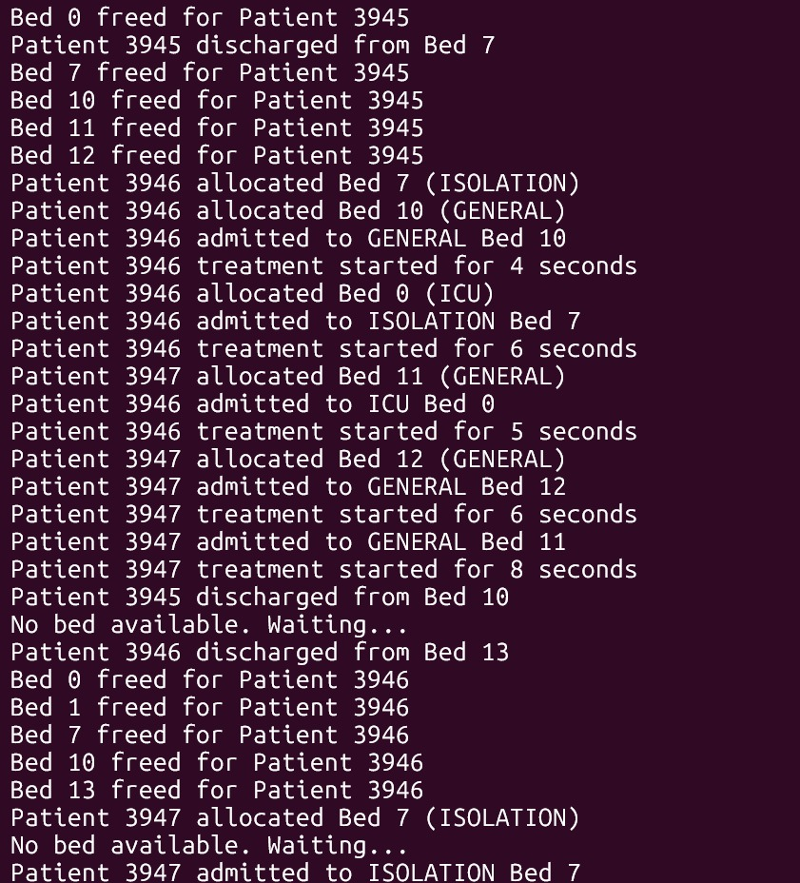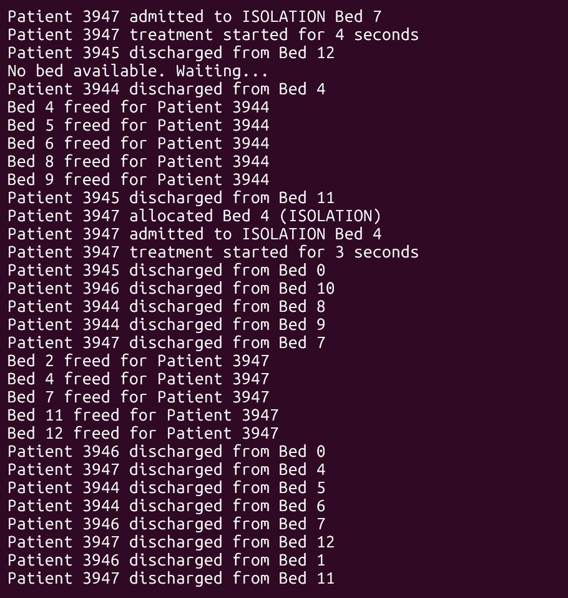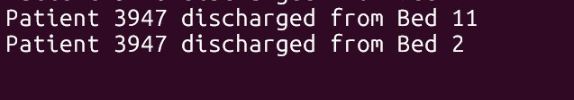

11. VALGRIND OUTPUT
Val grind was used to detect memory leaks.

Command

valgrind --leak-check=full ./admissions

Result
- No memory leaks detected
- All dynamically allocated memory freed successfully

Output:
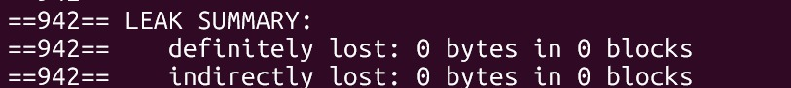

12. CHALLENGES & LESSONS LEARNED

Challenges Faced
- Synchronizing multiple threads
- Preventing race conditions
- Managing shared memory correctly
- Handling concurrent patient admissions
- Implementing semaphores correctly

Lessons Learned
- Importance of synchronization mechanisms
- Working with Linux system calls
- Process and thread management
- Memory allocation techniques
- Real-world applications of operating systems concepts

13. INDIVIDUAL CONTRIBUTIONS
Module | Nimrah Shahid | Saweba Gill | Saman Mahwash
Shell Scripts | ✓
Process Management | ✓ | ✓
IPC | ✓ | ✓
Scheduling |  | ✓
Threads & Synchronization |  | ✓ | ✓
Memory Management |  |  | ✓
Report & Documentation | ✓ |  | ✓

14. CONCLUSION
This project successfully demonstrated core operating system concepts using a real-world hospital management simulation. The system implemented process management, synchronization, memory allocation, IPC, and scheduling techniques in a concurrent Linux environment.
The project improved understanding of low-level system programming and practical implementation of operating system concepts.

SELF-EVALUATION FORM

Semester Project Self-Evaluation Form

A. Group Details

Group Members
- Saman Mahwash
- Nimrah Shahid
- Saweba Gill

Project Title
“Hospital Patient Triage & Bed Allocator”

B. Module Implementation Checklist

I. Shell Scripting & Environment
☒ triage.sh implemented
☒ start_hospital.sh implemented
☒ stop_hospital.sh implemented
☒ Makefile working correctly

II. Process Management & IPC
☒ fork() + execv() implemented
☒ SIGCHLD + waitpid(WNOHANG) implemented
☒ Concurrent patient processes supported
☒ Anonymous Pipe implemented
☒ Named FIFO implemented
☒ Shared Memory implemented

III. Scheduling
☒ Priority Queue implemented
☒ FCFS Scheduling implemented
☒ Priority Scheduling implemented
☒ Waiting and Turnaround Time calculated

IV. Threads & Synchronization
☒ Receptionist Thread implemented
☒ Scheduler Thread implemented
☒ Nurse Threads implemented
☒ Mutex synchronization implemented
☒ Condition variables implemented
☒ ICU semaphore implemented
☒ Isolation semaphore implemented
☒ Producer-consumer synchronization implemented

V. Memory Management
☒ Best-Fit allocation implemented
☒ First-Fit implemented
☒ Worst-Fit implemented
☒ Coalescing implemented
☒ Fragmentation analysis implemented
☒ Paging simulation implemented

C. Reflection & Analysis

Synchronization Challenge
During development, race conditions occurred when multiple threads attempted to allocate the same ICU bed simultaneously. This issue was solved using pthread mutex locks and condition variables.

Memory Allocation Trade-offs
Best-Fit reduced memory waste in many cases but sometimes increased fragmentation because smaller partitions became scattered throughout memory.

Known Bugs / Limitations
- Rare synchronization delays may occur under very heavy stress testing
- Paging simulation is simplified for demonstration purposes

D. Individual Contributions

Nimrah Shahid
- Shell scripts
- Shared memory implementation
- Documentation Support
- Process management

Saman Mahwash
- Memory allocation
- Fragmentation analysis
- Paging simulation
- Report Making

Saweba Gill
- Scheduling algorithms
- Semaphores
- Thread synchronization
- Priority queue

E. Integrity Declaration
We certify that this project was developed by our group and that we understand all implemented modules.
Name | Signature
Nimrah Shahid | ______________
Saweba Gill | ______________
Saman Mahwash | ______________

