Temperature kriging

Zofie Cimburova

23 juni 2017

## Libraries

library(rgdal)   
library(raster)  
library(gstat)  
library(automap)

# 1. Import datasets - temperature and underlying terrain model

* 250 m temperature and 250 m DEM

r.bio11 <- raster("BIO11_250m_sample.tif", band=1)  
r.dem <- raster("dem_250m_sample.tif", band=1)  
  
projection(r.bio11) <- "+proj=utm +zone=33 +ellps=GRS80 +towgs84=0,0,0,0,0,0,0 +units=m +no_defs"  
  
r.measurements <- brick(r.bio11, r.dem)  
names(r.measurements) <- c('BIO11','height')

* new data for prediction: 10 m DEM

r.dem_new <- raster("dem_10m_sample.tif", band=1)  
names(r.dem_new) <- "height"

* set NaNs to 0

r.measurements$height[is.na(r.measurements$height)] = 0  
r.dem_new[is.na(r.dem_new[])] = 0

* set projections

projection(r.measurements) <- "+proj=utm +zone=33"  
projection(r.dem_new) <- "+proj=utm +zone=33"

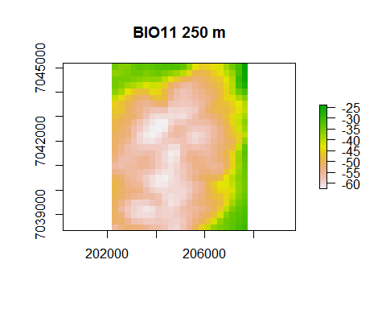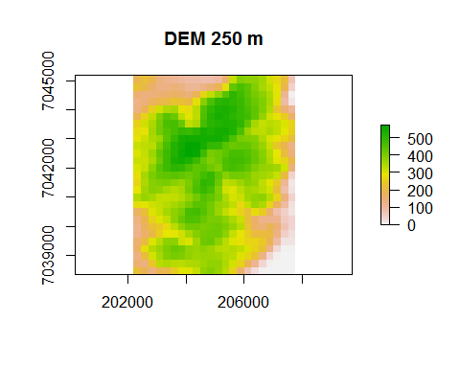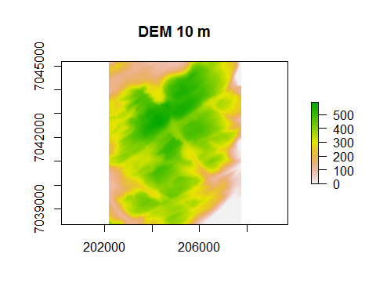

## [1] 27 22 1

## [1] 27 22 1

## [1] 682 557 1