INLA for ECOFUNC

include=FALSE nothing message=FALSE no output echo=FALSE no code

## 1. Load the data

470 501 observations are exported from GRASS. For each observation point, its x- and y- coordinate, row and column number, total number of forest pixels, total number of forest and open land pixels and median values of environmental explanatory variables are stored.

input_data <- read.csv("variables_avg_med_std.csv")

## water_med aspect_med curv_med slope_med topex_e_med topex_n_med  
## 1 206.15528 190.2394 -0.0001985216 10.23331 1.9473065 4.460040  
## 2 154.05694 190.0079 -0.0005031548 12.15138 5.3213400 4.146689  
## 3 300.00000 202.9225 0.0000000000 11.13258 2.0808316 4.915342  
## 4 85.35534 198.5654 0.0003948833 14.39963 1.6229463 6.402441  
## 5 50.00000 221.5318 0.0001157182 11.84057 0.5858289 4.687766  
## 6 50.00000 197.3695 0.0010081581 12.97935 3.9471529 3.690465  
## topex_ne_med topex_nw_med topex_s_med topex_se_med topex_sw_med  
## 1 2.440755 4.934301 1.890075029 1.5237084 2.26200745  
## 2 5.880727 1.632487 0.859372331 3.6048700 -0.03437747  
## 3 3.932897 4.431565 1.460725899 1.2245110 1.31757234  
## 4 5.122872 5.066975 2.976699955 1.7183580 1.72685024  
## 5 2.890981 3.407124 -0.154698233 -0.1188886 -0.05729576  
## 6 4.700571 1.203035 -0.005729578 1.0312122 0.65682630  
## topex_w_med tpi_250_med tpi_500_med tpi_1000_med tpi_2500_med  
## 1 2.9195552 1.018805 2.321847 2.998959 -0.2969551  
## 2 0.8498251 1.210523 2.563129 7.668012 2.0935794  
## 3 2.2906100 -1.812025 -7.540287 -24.279856 -39.5940497  
## 4 2.9731273 3.993119 8.222554 17.205572 25.3239514  
## 5 0.5729387 1.219902 3.168644 8.099478 28.9341941  
## 6 0.8250022 2.489182 2.343467 6.197872 2.2298732  
## tpi_5000_med tri_med solrad_apr_med solrad_autumn_med solrad_jan_med  
## 1 10.66296 1.437500 35002.0 25100.0 4086  
## 2 10.51268 1.775000 35046.0 25875.0 4394  
## 3 -26.13902 1.587501 35196.0 25665.5 4267  
## 4 19.61821 2.075000 35364.5 26010.0 4257  
## 5 47.54461 1.700000 35986.0 28050.0 4975  
## 6 13.09215 1.850000 35361.0 26287.0 4475  
## solrad_jul_med solrad_oct_med solrad_spring_med solrad_summer_med  
## 1 47565.0 14058.5 126702 125533.0  
## 2 47396.0 14320.0 126566 125385.0  
## 3 47711.0 14294.0 127225 126057.5  
## 4 47600.5 14547.5 127318 126140.5  
## 5 48012.0 15283.0 129148 127961.0  
## 6 47741.0 14517.0 127511 126336.0  
## solrad_winter_med solrad_year_med bio01_med bio02_med bio10_med  
## 1 25219.5 302560.0 66.83707 64.96054 142.8538  
## 2 26058.0 303672.0 65.66058 63.96765 140.8750  
## 3 25801.5 304572.5 65.29499 65.34832 141.3120  
## 4 26172.0 305227.0 66.73115 67.31291 141.7201  
## 5 28308.0 313470.0 67.90534 62.88028 144.9871  
## 6 26491.0 306306.0 65.56265 62.67090 140.4025  
## bio11_med bio12_med bio15_med bio18_med bio19_med sea_med sea_open_med  
## 1 -6.887221 1339.930 31.70146 283.1354 307.1634 196.97716 7229.972  
## 2 -8.097725 1351.973 31.03051 285.4983 310.5674 155.56349 7605.672  
## 3 -9.582597 1347.168 31.33226 284.4750 309.1902 491.93496 8174.427  
## 4 -7.199246 1386.477 31.02343 293.6740 321.1713 86.02325 8765.058  
## 5 -7.088239 1463.103 31.62241 306.1731 333.5310 28.28427 5106.490  
## 6 -8.044944 1395.067 31.36068 294.1772 319.6613 10.00000 6311.200  
## height  
## 1 23.32068  
## 2 24.40883  
## 3 54.63885  
## 4 22.52763  
## 5 16.55163  
## 6 26.73613

## 2. some filtering

All incomplete observations are removed, i.e. each observation point contains full data

input_data_na_rm <- input_data[complete.cases(input_data),]

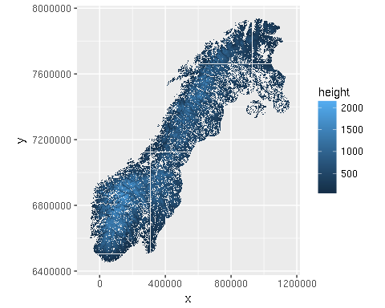

## 3. assign node ID for INLA

In order for INLA to work, each observation point is assigned an ID which determines its position in raster. Indices are assigned vertically from top left corner to bottom right corner.

require(INLA)  
  
nrows=1808  
ncols=1414  
  
input_data_na_rm$ID <- NA  
input_data_na_rm$ID = inla.lattice2node(input_data_na_rm$row, input_data_na_rm$col, nrows, ncols)

# 4. standardize data

For logistic regression predictors need to be standardized to zero mean and standard deviation equal to one, i.e. column mean is subtracted and the result is divided by standard deviation. Column means and standard deviations are kept in order to be utilized in prediction.

library(robustHD)  
  
input_data_na_rm.scaled <- input_data_na_rm  
input_data_na_rm.scaled[,observations.names] <- standardize(input_data_na_rm[,observations.names])  
  
input_data_na_rm.means <- colMeans(input_data_na_rm[,observations.names])  
input_data_na_rm.stddev <- apply(input_data_na_rm[,observations.names], 2, sd)

# 5. exploratory data analysis

## Correlation coefficient of response~predictor

First, correlations between response and predictors are explored.

data.cor.coef <- data.frame(cor.coef=double())  
i = 1  
for (predictor in observations.names) {  
 data.cor.coef[i,] <- cor(input_data_na_rm.scaled$nsuccess/input_data_na_rm.scaled$ntrials, input_data_na_rm.scaled[,predictor])  
 row.names(data.cor.coef)[i]<- predictor  
 i = i+1  
}  
  
data.cor.coef$predictor <- rownames(data.cor.coef)  
data.cor.coef <- data.cor.coef[order(data.cor.coef$cor.coef),]   
data.cor.coef$predictor <- factor(data.cor.coef$predictor, levels = data.cor.coef$predictor[order(data.cor.coef$cor.coef)])

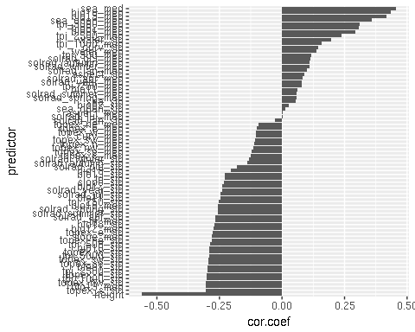

## Correlations between predictors

Correlations between predictors are checked and eliminated by three methods - first, correlation matrix is computed and pairs with correlation coefficient larger than 0.7 are explored. Second, full model is fitted with GLM, and predictors with variance inflation factor larger than 4 are exluded. Third, the data are projected on the first two principal components and predictors with similar directions are explored.

* Correlation matrix: In a pair of correlated predictors, the one with larger correlation coefficient with response is generally kept.

M.med <- cor(input_data_na_rm.scaled[,observations.names.mod])  
M.med.lim <- M.med*(abs(M.med)>=0.7)

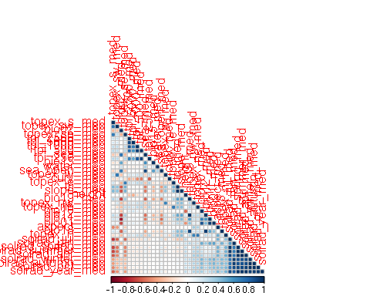

observation.names.mod.exclude <- observations.names.mod[!observations.names.mod %in%   
 c("solrad_jul_med","solrad_spring_med","solrad_summer_med",  
 "solrad_year_med","solrad_apr_med","solrad_jan_med",  
 "tpi_2500_med","solrad_winter_med","solrad_autumn_med",  
 "bio12_med","topex_ne_med","topex_sw_med",  
 "topex_se_med","tri_med","bio01_med","tpi_250_med",  
 "tpi_500_med","bio02_med","sea_open_med","bio18_med"  
 )]  
  
M.med.2 <- cor(input_data_na_rm.scaled[,observation.names.mod.exclude])  
M.med.2.lim <- M.med.2*(abs(M.med.2)>=0.7)

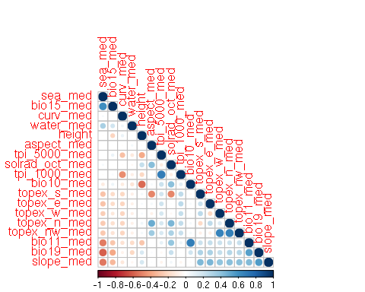

* VIF: A full logistic model is fitted with GLM, ommiting the spatial random effect. Predictiors with VIF larger than 4 are removed one-by-one using a backwards, stepwise procedure. Excluded predictors are solrad_oct_med, topex_nw_med and slope_med.

library(car)  
  
formula.med <- lc ~ water_med + sea_med +   
 aspect_med + curv_med +   
 topex_e_med + topex_n_med+ topex_s_med + topex_w_med +  
 tpi_1000_med + tpi_5000_med +   
 bio10_med + bio11_med + bio15_med + bio19_med + height  
  
mod.glm.med <- glm(formula.med,   
 data=input_data_na_rm.scaled,   
 family=binomial(link='logit'))

## Warning: non-integer #successes in a binomial glm!

vif(mod.glm.med)

## water_med sea_med aspect_med curv_med topex_e_med   
## 1.119094 3.038197 1.741380 1.385605 1.715937   
## topex_n_med topex_s_med topex_w_med tpi_1000_med tpi_5000_med   
## 1.957463 2.050504 1.610099 2.437915 2.082447   
## bio10_med bio11_med bio15_med bio19_med height   
## 2.406602 3.375371 1.494600 2.220417 1.920338

-PCA: excluded: bio11_med, tpi_100_med

#fit <- princomp(input_data_na_rm.scaled[,c("water_med","sea_med","aspect_med","curv_med",  
# "topex_e_med","topex_n_med","topex_s_med","topex_w_med",  
# "tpi_5000_med","bio10_med",  
# "bio15_med","bio19_med")], cor=TRUE)   
#summary(fit) # variance accounted for, pulls out the variables on the first 2 axes  
#loadings(fit) # pc loadings