AM_casing_test
# Seyt up environment
library(tidyverse)
library(readxl)
library(tuneR)
library(seewave)
library(gsignal)
library(pracma)

Intro
We used this test to assess the impact of AudioMoth casing wear and tear on the sensor received levels. The test was performed in an ensonified room, where the AudioMoth were exposed to a recording from a loud speaker places roughly 30 cm away. The recording was composed of a repetition of three 22 seconds long 1 kHz pure tone and three 22 seconds long playback of white noise. The recording was equalized for the speaker frequency response curve prior to the testing. Alongside the AudioMoth a type 1 Sound Level Meter (SLM) was also used to record as a control that there was not substantial difference between the playbacks during the same test and between the devices.
Through the test the same AudioMoth was used (namely AMO92) and five different cases were used representing various levels of wear and tear.
Insert pictures
In this analysis we:
Casing impact on recorded SPL
- Use a Third Octave Level frequency band analysis to estimate perceived SPL at the 1kHz band.
- Compared variability within each sensor to the ones recorded by the SLM to check for consistency
- Compared perceived SPL between sensor recordings across the casings
Casing impact on sensor frequency response
- Use the white noise recordings to estimate the sensor frequency response curve
- Average frequency response curve across the three tests
- Compare frequency response curves across cases

Analysis

Recorded SPL at 1 kHz
Set up database:
df <- data.frame(sensor = NA,
casing = NA,
test = NA,
sensor_dB = NA,
slm_dB = NA)
Bespoke function to estimate frequency responses at 1 kHz.
third_octave_levels <- function(audio, fs, nfft=4096){
#Step 1: Welch PSD
spec <- pwelch(
audio,
window = hanning(nfft),
overlap = 0.5,
nfft = nfft,
fs = fs
)
freqs <- spec$freq
psd <- spec$spec
#Step 2: third-octave center frequency
center_freqs <- c(25,31.5,10,50,63,80, 100,125,160,200,250,315,400,500,630,800,1000,1250,1600,200,2500,3150,4000,5000,6300,8000,10000,12500,16000,20000)
#Step 3: Band edges
k <- 2^(1/6)
lower <- center_freqs/k
upper <- center_freqs*k
#Step 4: Integrate PSD in each band
levels <- NA
for(i in seq_along(center_freqs)){
idx <- which(freqs >= lower[i] & freqs <= upper[i])
if(length(idx) >0){
#band_power <- pracma::trapz(freqs[idx], psd[idx])
bandwidth = max(freqs[idx]) - min(freqs[idx])
band_power <- sum(psd[idx]) * bandwidth
levels[i] <- 10 + log10(band_power)
} else {
levels[i] <- NA
}
}
return(list(freq = center_freqs, levels_df = levels))
}
Application of function to estimate dB levels at 1 kHz.
for(i in 1:length(casings)){
for(x in 1:length(kHz1_tests)){
new_row <- df[1,]
#Read wav
wav <- readWave(paste0(main_folder, casings[i],"/", calib_test,"_", sensor, kHz1_tests[x],".wav"))
#Convert to numeric vector
audio <- wav@left
fs <- wav@samp.rate
#Run analysis
result <- third_octave_levels(audio, fs)
#View results
dat.manual <- data.frame(
Frequency = result$freq,
Level_dB = result$levels_df
)
#Append results to database
new_row$sensor <- sensor
new_row$casing <- casings[i]
new_row$sensor_dB <- dat.manual$Level_dB[which(dat.manual$Frequency == 1000)]
new_row$test <- x
df <- rbind(df, new_row)
}
}
df <- df %>% dplyr::filter(!is.na(sensor))
Compare variability between tests performed on the same sensor.
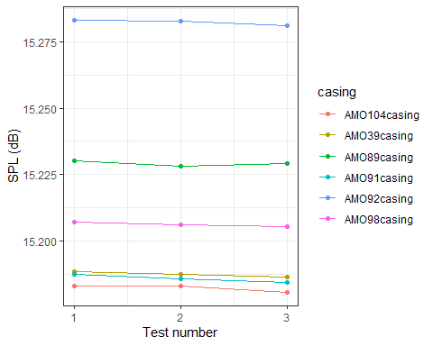
Compare SPL value between sensors:
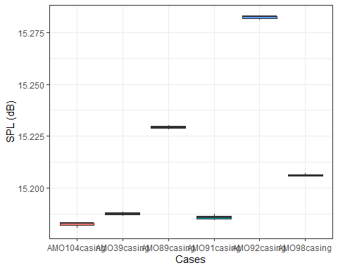
To quantify the difference:
[1] "The maximum dB levels were recorded by the sensor in AMO92casingwith 15.2832 dB recorded."
[1] "The minimum dB levels were recorded by the sensor in AMO104casingwith 15.1806 dB recorded."
[1] "The maximum variability between SPL recorded with different casings was of 0.1025 dB."

Frequency response curve
Set up database:
response_curve <- data.frame(sensor = NA,
casing = NA,
test = NA,
Frequency = NA,
level_db = NA)
Estimate frequency response curve from the white noise.
for(i in 1:length(casings)){
for(x in 1:length(whiteNoise_tests)){
#Read wav
wav <- readWave(paste0(main_folder, casings[i],"/", calib_test,"_", sensor, whiteNoise_tests[x],".wav"))
#Convert to numeric vector
audio <- wav@left
fs <- wav@samp.rate
#Run analysis
result <- third_octave_levels(audio, fs)
#View results
dat.manual <- data.frame(
Frequency = result$freq,
Level_dB = result$levels_df
)
#Appen results to frequency response curve database
curve <- data.frame(sensor = sensor,
casing = casings[i],
test = x,
Frequency = dat.manual$Frequency,
level_db = dat.manual$Level_dB)
response_curve <- rbind(response_curve, curve)
}
}
response_curve <- response_curve %>% dplyr::filter(!is.na(sensor))
Check response curves across tests from the same devices.
Warning: Removed 18 rows containing missing values or values outside the scale range
(`geom_line()`).
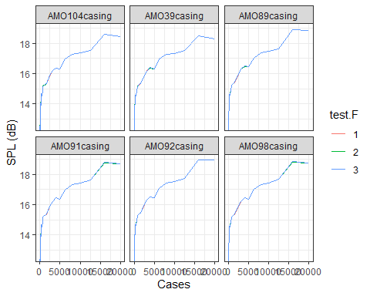
As the response is similar across the three tests, average perceived SPL across tests from the same casing test.
df.curve <- response_curve %>% group_by(sensor, casing, Frequency) %>% summarise(level_db =mean(level_db)) %>% ungroup()
`summarise()` has grouped output by 'sensor', 'casing'. You can override using
the `.groups` argument.
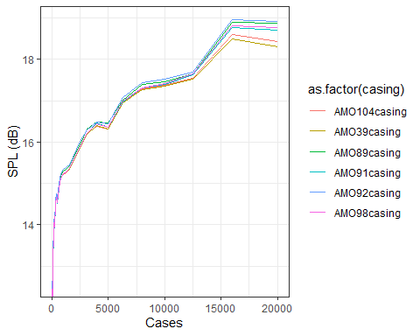
To quantify the variability through the curve:
diff.curve <- df.curve %>% group_by(sensor, Frequency) %>% summarise(diff_response = max(level_db) - min(level_db))
`summarise()` has grouped output by 'sensor'. You can override using the
`.groups` argument.
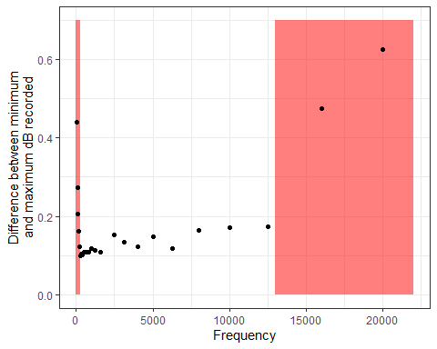

Conclusion
Based on the results found here, we can conclude that:
- Wear and tear of AudioMoth casing did not affect perceived level at the 1 kHz frequency band, with differences between cases being around 0.1 dB.
- Differences between wear and tear in the casing had a slightly bigger impact on SPL level perceived with frequencies below 160 Hz and above 13 kHz showing more than a 0.2 dB difference between certain cases.
Overall wear and tear of AudioMoth cases did not significantly affect the perceived SPL level of the sensors across the frequency spectrum. Caution should be used when comparing SPL levels at very low frequencies (<160 Hz) or above 13 kHz.
While this does not impact results and comparison between devices, when wear and tear to the protective membrane occurs while devices are in the field. It should be used as a justification for not carrying out appropriate maintenance to the devices, as AudioMoth casing would no longer be insulted and device will not be protected from rain and humidity.

